Screen shot of the class diagram for the elevator scenario ,designed in visio.

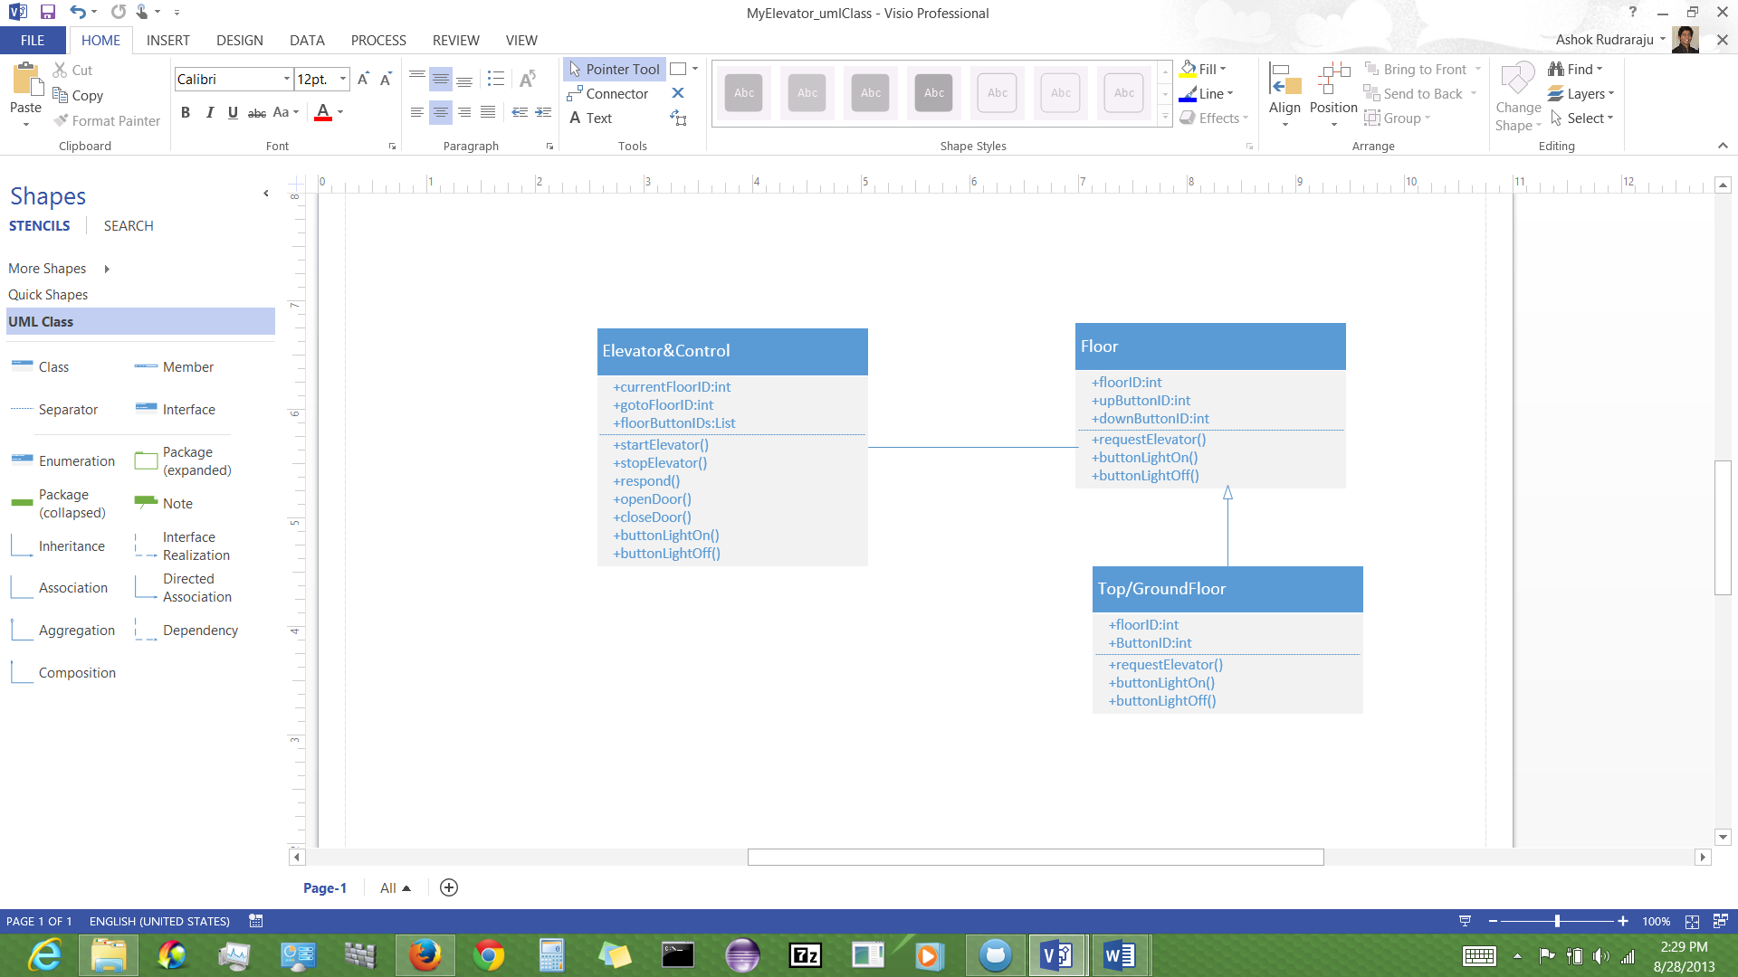

The following screen shots show the sequence diagram step by step in visio.

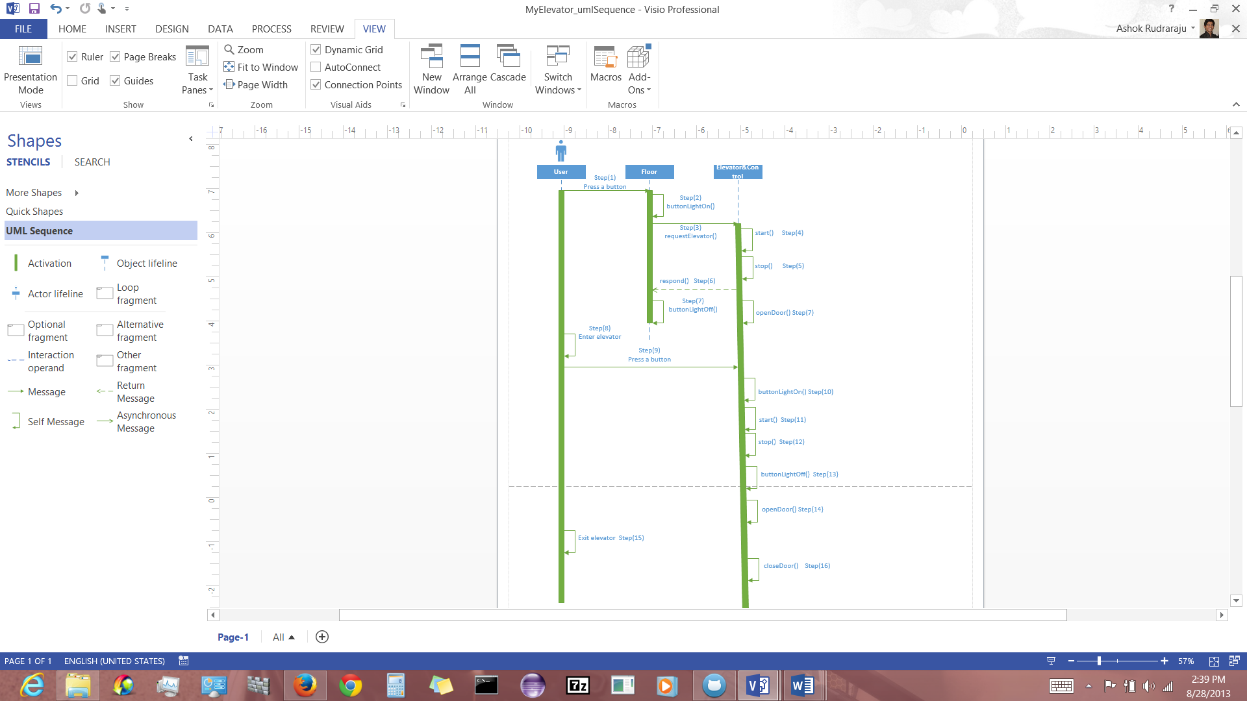

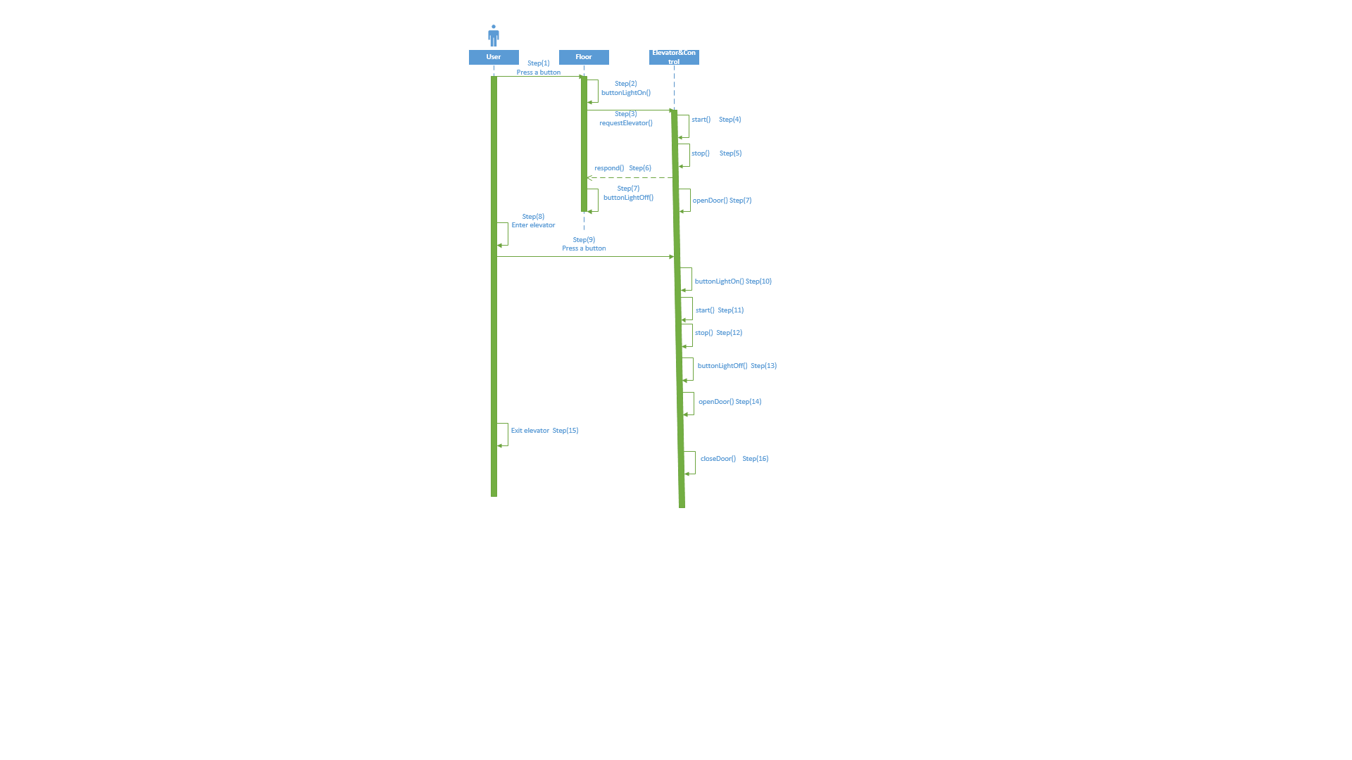

System architecture diagram in visio.

