**Employee Management**

User Manual

MD Shohel Arman

Lecturer

Department of Software Engineering

Daffodil International University

Ummay Honey Alam Mojumder

ID: 171-35-2009

Department of Software Engineering

Daffodil International University

INTRODUCTION

The User Manual contains all essential information for the user to make full use of the Employee Management system. This manual includes a description of the system functions and capabilities, contingencies and alternate modes of operation, and step-by-step procedures for system access and use. Use graphics where possible iii this manual. The manual format may be altered if another format is more suitable for the particular project.

I have included the original Table of Contents to illustrate how much detail the manual provided. Following that is one section of the manual, so the reader understands my writing style. All references to any proprietary information has been removed.

This the First page of this website.

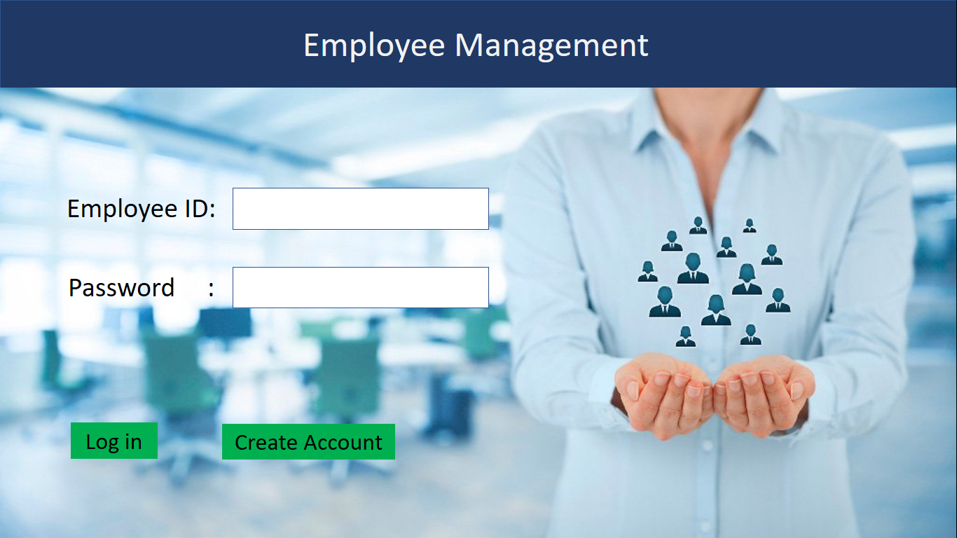

This is the Log in page. User has to fill the blanks and click on the login to enter.

If the user has no account has to click on ‘Create Account’.

After clicking on ‘Create Account’ this page will appear

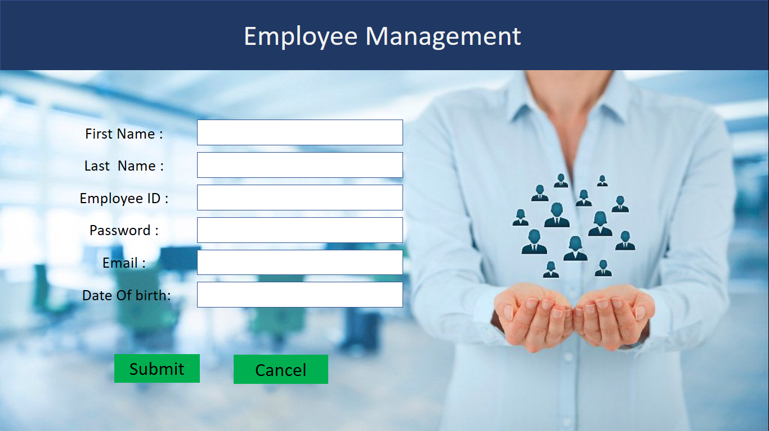



In here every blank has to fill and click on submit. If the user click on cancel it will go back to Login page.

After click on ‘submit’ this page will appear.

This page will also appear after Login.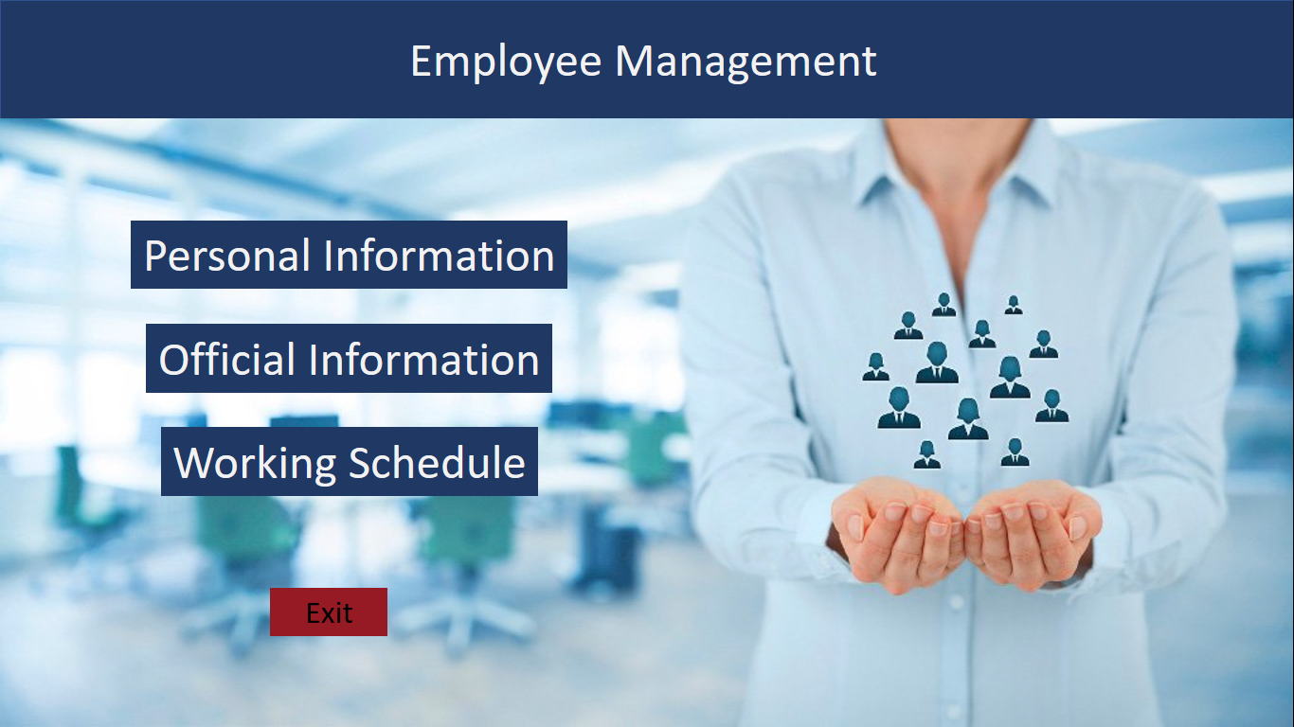

Clicking on ‘Personal Information’ the Personal information page will appear.

Clicking on ‘Official Information’ Official information page will appear.

Clicking on ‘Working Schedule’ schedule page will appear.

Personal Info page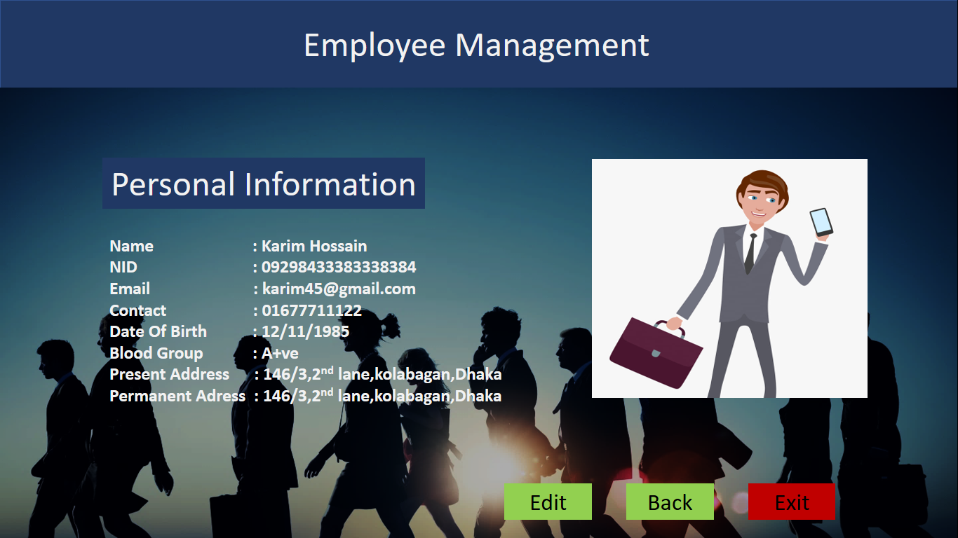

This Option is for editing the personal information.

Official Information Page

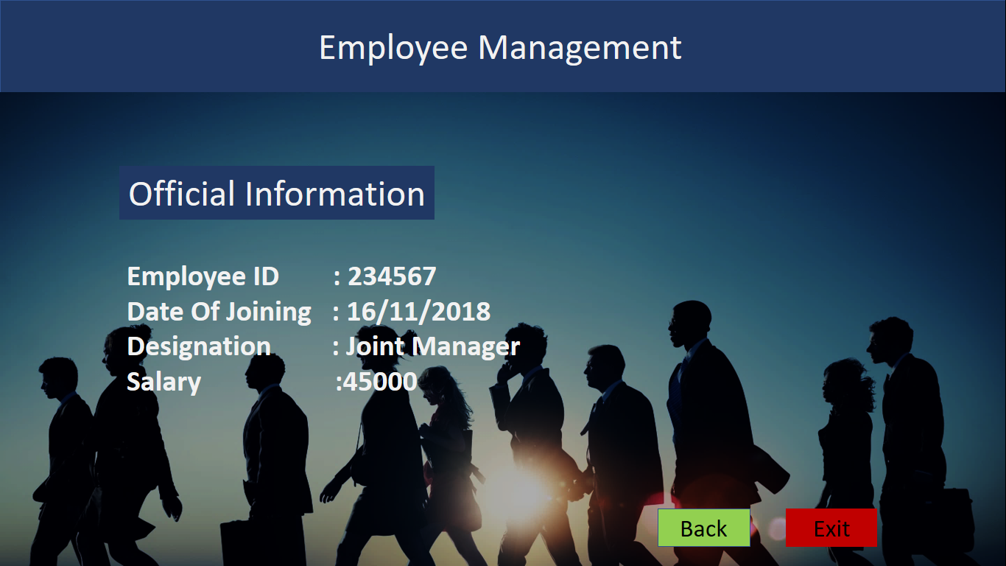

This option will take back the user to main menu.

Working Schedule page

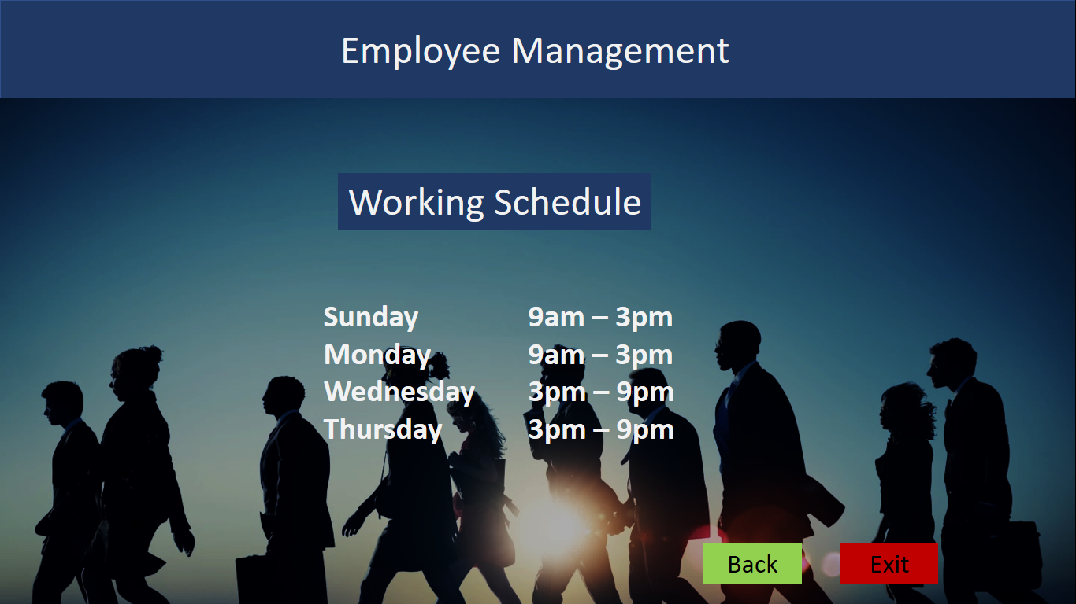

This button is for exiting the site