**Employee Management**

Documentation

MD Shohel Arman

Lecturer

Department of Software Engineering

Daffodil International University

Ummay Honey Alam Mojumder

ID: 171-35-2009

Department of Software Engineering

Daffodil International University

INTRODUCTION

The documentation is an example of user manual for an online based Employee Management system. Employees are only user here. The assumption was that the users are not very technically savvy, so the application and the user manual had to be intuitive and easy to use.

I have included the original Table of Contents to illustrate how much detail the manual provided. Following that is one section of the manual, so the reader understands my writing style. All references to any proprietary information has been removed.

This the First page of this website.

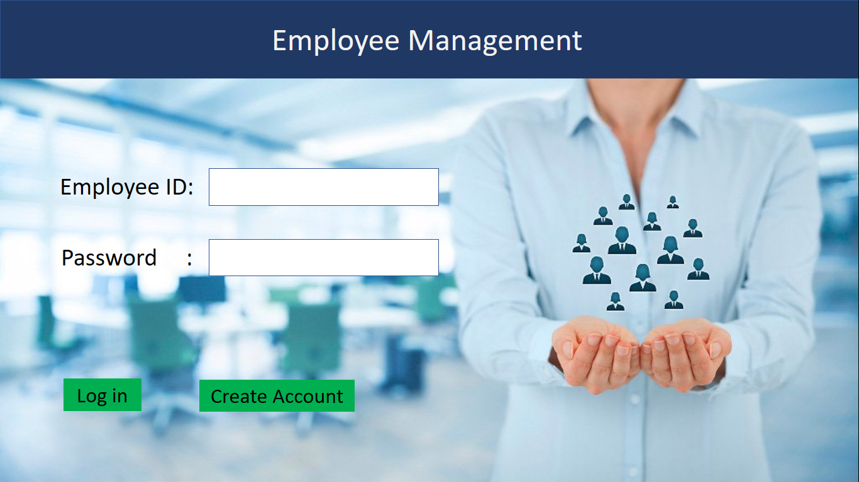

This is the Log in page. User has to fill the blanks and click on the login to enter.

If the user has no account has to click on ‘Create Account’.

After clicking on ‘Create Account’ this page will appear

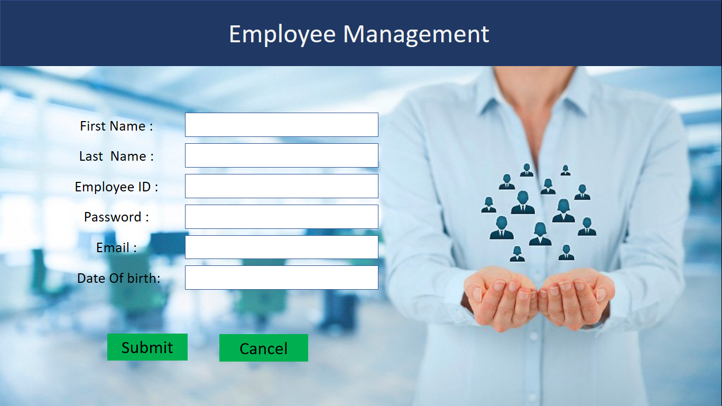



In here every information has to fill and click on submit. If the user click on cancel it will go back to Login page.

After click on ‘submit’ this page will appear.

This page will also appear after Login.

Main menu

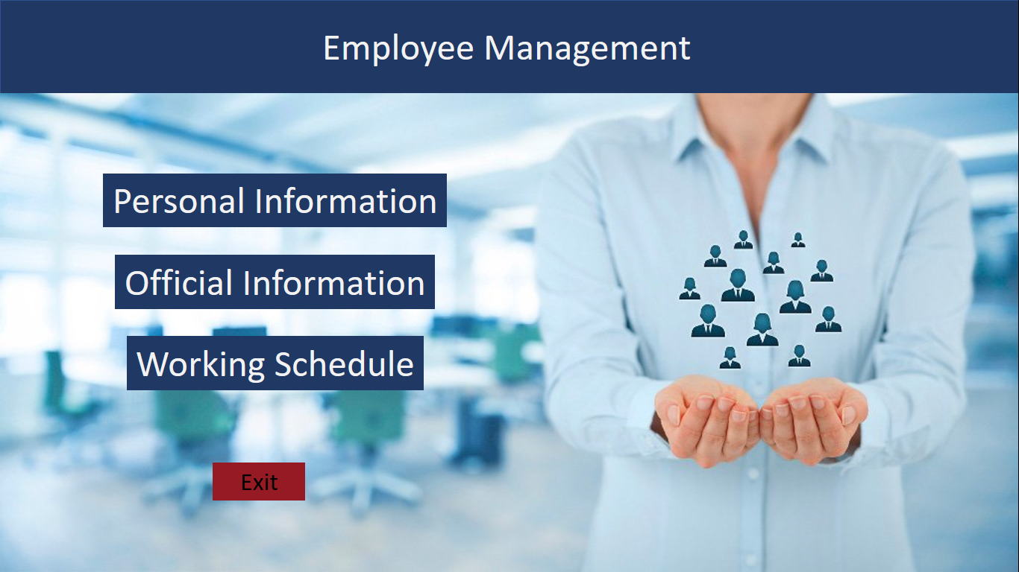

Clicking on ‘Personal Information’ the Personal information page will appear . Clicking on ‘Official Information’ Official information page will appear. Clicking on ‘Working Schedule’ schedule page will appear.

Personal Info page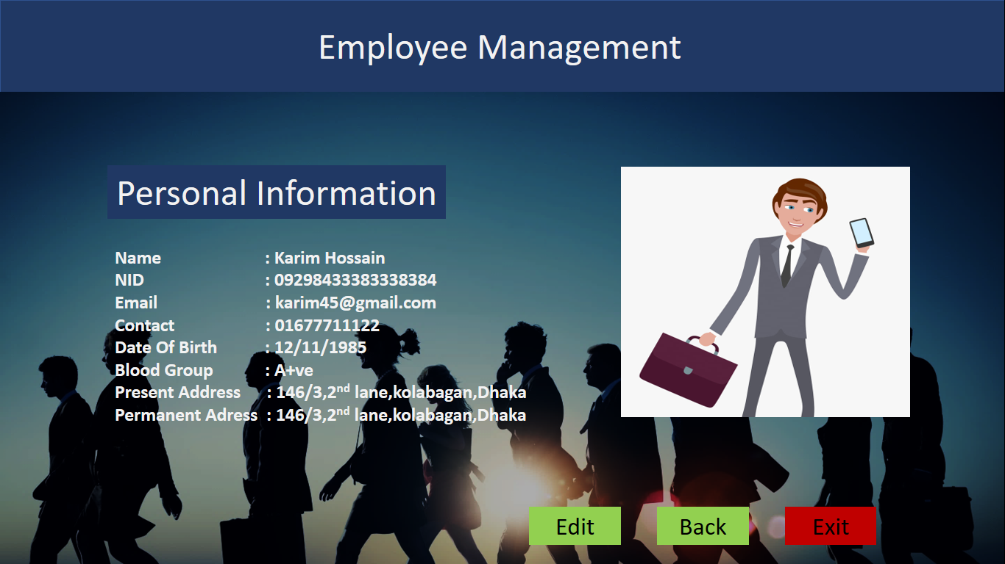

Edit option is for editing the personal information.

Exit button is for exiting the site.

Employee can check and edit their personal information here.

Official Information Page

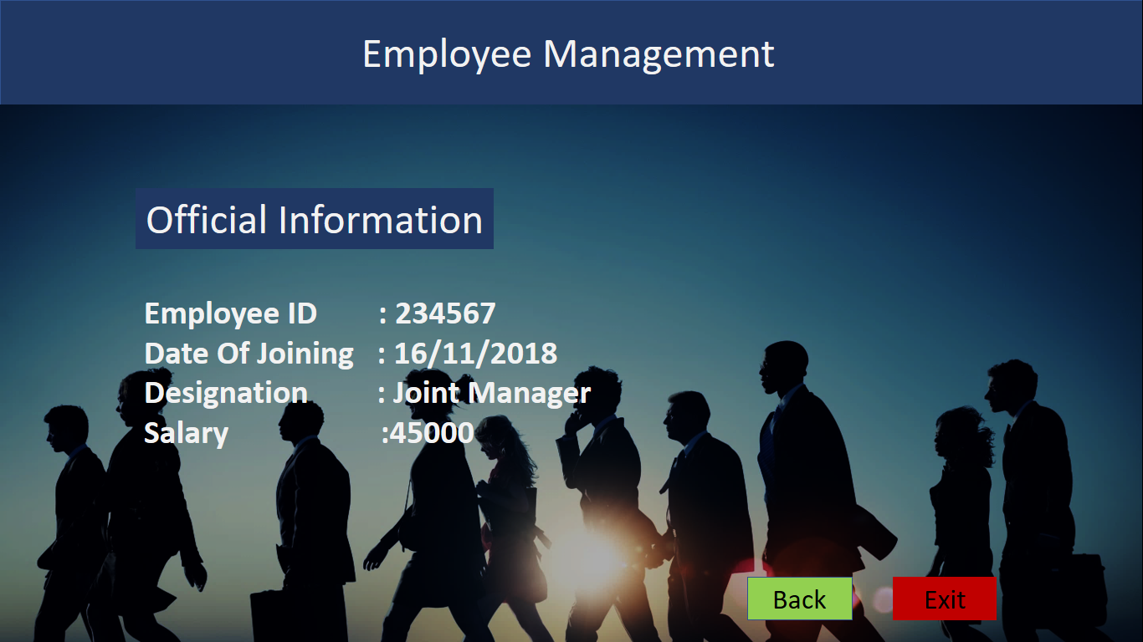back option will take back the user to main menu.

Employee can check their official information here.

Working Schedule page

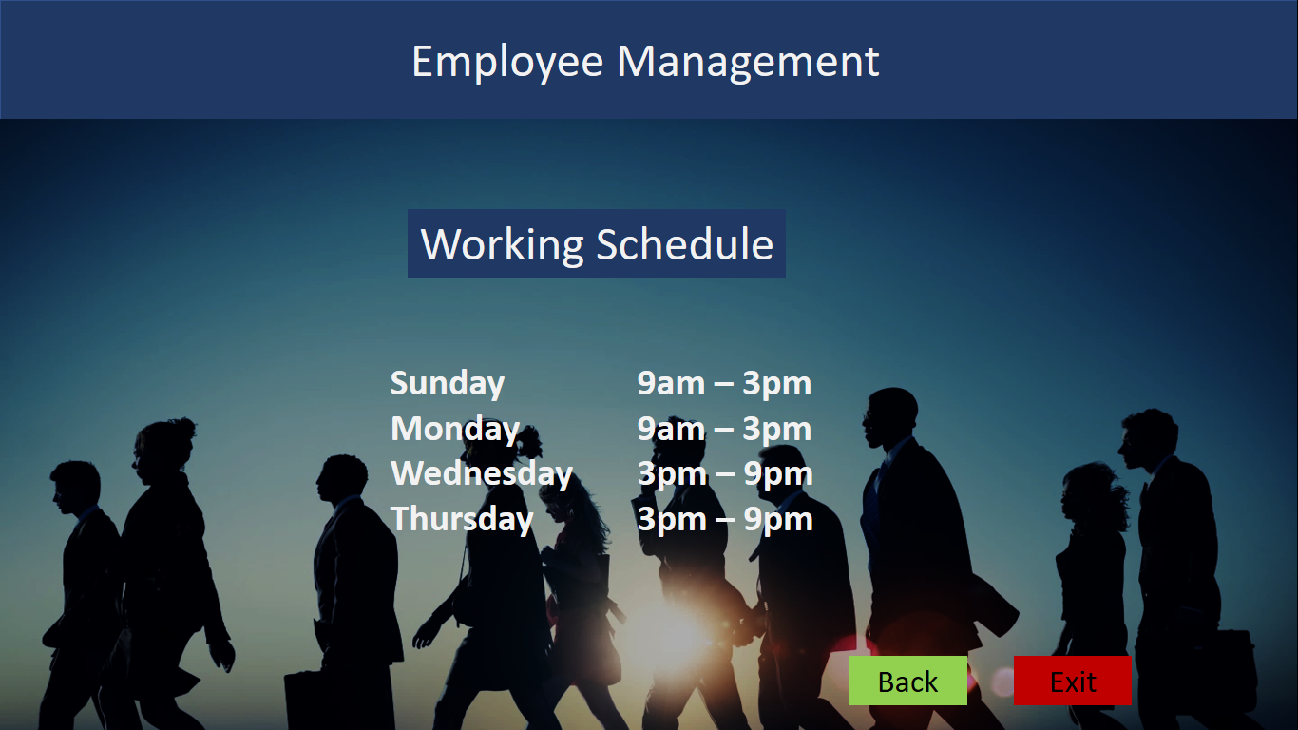

Back button will back user to the main menu.

Exit button is for exiting the site.

employee can see their working schedule here.