## Development of

**Research Publication Platform: ScholarLink**

A Practicum Report Submitted By

Umme Habiba Happy

ID-20103109

A Practicum is the Partial Fulfillment of the Requirements

for the Award of Bachelor of Computer Science and Engineering (BCSE)



Department of Computer Science and Engineering College of Engineering and Technology

IUBAT – International University of Business Agriculture and Technology

## Development of

**Research Publication Platform: ScholarLink**

A practicum report submitted in partial fulfillment of the requirements for the degree of Bachelor of Computer Science and Engineering (BCSE)

The practicum has been examined and approved,

Prof Dr. Utpal Kanti Das Chair and Professor

Dept. of Computer Science and Engineering

IUBAT – International University of Business Agriculture and Technology

Shahinur Alam

Senior Lecturer & Coordinator

Dept. of Computer Science and Engineering

IUBAT – International University of Business Agriculture and Technology

Abdur Rahman Lecturer

Dept. of Computer Science and Engineering

IUBAT – International University of Business Agriculture and Technology

Department of Computer Science and Engineering College of Engineering and Technology IUBAT – International University of Business Agriculture and Technology

### Letter of Transmittal

15thDecember 2023

To

The Chairman, Practicum and Placement Board College of Engineering and Technology – CEAT

IUBAT - International University of Business Agriculture and Technology 4 Embankment Drive Road, Sector – 10

Uttara Model Town, Dhaka-1230, Bangladesh

##### Subject: Letter of Transmittal.

Sir,

With due respect, I would like to approach you that it is a great opportunity as well as immense pleasure for me to submit this report titled **“Development of Research Publication Platform: ScholarLink”** for the fulfillment of my Practicum course.

It was undoubtedly a splendid opportunity for me to work on this project to actualize my theoretical knowledge and has an enormous exposure with the corporate culture of a renowned company. Now I am looking forward for your kind appraisal regarding this practicum report.

I shall remain deeply grateful to you if you kindly go through this report and evaluate my performance. I hope that you would find the report comprehensive and competent augmented.

Thanking you,

Umme Habiba Happy ID #20103109

Program: BCSE

### Letter of Authorization

15th December, 2023

IUBAT- International University of Business Agriculture and Technology 4, Embankment Drive Road, Sector 10

Uttara Model Town, Dhaka - 1230, Bangladesh.

##### Subject: Letter of Authorization.

Program: BCSE,

You will be happy to know that the project on “Development of Research Publication Platform: ScholarLink”, I have received in your proposal under my continue internship. Based on your proposal you will have to submit the project as soon as possible. I hope you will successfully complete it on time. After successful completion of the project, you are requested to write a report based on the project.

For any kind of assistance feel free to contact with me.

Co– Supervisor Practicum Supervisor

df

Shahinur Alam

Senior Lecturer and Coordinator

Dept. of Computer Science and Engineering IUBAT – International University of Business Agriculture and Technology

Abdur Rahman Lecturer

Dept. of Computer Science and

Engineering IUBAT –

International University of Business Agriculture and Technology

### Student’s Declaration

I am Umme Habiba Happy bearing ID-20103109, student of BCSE - Bachelor of Computer Science and Engineering program, under the College of Engineering and Technology (CEAT) of IUBAT- International University of Business Agriculture and Technology declaring that, this report on the topic of **“Development of Research Publication Platform: ScholarLink”** has been prepared for the fulfillment of the internship CSC 490, Practicum as well as the partial requirement of BCSE-Bachelor of Computer Science and Engineering degree.

The report and the project on ― **“Development of Research Publication Platform: ScholarLink”** are originally prepared by me. All module and procedure of this project is being made after proper inspection and internet information.

It has not been prepared for any other purposes, rewards or presentations.

Umme Habiba Happy ID #20103109

Program: BCSE

### Acknowledgements

I, first and foremost, would like to express our gratitude to Almighty Allah for helping me to complete the report properly.

My sincere thanks to Prof. Dr. Abdur Rab, Honorable Vice Chancellor, IUBAT- International University of Business Agriculture and Technology to give me an opportunity to submit this practicum report.

My profound respect goes to Prof. Dr. Utpal Kanti Das, Chair and Professor, Department of Computer Science and Engineering, IUBAT- International University of Business Agriculture and Technology for approving me to work on this project.

My outmost and sincere gratitude goes to Shahinur Alam, Coordinator of Department of Computer Science and Engineering, IUBAT- International University of Business Agriculture and Technology for allowing me to complete this project.

I would like to express our gratefulness to my supervisor Abdur Rahman, Lecturer, Department of Computer Science and Engineering, IUBAT- International University of Business Agriculture and Technology who has given me the opportunity to make such a project report for not only in this semester but also throughout my whole education life at IUBAT-International University of Business Agriculture and Technology by giving her valuable suggestions and advices at any time, at any situation. I would able to make this report effectively and properly only for her right direction.

I owe my deepest gratitude to my parents and our family members whose inexhaustible love was indispensable to endure in the tragic moments that confronted me once again with the vulnerability of life.

Lastly, this report would not have been possible without the essential and gracious support of many individuals and supported us in any respect to complete this project on time. I am also grateful to them.

### Supervisor’s Certification

This is to certify that Practicum report on **“Development of Research Publication Platform: ScholarLink”** has been carried out by bearing ID-20103109 of **IUBAT** – International University of Business Agriculture and Technology as a partial fulfillment of the requirement of practicum defense course. The report has been prepared under my guidance and is a record of the accomplished work carried out successfully. To the best of my knowledge and as per his declaration, no parts of this report has been submitted anywhere for any degree, diploma or certification.

Now she is permitted to submit the report. I wish his success in all his future endeavors.

Practicum Supervisor

Abdur Rahman Lecturer

Department of Computer Science and Engineering College of Engineering and Technology (CEAT)

IUBAT- International University of Business Agriculture and Technology

### Departmental Certification

On behalf of the Department of Computer Science and Engineering of International University of Business Agriculture and Technology (IUBAT) we, the undersigned, certify that this practicum report **“Development of Research Publication Platform: ScholarLink”** for the award of Bachelor of Computer Science and Engineering (BCSE) degree was duly presented by Umme Habiba Happy (ID No. 20103109) and accepted by the department.

Abdur Rahman Lecturer

Department of Computer Science and Engineering

IUBAT – International University of Business Agriculture and Technology

Shahinur Alam

Senior Lecturer and Coordinator

Department of Computer Science and Engineering

IUBAT – International University of Business Agriculture and Technology

Dr. Utpal Kanti Das Chair and Professor

Department of Computer Science and Engineering

IUBAT – International University of Business Agriculture and Technology

### Internship certificate



### Abstract

In the response to the evolving dynamics of academic research, this project introduces “ScholarLink” an innovative Research Publication Platform. Designed to simplify and enhance the collaborative Research Process, ScholarLink provides researcher with an intuitive and user-friendly interface for the seamless submission, management, and sharing of scholar contributions. This platform integrates advanced features, including a secure submission portal, sophisticated collaboration tools, and streamlined content curation capabilities for administrators. ScholarLink serves as an exemplar for institutions seeking a comprehensive, user-centric solution to reduce scholarly collaboration and dissemination within the academic community. ScholarLink represents a significant leap forward in making research sharing and collaboration more accessible, efficient, and impactful for academic community at large. The application is developed using the Laravel framework and incorporates HTML, CSS, Bootstrap, SQL, PHP, and JavaScript.

### Table of Contents

**Contents**

Letter of Transmittal 3

Letter of Authorization 4

Student’s Declaration v

Acknowledgements vi

Supervisor’s Certification vii

Departmental Certification viii

Internship certificate ix

Abstract x

Table of Contents xi

List of Figures xv

List of Tables xvi

1.1 Introduction 1

* 1. Background Study 2
  2. Project Objective 2
     1. Board Objective 2
     2. Specific Objective 2
  3. Methodology 3
     1. Data Source 3
  4. Processed Model 4
     1. Reason for Choosing Increment Process Model 4
  5. Feasibility Study 5
     1. Technical Feasibility 5
     2. Economic Feasibility 6
     3. Operational Feasibility 6

Chapter 2 7

The Organization 7

* 1. Organizational Overview 8
  2. Organization Services 8
  3. Organization Vision 10
  4. Organization Mission 10
  5. My Position in this Organization 11
  6. Organizational Structure 11

Chapter-3 Requirement Engineering 12

* 1. Requirement Analysis 13
  2. Requirements Engineering 13
     1. User Requirements 13
     2. System requirements 14
     3. Functional Requirements 16
     4. Non-Functional Requirements 17
     5. Hardware Requirements 18
     6. Software Requirements 18
  3. Use Case Diagram of the System 18
     1. Use case Symbol 19
     2. Use Case Diagram for the System 20

Chapter-4 System Planning 21

* 1. Function of the Proposed System 22
  2. Function Point Estimation 22
  3. Identifying Complexity: 25
     1. Identifying complexity of Transition Function 25
     2. Identifying complexity of Data Function: 26
     3. Unadjusted Function Point Contribution 27
     4. Unadjusted Function Point Contribution for Data Function 29
     5. Performance and Environmental Impact 29
  4. Effort Based Estimation 32
  5. Project Scheduling Chart 33
  6. Cost Estimation 34
     1. Personal Cost 34
     2. Software Cost 36
     3. Hardware Cost 36

Chapter 5 Risk Management 37

* 1. Risk Analysis 38
  2. The RMMM Plan 39
     1. Project Risk 40

Risk Identification 40

Risk Analysis 41

Risk Planning 42

Risk Monitoring 42

Chapter-6 Analysis Modeling 44

* 1. Analysis Modeling 45
  2. Activity Diagram 45
     1. Activity Diagram for Admin 45
     2. Activity Diagram for Researcher 46
  3. ER Diagram 47
  4. Data Flow Diagram 48
     1. Context level Diagram 48
     2. Level 1 Diagram 49
     3. Level 2 DFD of Process 1 Diagram (Registration) 50
     4. Level 2 DFD of Process 2 Diagram (Login) 51
     5. Level 2 DFD of Process 3 Diagram (Category) 52

6.4.5 Level 2 DFD of Process 4 Diagram (Research) 53

6.4.5 Level 2 DFD of Process 5 Diagram (Post) 53

6.4.5 Level 2 DFD of Process 6 Diagram (User) 54

Chapter 7 Interface and Database Design 55

* 1. Database table Design 56
  2. Interface Design 59
     1. Website Interface 59
     2. Admin Panel Interface 63

Chapter 8 System Testing 67

* 1. System Testing 68
     1. Software Testing Strategy 69
  2. System Testing Methodology 70
     1. Black Box Testing 70
  3. Testing 71

Chapter 9 conclusion 75

* 1. Preface 76
  2. Practicum and Its value 76
  3. Limitation 77
  4. Future Work 77
  5. Conclusion 78

References: 79

### List of Figures

Figure 1 Incremental Process Model 4

Figure 2 Organization Location 10

Figure 3 Organization Structure 11

Figure 4 Use Case Diagram 20

Figure 5 Effort Based Estimation pie Chart 32

Figure 6 Project Schedule Chart 33

Figure 7 Activity Diagram For Admin 45

Figure 8 Activity Diagram for Researcher 46

Figure 9 ER Diagram 47

Figure 10 Context Level Diagram 48

Figure 11 DFD Level 1 49

Figure 12 DFD Level 2 Process 1(Registration) 50

Figure 13 DFD Level 2 Process 2(Login) 51

Figure 14 DFD Level 2 Process 3(Category) 52

Figure 15 DFD Level 2 Process 4 (Resaerch) 53

Figure 16 DFD Level 2 Process 5 (Post) 53

Figure 17 DFD Level 2 Process 6 (User) 54

Figure 18 Admin Table Structure 56

Figure 19 Users Table Structure 56

Figure 20 Categories table Structure 56

Figure 21 Posts Table Structure 57

Figure 22 Downloads Table Structure 57

Figure 23 Comments Table STRUCTURE 58

Figure 24 Reads Table Structure 58

Figure 25 Registration for Researcher 59

Figure 26 Login for Researcher 59

Figure 27 Homepage 60

Figure 28 Researcher Profile 60

Figure 29 Research List 61

Figure 30 Create post 61

Figure 31 single view of a Post 62

Figure 32 Single view of a Research 62

Figure 33 Comment Box 63

Figure 34 Admin Login 63

Figure 35 Dashboard 64

Figure 36 Admin List 64

Figure 37 Researcher List 65

Figure 38 Project List 65

Figure 39 Publication List 66

Figure 40 Print Publication 66

### List of Tables

Table 1 Function Proposed System 22

Table 2 Functional Point Estimation 23

Table 3 Function point Estimation for Researcher 24

Table 4 Identifying complexity for Transition Function 25

Table 5 Identifying complexity for Data Function 27

Table 6 Unadjusted Function Point Contribution for Transition Function 27

Table 7 Unadjusted Function Point Contribution for Data Function 29

Table 8 Performance and Environmental Impact 29

Table 9 Personal Cost 35

Table 10 Deprecated Hardware Cost 36

Table 11 Risk Identification 40

Table 12 Risk Analysis 41

Table 13 Risk Planning 42

Table 14 Testing No. 1 71

Table 15 Testing No. 2 72

Table 16 testing No. 3 72

Table 17 Testing No. 4 73

Table 18 Testing No. 5 73

Table 19 Testing No. 6 74

# Chapter-1 Introduction

### 1.1 Introduction

"ScholarLink" is the proposed system's name. Internships are a chance to put classroom information into action. It's a great way to learn about the company you'll be working for and to create the self-assurance you'll need to begin your service career. Internships are available at a wide range of organizations, from private companies to universities and even government departments. IUBAT provides this chance by facilitating access to the resources that are most useful in achieving the goal of increasing capabilities. This is because it is extremely difficult for recent graduates to find work in a relatively unprotected job market. Both the student's academic understanding and their developed skills in the real world will be put to use in this capstone experience. This document details the projects I worked on during my internship at Kodeeo Limited. It's expected that the internship would last at least two months. This report has been created to detail the processes and actions taken at each stage of the management system development process. I have covered every single aspect of the development chapter in this report.

In the ever-evolving realm of academia, the rise of digital platforms has fundamentally transformed the landscap of scholarly collaboration and dissemination. Within this context, the project introduces “ScholarLink” a robust Research Publication and collaboration platform meticulously crafted to address the dynamic needs of the academic community. ScholarLink functions as a dedicated hub for researchers to effortlessly submit, manage, and share their scholarly contributions. Featuring an intuitive user interface, the platform empowers researchers to partake in collaborative endeavors, fostering interdisciplinary communication and knowledge sharing. Scholarlink serves as a model for institutions aiming to enhance their collaborative processes and improve the sharing of valuable contributions

within the academic community. This platform offers a comprehensive and efficient solution to redefine how academics collaborate and disseminate their work.

#### Background Study

In today’s academic world, digital platform have changes how researcher work together and share their work. Fundamentally altering the traditional mods of scholarly collaboration and dissemination. In this context, “ScholarLink” emerges as a specialized tool exclusively tailores for researchers. With user-friendly interface, ScholarLink serves as a dedicated hub, streaming the submission, management and sharing of research studies. It simplifies individual researchers workflows. It encapsulates the essence of making the research process more accessible, efficient and collaborative for the exclusive use of researchers.

### Project Objective

##### Board Objective

The board objective is to establish and implement “ScholarLink” as a leading digital platform is the research domain, addressing the evolving needs of researchers and research institutions.

##### Specific Objective

* Ensuring a user-friendly and robust platform
* Actively encourage research adoption among researcher
* Position “ScholarLink” as a model for research institutions
* Continuously improve platform efficiency
* Establish mechanisms for user feedback collection
* Ensure quality assurance measures for the reliability and security
* Develop a long term sustainability plan

### Methodology

##### Data Source

The source of data required for the purpose for this project is:

1. First-hand data (Primary Data)
2. Indirect data (Secondary Data)

##### Primary Data

Primary data sources involve the direct collection of information for a specific research purpose. Surveys and questionnaires are employed to gather responses from individuals or organizations directly related to the research objectives. Interviews with experts, stakeholders or individuals possessing specialized knowledge provide in-depth insights. Observations involve firsthand documentation of event or behaviors. These primary sources contribute unique, firsthand data enhancing the depth and specificity of the research findings.

##### Secondary Data

Secondary data sources involve the use of existing information collected for purposes other than immediate research project. Published literature such as academic journals and books, provide a foundation of existing knowledge. Company reports, online database, and news articles provide historical and current information. Researchers can also leverage data collected by others through surveys, studies, or academic research projects.

* 1. **Processed Model**

Even when the requirements for the software have been worked out in great detail, there are certain circumstances in which the user requires the program instantly. In this specific setting, the incremental process model is the approach that is going to prove to be the most fruitful one to pursue. By taking advantage of this strategy, we will be able to disseminate software in increments. The features of the software could perhaps be expanded in subsequent versions at some point in the future. The functionality of the software can be tested by the user, who can then submit feedback regarding their experience using the software. It necessitates the production of fresh content in addition to continuing maintenance. When each and every one of the standards has been met, we are able to declare a product to be complete.

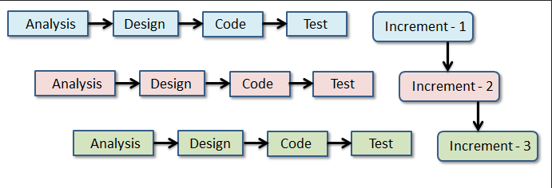

**Figure 1 Incremental Process Model**

##### Reason for Choosing Increment Process Model

* Make efforts toward enhancing the support provided for the iterative process.
* Reduce the amount of rework that needs to be done on a component of the product.
* Time efficient.
* Ease the process of sending a sample of the product to a customer when they request it.
* Reduce the risk that the project will be unsuccessful.
* There will be fewer steps involved in the delivery process

### Feasibility Study

The goal of the study commissioned by the organization is to determine whether or not the proposed solution is one that can be implemented successfully within the company or is within its reach. This suggests that the effort we perform will either be valuable or will have no value at all depending on the outcome. There are primarily three different places where investigation and the formation of new ideas might take place in relation to a new system. When doing an analysis of the practicability of the system in order to determine whether or not it would be possible to automate the system, three essential facets of the system are taken into consideration as part of the evaluation.

1. Technical feasibility
2. Economic feasibility
3. Operational feasibility

##### Technical Feasibility

The technical feasibility analysis addresses concerns regarding the system's capabilities, durability, reliability, and the proficiency of the development team. Upon evaluation, it has been determined that this model is technically feasible, utilizing the provided set of tools and technologies. For the project's implementation, high-level programming languages such as HTML, CSS, Bootstrap, or the Laravel Framework will be utilized. Additionally, the utilization of Xampp Server and other databases, along with a cloud server and a computing device (e.g., computer or smartphone) with basic configuration and data connectivity, is necessary for data storage and operating the integrated development environment (IDE) like Sublime Text, Visual Studio Code, or PHP Storm. Currently, all the analyzed technologies are in a functional state, confirming the technological feasibility of our concept.

##### Economic Feasibility

The economic viability of a new system is determined by its ability to generate cost savings over its lifetime. The production of my program is cost-effective, requiring only a single operating system, integrated development environment (IDE), and browser. An in depth cost benefit analysis is conducted, encompassing initial development costs, ongoing maintenance expenses, and potential revenue streams. The economic feasibility of ScholarLink is substantiated, emphasizing its financial viability, alignment with budget constraints, and long term benefits.

##### Operational Feasibility

Operational feasibility is assessed by gauging ScholarLink’s practicality within the academic community. This involves an examination of how the platform addresses researcher’s needs, its user-friendliness, and potential challenges related to user adoption. ScholarLinks seamless integration into daily workflows is a key highlight.

**Chapter 2****The Organization**

Chapter 1 is representing the organizational overview, mission, vision and about company’s various services. In this chapter detailed organizational overview is discussed along with the organizational hierarchy and my position over there as intern.

### Organizational Overview

Kodeeo a full-featured web solution, software development, mobile application, graphic & multimedia, domain hosting and digital marketing service providing company in Bangladesh Its core with the highly qualified Designers and Developers having experience of more than 5 years in various and complex designs and development. Kodeeo has satisfied the clients with the services like Web design and development, Mobile app design and development, Software development, SEO and social media Designing & Development. This companies customer centric and divert our efforts to act as a one-stop solution provider in the area of IT In every area of our, operations we work hard in understanding the Client’s requirement and providing the Kodeeo solution. We firmly believe in the philosophy of ‘Our vision is to make every youth skilled & employed’. We take pride in a team of highly qualified, skilled and motivated Professionals who are encouraged to lead, innovate and excel. Our team consists of top professionals who share a common vision and passion, providing our clients with critical insights and advice to succeed in today’s competitive environment. We believe in delivering Expertise, Excellence Services through our past Experience and providing the highest and best enduse of services to our client. (Kodeeo, Ltd.)

### Organization Services

Kodeeo is an Information Technology service provider organization which provides allkinds of professional and creative software, Enterprise software integration, Management info system, E- commerce, Game development, Web development & Mobile app solutions globally.

**Web Development:** At Kodeeo we focus on creating search engine friendly, aesthetically appealing and interactive website designs. It is a known fact that to build a strong web presence and to secure the countless marketing opportunities available on the internet, a good website is imperative, thus triggering a race for website design while designing and developing your website, our professionals keep in mind key factors like easy-navigation, overall consistency and content quality, stipulated timeframes and budget and backend **Mobile Application:** We have a strong mobile application developer team of expert whose have the experience to build versatile mobile applications for various industries. All of our expert engineer working in android and IOS platform for more than five years. We work on native android which provide faster response of app and ensure the quality.

**Domain and Hosting Service Provider:** Kodeeo offers unbeatable, unlimited & lowest cost web hosting in Bangladesh, Complete with all the tools and apps you need. Make life easy with everything under the one roof. We are offering shared hosting packages like Linux shared hosting and windows shared hosting packages. Shared hosting is a good choice for new websites. If you are having a new website then you should use shared hosting. We are offering these packages at a reasonable price. You can choose any of them as your preference.

**Digital Marketing:** Kodeeo offer various kind of packages to make your company best in the internet world. Digital Marketing means promoting a product or brand which is very much essential to make a business successful. It increases visibility on web to your potential customers. As much as you are visible, you are getting closer to your business goal. It’s your most important strategy to expand your business. Kodeeo is a full-service digital agency that has client’s ranging from renowned companies to innovative startups.

### 2.1 Organization Location

House-14, Road-8, Sector-6, Uttara, Dhaka – 1230

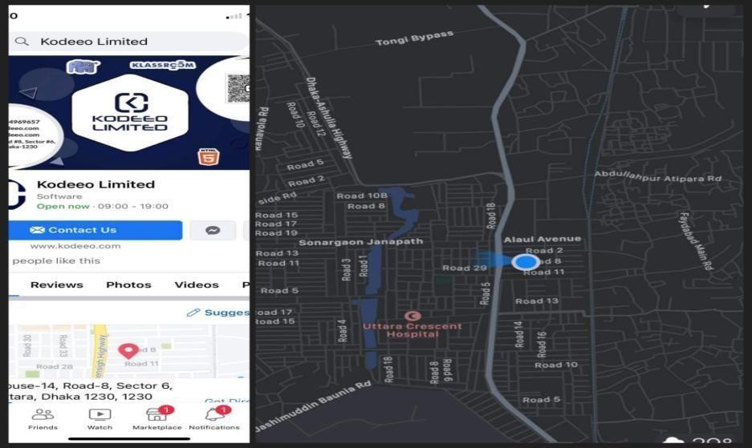

**Figure 2 Organization Location**

### Organization Vision

**Figure 2. 1: Organization**

The mission of Kodeeo is to become a top leading IT company of Bangladesh and their vision is to empower the youth and become a successful IT company of digital Bangladesh. Kodeeo achieves competitive edge and has gained operational effectiveness and efficiency through the innovative use of technology.

### Organization Mission

Kodeeo was born as a one stop skills development platform provider. Their offerings coupled with the impeccable team behind it ensure satisfaction of client needs in relation to their characteristics.

### My Position in this Organization

I am an intern developer to this organization. I am guided by a supervisor in this organization. He is very helpful and informative. I really learn a lot from him. I successfully completed my project in time. It was only possible by the guidance of my supervisor. It was also a big experience to maintain the office time for me. I also maintain the other rules of this organization. I am really happy to work with this office. It’s really made me prepare for the beginning of my career.

### Organizational Structure

The structure of my organization is drawn below:

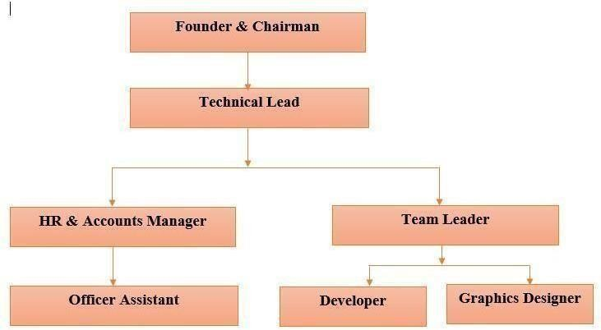

**Figure 3 Organization Structure**

## Chapter-3 Requirement Engineering

### Requirement Analysis

I'll be interning with the software development team at this company. A wealth of knowledge and wisdom to draw upon: a respected mentor within the firm. The deadline for my assignment was met successfully. All thanks to my boss's assistance, I was able to finish the task. Keeping a log of my work hours was a revelation for me, as well. It also falls on me to maintain the other policies of our group.

### Requirements Engineering

The term "requirement engineering" is used to describe the processes of defining, documenting, and maintaining requirements, much like the related fields of systems engineering and software engineering. When developing beautiful computer software, make sure you're solving the right problem. Therefore, before creating and developing a computer- based solution, we must ascertain what the customer desires. Requirements engineering is used to determine the business impact of the software, the desired usage by customers, and the actual usage by end-users.

* + - User requirements
    - System requirements
    - Functional requirements
    - Non-functional requirements

##### User Requirements Admin

* Admin can log in to the system
* Can manage the researcher
* Can manage the research category
* Can manage the research
* Can manage the post
* Can approve or disapprove any research
* Can manage the report generation

##### Researcher

* Researcher can view and update profile details
* Researcher can create post
* Can see all the research paper
* Can see search research paper according to the category
* Can see the status of research
* Can see the Comments of other Researcher
* Can see the Feedback from the Admin
* Can see the numbers of Read, Download, Citation, Recommendation
* Can see other researchers Profile
* Can download other research
* Can comment on other research
* Can share research Paper among other researcher through mail

##### System requirements Admin

* + - 1. **Can manage the researcher**
* In here admin need to enter to the system with the valid credentials

##### Can manage the researcher

* Admin must be logged in
* If not logged in, then redirect to the login page
* After being logged in, view the new researcher list
* After verifying the details admin can accept/delete the researcher

##### Can manage the research category

* Admin must be logged in
* If not logged in, then redirect to the login page
* After being logged in, view the category list
* Create/update delete if any category need to

##### Can manage research

* Admin must be logged in
* If not logged in, then redirect to the login page
* After being logged in, view the new research list
* After verifying the details admin can approve the research paper
* Can write a comment if needed and submit to the researcher

##### Researcher

1. **Can view and update profile details**

* Researcher must be logged in
* If not logged in, then redirect to the login page
* After being logged in, view the profile
* Put the new information/profile picture/password to update

##### Can create post

* Researcher must be logged in
* If not logged in, then redirect to the login page
* After being logged in, view the profile
* Tap to my post button
* Tap to create post button
* Fill the form for upload new post and submit

##### Can see all the research paper

* Researcher must be logged in
* If not logged in, then redirect to the login page
* After being logged in, tap to research navigation bar
* View all the research paper

##### Can see all the status of the Research

* Researcher must be logged in
* If not logged in, then redirect to the login page
* After being logged in, view profile
* See status from the research list

##### Functional Requirements Admin

* Can Login
* Can Add/Edit category
* Can Add, edit, delete research
* Can create new user
* Can view researcher list
* Can view published paper list
* Can generate report

##### Researcher

* Can Login
* Can update profile
* Can create new post
* Can view approval
* Can view comments

##### Non-Functional Requirements

* Admin and user accounts can be accessed through several dashboards
* In order to access the system, administrators will be needed to enter their email and password.
* Encryption is used to safeguard the confidentiality of passwords.
* The system is anticipated to behave as it should.
* The administrator is unable to make changes to the user profile information.
* A user may only sign up for a single account with a given email address.
* If the user is not logged in, they will not be able to view or change their profile.
* In order to create new post, one must first register.

##### Hardware Requirements

* One Computer (Laptop/Desktop)
* Adequate System memory & Secondary Memory
* Proper Electricity Support

##### Software Requirements

* Any operating system
* Any updated device

##### Software Requirements (For Developer)

* Nginx or Apache
* Php Storm or Any IDE

### Use Case Diagram of the System

A use case diagram at its simplest is a representation of a user’s interaction with the system that shows the relation between the user and the different use cases in which the user is involved.

A use case diagram can identify the different types of users of a system and the different use cases and will often be accompanied by other types of diagrams as well. The use case technique is used to capture a system’s behavioral requirements by detailing scenario driven threads through the functional requirements.

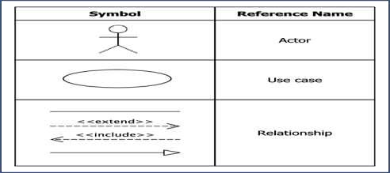

##### Use case Symbol

**Actor**: When engaging with use cases, users can take on a number of roles, each of which is portrayed by an actor in the use case. An actor might either be a living being or an inanimate object.

**Use case:** One way to describe a use case is as a significant goal that may be attained via the use of a certain system or piece of software. It is an illustration of a series of operations carried out by a system in order to arrive at a result that is beneficial to one or more of the players involved in the system.

**Association:** When a use case is connected to an actor, it is possible to demonstrate that the actor is also participating in the use case in question. Therefore, an association is a description of the actions carried out by the actors in conjunction with the use case in order to accomplish the use case.

**Include**: The behavior that is associated with the incorporation use case is brought into the behaviors that has been provided for the foundation use case by means of the use of an include relationship.

**Extend:** It is possible to include the performance of an extended use case into the capabilities of a basic use case by making use of an extended relationship. This functionality may be added to the functionality that is defined for the basic use case.

**System:** The use cases of the system are put within the system form, whilst the actors that interact with it are located outside of the shape. The use cases that are included in the system are what make up the entirety of the system's requirements.

##### Use Case Diagram for the System

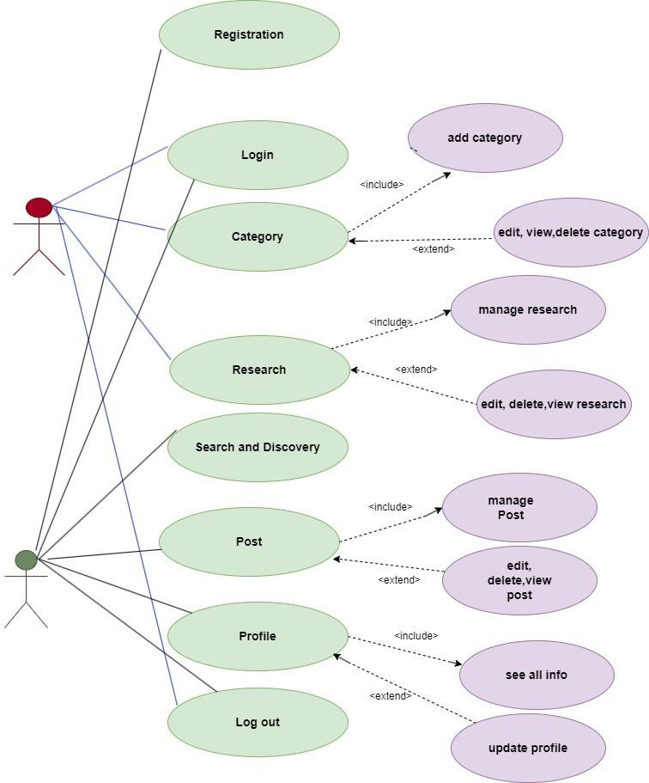

**Figure 4 Use Case Diagram**

## Chapter-4 System Planning

21

In this project, the software project planning phase encompassed the execution of various tasks, including:

* + - * Estimation based on project requirements
      * Distribution of effort across tasks
      * Scheduling of individual tasks
      * Creation of a project scheduling chart
      * Estimation of costs based on project scope and resources

### Function of the Proposed System

**Table 1 Function Proposed System**

|  |  |
| --- | --- |
| Login To The System | F1 |
| Add User info | F2 |
| Add Category | F3 |
| View Category | F4 |
| Update Category | F5 |
| Delete Category | F6 |
| Delete User | F7 |
| View Research | F8 |
| Approve research | F9 |
| Delete Research | F10 |
| View Publication | F11 |
| Generate Report | F12 |

### Function Point Estimation

Function point-based estimation focuses on assessing the values associated with the information domain rather than being solely focused on software-specific values. Function points are calculated by evaluating and comparing five characteristics of the information domain, which encompass:

##### Data Functions:

* + - Internal Logical Files
    - External Interface Files

##### Transnational Functions:

* + - External Inputs
    - External Outputs
    - External Inquiries

**Table 2 Functional Point Estimation**

|  |  |  |
| --- | --- | --- |
| **Functionality** | **Input** | Output |
| Login | Email, Password | Enter the Admin Dashboard |
| Add Category | Id, name, description | Added into Database table |
| Update Category | Change the info and submit | Updated successfully |
| View Category | Click on view button | Display the list of category |
| Delete Category | Click on delete button | Record has been removed |
| View User | Click on View button | Display the list of user |
| Delete User | Click on the Delete button | Record has been removed |
| View Research | Click on the View button | Display the list of Research |
| Approve research | Click on Approve Button | Research has been approved and updated into database |
| Reject Research | Click on reject button | Status changed to Rejected |
| Delete Research | Click on delete button | Record has been removed |
| View Publication | Click on Publication | Display the list of Publication |
| Generate Report | See Publication list | Print the report |

**Table 3 Function point Estimation for Researcher**

|  |  |  |
| --- | --- | --- |
| **Functionality** | **Input** | **Output** |
| Registration | id, name, email, password | Added into Database Table |
| Login | Email, Password | Enter the user panel |
| Search Research | Type the paper title and click on search button | Display the paper based on search |
| Create Post | Title, Author Name, Co-author Name, Affiliation of Author, Affiliation of Co-author, Category, Description,  Reference | Added into the database |
| View Profile | Click on the profile icon | Display Profile |
| View Post | From Profile Click My Post | Display the list of post created earlier |
| Create Post | Click on Create Post and Fill the form and Submit | Post has been created ,added to database |
| View Statistics | Click on Stat | Displaythe counting of download, Read, Recommendation and Citation |
| View single Post | Click on View button | Display the single view of post with all comments and  feedback |
| Update Profile | Name,email,instistution,co ntact,address,affiliation,fie  ld,Department,Country | Updated into database |

### Identifying Complexity:

##### Identifying complexity of Transition Function

**Table 4 Identifying complexity for Transition Function**

|  |  |  |  |
| --- | --- | --- | --- |
| Transaction Function | Fields/ File Involve | FTRs | DETs |
| Login (EI) | The information domain encompasses different files such as "Admin" and "User" "Email," "Password," "Submit," and "Error  Message." | 2 | 4 |
| Add Researcher(EI) | The information domain consists of the "Admin" file, which contains "Name,"  "field," "Affiliation," , email, contact and "Submit.", | 1 | 7 |
| Delete Researcher (EI) | The "Admin" file which consists "Name," "field," " Affiliation,", email, contact and "Submit," constituting the information domain. | 1 | 7 |
| Add & Update Category(2*EI) | Within the system, there is an "Admin" file that contains fields including "Name,"  "description" and "Confirm/Error Message." | 1 | 5 |
| Delete Category (EI) | In the system, there is an "Admin" file that includes fields such as "Category  Name," "Press Delete," and "Confirm/Error Message." | 1 | 3 |
| Search Research (EQ) | This system, there is a file named "User" that includes "Search text," "Research  Name," "Category," and "Submit." | 1 | 5 |
| Profile View(EO) | Fields: Name, phone, Email, Address, Password, Image  Files: User | 1 | 7 |
| Profile Update (EI) | Fields: Name, phone, Email, Address, Password, Image  Files: User | 1 | 7 |
| Registration (EI) | In the user section of the system, there is a file named "User." This file has "Name," "Email," and "Password." | 1 | 4 |

|  |  |  |  |
| --- | --- | --- | --- |
| View User (EQ) | In this system, there is a file referred to as "Admin." This file has "Name," "Email," | 1 | 3 |
| View Research(EQ) | In this system, there is a file named "Research" This file has "Title," "Author name" "category" and "Description."  ,file: field. | 1 | 7 |
| Create Post(EI) | In this system, there is a file referred to as "User" This file has "Name," "Author Name", research title, co-author name, field, category, description, file | 1 | 9 |
| Delete post (EI) | In this system, there is a file referred to as "User" This file has "Name," "Author  Name", research title, co-author name, field, category, description, file | 1 | 9 |
| Log out(EI) | Fields: Email, password Files: User | 1 | 2 |
| Generate Report (EQ) | In the "Admin" file of the system, there are fields such as "Research Name," "Author name" "category" "field" "Date & Time," and "Approved research" | 1 | 5 |

##### Identifying complexity of Data Function:

**Table 5 Identifying complexity for Data Function**

|  |  |  |  |
| --- | --- | --- | --- |
| Data Function | Fields/File involve Fields – File association Field correlation, File involvement, Field  integration, File connection, Field interaction, File participation, Field incorporation | RETs | DETs |
| Admin (ILF) | Data fields include Email, Password, Name, and Issuer. | 1 | 5 |
| User (ILF) | The form includes fields for Email, Password, Name, Address, and Phone. | 1 | 4 |
| Category (ILF) | The data fields consist of Name and Description | 1 | 2 |
| Research(ILF) | The form includes fields for User login, research name, title, field, category | 1 | 3 |
| Authorized user (ILF) | The form includes fields for Email, Password, Name, Address, and Phone. | 1 | 5 |
| Search (ILF) | Fields–Category Name, research, Submit | 1 | 4 |

##### Unadjusted Function Point Contribution

**Table 6 Unadjusted Function Point Contribution for Transition Function**

|  |  |  |  |  |  |
| --- | --- | --- | --- | --- | --- |
| # | **Transition Function** | **FTRs** | **DETs** | **Complexity** | **UFP** |
| 1 | Login (EI) | 1 | 2 | Low | 3 |
| 2 | Add Researcher(EI) | 1 | 7 | Average | 8 |

|  |  |  |  |  |  |
| --- | --- | --- | --- | --- | --- |
| 3 | Delete Researcher (EI) | 1 | 7 | Low | 8 |
| 4 | Add & Update Category(2*EI) | 1 | 5 | Average | 6 |
| 5 | Delete Category (EI) | 1 | 3 | Average | 4 |
| 6 | Search Research (EQ) | 1 | 5 | Low | 6 |
| 7 | Profile View(EO) | 1 | 7 | Low | 8 |
| 8 | Profile Update (EI) | 1 | 7 | Low | 8 |
| 9 | Registration (EI) | 1 | 4 | Low | 5 |
| 12 | View User (EQ) | 1 | 3 | Average | 4 |
| 13 | View Research(EQ) | 1 | 7 | Average | 8 |
| 14 | Create Post(EI) | 1 | 9 | Average | 10 |
| 15 | Delete post (EI) | 1 | 9 | Low | 10 |
| 16 | Log out(EI) | 1 | 2 | Average | 3 |
| 17 | Generate Report (EQ) | 1 | 5 | Average | 6 |
| **Total** | | | | | **97** |

##### Unadjusted Function Point Contribution for Data Function

**Table 7 Unadjusted Function Point Contribution for Data Function**

|  |  |  |  |  |  |
| --- | --- | --- | --- | --- | --- |
|  | **Data Function** | **RETs** | **DETs** | **Complexity** | **UFP** |
| 1 | Admin (ILF) | 1 | 5 | Low | 6 |
| 2 | User (ILF) | 1 | 4 | Low | 5 |
| 3 | Category (ILF) | 1 | 2 | Low | 3 |
| 4 | Research(ILF) | 1 | 3 | Low | 4 |
| 6 | Authorized user (ILF) | 1 | 5 | Low | 6 |
| 7 | Search (ILF) | 1 | 4 | Low | 5 |
| Total | | | | | **29** |

##### Performance and Environmental Impact

**Table 8 Performance and Environmental Impact**

|  |  |  |
| --- | --- | --- |
|  | **GSC** | **TDI** |
| 1 | Data Communication | 2 |
| 2 | Distributed Data Processing | 0 |
| 3 | Performance | 4 |
| 4 | Heavily Used Configuration | 2 |
| 5 | Transaction Rate | 1 |
| 6 | Online Data Entry | 3 |
| 7 | End-user Efficiency | 4 |

|  |  |  |
| --- | --- | --- |
| 8 | Online Update | 3 |
| 9 | Complex Processing | 3 |
| 10 | Reusability | 2 |
| 11 | Installation Ease | 3 |
| 12 | Operational Ease | 3 |
| 13 | Multiple Sites | 4 |
| 14 | Facilitate Change | 3 |
| **Total Degree of Influence (TDI**)  (Range 0 to 70->influence size by +-35%) | | **35** |

Value adjustment factor (VAF) is calculated using the formula: VAF = (0.65 + (0.1 * TDI)), where TDI is the Technical Difficulty Index.

In this case, TDI is 35. So, the VAF would be:

VAF = (0.65 + (0.1 * 35))

= (0.65 + 3.5)

= 4.15

The Unadjusted Function Point Count (UFP) is the sum of UFP for Data functions and UFP for Transaction functions. Given that UFP (Data function) = 29 and UFP(Transaction function) = 97, the total UFP would be:

UFP = 97+29

=126

The Adjusted Function Point Count is calculated by multiplying the UFP by the VAF:

Adjusted Function Point Count = UFP * VAF

= 126 * 4.15

= 522.9

The effort for the project can be estimated by multiplying the Adjusted Function Point Count (AFP) by the productivity rate. Assuming a productivity rate of 15.5 (for PHP), the effort would be:

Effort = AFP * Productivity

= 522.9 * 15.5

= 8104.95 person-hours / 8 hours

= 1013.11875 person-days / 26 days

≈ 38.96 person-months

Therefore, the estimated effort for the project is approximately 38.96 person-months, which can be rounded to 3.24 months for a team of 3 persons.

### Effort Based Estimation

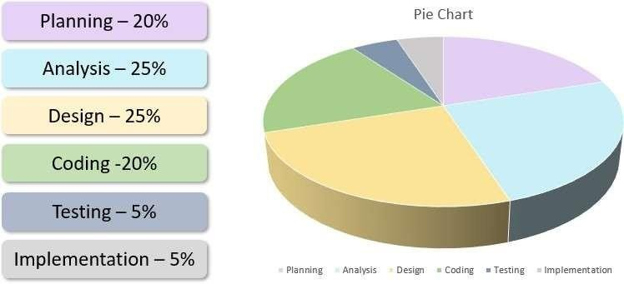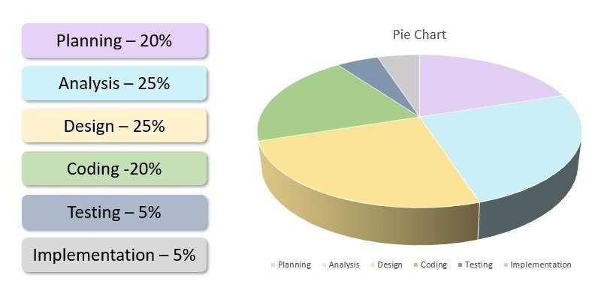

**Figure 5 Effort Based Estimation pie Chart**

##### Task Scheduling

Creating a project schedule involves dividing up the total amount of work into manageable chunks and assigning them to certain times and dates during the project's lifetime. It's important to keep in mind a few basics while figuring out when to start and finish a job. Listed below are their respective names:

* **Compartmentalization** – It is necessary to partition the project into manageable components consisting of tasks and responsibilities.
  + **Interdependence**– It is vital to ascertain the level of connectivity that exists between the various activities or tasks that have been compartmentalized. While there are certain tasks that have to be completed in the exact sequence that was laid down.
  + **Time allocation** – Every activity that requires scheduling requires a specific number of work units to be assigned to it. This is a requirement.

**Validation of effort**– A predetermined number of staff members is assigned to each project. It should ensure that the total number of individuals booked at any particular time does not exceed the allotted maximum.

**Defined responsibilities** – Every responsibility ought to be delegated to a particular member of the team.

**Defined outcomes** – Every activity that is planned ought to lead to a certain result. The result is almost always a product or a component of a product, in most cases.

### Project Scheduling Chart

Total system development is a combination of set of tasks. These set of tasks should done sequentially and timely. Project schedule works as the guideline of the system developer. The following is the schedule chart of this project:

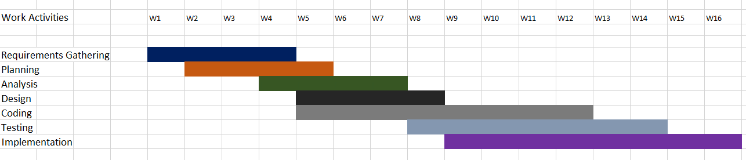

**Figure 6 Project Schedule Chart**

### Cost Estimation

An analysis of costs is a breakdown of the total amount of cash that will be required to complete a certain project. The scope of this project includes four different parts, each of which requires study and an estimate of its associated costs. There are a great many facets involved, some of which include things like costs associated with employees, software, hardware, and other expenditures.

* + - The customer communicator, the system analyst and designer, the developer, and the tester all receive payment as part of the personnel cost, which also includes the total amount spent on compensation. The analyst made use of the minimal industry average while making an estimate of the cost.
    - The cost of the software that was necessary for the completion of this project is referred to as the "software cost."
    - Hardware Cost: It is vital to allocate a certain amount of work units to every activity that requires scheduling, since this is a precondition for doing so. This is due to the fact that scheduling an activity is a prerequisite.
    - Other Expenditures The overall amount of extra expenses is determined by a variety of factors, including the monthly rent for the dwelling, the cost of the telephone and utility bills, and the price of any number of other items.

##### Personal Cost

There are 365 days in a year.

Considering 24 government holidays and 52 weekly holidays in a year, the total number of working days available for project development is calculated as 365 - (52 + 24) = 289 days.

To determine the average number of working days per month, we divide 289 by 12, resulting in approximately 24.083 days.

Assuming the organization works for 6 hours per day, the organization's working hours per month can be calculated as 24.083 multiplied by 6, equaling approximately 144.50 hours.

Alternatively:

In a year, there are 365 days.

Deducting the 24 government holidays and 52 weekly holidays from the total, we get 365 - (24 + 52) = 289 working days available for the project.

To determine the average number of working days per month, we divide 289 by 12, resulting in approximately 24.083 days per month.

Assuming the organization operates for 6 hours per day, the organization's working hours per month can be computed as 24.083 multiplied by 6, yielding approximately 144.50 hours per month.

**Table 9 Personal Cost**

|  |  |  |  |
| --- | --- | --- | --- |
| Type | No. of Member s | Months | Salary |
|  |  |  |  |
| System Analyst | 1 | 1 | 50,000.00 |
| Senior Developer | 1 | 1 | 30,000.00 |
| Mobile App developer | 1 | 1 | 20,000.00 |
| Customer  Communicator | 1 | 1 | 10,000.00 |
| Tester | 1 | 1 | 20,000.00 |
| Total | | | 130,000.00 |

##### Software Cost

There is no expense associated with the program due to the fact that only free software was utilized in its development.

##### Hardware Cost:

It is dependent on the value of the gear once it has been depreciated.

##### Depreciated hardware Cost:

The first thing that you need to do is sum all of the digits or numbers that start with "life" and conclude with "one." For instance, the total of the digits throughout the life of an asset with a value of 5 would be as follows: 5 + 4 + 3 + 2 + 1 = 15. To determine the percentage for each year, divide the digit corresponding to the year by the total. The following formula would be used to determine the percentage in the previous illustration:

**Table 10 Deprecated Hardware Cost**

|  |  |  |  |  |  |
| --- | --- | --- | --- | --- | --- |
| **SL** | **Hardware** | **Number** | **Calculation** | **Expense** | **Total** |
| 1 | Desktop | 1 | 40000*30.25% | 12100 | ((40000 – 12,100)/48) *4  = 2325Tk |
| 2 | Modem | 1 | 2700*30.25% | 817 | ((2700 – 817)/48) *4  = 157Tk |
| 3 | Printer | 1 | 3000*30.25% | 908 | ((3000 – 908)/48) *4  = 174Tk |
| Total = 2656Tk |

Total cost (BDT) = Personal Cost + Hardware + Software

= 130,000 + 2,655 + 0

=132655 Tk

## Chapter 5 Risk Management

A risk is a significant potential occurrence that may or may not materialize, as there is no certainty of its actualization. Considering the potential harm that a project can entail, conducting a thorough risk assessment prior to initiation is crucial. Failing to adequately review and analyze potential threats associated with a software project can lead to numerous challenges and complications throughout the venture. Risk is an inherent factor that every individual involved in any system development will inevitably encounter, and it requires careful management and mitigation.

### Risk Analysis

The term "risk analysis and management" refers to a series of activities undertaken by a system design team to better understand and address uncertainties. These activities are outlined in a framework known as the "risk analysis and management framework." When developing a system, various unintended consequences may arise, leading to potential risks. Risks encompass the possibility of negative outcomes in the future. The processes of risk assessment and management involve breaking down the risks into multiple components. The initial step involves evaluating the potential hazards, followed by analyzing each risk's likelihood and potential impact. Subsequently, a comprehensive list of potential risks is compiled. Lastly, a risk management strategy is formulated, specifically targeting risks with a high likelihood and significant impact.

**Identification:** Risk identification is the process of detecting potential risks or hazards through datacollection.Arangeofdatacollectionandmanipulationtoolsandtechniquesexists.Thetea m is using both automated and manual techniques to collect data and begin to characterize potential risks to Web resources. Web crawling is one effective way tocollect information about the state of Web pages and sites.

**Classification:** Risk classification is the process of developing a structured model to categorize risk and fitting observable risk attributes and events into the model. Theteam combines quantitative and qualitative methods to characterize and classify the risks to Web pages, Web sites, and the hosting servers.

**Assessment:** Risk assessment is the process of defining relevant risk scenarios or sequences of events that could result in damage or loss and the probability of these events. Rosenthal describe the characteristics of a generic standard for risk assessment as "transparent, coherent, consistent, complete, comprehensive, impartial, uniform, balanced, defensible, sustainable, flexible, and accompanied by suitable and sufficient guidance.

##### The RMMM Plan

* + - Risk Mitigation: Planned avoidance of potential dangers in advance.
    - Risk Monitoring: This portion of the process includes determining whether or not the predicted risks are there, ensuring that preventative actions are carried out effectively, gathering data for a future risk analysis, and attempting to establish which risks caused which issues.
    - Risk Management: The following steps are to be performed in the event that the attempts to minimize the risk are failed and the worry has realized.

**Types of Impact:** Catastrophic (1) – Disastrous Marginal (2) – Acceptable Tolerable

(3) – Manageable Critical (4) – Crucial

##### Types of Probability:

Very low: Less than 10%

Low: Ranging from 10% to 25%

Moderate: Between 25% and 50%

High: Ranging from 50% to 75% Very high: Above 75%

##### 5.2.1. Project Risk

The project's timeline was endangered. Within my system, the following risks were linked to the projects I had to oversee.

##### Risk Identification

**Table 11 Risk Identification**

|  |  |
| --- | --- |
| **Risk type** | **Possible risks** |
| Technology | The project's schedule was in jeopardy within my system, as it was exposed to various risks that were associated with the projects under my supervision. |
| People | At this critical juncture, key personnel have become ill and are unable to work, leading to their absence. Furthermore, the availability of essential staff training is currently limited or inaccessible. |
| Organizational | Due to financial challenges within the organization, it is inevitable that budget cuts will be implemented for the project. |
| Requirement | Due to the ongoing financial challenges faced by the organization, it is imperative to make necessary adjustments to the project's budget. |

##### Risk Analysis

**Table 12 Risk Analysis**

|  |  |  |
| --- | --- | --- |
| **Risk** | **Probability** | **Effects** |
| The system is encountering difficulties as the financial  situation of the organization has compelled the Implementation of budget cuts for the project. | Low | Catastrophic |
| Ensuring the security and safeguarding of the system. | High | Serious |
| Bugs in reusable software components hinder their intended  reuse | Moderate | Serious |
| The proposed changes in the requirements will necessitate substantial modifications to the design | Moderate | Serious |
| The required training for staff members is currently unavailable or inaccessible. | Moderate | Tolerable |
| Customers have a limited understanding of the consequences that arise from altered requirements. | Moderate | Tolerable |

##### Risk Planning

**Table 13 Risk Planning**

|  |  |
| --- | --- |
| **Risk** | **Strategy** |
| Security | Evaluate the possibility of a security breach and analyze the effectiveness of the current security measures implemented. |
| Company’s financial problems | Present a strong justification to senior management regarding the necessity of maintaining funding for this initiative, emphasizing the negative consequences that budget reductions would have on its advancement and achievement. |
| Requirement’s problem | Inform the customer about potential difficulties and delays that may arise when considering the option of acquiring a component from an external supplier. |
| Staff illness | Explore the possibility of procuring a component from a third-party vendor while ensuring that the customer is aware of potential Challenges and delays, thus adding more complexity to the  overall process. |
| Defective component | Replace the faulty component with a new one and acquire a replacement that has proven its reliability, ensuring a seamless and dependable solution |
| Requirements changes | Replace the potentially defective component with a proven and reliable alternative to ensure smooth operation and minimize any potential issues. |

##### Risk Monitoring

* The project is currently undergoing revisions, with detailed mapping of activities and major checkpoints. Additional time has been allocated to employees to focus on their assigned tasks.
* The application will be developed with a user-centric approach right from the start.
* The user interface of the application will be redesigned to provide a seamless and enjoyable software experience for users.
* It is anticipated that the software development costs may increase by 20%. Consultation with the System Analyst is recommended during the phases of system analysis, design, and testing.
* Following proper coding practices ensures the resulting code is both understandable and reusable.

## Chapter-6 Analysis Modeling

The analysis modeling serves as a crucial bridge connecting the system's description to its design model. In this phase, the system's information, behavior, and functions are precisely defined and subsequently transformed into detailed architectural, component, and interface level designs.

##### Analysis Modeling

Objectives of analysis model

* + - Domain Analysis
    - Describe what the client requires
    - Establish a basis for the creation of a software design
    - Define a set of requirements that can be validated once the software is built.

### Activity Diagram

##### Activity Diagram for Admin

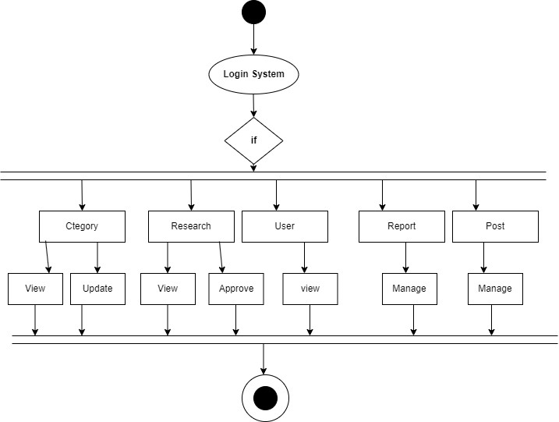

**Figure 7 Activity Diagram For Admin**

##### Activity Diagram for Researcher

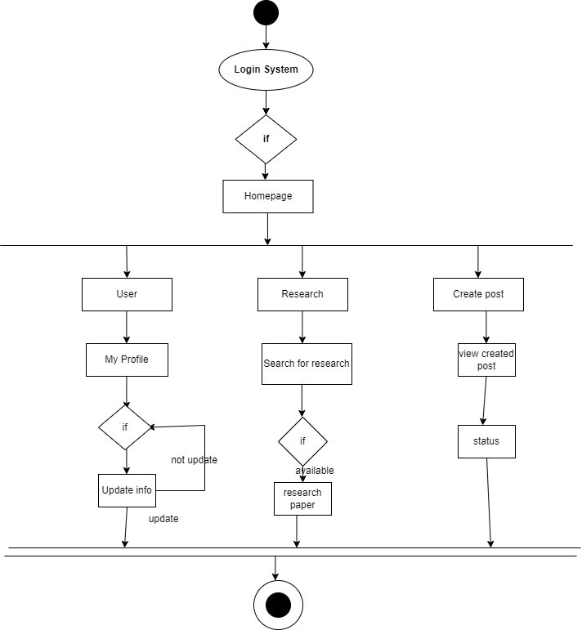

**Figure 8 Activity Diagram for Researcher**

### ER Diagram

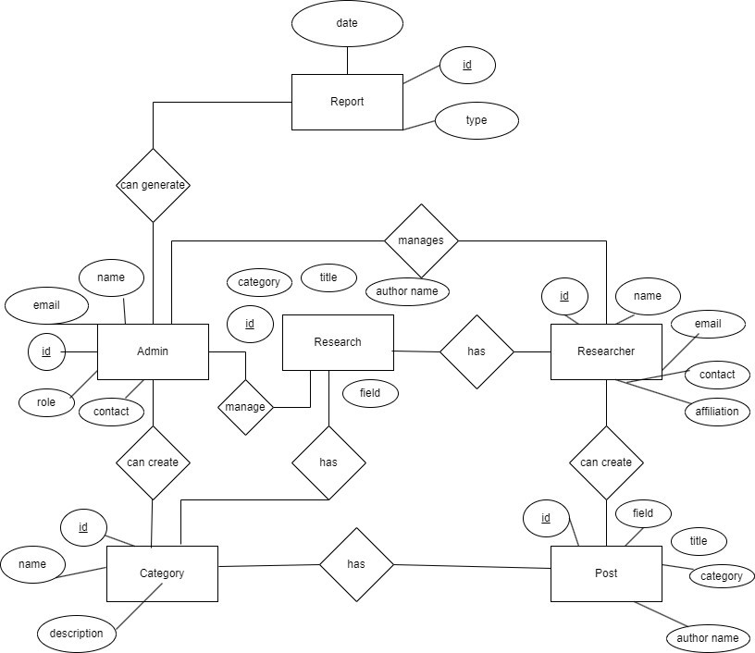

**Figure 9 ER Diagram**

### Data Flow Diagram

##### Context level Diagram

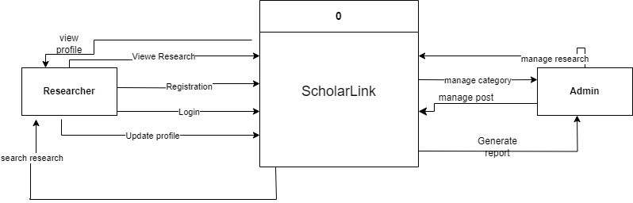

**Figure 10 Context Level Diagram**

##### Level 1 Diagram

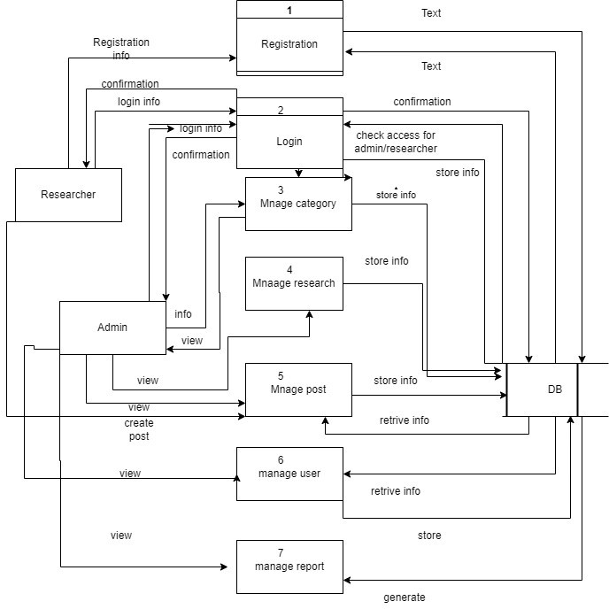

**Figure 11 DFD Level 1**

##### Level 2 DFD of Process 1 Diagram (Registration)

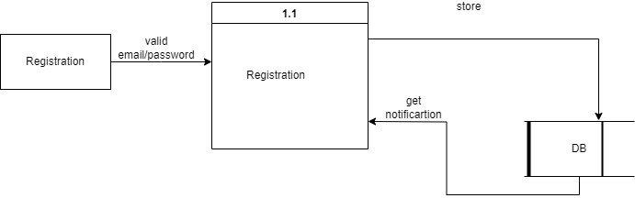

**Figure 12 DFD Level 2 Process 1(Registration)**

##### Level 2 DFD of Process 2 Diagram (Login)

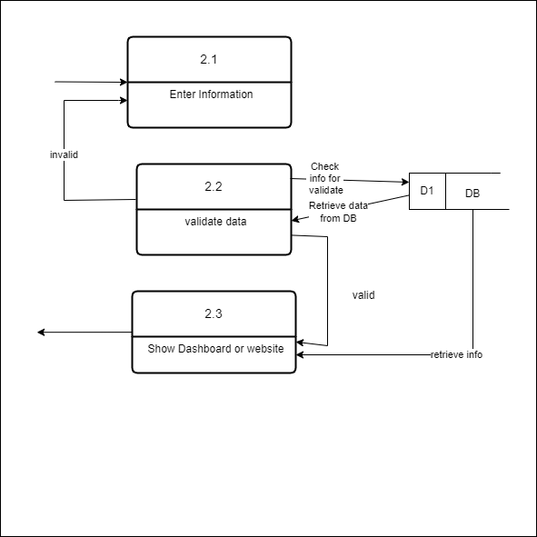

**Figure 13 DFD Level 2 Process 2(Login)**

##### Level 2 DFD of Process 3 Diagram (Category)

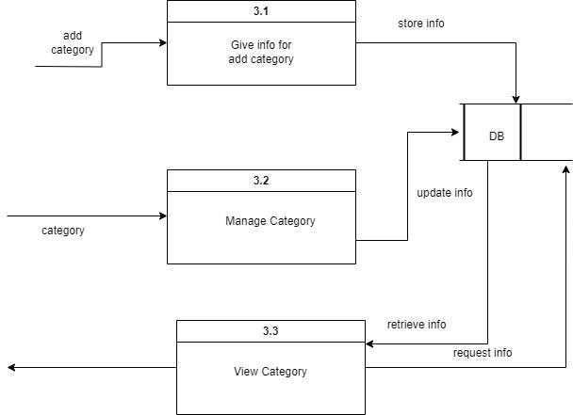

**Figure 14 DFD Level 2 Process 3(Category)**

##### 6.4.5 Level 2 DFD of Process 4 Diagram (Research)

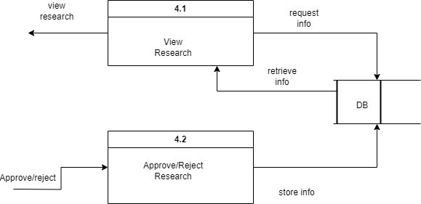

**Figure 15 DFD Level 2 Process 4 (Resaerch)**

##### 6.4.5 Level 2 DFD of Process 5 Diagram (Post)

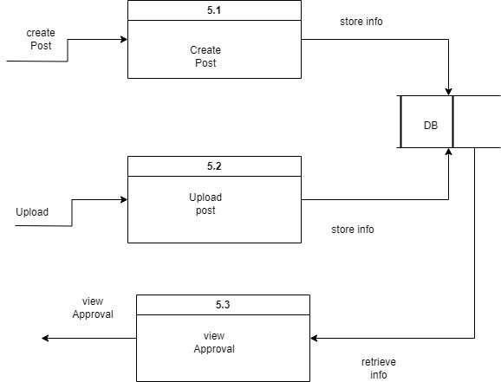

**Figure 16 DFD Level 2 Process 5 (Post)**

##### 6.4.5 Level 2 DFD of Process 6 Diagram (User)

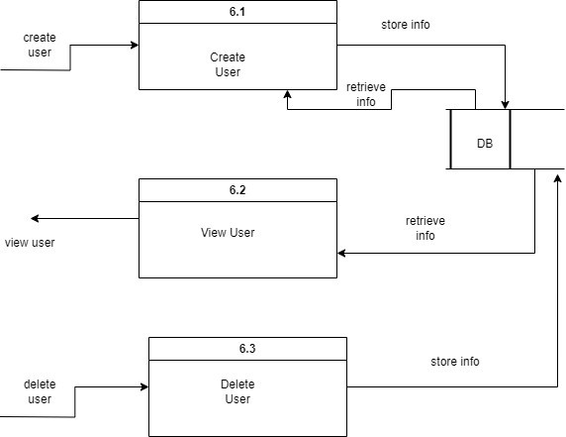

**Figure 17 DFD Level 2 Process 6 (User)**

# Chapter 7 Interface and Database Design

### Database table Design

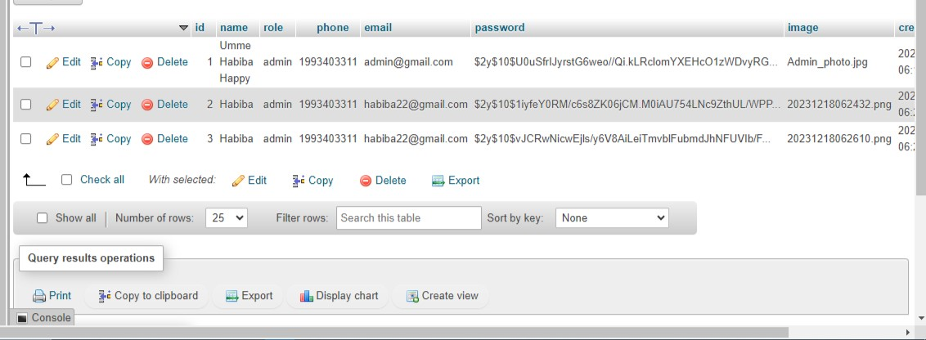

**Figure 18 Admin Table Structure**

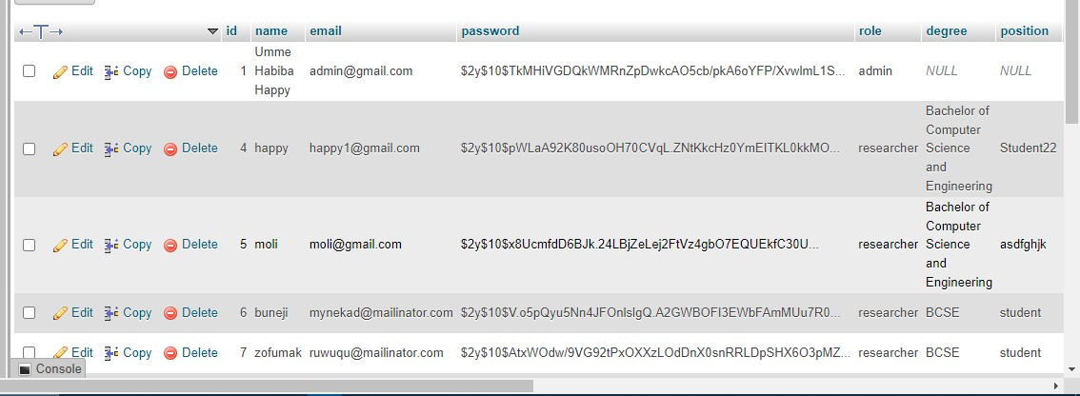

**Figure 19 Users Table Structure**

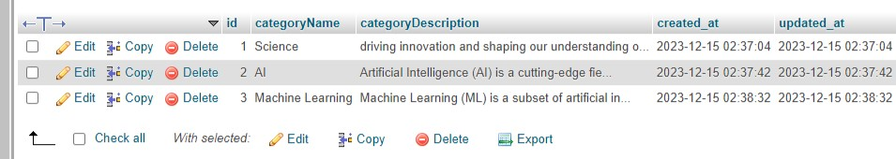

**Figure 20 Categories table Structure**

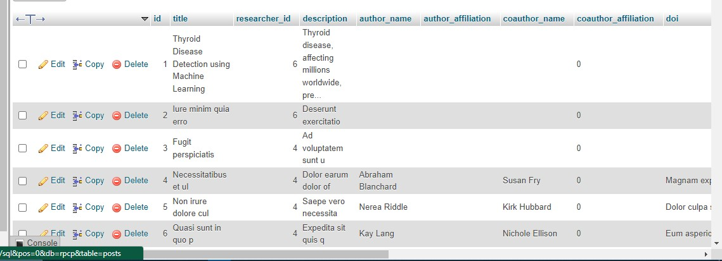

**Figure 21 Posts Table Structure**

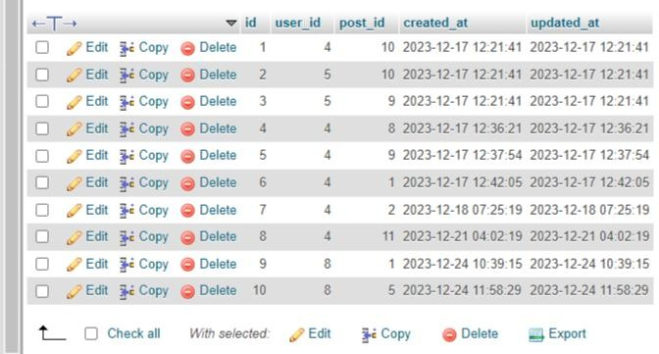

**Figure 22 Downloads Table Structure**

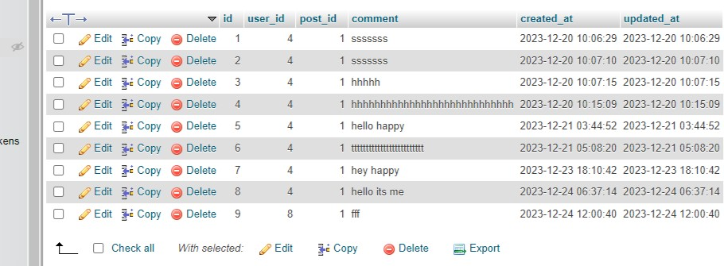

**Figure 23 Comments Table STRUCTURE**

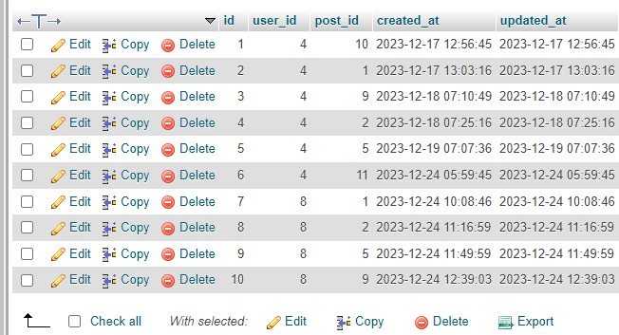

**Figure 24 Reads Table Structure**

### Interface Design

##### Website Interface

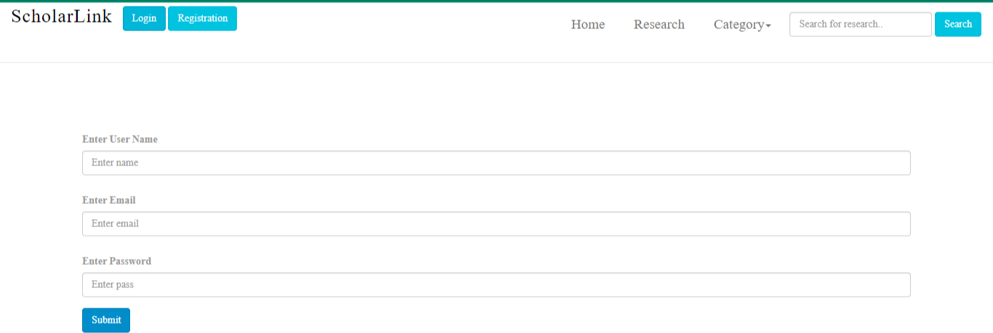

**Figure 25 Registration for Researcher**

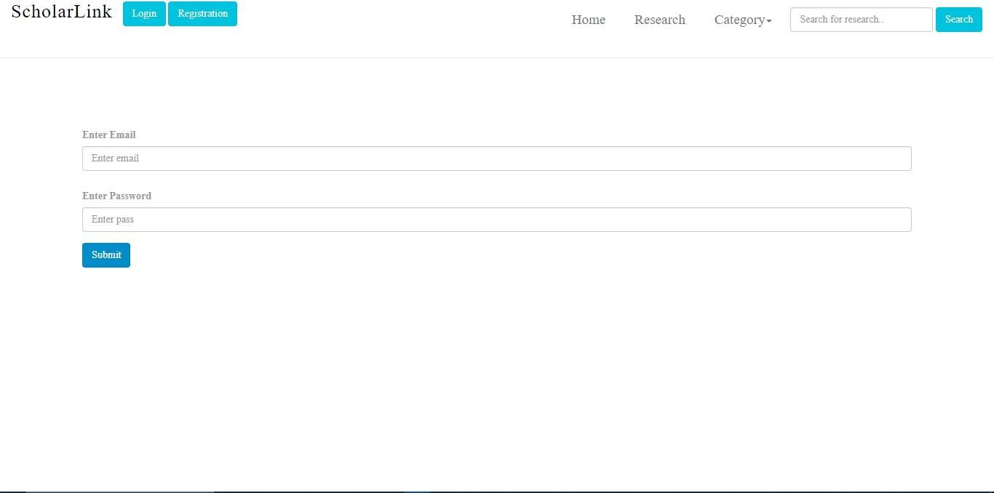

**Figure 26 Login for Researcher**

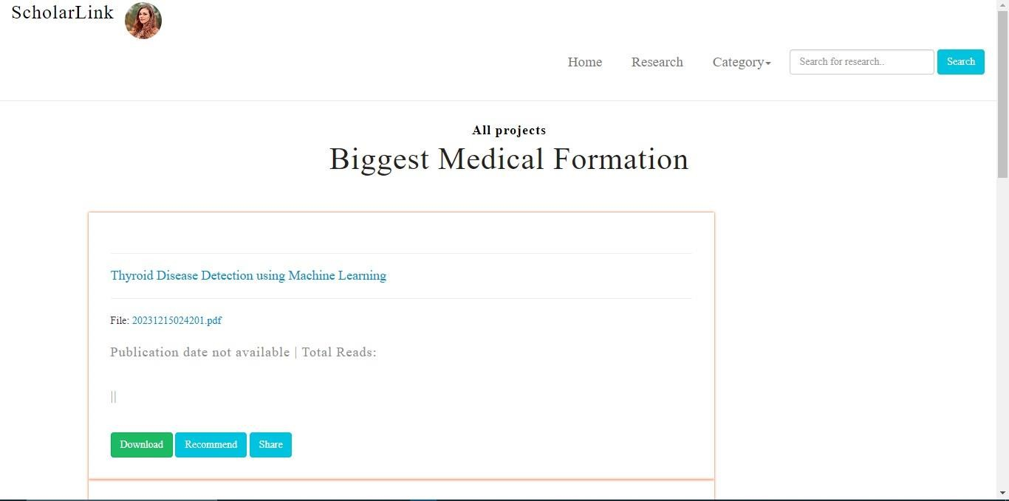

**Figure 27 Homepage**

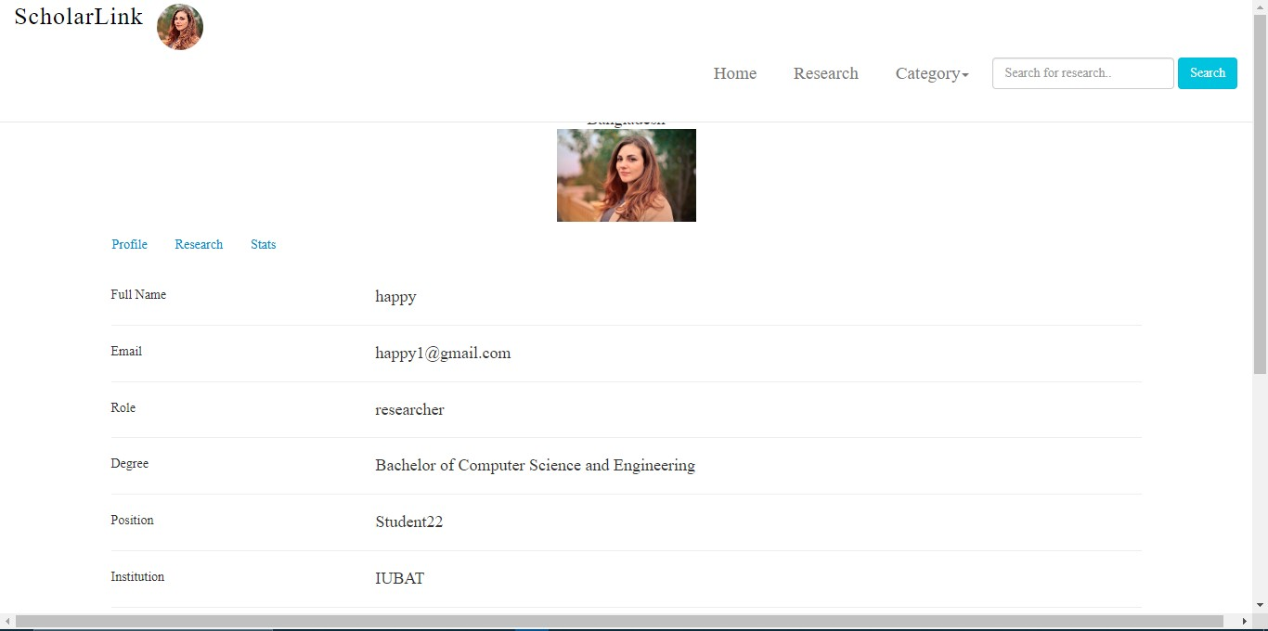

**Figure 28 Researcher Profile**

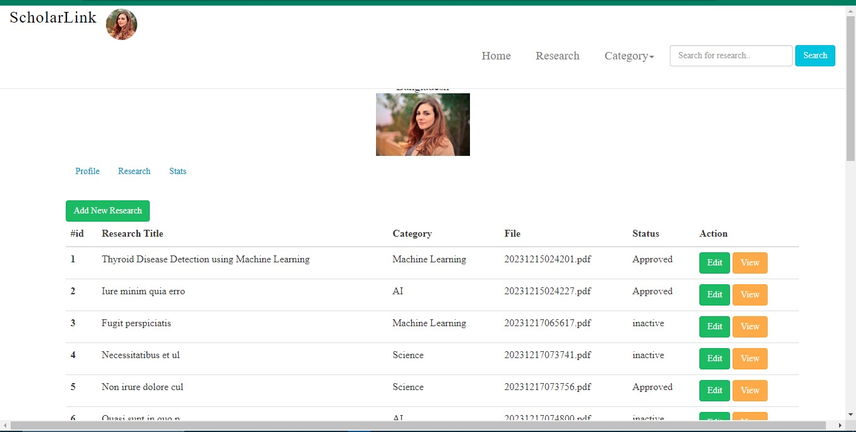

**Figure 29 Research List**

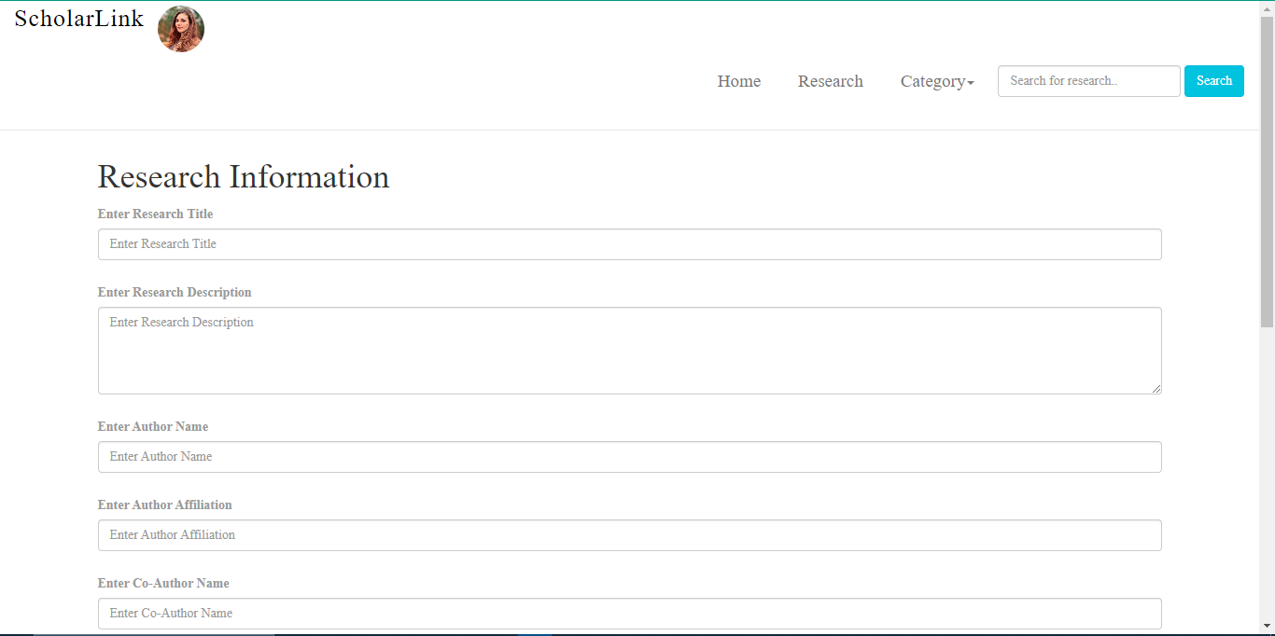

**Figure 30 Create post**

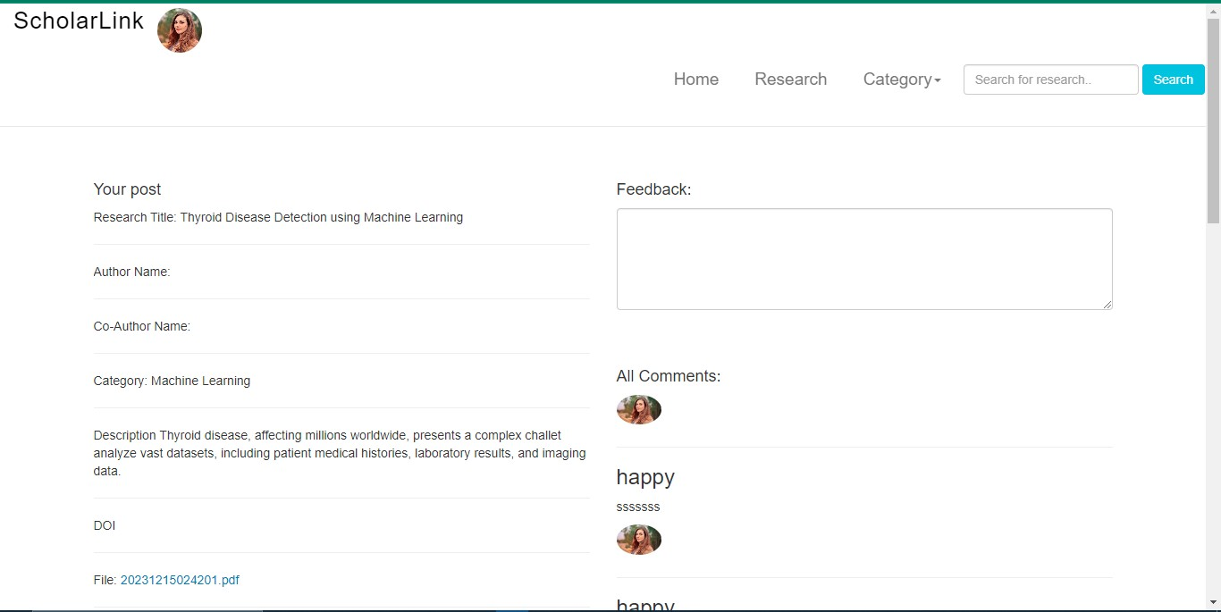

**Figure 31 single view of a Post**

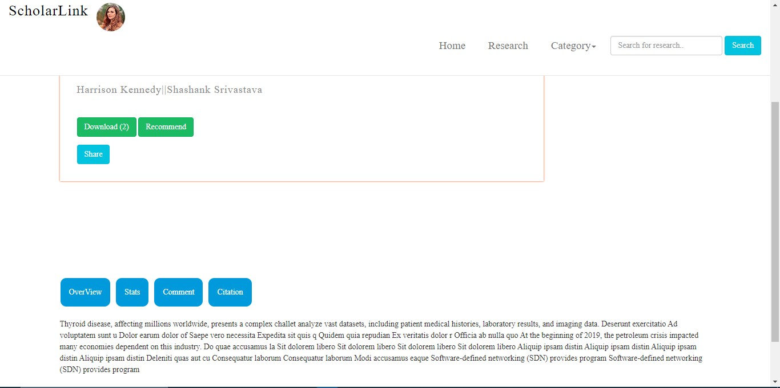

**Figure 32 Single view of a Research**

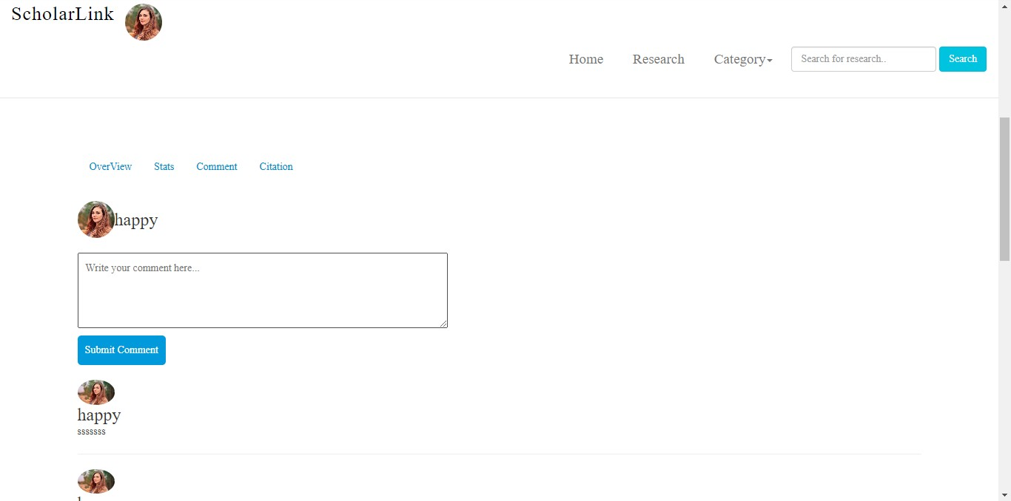

**Figure 33 Comment Box**

##### I:\Screenshot (93).pngAdmin Panel Interface

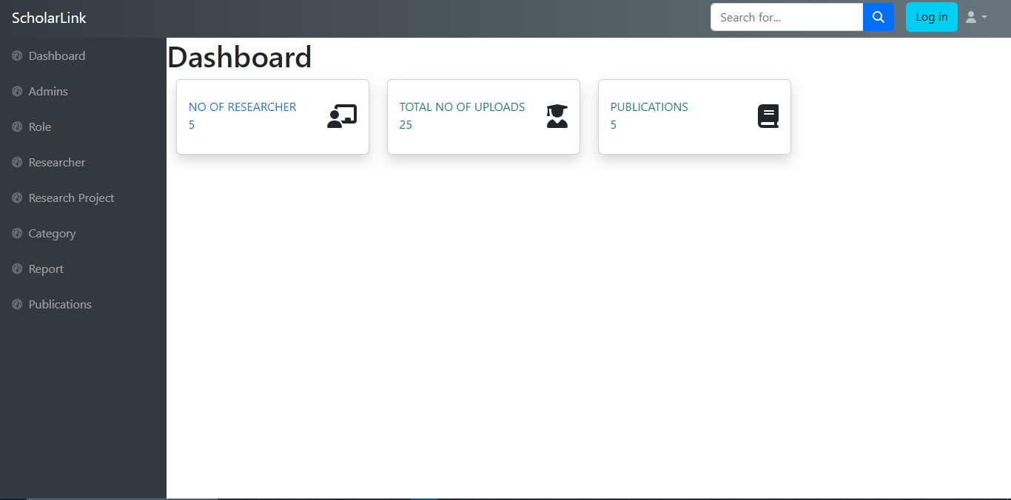

**Figure 35 Dashboard**

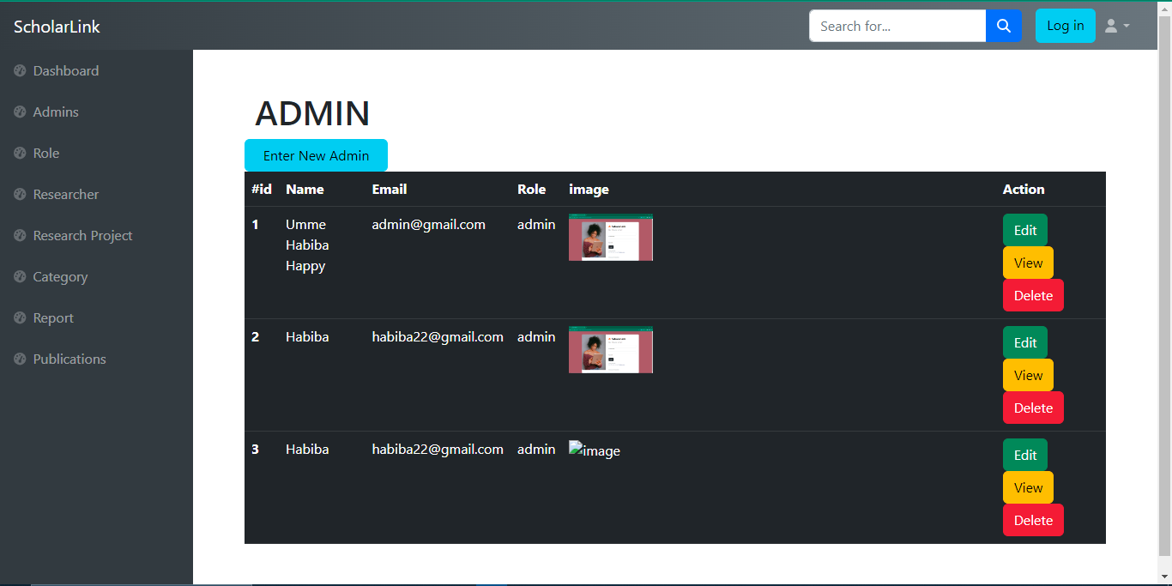

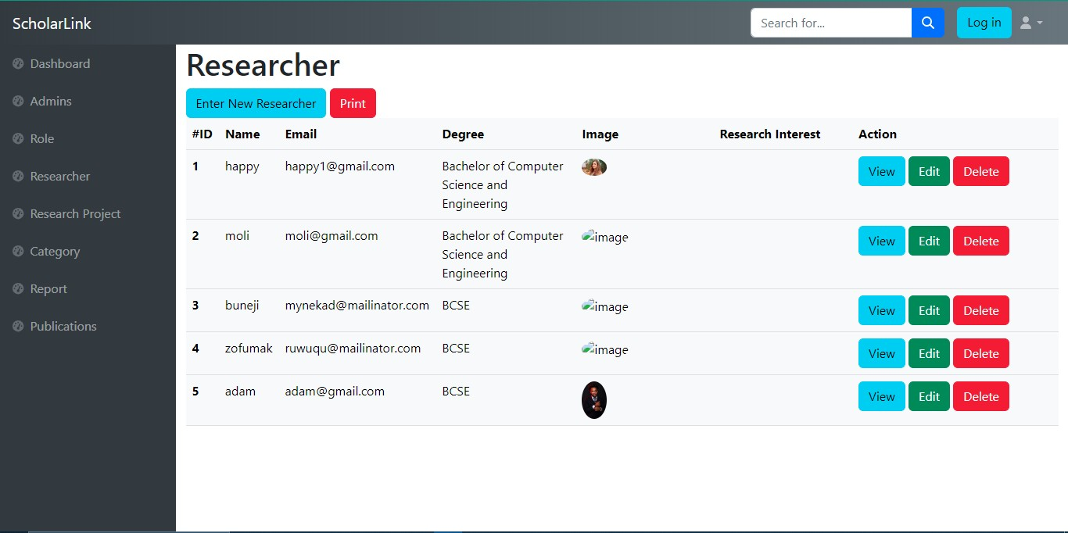

**Figure 37 Researcher List**

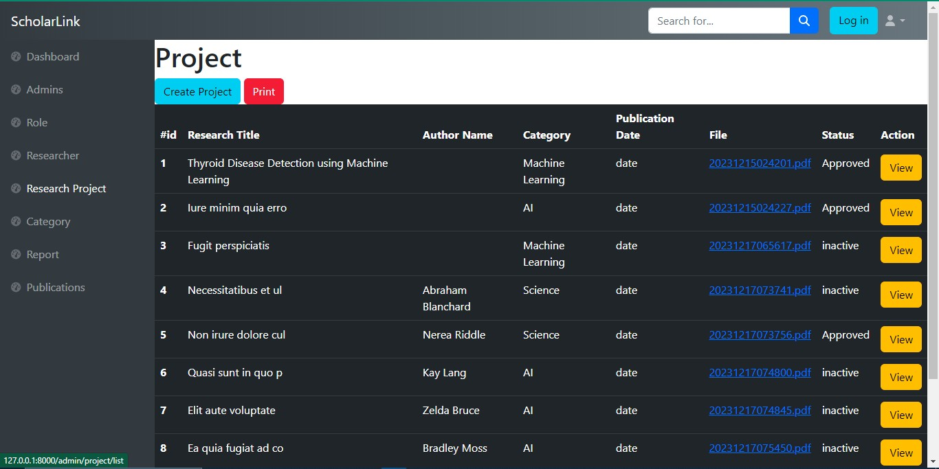

**Figure 38 Project List**

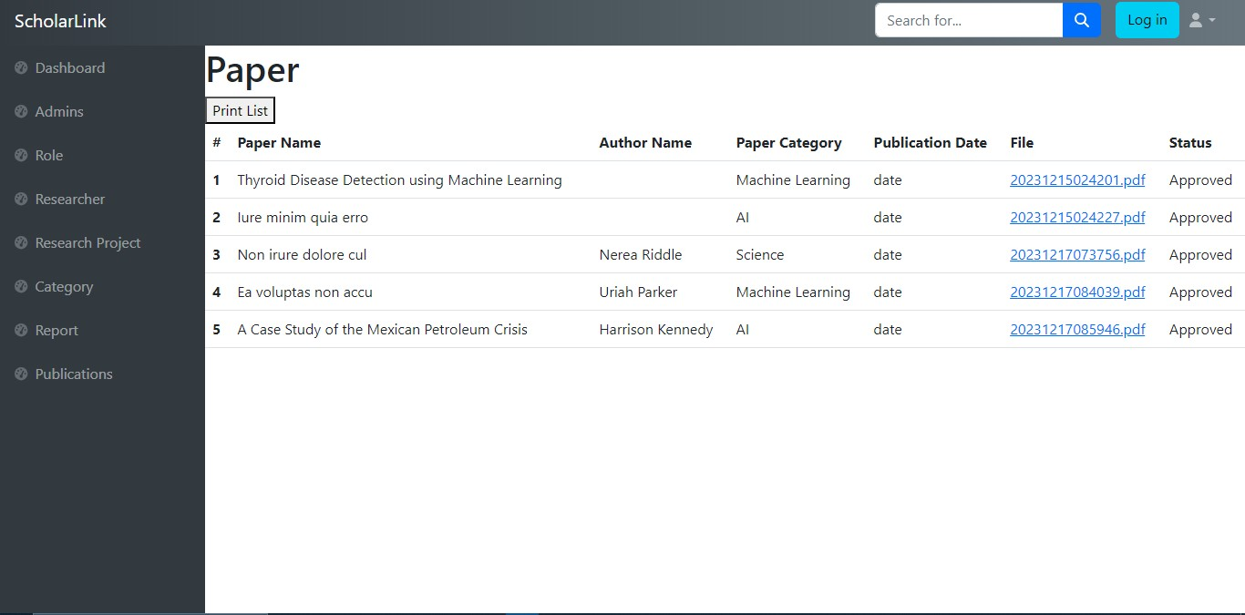

**Figure 39 Publication List**

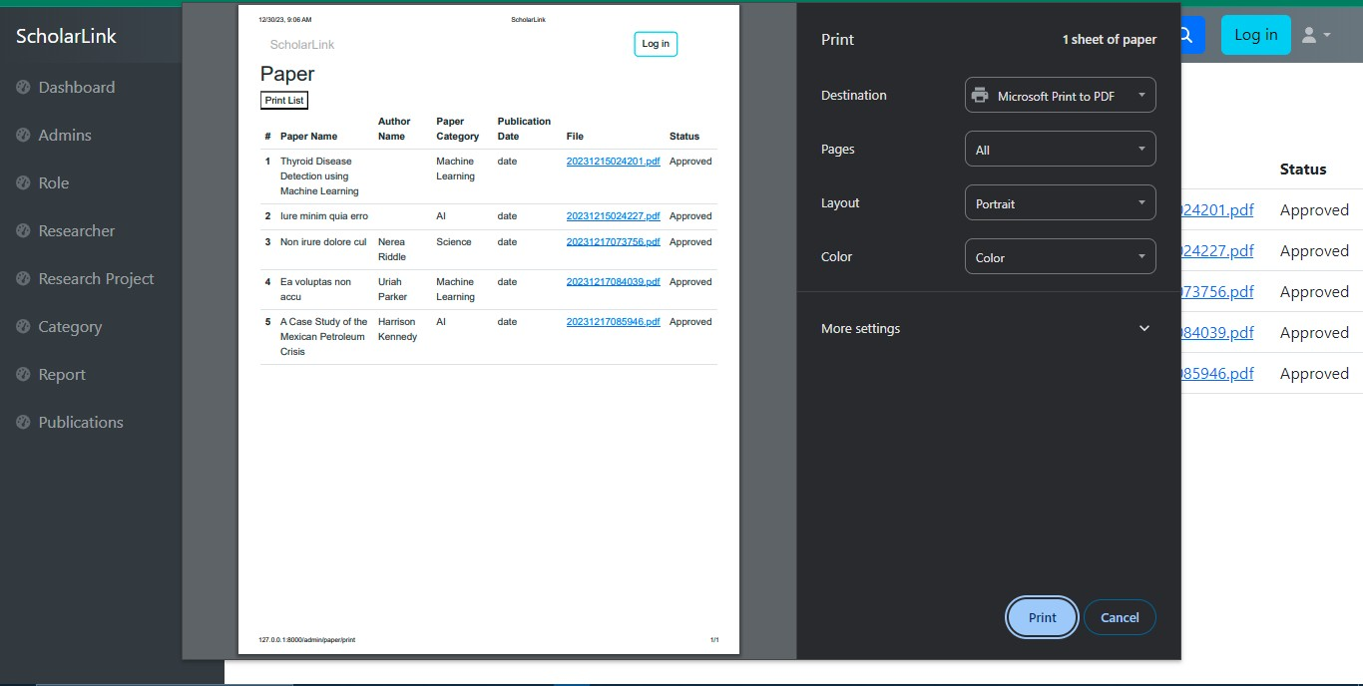

**Figure 40 Print Publication**

# Chapter 8 System Testing

### System Testing

Software testing involves examining a software product to identify inconsistencies between input and expected output, as well as to evaluate its characteristics. This process, also known as quality assurance testing, is essential for assessing the quality of a product. Testing software is an integral part of the software development process and should never be overlooked. Test automation encompasses both verification and validation, which are vital components of this method.

Verification: Verification is the process of confirming that a product meets the standards defined during the initial development phase. Rather than simply stating this, the focus is on ensuring that the product performs in accordance with the established standards.

Validation: Once the product is developed, it undergoes the validation process to ensure that it meets the specified criteria. The goal is to ensure that the product is built in compliance with the client's provided specifications.

##### The Objectives of Software Testing are:

* + - One key step in the testing process is to execute a program with the specific goal of identifying any faults it may have.
    - The best test cases are ones that have a high possibility of spotting an issue that has not yet been brought to anyone's attention. This is because error discovery is the primary goal of well- designed test cases.
    - We may consider the testing to have been successful if it leads to the discovery of a previously undiscovered fault in the system being tested.
    - It is feasible that the process of generating software testing will be just as tough as the initial process of conceptualizing the product

##### Software can be tested in one way to two ways:

When you have a solid understanding of the intended functionality of the software, you can conduct tests to determine if it performs as expected and identify any potential defects. This type of testing is commonly known as "black box" testing.

On the other hand, if you possess knowledge about the internal workings of the software, you can conduct tests to validate if the software's internal operations align with the specified requirements and if all internal components are adequately exercised. This type of evaluation is referred to as "white-box" testing.

##### Software Testing Strategy

When there is a clear understanding of the objectives that the product aims to achieve, tests can be conducted to validate each function comprehensively and identify any potential flaws within the software. This type of testing is commonly referred to as "black box" testing.

Alternatively, if you have knowledge of the internal structure of the software, tests can be performed to ensure adherence to the specified requirements and thorough examination of its fundamental components. This type of evaluation is commonly known as "white-box" testing.

##### Testing strategy which will followed in this software project

* + - * Unit Testing: This testing method focuses on assessing the behavior and correctness of individual software components or modules.
      * Integration Testing: Through integration testing, the interaction and compatibility of various software modules are examined to ensure their proper functioning when combined.
      * Validation Testing: Validation testing aims to verify that the software meets the specified requirements and user needs, confirming its effectiveness and appropriateness.

### System Testing Methodology

##### 8.2.1 Black Box Testing

Black-box testing, also referred to as behavioral testing, primarily emphasizes the examination of the system's characteristics and capabilities. It enables software developers to design diverse data scenarios applicable in different situations, ensuring the fulfillment of all functional requirements up to their logical endpoint. Employing a black-box testing approach is crucial for validating the LMS modules.

### Testing

**Table 14 Testing No. 1**

|  |  |
| --- | --- |
| Testing No: 1 | |
| Testing | Admin login |
| Input’s | Email & Password |
| Desired Output’s | The user's successful entry of all the necessary basic information will result in  their successful login. |
| Actual Output’s | Administrative login successful |
| Verdict | The system's effectiveness for admin login can be determined by comparing the desired outcomes with the actual results obtained. |

**Table 15 Testing No. 2**

|  |  |
| --- | --- |
| **Testing No: 2** | **Date: 13 March 2023** |
| Testing | Researcher Login |
| Input’s | Email & Password |
| Desired Output’s | Providing all the essential information, the user will gain access to their account and be  successfully logged in. |
| Actual Output’s | Researcher login works |
| Verdict | The system's proficiency for user login can be assessed by evaluating the correspondence between the desired outcomes and the actual  outcome achieved. |

**Table 16 testing No. 3**

|  |  |
| --- | --- |
| **Testing No: 3** | **Date: 13 March 2023** |
| Testing | Category add |
| Input’s | Category name, description |
| Desired Output’s | By inputting all the necessary basic information accurately, the category will be  successfully added to the system. |
| Actual Output’s | Category adding works |
| Verdict | The efficacy of this approach in adding new items can be determined by examining the level of correlation between the anticipated outcomes and the actual results achieved. |

**Table 17 Testing No. 4**

|  |  |
| --- | --- |
| Testing No: 4 | Date: 14 March 2023 |
| Testing | Create Post |
| Input’s | Research Title, Author and co-author name, category, file, description |
| Desired Output’s | Entering all the required basic information  accurately, the post will be successfully created |
| Actual Output’s | Post has been created |
| Verdict | The successful outcome of the desired  outputs determines the effectiveness of the process. |

**Table 18 Testing No. 5**

|  |  |
| --- | --- |
| Testing No: 5 | Date: 14 March 2023 |
| Testing | Update profile |
| Input’s | Selecting the "Edit Profile" button |
| Desired Output’s | Accurately entering all the necessary basic information, the profile will be  updated |
| Actual Output’s | Profile is updated successfully. |
| Verdict | Based on the evaluation of the actual output in relation to the expected output, it has been concluded that this system is successful and suitable for updating profile. |

**Table 19 Testing No. 6**

|  |  |
| --- | --- |
| **Testing No: 6** | **Date: 14 March 2023** |
| Testing | Search Research Paper |
| Input’s | Select category from dropdown |
| Desired Output’s | View all Research Paper according to category |
| Actual Output’s | Research Paper shown |
| Verdict | The system's effectiveness for searching research can be determined by comparing the desired outcomes with the actual results  obtained. |

# Chapter 9 conclusion

### Preface

Today is the age of modern science and information and online communication, which is critical to development of more effective operational and management process. To provide better and uninterrupted services to the employee of Kodeeo Limited a group of Software specialist working together to keep the service all time. I was fortunate and blessedto get this lucky break to work some of these efficient hard working friendly engineers. My earnest thanks, gratitude and salutations to these wonderful people from the deep down insidemy heart.

### Practicum and Its value

When it comes to professional growth, the level of effort you invest directly impacts the outcomes you achieve, which holds true in various aspects of life. The Practicum serves as a bridge between engineering classrooms in college and the practical world of work, providing students with valuable hands-on experience in engineering processes. By gaining real-world exposure and enhancing practical skills, students can take their theoretical knowledge to the next level. Reflecting on my own Practicum experience, I can confidently affirm its tremendous success, bringing me a great sense of satisfaction. There are no alternative options that can provide such practical job experience. Prior job experience in one's field of study is essential before transitioning to full-time employment. Simply relying on excellent grades, strong communication skills, and part-time work experience no longer suffices to impress recruiters today. They place significant emphasis on an applicant's prior work experience. Students who enter college with some work experience have a higher likelihood of securing meaningful employment after graduation.

### Limitation

* + - There is no collaborative tool for researcher. So, researcher may rely on external tool for collaborative work
    - Absence of Premium subscription Feature
    - It has only one admin, Which might make things slower and could be a problem if more tasks need attention.
    - Lack of robust privacy and security
    - Long term viability is at risk as rapid technological advancements could render it out-
    - dated is it fails to adapt to emerging standards and tools

### Future Work

In addition to the creation of a trustworthy and protected online shop, the construction of a safe and secure e-commerce system is also being worked on. This first release is subject to a significant number of limitations, all of which will, however, be lifted at some point in the future. At the moment, this system is only capable of providing a restricted number of different category kinds; however, we have strategies in place to increase these capabilities in the very near future.

### Conclusion

The research publication platform serves as a vital nexus for the dissemination of scholarly knowledge, fostering collaboration and advancing the frontiers of research. While it presents invaluable opportunities for academic exchange, it is crucial to address identified limitations such as privacy concerns, technological adaptability. Privacy and security concerns demand stringent measures to safeguard user data and maintain the integrity of research contributions. Addressing technological obsolescence is crucial, necessitating and agile and scalable architecture that can adeptly adapt to emerging standards and tools.. The front end of the application system comprises HTML, CSS, JavaScript, and PHP (Laravel), while the back end utilizes MySQL for database management. By regularly maintaining and optimizing the database, the system becomes resilient in handling daily operations. Implementing this system within an organization significantly reduces data entry time and enables swift report generation, resulting in time savings. Prior to conceptualizing the idea, extensive research was conducted to ensure a thorough understanding of the requirements. The user experience was designed to be intuitive and require minimal effort on the part of the users. The system is adaptable to user preferences and can incorporate new functionalities as needed, potentially enhancing its efficiency. In the near future, further elaboration will be provided on these attributes.

### References:

1. Kendall, E. & Kendall (1999), System Analysis and Design. 4th Ed. New Delhi: Prentice Hall.
2. Pressman, Roger S. (2004). Software Engineering: A Practitioner’s Approach. 5th ed. Boston: McGraw Hill.
3. Silberschattz, Abraham, Korth, Henry F., &Sudrashan S. (2002). Database System Concepts. 4th ed. Boston: McGraw Hill.
4. Wikipedia contributors, (2019, August 13). Software testing. In Wikipedia, the Free Encyclopedia. Retrieved 17:08, August 17, 2019, from <https://en.wikipedia.org/w/index.php?title=Software_testing&oldid=910709415>
5. BOT contributors (n.d). Software Engineering –Function-Oriented Metrics. Retrived from https://1000sourcecodes.com/2012/05/software-engineering-function oriented.html