
CS4059 – Fundamentals of Computer Vision
Assignment Number 3
Spring 2026

Total Marks: 50 Due Date: 29 April 2026

Submitted By
Name: Umm E Aiman
Student ID: 22F-3480
Section: 8A

Submitted To
Engr. Rana Mobeen
Lecturer– CE Department

Submission Date
29 April 2026

Executive Summary
In this project, I built an end-to-end pipeline that starts from dataset download and ends with model evaluation and visual explanation. I implemented two models from scratch: a custom CNN and a ResNet-style model with residual connections. I also added one extra section using patch-based transfer learning (ResNet18) because sometimes full-image training gives very low accuracy. This improved approach helps the model focus on the actual defect area.
The pipeline includes preprocessing, augmentation, class balancing, model training, early stopping, checkpoint saving, and final evaluation with accuracy, precision, recall, F1-score, confusion matrix, ROC-AUC, and Grad-CAM.
Introduction
Printed Circuit Boards are very important in electronics. If there is a defect like open circuit or short circuit, the final product may fail. In factories, manual inspection is slow and can miss small defects, especially when workers are tired. A vision model can support faster and more reliable inspection.
The objective of this assignment is to build a practical and reproducible computer vision system that can classify PCB defects and provide understandable results through clear metrics and visualizations.
Dataset Description
I used the Kaggle PCB defects dataset. It contains multiple classes, including missing hole, mouse bite, open circuit, short, spur, and spurious copper. I prepared the data using a 70% training split, 15% validation split, and 15% testing split. I used stratified splitting so that class distribution stays balanced across all sets.
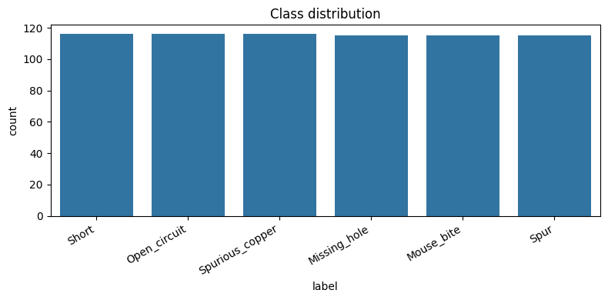
Preprocessing and Augmentation
Before training, all images were resized to 224 by 224 and normalized. During training, I used augmentation methods like random horizontal flip, random rotation, and brightness/contrast changes. I also added slight Gaussian noise in the from-scratch pipeline. These steps make the model stronger against real-world variation such as different angles, lighting, and camera conditions.
I also used weighted sampling for class imbalance. This helps the model not ignore smaller classes and improves fairness across defect categories.
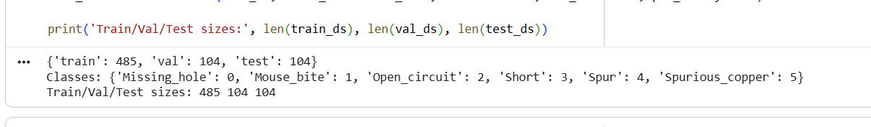Model Design
I implemented a custom CNN from scratch with five convolution blocks. The network uses convolution, batch normalization, ReLU activation, pooling, dropout, and a final classifier. This model is a strong baseline and learns defect features in a simple and controlled way.
I also implemented a ResNet-style model from scratch. This model uses residual blocks with skip connections. Skip connections help gradient flow and make deeper training more stable. In many cases, this model performs better on hard classes because it can learn richer features.
I additionally added a patch-based transfer learning section with pretrained ResNet18 on cropped defect regions. This section is useful when full-image training gives very low accuracy.
Training Setup
I used CrossEntropy loss and Adam optimizer. I monitored validation loss during training and used early stopping to avoid overfitting. I also saved the best checkpoint so final testing uses the best model state, not just the last epoch.
For reproducibility, I fixed random seeds and used a clear train/validation/test process.
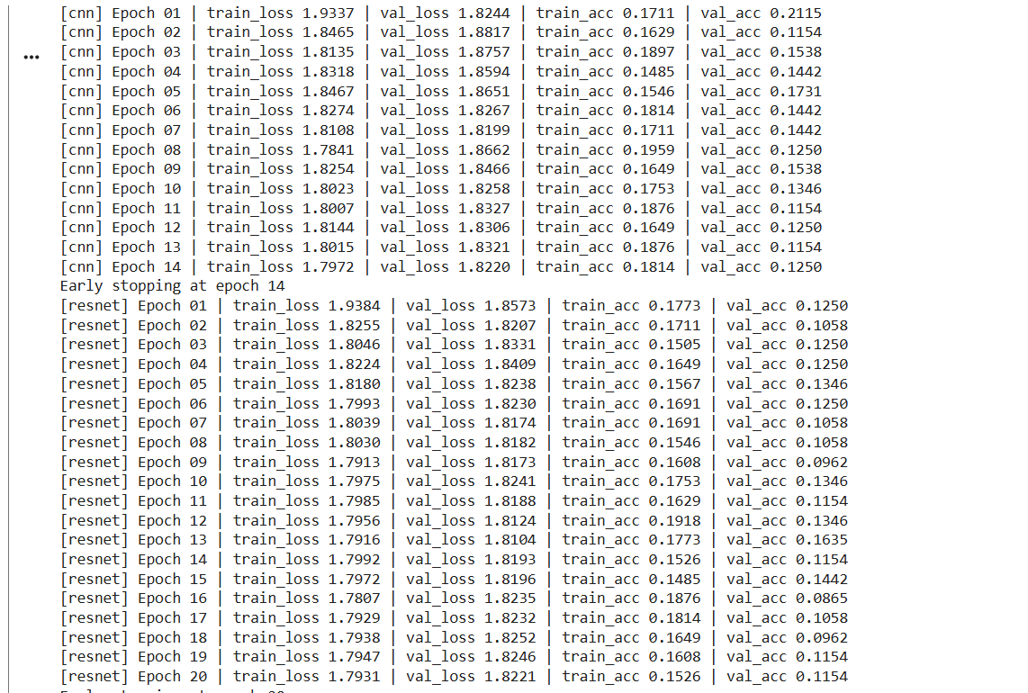
Results and Evaluation
I evaluated models on the test set using accuracy, precision, recall, F1-score, confusion matrix, and ROC-AUC (where applicable). These metrics give both overall and class-wise performance.
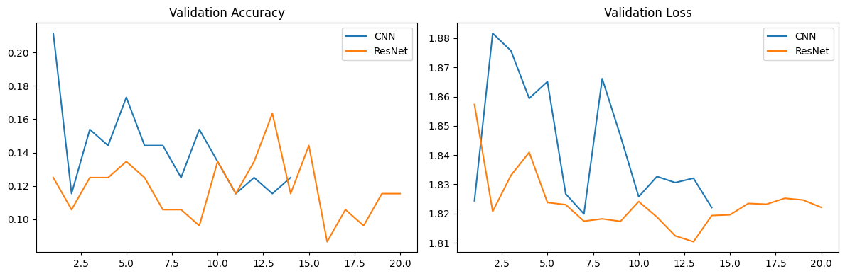

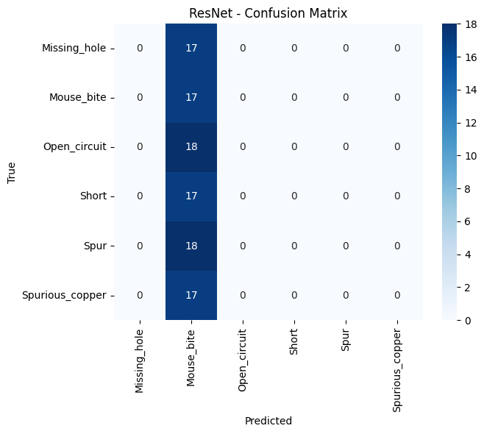

Interpretability and Error Analysis
I used Grad-CAM to see where the model focuses while predicting defects. This is important because it helps verify that the model is attending to defect regions and not random background.
Common errors usually happen when two classes look similar, defects are very small, or image contrast is low. This explains some wrong predictions and gives direction for future improvement.
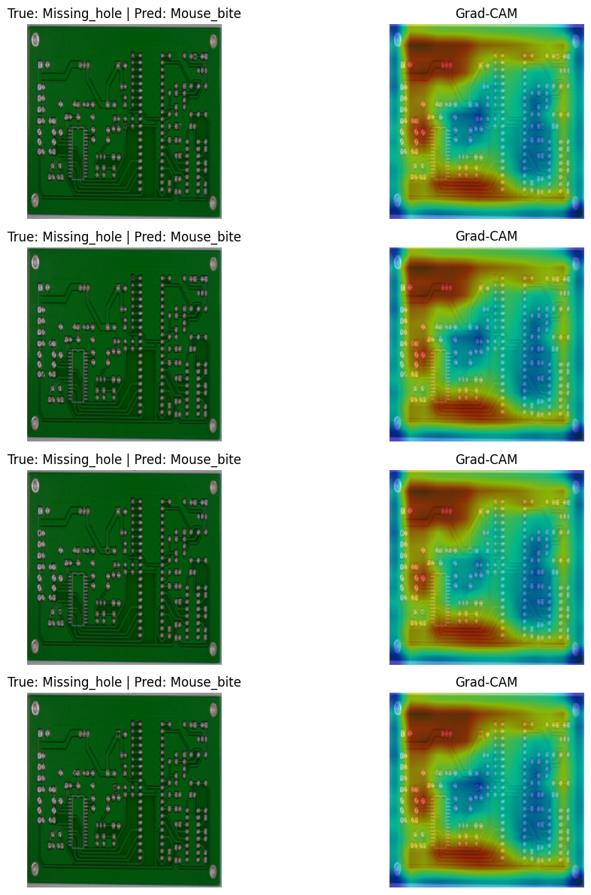
Comparative Discussion
The custom CNN gave a good baseline and proved that from-scratch learning is possible for this task. The ResNet-style model was generally more stable because residual connections improve deep learning behavior. The patch-based transfer learning approach was especially useful when baseline full-image accuracy was poor, because cropped regions reduce background noise and highlight defect signals.
For practical factory use, model selection should not depend only on accuracy. It should also consider recall for critical defect classes, inference speed, and the business cost of missed defects.
Conclusion
This project successfully delivers a full PCB defect classification pipeline from data preparation to explainable model outputs. The work meets assignment requirements and shows practical understanding of deep learning in manufacturing inspection.
The main learning points are that good preprocessing, balanced sampling, and architecture choice strongly affect performance. Visual tools like Grad-CAM are also very useful to build trust in model predictions
Limitations and Future Work
This work still has limitations. Performance depends on dataset quality and annotation quality. Very small defects are difficult at fixed resolution, and this setup is mainly classification-focused rather than full localization
In future work, I can improve performance with better hyperparameter tuning, focal loss for hard classes, multi-scale patches, and detection/segmentation models for exact defect location.
Final Submission Notes
I have prepared the required files for GitHub submission: final notebook, report draft, README, requirements, and checklist. Before final submission, I will paste all diagrams in the marked figure positions, insert final metric values, add GitHub link on the cover section, and export this report to PDF.
References
He, K., Zhang, X., Ren, S., Sun, J. (2016). Deep Residual Learning for Image Recognition.
PyTorch Documentation: https://pytorch.org/docs/stable/
Kaggle PCB Defects Dataset: https://www.kaggle.com/datasets/akhatova/pcb-defects

