**PRACTICAL 13**

Q1 Write a Program to Create, Modify, Delete and Display the Cookie Details.

HTML:

<html>

<body>

20438 UMME ATIYA<br><hr>

<form action="p13q1.php" method="post">

Cookie Name: <input type="text" name="cookie_name"/><br><br>

Cookie Value:<input type="text" name="cookie_value"/><br><br>

<input type="submit" name="button" value="Create Cookie"/>

<input type="submit" name="button" value="Modify Cookie"/><br><br>

<input type="submit" name="button" value="Delete Cookie"/>

<input type="submit" name="button" value="Show Cookie"/><br><br>

</form>

</body>

</html>`

PHP:

<?php

if (!empty($_POST['cookie_name'])) {

$cookie_name = $_POST['cookie_name'];

$cookie_value = $_POST['cookie_value'];

if (isset($_POST['button'])) {

switch ($_REQUEST['button']) {

case "Create Cookie":

setcookie($cookie_name, $cookie_value, time() + (86400 * 30), "/");

echo "Cookie Created Successfully<br>";

break;

case "Modify Cookie":

setcookie($cookie_name, $cookie_value, time() + (86400 * 30), "/");

echo "Cookie Modified Successfully<br>";

break;

case "Delete Cookie":

setcookie($cookie_name, null, time() - (86400 * 30), "/");

echo "Cookie Deleted Successfully<br>";

break;

}

}

}

if (!empty($_POST['button']) && !empty($_POST['cookie_name'])) {

if ($_POST['button'] == "Show Cookie") {

echo "Value of Cookie is " . $_COOKIE[$cookie_name];

}

}

?>

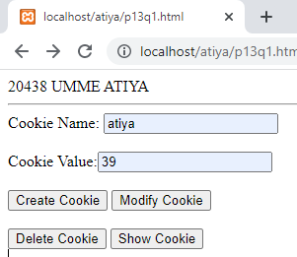 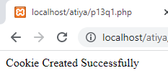

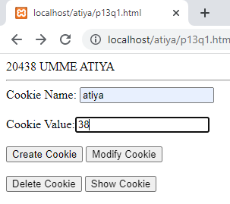 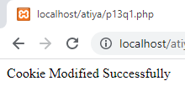

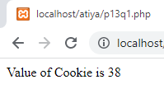 

Q2 Create a registration page and accept the details from user and store them in session variable. Display all details on next page.

<?php

session_start();

?>

<html>

<body>

<form name="form1" method="post">

Enter your Name: <input type="text" name="txt1" /><br>

Select your Gender: <br>

<input type="radio" name="gender" value="Male" /> Male

<input type="radio" name="gender" value="Female" /> Female

<input type="radio" name="gender" value="Other" /> Other

<br>Select your Hobbies: <br>

<input type="checkbox" name="cb[]" value="Programming" />Programming

<input type="checkbox" name="cb[]" value="Cricket" /> Cricket

<input type="checkbox" name="cb[]" value="Cycling" /> Cycling

<input type="checkbox" name="cb[]" value="Sleeping" /> Sleeping

<br>Select your Country: <br>

<select name="lb1">

<option value="India">India</option>

<option value="New Zealand">New Zealand</option>

<option value="Australia">Australia</option>

</select>

<br>Select your Language: <br>

<select name="lb2[]" multiple="multiple" size="3">

<option value="English">English</option>

<option value="Hindi">Hindi</option>

<option value="Marathi">Marathi</option>

</select>

<br>Hidden: <br>

<input type="hidden" name="hd" value="This is hidden" />

<br>Click to Submit: <br>

<button name="btn" type="submit" value="submit">Submit</button>

<input type="reset" name="reset" value="Reset" />

</form>

<?php

if (!empty($_POST['txt1']) && !empty($_POST['gender']) && !empty($_POST['cb']) && !empty($_POST['lb1']) && !empty($_POST['lb2']) && !empty($_POST['hd'])) {

$f_name = $_POST['txt1'];

$_SESSION['fname'] = $f_name;

$gender = $_POST['gender'];

$_SESSION['gender'] = $gender;

$hobbies = "";

$a = $_POST['cb'];

foreach ($a as $key => $val) {

$hobbies = $hobbies . " " . $val;

}

$_SESSION['hobbies'] = $hobbies;

$country = $_POST['lb1'];

$_SESSION['country'] = $country;

$language = "";

$b = $_POST['lb2'];

foreach ($b as $key => $val) {

$language = $language . " " . $val;

}

$_SESSION['language'] = $language;

$password = $_POST['hd'];

$_SESSION['password'] = $password;

echo "<br><b>Session Set!";

header("Location: p13q1b.php");

echo "<script>window.close();</script>";

} ?>

</body>

<html>

**2nd file:**

<?php

session_start();

echo "<b>SESSION VALUES</b><br>";

echo "First Name: " . $_SESSION['fname'] . "<br>";

echo "Gender: " . $_SESSION['gender'] . "<br>";

echo "Hobbies: " . $_SESSION['hobbies'] . "<br>";

echo "Country: " . $_SESSION['country'] . "<br>";

echo "Languages: " . $_SESSION['language'] . "<br>";

echo "Password: " . $_SESSION['password'] . "<br>";

session_unset();

session_destroy();

?>

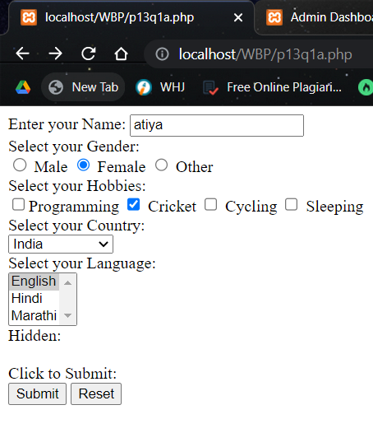 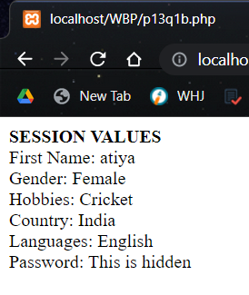

**PRACTICAL 14**

Q1 Write a php script to send Email using mail() function.

HTML:

<html>

<body>

<form method="POST">

Email Id: <input type="text" id="email" name="email"><br><br>

Subject: <input type="text" id="subject" name="sub"><br><br>

Message: <input type="text" id="header" name="message"><br><br>

<br><input type="submit" id="btn" name="btn" value="send">

</form>

<?php

if(isset($_POST["btn"]))

{

$to_email = $_POST["email"];

$subject = $_POST["sub"];

$message = $_POST["message"];

$headers = 'From: noreply @ company . com';

mail($to_email,$subject,$message,$headers);

}

?>

</body>

</html>

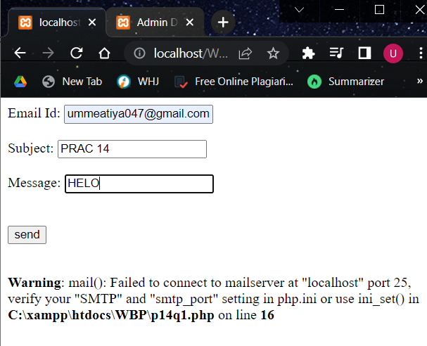

**PRACTICAL 15**

Q1 Write a Program to create a form and store the entered data in the database also displays the entered data.

<html>

<head></head>

<body>

<form name='form1' method='post'>

YOUR NAME: <input type="text" id="p_name" name="p_name"><br><br>

EMAIL ID: <input type="text" id="email" name="email"><br><br>

PHONE NUMBER:<input type="number" id="mob_number" name="mob_number"><br><br>

LOCATION: <input type="text" id="loc" name="loc"><br><br>

<input type="submit" id="btn" name="btn" value="insert">

<input type="submit" name="btn" value="display" />

</form>

<?php

if ($_SERVER['REQUEST_METHOD'] === 'POST') {

switch ($_REQUEST['btn']) {

case 'insert': {

$con = mysqli_connect('localhost', 'root', '');

mysqli_select_db($con, 'phpexp');

$name = $_POST['p_name'];

$email = $_POST['email'];

$phone = $_POST['mob_number'];

$loc = $_POST['loc'];

$sql = "INSERT INTO `mytab` (P_NAME, EMAIL, PHONE, LOC) VALUES ('$name', '$email', '$phone', '$loc')";

if (mysqli_query($con, $sql)) {

echo "<script> alert('Record Added Successfully.') </script>";

} else {

echo "<script> alert('Error in adding Record, please try again in some time.') </script>";

}

mysqli_close($con);

}

case 'display':

$con = mysqli_connect('localhost', 'root', '', );

mysqli_select_db($con, 'phpexp');

$sql = "SELECT * FROM mytab";

$retval = mysqli_query($con, $sql);

if (mysqli_num_rows($retval) > 0) {

while ($row = mysqli_fetch_assoc($retval)) {

echo " Name: {$row['P_NAME']} <br>" .

" Email: {$row['P_NAME']} <br>" .

" Phone: {$row['PHONE']} <br>" .

" Location: {$row['LOC']} <br>" .

"_________________________________________<br>";

}

} else {

echo "No records";

}

break;

}

}

?>

</body>

</html>

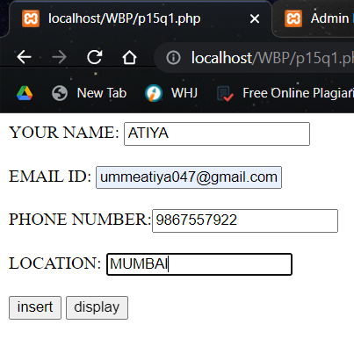

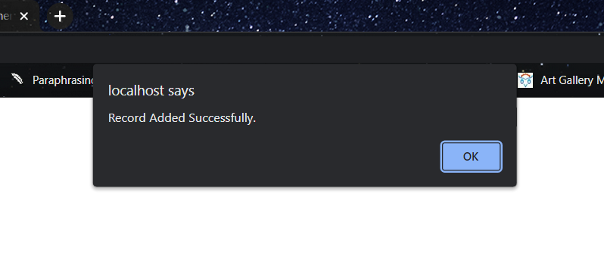

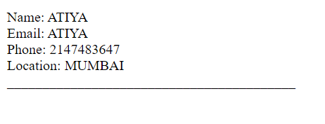

**PRACTICAL 15**

Q1 Write a Program to create a form and update the entered data in the database also displays and delete the entered data.

<html>

<head></head>

<body>

<form name='form1' method='post'>

NAME: <input type="text" id="P_NAME" name="P_NAME"><br><br>

EMAIL: <input type="text" id="EMAIL" name="EMAIL"><br><br>

<input type="submit" id="btn" name="btn" value="update">

<input type="submit" name="btn" value="display" />

<input type="submit" name="btn" value="delete" />

</form>

<?php

if ($_SERVER['REQUEST_METHOD'] === 'POST') {

switch ($_REQUEST['btn']) {

case 'update': {

$con = mysqli_connect('localhost', 'root', '');

mysqli_select_db($con, 'phpexp');

$name = $_POST["P_NAME"];

$email = $_POST["EMAIL"];

$sql = "update mytab set EMAIL='$email' where P_NAME='$name' ";

if (mysqli_query($con, $sql)) {

echo "<script> alert('Record Updated Successfully.') </script>";

} else {

echo "<script> alert('Error in updating record, please try again in some time.') </script>";

}

mysqli_close($con);

break;

}

case 'delete': {

$con = mysqli_connect('localhost', 'root', '');

mysqli_select_db($con, 'phpexp');

$name = $_POST["P_NAME"];

$sql = "delete from mytab where P_NAME='$name' ";

if (mysqli_query($con, $sql)) {

echo "<script> alert('Record Deleted Successfully.') </script>";

} else {

echo "<script> alert('Error in deleting record, please try again in some time.') </script>";

}

mysqli_close($con);

}

break;

case 'display': {

$con = mysqli_connect('localhost', 'root', '', );

mysqli_select_db($con, 'phpexp');

$name = $_POST["P_NAME"];

$sql = "select * FROM mytab where P_NAME= '$name' ";

$retval = mysqli_query($con, $sql);

$row = mysqli_fetch_assoc($retval);

echo " Name: {$row['P_NAME']} <br>" .

" Email: {$row['EMAIL']} <br>" .

" Phone: {$row['PHONE']} <br>" .

" Location: {$row['LOC']} <br>" .

"_________________________________________<br>";

break;

}

}

} ?>

</body>

</html>

