**Project Report**

**Group Members**

**Duaa Fatima**

**Umm-e-Hani**

**Dawood Tanvir**

**Introduction**

We were given a case study regarding a software knows as ‘PWB’. It is supposedly a project management software based on agile system. We were asked to implement it using sql dml and ddl and nodeJS.

**Mind Map**

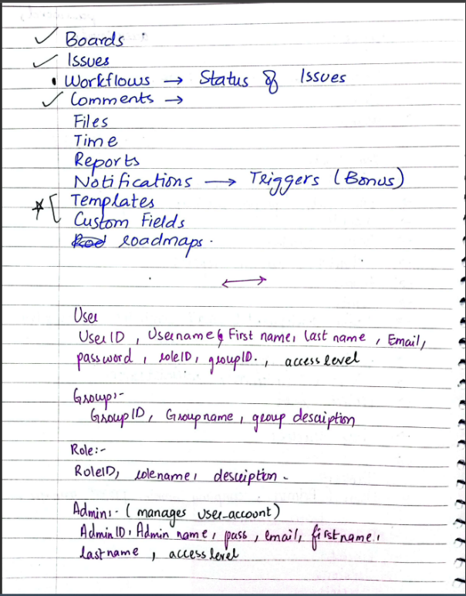

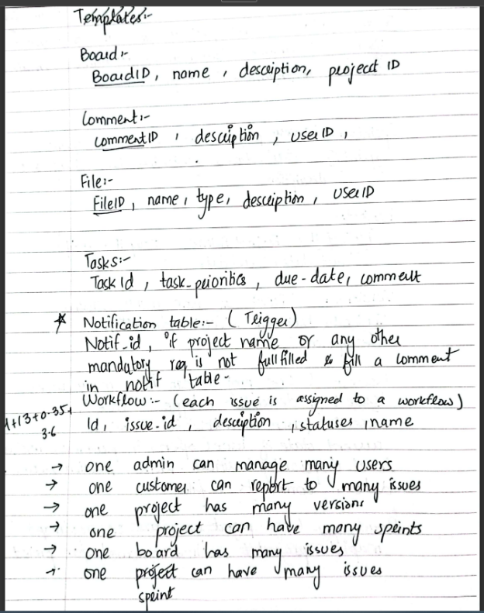

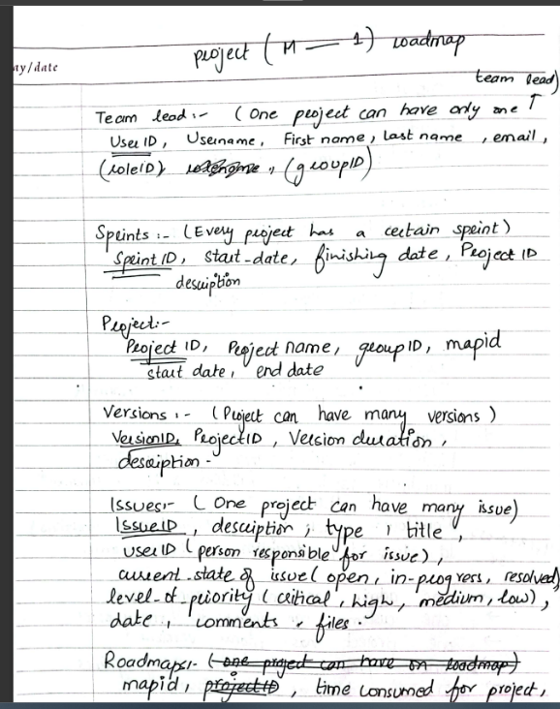

**ERD**

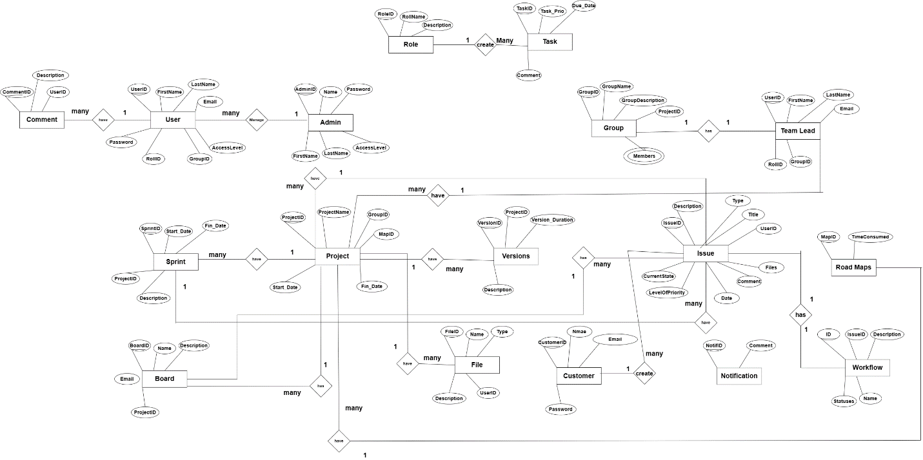

**Relational Schema**

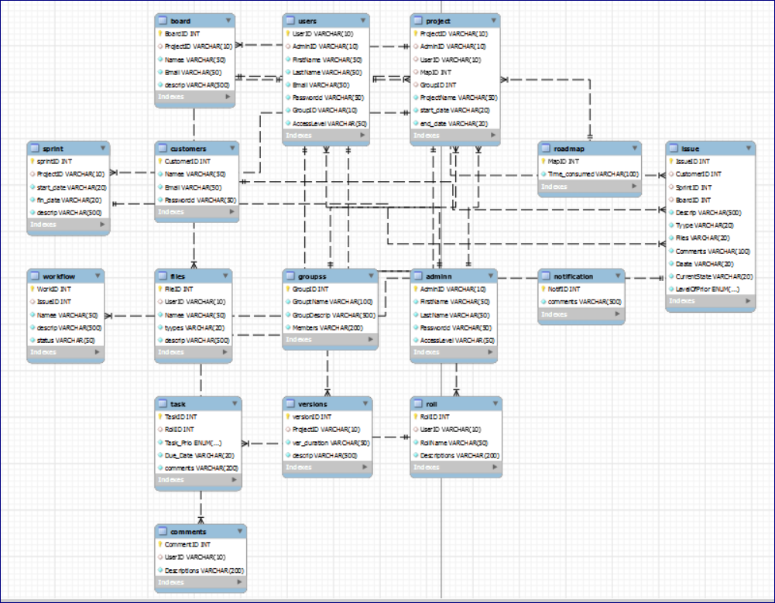

**Table Description**

**Admin**

| **Attribute** | **Description** | **Constraint** | **Type** | **Example** |
| --- | --- | --- | --- | --- |
| AdminID | Unique identifier for admin | Not null, Unique, Primary Key | varchar(10) | "AD001" |
| FirstName | First name of the admin | Not null | varchar(50) | "John" |
| LastName | Last name of the admin | Not null | varchar(50) | "Doe" |
| Passwordd | Password of the admin | Not null | varchar(50) | "mypassword123" |
| AccessLevel | Access level of the admin | Not null | varchar(50) | "Superadmin" |

**Groups**

| **Attribute** | **Description** | **Constraint** | **Type** | **Example** |
| --- | --- | --- | --- | --- |
| GroupID | Unique identifier for each group | NOT NULL, PRIMARY KEY, AUTO_INCREMENT | int | 1, 2, 3 |
| GroupName | Name of the group | NOT NULL | varchar | "abc” |
| GroupDescrip | Brief description of the group | NOT NULL | varchar | "This group is responsible for marketing campaigns." |
| Members | List of members in the group separated by comma | NOT NULL | varchar | "John, Jane, Jim" |

**Users**

| **Attribute** | **Description** | **Constraint** | **Type** | **Example** |
| --- | --- | --- | --- | --- |
| UserID | Unique identifier for a user | NOT NULL, UNIQUE, PRIMARY KEY | varchar(10) | "user123" |
| AdminID | Unique identifier for the user's admin |  | varchar(10) | "admin456" |
| FirstName | First name of the user | NOT NULL | varchar(50) | "John" |
| LastName | Last name of the user | NOT NULL | varchar(50) | "Doe" |
| Email | Email address of the user | NOT NULL | varchar(50) | "[johndoe@example.com](mailto:johndoe@example.com)" |
| Passwordd | Password for the user's account | NOT NULL | varchar(50) | "password123" |
| GroupID | Unique identifier for the user's group | NOT NULL, UNIQUE | varchar(10) | "group789" |
| AccessLevel | Access level of the user (e.g. admin, regular user) | NOT NULL | varchar(50) | "admin" |

**Comments**

| **Attribute** | **Description** | **Constraint** | **Type** | **Example** |
| --- | --- | --- | --- | --- |
| CommentID | Unique ID of the comment | NOT NULL, AUTO_INCREMENT, PRIMARY KEY | int | 1 |
| UserID | ID of the user who made the comment | foreign key references Users(UserID) | varchar | "U0001" |
| Descriptions | The text content of the comment | NOT NULL | varchar | "This is a comment." |

**Role**

| **Attribute** | **Description** | **Constraint** | **Type** | **Example** |
| --- | --- | --- | --- | --- |
| RollID | Unique identifier for each roll | PRIMARY KEY, AUTO_INCREMENT | int | 1 |
| UserID | Unique identifier for each user | FOREIGN KEY | varchar(10) | 'U001' |
| RollName | Name of the roll | NOT NULL | varchar(50) | 'Admin' |
| Descriptions | Brief description of the roll | NOT NULL | varchar(200) | 'Can manage all activities' |

**Task**

| **Attribute** | **Description** | **Constraint** | **Type** | **Example** |
| --- | --- | --- | --- | --- |
| TaskID | Unique identifier for each task | NOT NULL | int | 1 |
| RollID | Foreign key referencing Roll table |  | int | 2 |
| Task_Prio | Priority level of the task | NOT NULL | enum('1'...'5') | '3' |
| Due_Date | Deadline for completing the task | NOT NULL | varchar(20) | '2023-06-01' |
| comments | Additional comments or notes for the task | NOT NULL | varchar(200) | 'Need to update the status' |

**RoadMap**

| **Attribute** | **Description** | **Constraint** | **Type** | **Example** |
| --- | --- | --- | --- | --- |
| MapID | Unique identifier for each RoadMap item | NOT NULL, PRIMARY KEY | int | 1 |
| Time_consumed | The amount of time spent on the task described in hours | NOT NULL | varchar(100) | "2.5 hours" |

**Project**

| **Attribute** | **Description** | **Constraint** | **Type** | **Example** |
| --- | --- | --- | --- | --- |
| ProjectID | Unique identifier for a project | NOT NULL, PRIMARY KEY, UNIQUE | varchar(10) | PROJ-001 |
| AdminID | Identifier of the admin who created the project | FOREIGN KEY | varchar(10) | ADM-001 |
| UserID | Identifier of the user who created the project | FOREIGN KEY | varchar(10) | USR-001 |
| MapID | Identifier of the roadmap for the project | FOREIGN KEY | int | 1 |
| GroupID | Identifier of the group for the project | FOREIGN KEY | int | 10 |
| ProjectName | Name of the project | NOT NULL | varchar(50) | Project A |
| start_date | Start date of the project | NOT NULL | varchar(20) | 2023-06-01 |
| end_date | End date of the project | NOT NULL | varchar(20) | 2023-12-31 |

**Versions**

| **Attribute** | **Description** | **Constraint** | **Type** | **Example** |
| --- | --- | --- | --- | --- |
| versionID | Unique identifier for a version | PRIMARY KEY, NOT NULL, AUTO_INCREMENT | int | 1 |
| ProjectID | ID of the project the version belongs to | FOREIGN KEY, NOT NULL, REFERENCES Project(ProjectID) | varchar(10) | "PROJ001" |
| ver_duration | Duration of the version | NOT NULL | varchar(50) | "2 weeks" |
| descrip | Description of the version | NOT NULL | varchar(500) | "Added new feature X" |

**Sprint**

| **Attribute** | **Description** | **Constraint** | **Type** | **Example** |
| --- | --- | --- | --- | --- |
| sprintID | Unique identifier for each sprint | Not null, Primary Key | int | 1 |
| ProjectID | The ID of the project the sprint belongs to | Foreign key to Project | varchar(10) | 'PROJ001' |
| start_date | The date on which the sprint starts | Not null | varchar(20) | '2023-06-01' |
| fin_date | The date on which the sprint ends | Not null | varchar(20) | '2023-06-14' |
| descrip | Description of the sprint | Not null | varchar(500) | 'This sprint will focus on bug fixes.' |

**Board**

| **Attribute** | **Description** | **Constraint** | **Type** | **Example** |
| --- | --- | --- | --- | --- |
| BoardID | Unique identifier for the board | NOT NULL | int | 1 |
| ProjectID | Identifier for the related project |  | varchar | "PROJ001" |
| Namee | Name of the board creator | NOT NULL | varchar | "John Smith" |
| Email | Email address of the board creator | NOT NULL | varchar | "[john@example.com](mailto:john@example.com)" |
| descrip | Description of the board's objectives | NOT NULL | varchar | "Task management board for Project X" |
| FOREIGN KEY (ProjectID) | Reference to the related project |  |  |  |

**Files**

| **Attribute** | **Description** | **Constraint** | **Type** | **Example** |
| --- | --- | --- | --- | --- |
| FileID | Unique ID for each file | NOT NULL | int | 1 |
| UserID | ID of the user who uploaded the file |  | varchar | "user123" |
| Namee | Name of the file | NOT NULL | varchar | "document.pdf" |
| tyypes | Type of the file (e.g. PDF, JPEG, Word document) | NOT NULL | varchar | "PDF" |
| descrip | Description of the file | NOT NULL | varchar | "Report 2022" |

**Customers**

| **Attribute** | **Description** | **Constraint** | **Type** | **Example** |
| --- | --- | --- | --- | --- |
| CustomerID | Unique identifier for customers | NOT NULL | int | 1001 |
| Namee | Name of the customer | NOT NULL | varchar | John Smith |
| Email | Email address of the customer | NOT NULL | varchar | [john@xyz.com](mailto:john@xyz.com) |
| Passwordd | Password for the customer | NOT NULL | varchar | abc123 |

**Issue**

| **Attribute** | **Description** | **Constraint** | **Type** | **Example** |
| --- | --- | --- | --- | --- |
| IssueID | Unique identifier for the issue | NOT NULL, PRIMARY KEY | int | 1 |
| CustomerID | Foreign key referencing Customers |  | int | 1 |
| SprintID | Foreign key referencing Sprint |  | int | 1 |
| BoardID | Foreign key referencing Board |  | int | 1 |
| Descrip | Description of the issue | NOT NULL | varchar(500) | "This is an issue" |
| Tyype | Type of the issue | NOT NULL | varchar(20) | "Bug" |
| Files | File associated with the issue | NOT NULL | varchar(20) | "file.pdf" |
| Comments | Comments related to the issue | NOT NULL | varchar(100) | "This is a comment" |
| Daate | Date of the issue | NOT NULL | varchar(20) | "2023-05-15" |
| CurrentState | Current state/status of the issue | NOT NULL | varchar(20) | "Open" |
| LevelOfPrior | Level of priority for the issue | NOT NULL | enum('1', '2', ...) | "3" |

**WorkFlow**

| **Attribute** | **Description** | **Constraint** | **Type** | **Example** |
| --- | --- | --- | --- | --- |
| WorkID | Unique identifier for the workflow | NOT NULL, PRIMARY KEY | int | 1 |
| IssueID | Foreign key referencing Issue |  | int | 1 |
| Namee | Name of the workflow | NOT NULL | varchar(50) | "Workflow 1" |
| descrip | Description of the workflow | NOT NULL | varchar(500) | "This is a workflow" |
| status | Status of the workflow | NOT NULL | varchar(50) | "Active" |

**Work Distribution**

Duaa: Made mind map of the study case and wrote table description. Performed DML, made some web pages and tried to connect database with NodeJS.

Dawood: I made the ERD and designed and created most of the frontend about 8 pages and integrated pages with eachother.

Hani: I made the DDLof the project and schema. Also tried connecting database pages but wasn’t successful in doing that.