**Overview:**

The project is done using Symfony 5.0.7 and xampp.To navigate to login page write [http://symphart.test/login in address bar.The](http://symphart.test/login%20%20in%20address%20bar.The) configuration of virtual host is necessary.

**Configuring virtual host :**

In httpd-vhosts.conf which is located somewhere like C:\bulaprog\xampp\apache\conf\extra

write

<VirtualHost *:80>

DocumentRoot "C:/bulaprog/xampp/htdocs/symphart/public"

ServerName symphart.test

</VirtualHost>

and make sure port 80 is not listening to any other process.

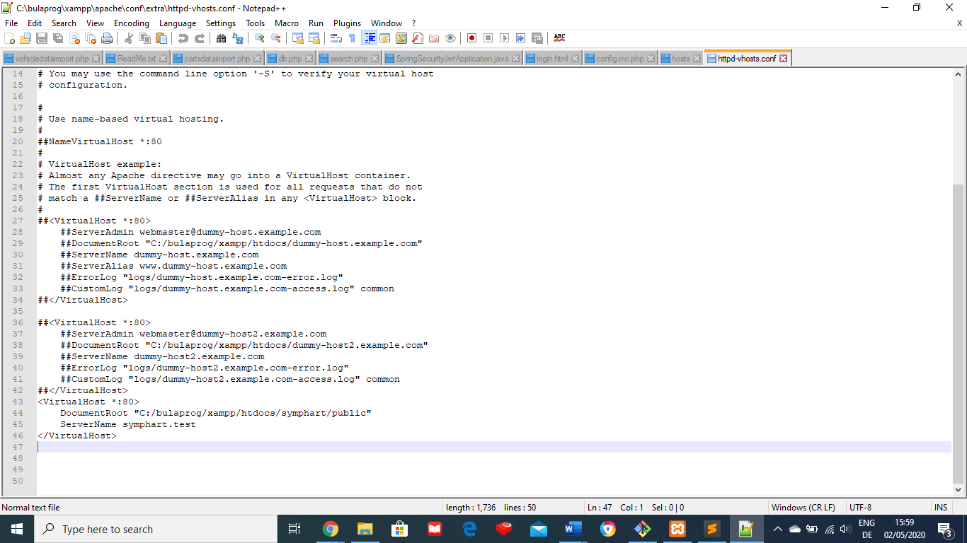

Now open the hosts file which is located C:\Windows\System32\drivers\etc and edit as shown in the screenshot.Write 127.0.0.1 symphart.test in the hosts file.Make sure while editing using notepad or notepad++ open it in adminstrater mood.

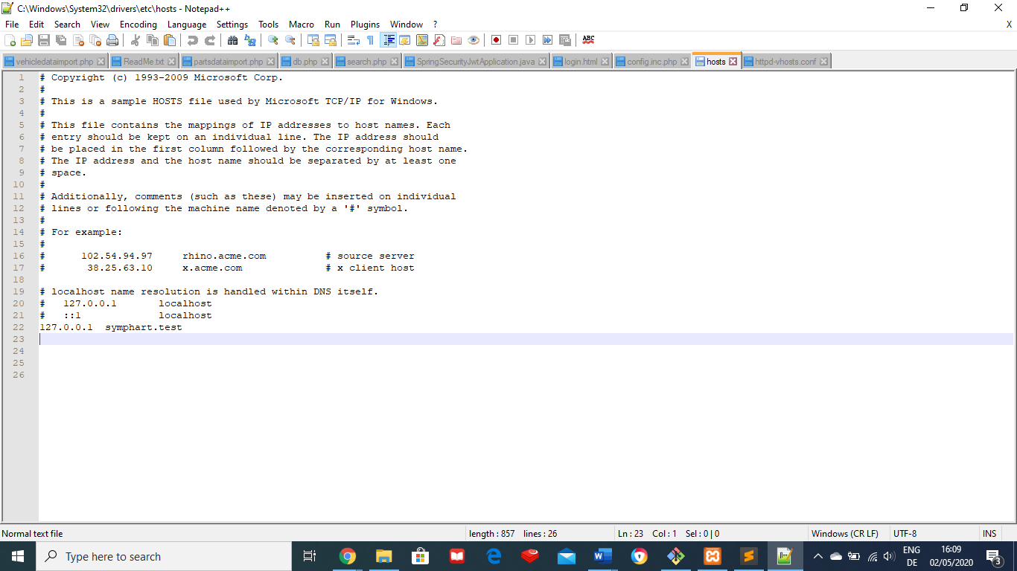

After doing these things please restart Apache server.

Screenshot of the project :

