Bangladesh University of Engineering and Technology
Department of Electrical and Electronic Engineering

[Course Code] ([Term])
[Course Title]
Final Project Report
Section: [Section] Group: [Group]

Classical rPPG Monitor for Contactless Heart Rate Estimation
Prepared by: [Student Name 1] ([Student ID 1])
[Student Name 2] ([Student ID 2])

Course Instructor / Supervisor:
[Supervisor Name], [Designation]

Signature of Instructor: ___________________________________________________

Academic Honesty Statement:
In signing this statement, we certify that this report and the software work it describes are our own. Literature, algorithms, datasets, and software libraries used in the project are cited. Student signatures: [Student 1] ____________ [Student 2] ____________

- Table of Contents
Abstract
Introduction
Design
Problem Formulation (PO(b))
Design Method (PO(a))
System Architecture
Algorithm Design
Software Implementation
Real-Time Execution and Profiling
Implementation
Design Analysis and Evaluation
Reflection on Individual and Team Work (PO(i))
Communication to External Stakeholders (PO(j))
Project Management (PO(k))
Future Work (PO(l))
References

Abstract
Remote photoplethysmography (rPPG) estimates a pulse-related signal from subtle color variation in facial video. This report presents a software-only classical rPPG monitor designed as an interpretable digital signal processing application for educational and research use. The system reads a live or stored video stream, obtains face landmarks, selects forehead and cheek regions, rejects frames with inadequate skin evidence or excessive landmark motion, and derives robust RGB traces. It then corrects timing irregularity by interpolation, suppresses slow drift using smoothness-priors detrending, evaluates Green, PCA, CHROM, and POS pulse candidates, applies a zero-phase Butterworth band-pass filter, and estimates BPM using Welch spectral analysis and peak intervals. A quality-aware fusion stage combines agreement, coverage, illumination, motion, and spectral evidence before updating the displayed BPM. The application also supports a desktop user interface, headless replay, session logging, and UBFC-rPPG-compatible evaluation utilities. The work deliberately separates an estimate from a clinical measurement: the software is not a medical device, does not diagnose disease, and must not be used for treatment or emergency decisions. The report describes the theoretical basis, design choices, implementation structure, verification plan, limitations, ethics, and future development path.

Introduction
Heart rate is commonly measured by contact sensors, but a video-based estimate can be useful when a non-contact educational demonstration or retrospective video analysis is preferred. The target signal is extremely weak: normal facial movement, ambient-light changes, automatic image adjustments, compression, and missed landmarks can be much larger than the pulse-related variation. A credible solution therefore requires more than a single frequency peak. It must create a trace from meaningful facial regions, preserve timing information, evaluate competing pulse models, and reject observations that lack sufficient evidence.
The project adopts a classical DSP approach. Unlike a trained end-to-end model, this approach has visible intermediate signals and a direct relationship between the engineering assumptions and the outcome. The green channel is a useful baseline because hemoglobin absorption makes its relative variation informative under suitable light [1]. CHROM and POS form color-space projections that seek to reduce common-mode illumination variation [3], [4]. PCA provides an additional data-driven candidate. Each method can fail in different conditions, so the system compares candidates rather than treating one method as universally reliable.
The problem is a complex engineering problem because the input is non-stationary, the sample timing is imperfect, the desired component is small, and the outcome must remain understandable when it is rejected. The constraints include a rolling analysis window, physiological search limits, absence of reliable input during face loss, and a user interface that should never imply false certainty. The project therefore emphasizes traceability: accepted RGB samples, rejected frame events, quality features, and BPM estimates are written to a session directory for review.
The report is framed as a final course project. It retains the course-report sections required by the supplied template while focusing exclusively on software design, signal processing, evaluation, project management, and responsible use. It does not include thesis-only front matter or any physical design material.

Design

Problem Formulation (PO(b))

Identification of Scope
The software accepts a permitted live video stream, a saved video file, or a compatible recorded dataset folder. It outputs an estimated BPM only after an accepted analysis window. The system is responsible for landmark-guided region selection, skin-pixel screening, RGB extraction, temporal preprocessing, candidate construction, filtering, spectral and peak estimation, quality control, smoothing, display, and session evidence. It is not intended to measure oxygen saturation, diagnose disease, infer emotion, identify people, or make a medical decision.

Literature Review
Verkruysse, Svaasand, and Nelson showed that pulse-related variation can be observed in ordinary ambient-light video [1]. Poh, McDuff, and Picard introduced blind-source separation for non-contact cardiac pulse measurement [2]. De Haan and Jeanne proposed CHROM, which uses chrominance information to improve robustness [3]. Wang et al. described the POS algorithmic principle [4]. Tarvainen et al. introduced smoothness-priors detrending for physiological time series [5], while Welch described averaged periodograms for more stable power-spectrum estimates [6]. These works motivate the selectable, inspectable components of the present project.

Formulation of Problem
Let c[k] = [R[k], G[k], B[k]]^T denote a timestamped RGB observation extracted from accepted skin pixels. The desired scalar pulse component p[k] is obscured by illumination I[k], non-pulsatile reflectance, movement, and noise. A simplified observation model is c[k] = I[k](u_s s[k] + u_d d_0) + u_p p[k] + n[k], where the terms represent common reflection, static diffuse color, pulse-related color variation, and noise. The software seeks a BPM value b = 60f from a dominant in-band frequency f while requiring temporal, spatial, and spectral evidence sufficient to accept the result.

Analysis
The analysis window is not assumed to be uniformly sampled. Timestamps are sorted, duplicate times are aggregated, excessive gaps are rejected, and finite RGB observations are linearly interpolated onto a uniform grid. If the median interval is delta t, the effective sampling rate is f_s = 1/delta t. The selected heart-rate band is 55 to 200 BPM, or approximately 0.917 to 3.333 Hz. The upper edge is clamped below Nyquist so that a low-rate stream cannot silently produce an invalid filter or spectrum.
The core decision is intentionally conservative. A valid spectrum alone is insufficient if the recent window has poor sample coverage or unstable illumination. Likewise, a peak-interval value is not accepted unconditionally. The final quality score contains a spectral term, FFT-to-peak agreement, accepted-sample coverage, face-detection availability, skin-mask coverage, motion quality, and illumination quality. The result is rejected if a required timing or quality condition fails.

Design Method (PO(a))
The design applies mathematics, signal processing, and software engineering in a connected sequence. Temporal sampling theory determines whether a received stream can represent the accepted pulse band. Robust statistics reduce the influence of bright or dark outlier pixels. Regularized detrending separates slow baseline variation from the target pulse range. Color projection creates several candidate pulse traces. Frequency and time-domain estimates provide complementary evidence. Finally, an event-driven program architecture preserves the evidence needed to explain why a window was accepted, warming up, or rejected.
For each color channel y, smoothness-priors detrending estimates a slowly varying trend z by solving z_hat = (I + lambda^2 D_2^T D_2)^(-1)y, where D_2 is a second-difference matrix and lambda controls trend smoothness [5]. The residual y - z_hat is standardized before candidate generation. The implementation uses a sparse factorization cache for repeated window lengths, which avoids constructing the same linear solve on every update.
After candidate construction, a third-order Butterworth band-pass filter is applied in forward and reverse directions. The effective magnitude is squared while phase distortion is cancelled in the buffered analysis window. Welch PSD analysis averages overlapping tapered segments, which reduces variance compared with a single raw periodogram [6]. Local parabolic interpolation around the strongest spectral bin refines the frequency estimate without reporting a value outside the configured band.

System Architecture
The system is organized into five software layers. The acquisition layer obtains frames and selects a progressing timestamp source. The perception layer returns face landmarks and derives named regions. The extraction layer applies ROI masks and produces one robust RGB observation only when sufficient valid pixels are present. The DSP layer maintains the rolling sample window, builds candidate signals, calculates quality measures, and emits an accepted or rejected analysis result. The presentation and persistence layer updates the user-facing telemetry and writes metadata and CSV records.
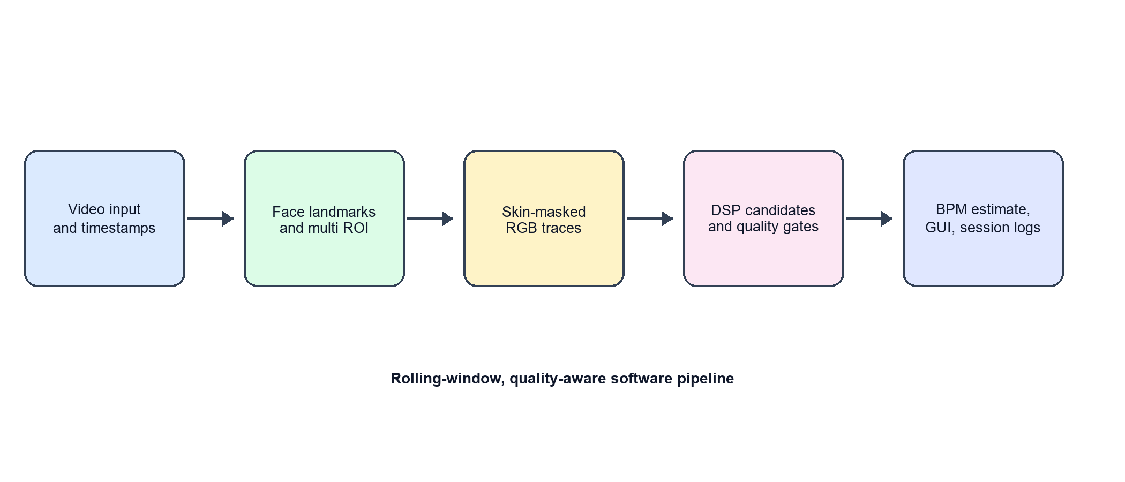
Figure 1: Software-only architecture of the classical rPPG monitor
Table 1: Software layers and their responsibilities
Layer | Main responsibility | Evidence produced
Acquisition | Read frames and normalize timestamps | Frame timing and source label
Perception | Locate landmarks and derive facial regions | Region geometry and motion measure
Extraction | Select valid skin pixels and compute RGB means | RGB sample and mask coverage
DSP | Create, filter, score, and fuse pulse candidates | BPM candidates and quality features
Presentation | Update GUI and write session artifacts | Status, plots, CSV, metadata

Algorithm Design

Region Selection and RGB Extraction
The face is represented by landmarks from which the forehead, left cheek, and right cheek regions are derived. The regions are smoothed over time to reduce coordinate jitter. A normalized landmark displacement is calculated between consecutive frames. When displacement exceeds the configured motion threshold, the RGB observation is excluded from the pulse window. This prevents a large facial movement from being treated as a color oscillation.
Within each region, pixels are converted to YCrCb. A fixed chrominance mask uses configurable Y, Cr, and Cb limits. The software also provides current-frame adaptive chroma and temporal adaptive variants, but the mask strategy remains explicit in the session record. Per-channel robust means use values clipped between configured low and high percentiles. The extraction stage returns non-finite RGB when the total valid-pixel requirement is not met; it does not substitute arbitrary fallback color values.

Candidate Pulse Signals
The Green candidate is the standardized green trace. PCA decomposes the normalized three-channel matrix and evaluates each component by spectral quality and explained variance. Its sign can be aligned against the green candidate to make inspection more consistent. CHROM forms X = 3R - 2G and Y = 1.5R + G - 1.5B, then combines them using an adaptive standard-deviation weight. POS forms S1 = G - B and S2 = -2R + G + B with the corresponding adaptive combination. CHROM and POS are evaluated in overlapping local windows after local channel normalization so that their coefficients respond to recent conditions rather than a single global mean.

Filtering, Spectrum, and Peak Estimates
Every valid candidate is filtered in the active search band. The system begins with a global band or forms an adaptive band around the last reliable BPM. A periodic global-band probe is retained so that the adaptive search does not remain locked to a stale local range. Welch analysis returns frequency bins and power values. The peak frequency is refined, clipped to the active band, checked for a plausible subharmonic, and penalized when it lies too close to a band edge. Independent peak detection measures the median inter-peak period in the filtered waveform and optionally evaluates both polarities.

Estimate Fusion and Temporal Tracking
The spectral BPM is the anchor estimate. If the peak BPM is finite, it receives a maximum configurable share that decreases continuously as its disagreement with the spectral BPM grows. A jump guard rejects sudden changes relative to the previous accepted BPM. The runner then applies either a time-aware exponential moving average or an optional BPM Kalman tracker. Consecutive rejections reset the tracked state so that an old estimate is not displayed as though it were current.
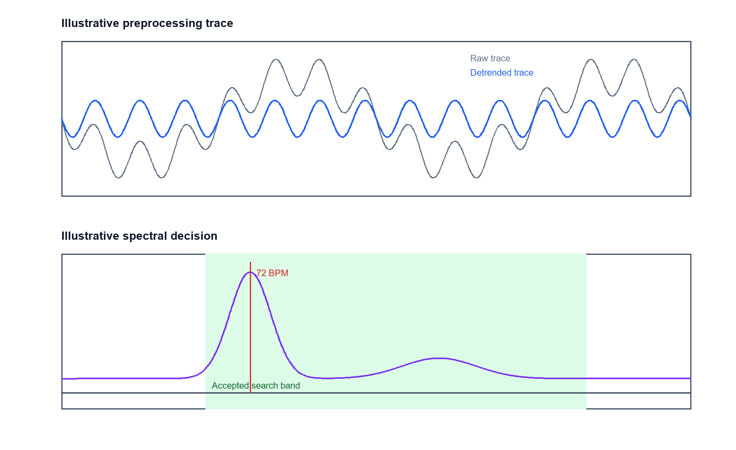
Figure 2: Illustrative time-domain and frequency-domain behavior of the DSP pipeline

Software Implementation
The implementation uses a Python source-layout package. Configuration is represented by validated dataclasses that group camera/video input settings, ROI settings, and analysis settings. The DSP package contains preprocessing, filtering, spectral estimation, and peak utilities. The algorithms package contains candidate generation, analysis, and temporal tracking. Separate modules manage ROI geometry, RGB extraction, landmarks, timing, session writing, calibration evidence, evaluation, and visualization.
The runner maintains deques for accepted samples and all frame events. The accepted-sample deque is pruned to the configured analysis-window duration; the frame-event deque supports coverage and detection checks over the same window. Each analysis event has an incrementing sequence number, a status, a rejection category when applicable, sample count, timing metrics, and accepted-result metadata. This structure supports replay, debugging, and reproducible inspection without coupling the analysis logic to the GUI.
The desktop interface is separated from the analysis engine through a background worker and queues. Frame delivery favors recency by dropping an outdated display frame when the queue is full. Telemetry messages contain only the values needed for the current UI update, including BPM, quality, selected method, waveform, spectrum, and status. This separation keeps the event loop responsive while the DSP code operates on the latest completed window.

Real-Time Execution and Profiling
Real-time behavior is managed through bounded work rather than an assumption that every machine has the same speed. Face processing occurs per frame, while full-window analysis is scheduled at a configurable interval. The window is normally 24 seconds and the update interval is one second. A warm-up requirement prevents early analysis. If accepted samples become stale, the program clears the displayed BPM and resets its tracker. For offline video, the GUI engine paces playback using the declared frame rate where it is credible so that visual replay remains understandable.
Profiling should record separate costs for landmark detection, ROI extraction, preprocessing, candidate generation, filtering, spectral estimation, peak detection, and UI dispatch. The repository provides timing and session metrics but a final performance figure depends on the actual execution environment, input resolution, source codec, and configured methods. The report therefore gives a reproducible profiling method rather than presenting unverified latency as a universal claim.

Implementation

Description
A session begins by validating configuration and creating an output directory with logs, metadata, CSV files, and figure locations. The application opens the configured input, initializes the landmark model, and begins collecting frame events. During normal operation it shows a warm-up state until the data window contains enough recent accepted RGB samples. After a valid analysis update, the status contains BPM and the latest quality measure. When quality is low, the interface keeps the reason visible rather than silently continuing the previous display.

Threading and State Management
The background engine owns frame acquisition and DSP state. The GUI polls queues for the newest image and events, avoiding direct mutation of analysis buffers from the display thread. Stop requests are represented by an event checked inside the processing loop. Resources are closed in a finalization block so that a video capture, landmarker, dashboard, and CSV writers are released after normal completion or failure. The same design is used for command-line processing, with the presentation portion omitted in headless mode.

Configuration and Reproducibility
The default TOML configuration documents requested input dimensions, target frame rate, ROI thresholds, analysis window, filter order, accepted BPM limits, peak settings, spectral settings, smoothing behavior, and quality limits. The command line exposes selected overrides, such as input source, ROI strategy, analysis-window duration, candidate method, and output directory. Each session stores a configuration snapshot, allowing a later reader to reproduce the stated setting rather than infer it from the code version.

Verification Through Automated Tests
The repository contains automated tests spanning configuration validation, timestamp behavior, ROI clamping, RGB extraction, temporal masks, spectral refinement, filtering, fusion, candidate selection, tracking, session CSV schemas, UBFC reference parsing, evaluation, and GUI components. These tests express behavior on controlled inputs: for example, a synthetic sinusoid should be estimated near its known BPM, a timestamp gap should cause rejection, and an invalid skin mask should not create an RGB sample. The test suite is a regression guard, not a substitute for reference-device validation on real video.
Table 2: Verification matrix for the software pipeline
Verification target | Controlled input | Expected behavior
Timestamp handling | Duplicate, backward, or gapped times | Aggregate duplicates; reject unsafe gaps
Signal processing | Synthetic known-frequency trace | Estimate remains within configured tolerance
ROI extraction | Invalid or low-coverage region | Reject RGB sample without fallback
Candidate selection | Finite and non-finite candidate traces | Prefer accepted high-quality candidate
Session evidence | Accepted and rejected analyses | Write stable CSV fields and categories
User interface | Engine lifecycle and widget state | Remain responsive and report state

Design Analysis and Evaluation

Novelty
The project does not claim a novel physiological principle. Its contribution is a disciplined integration of established classical methods into one inspectable software workflow. The integration includes landmark-aware multi-region extraction, robust pixel pooling, timing-aware interpolation, multiple color projections, spectral and time-domain agreement, periodic global-band recovery, quality-context logging, and a user interface that distinguishes a valid estimate from a poor-quality window. This is valuable in a course setting because every major decision can be traced to a configurable rule or recorded session field.

Design Considerations (PO(c))

Considerations to Public Health and Safety
A numerical BPM display can be misinterpreted as a clinical reading. The application therefore describes its output as an estimate, uses rejection states, and does not offer diagnostic recommendations. The software must not be used for triage, medication decisions, emergency assessment, or any setting where a qualified measurement is required. Quality gating reduces obvious misuse of poor input; it does not establish medical-grade accuracy.

Considerations to Environment
The project is software-only and does not require project-specific consumables. Its environmental footprint is mainly ordinary compute and display use. Bounded buffers, replay-based debugging, and configurable logging can reduce unnecessary repeated processing and storage. These benefits are modest and should not be overstated.

Considerations to Cultural and Societal Needs
Facial-video methods can perform differently with lighting, camera processing, motion, facial hair, occlusion, compression, and appearance. The design avoids claiming equal performance for all people or conditions. It records coverage and rejection signals so that a failed or weak observation can be recognized. Evaluation should use authorized data, report condition-specific limitations, and avoid any deployment that turns video observation into unconsented monitoring.

Investigations (PO(d))

Design of Experiment
A controlled evaluation replays a permitted recorded sequence with fixed configuration and compares each accepted BPM with a timestamp-aligned reference series. The protocol first records frame count, effective FPS, detection availability, sample acceptance, and rejection categories. It then reports the number of valid estimate-reference pairs. Only after these availability measures are known should mean absolute error (MAE), root mean squared error (RMSE), mean bias, and correlation be interpreted. A simple definition is MAE = (1/N) sum |b_est,i - b_ref,i| and RMSE = sqrt((1/N) sum (b_est,i - b_ref,i)^2).

Data Collection
The software supports an UBFC-rPPG folder layout containing a video and a ground-truth text file. It reads finite BPM and timestamps, normalizes timestamp units where needed, and writes comparison records only over the overlapping time interval. No new human-subject data are claimed in this report. Any new recording should be performed with informed consent, an approved collection procedure where applicable, and storage controls appropriate to facial video.

Results and Analysis
The codebase includes the mechanisms required for reproducible session evaluation: accepted RGB samples, frame events, BPM estimates, analysis events, reference alignment, and aggregate error calculations. A valid completed benchmark table must be generated by running the software in a repaired environment against an identified input and reference. The available project virtual environment currently points to an unavailable Python installation, so this report does not represent a fresh local execution result as a measured result. This limitation is stated explicitly to preserve academic honesty.
Table 3: Required reporting fields for a reproducible evaluation
Metric | Meaning | Report requirement
Paired estimates | Number of in-range estimated/reference pairs | State count before error metrics
MAE | Average absolute BPM deviation | State unit BPM and window policy
RMSE | Error magnitude with larger-error emphasis | State unit BPM and pairing method
Bias | Mean signed BPM deviation | Identify positive or negative direction
Coverage | Accepted samples relative to received frames | Report with face-detection availability
Rejections | Why analysis windows were rejected | Report categories and counts

Interpretation and Conclusions on Data
An error metric without context can be misleading. A low MAE from a small, stable subset of a video does not prove robustness during face loss or motion. Conversely, a high rejection rate may protect against false BPM updates but lower the fraction of time for which the system is useful. The appropriate interpretation combines availability, rejection reasons, and paired-estimate accuracy. This report therefore treats the evaluation harness as a core deliverable and reserves strong performance claims for a completed, reproducible experiment.
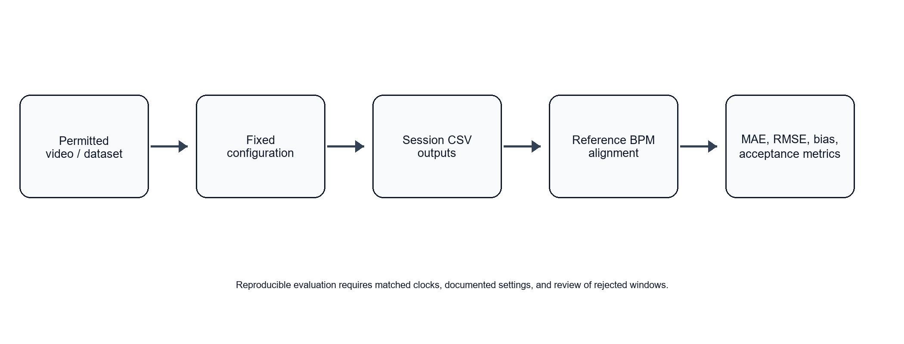
Figure 3: Reproducible evaluation flow for accepted BPM estimates

Limitations of Tools (PO(e))
The software depends on input-timestamp quality, landmark reliability, library versions, and operating-system scheduling. Automatic exposure or white balance behavior may produce intensity changes that a classical projection cannot fully remove. Low illumination raises noise and longer exposure can blur motion. Major pose changes or occlusions can prevent stable ROI extraction. A fixed 30 FPS target is adequate for basic heart-rate estimation in the accepted band but does not support fine waveform morphology or precise pulse-transit analysis. The saved environment’s missing interpreter target is also a practical reproducibility limitation that must be corrected before execution evidence is submitted.

Impact Assessment (PO(f))

Assessment of Societal and Cultural Issues
A contactless estimate can be attractive in education, wellness demonstrations, and non-contact interaction, but a face stream is sensitive information. Users should know when capture is active, whether frames are stored, and where session evidence is written. The application should never be repurposed for covert observation or evaluation of a person without consent.

Assessment of Health and Safety Issues
The primary safety risk is over-trust in a value that is inaccurate or stale. The mitigation is software behavior and user communication: state a non-medical purpose, reset stale data, reject low-quality windows, expose status, and avoid clinical language. Users must seek qualified care for health concerns rather than relying on this application.

Assessment of Legal Issues
Use of face video, reference data, and public datasets must respect consent, license terms, institutional requirements, and applicable privacy law. Session directories may contain timestamps and derived physiological estimates, so access should be limited and retention should be deliberate. The report references established algorithms and identifies third-party libraries and datasets rather than presenting them as original work.

Sustainability Evaluation (PO(g))
The system’s sustainability consideration is primarily efficient software operation. It uses a bounded rolling window, a scheduled analysis interval, and session-local outputs. Such choices limit unnecessary memory growth and repeated computation. Any broader sustainability claim would require measurement of deployment-specific energy use, which is outside the present project scope.

Ethical Issues (PO(h))
Ethical design requires that a rejected condition remain visible instead of being hidden behind a plausible-looking number. The project preserves that distinction through quality gates and logs. It also requires consent for recording, careful treatment of facial-video data, and honesty about unequal performance across conditions. The project intentionally avoids claims of clinical validation and does not use individual identity as a feature of the analysis.

Reflection on Individual and Team Work (PO(i))

Individual Contribution of Each Member
[Student Name 1] - [Replace with actual contribution: literature review, DSP design, implementation, testing, or documentation].
[Student Name 2] - [Replace with actual contribution: GUI, evaluation, session logging, testing, or documentation].

Mode of Team Work
The team should divide work by module boundaries, agree on configuration and data contracts before integration, and review changes against automated tests and documented expected behavior. A practical workflow is to assign one member responsibility for a module while keeping shared ownership of interfaces, validation, report writing, and final demonstration. Replace this statement with the team’s actual working process before submission.

Diversity Statement of Team
The team commits to respectful collaboration, equitable participation, accessible communication, and evidence-based technical discussion. Work allocation and review should be based on declared responsibilities and available time, not personal characteristics. Design decisions should be challenged through requirements, data, and tests.

Log Book of Project Implementation
Table 4: Software project implementation log
Date | Milestone achieved | Individual role | Team role | Comments
[Date] | Scope, requirements, and literature reviewed | [Name] | Planning | Replace with actual record
[Date] | ROI and RGB extraction integrated | [Name] | Implementation | Replace with actual record
[Date] | DSP candidate and quality pipeline completed | [Name] | Integration | Replace with actual record
[Date] | GUI, session logging, and tests reviewed | [Name] | Validation | Replace with actual record

Communication to External Stakeholders (PO(j))

Executive Summary
This project is a desktop software tool that estimates a pulse-related frequency from facial video using established signal-processing methods. It tracks facial regions, converts valid skin-pixel colors into a time signal, compares several classical rPPG methods, and withholds updates when the data are unreliable. The program saves evidence for later review. It is intended for learning and research demonstration, not medical care. Any wider use would require consented evaluation, clear privacy controls, and independent validation against an appropriate reference measurement.

User Manual
1. Prepare a valid Python environment and install the project dependencies. 2. Start the desktop application or command-line runner. 3. Choose a permitted live source, saved video, or compatible dataset folder. 4. Keep the face visible in steady illumination and minimize motion during warm-up. 5. Wait for the analysis window to fill. 6. Treat a BPM value as usable only when the status indicates an accepted quality result. 7. Stop the session normally. 8. Review the created session directory for configuration metadata, frame events, RGB samples, BPM estimates, and analysis events. 9. Do not use the output for diagnosis or urgent decisions.

Source Repository Link
[Insert authorized source repository URL]

Demonstration Video Link
[Insert authorized demonstration video URL]

Project Management (PO(k))

Timeline of Project Implementation
The project is managed as a sequence of software deliverables: requirements and literature review, architecture definition, ROI and extraction development, DSP implementation, GUI/session integration, automated testing, controlled replay evaluation, and report review. Each phase should have an owner, a review point, and a clear artifact. A risk register should include unavailable dependencies, missing input permissions, unstable video timing, and unverified benchmark claims.
Table 5: Software project timeline and deliverables
Phase | Activity | Deliverable | Primary risk
1 | Requirements and literature review | Approved scope and citations | Overstated health claim
2 | Architecture and configuration | Module contract and defaults | Unclear data flow
3 | ROI, extraction, and DSP integration | Runnable core pipeline | Weak input quality
4 | GUI, logging, and tests | Auditable session workflow | Thread/state mismatch
5 | Replay evaluation and reporting | Reproducible evidence | Missing environment or reference alignment

Future Work (PO(l))
The immediate next step is to repair and lock the Python environment, run the automated tests, and record exact dependency versions. Controlled replay should then be performed on authorized data with known reference timestamps. Future software work can improve GUI logging parity, add a profiling report, provide a configuration wizard, display quality factors more clearly, and make privacy retention configurable. Algorithmic research could investigate stronger motion compensation, confidence calibration, broader condition-specific evaluation, and carefully validated learned models. Heart-rate variability, respiration estimation, and oxygen-related measures are separate research topics and must not be represented as features of the present application without independent validation.

References
[1] W. Verkruysse, L. O. Svaasand, and J. S. Nelson, "Remote plethysmographic imaging using ambient light," Optics Express, vol. 16, no. 26, pp. 21434-21445, 2008.
[2] M.-Z. Poh, D. J. McDuff, and R. W. Picard, "Non-contact, automated cardiac pulse measurements using video imaging and blind source separation," Optics Express, vol. 18, no. 10, pp. 10762-10774, 2010.
[3] G. de Haan and V. Jeanne, "Robust pulse rate from chrominance-based rPPG," IEEE Transactions on Biomedical Engineering, vol. 60, no. 10, pp. 2878-2886, 2013.
[4] W. Wang, A. C. den Brinker, S. Stuijk, and G. de Haan, "Algorithmic principles of remote PPG," IEEE Transactions on Biomedical Engineering, vol. 64, no. 7, pp. 1479-1491, 2017.
[5] M. P. Tarvainen, P. O. Ranta-aho, and P. A. Karjalainen, "An advanced detrending method with application to HRV analysis," IEEE Transactions on Biomedical Engineering, vol. 49, no. 2, pp. 172-175, 2002.
[6] P. Welch, "The use of fast Fourier transform for the estimation of power spectra," IEEE Transactions on Audio and Electroacoustics, vol. 15, no. 2, pp. 70-73, 1967.
[7] C. Lugaresi et al., "MediaPipe: A framework for building perception pipelines," arXiv:1906.08172, 2019.
[8] S. Bobbia, R. Macwan, Y. Benezeth, A. Mansouri, and J. Dubois, "Unsupervised skin tissue segmentation for remote photoplethysmography," Pattern Recognition Letters, vol. 124, pp. 82-90, 2019.
[9] SciPy Community, "SciPy Signal Processing documentation," https://docs.scipy.org/doc/scipy/reference/signal.html, accessed September 2026.
[10] OpenCV, "OpenCV documentation," https://docs.opencv.org/, accessed September 2026.

