DineHub
Restaurant Management System
Database Systems Project Report
MySQL | Python Flask | MySQL | JWT | HTML / CSS / JavaScript
Group Members
Umna Syed (24K-0909)
Vaania Ahmad (24K-0504)
Abeer Fatima (24K-0985)

1. Project Overview
DineHub is a full-stack Restaurant Management System built as a Database Systems group project. It digitises and automates every operational aspect of a modern restaurant — customer registration, table reservations, order placement, kitchen queue management, delivery tracking, inventory control, and revenue reporting.

1.1 Objectives
- Design and implement a fully normalised relational database in MySQL with 14 tables, 16 indexes, 6 views, and 6 triggers.
- Build a REST JSON API in Python Flask with JWT authentication and role-based access control.
- Develop a responsive HTML/CSS/JS frontend for customers and staff.
- Integrate AI algorithms for table allocation (greedy best-fit), rider assignment, and order prioritisation.
- Enforce data integrity through database-level constraints, triggers, and transactions.

1.2 System Architecture

Tier | Technology | Responsibility
Presentation | HTML, CSS, JavaScript | Customer and staff interfaces (home.html, index.html, script.js, styles.css)
Application | Python 3, Flask, MySQL | REST API (auth, orders, menu, reservations, deliveries, tables) + AI Engine
Data | MySQL (InnoDB) | 14 tables, 16 indexes, 6 views, 6 triggers — normalised to 3NF

2. Database Design

2.1 ER Diagram

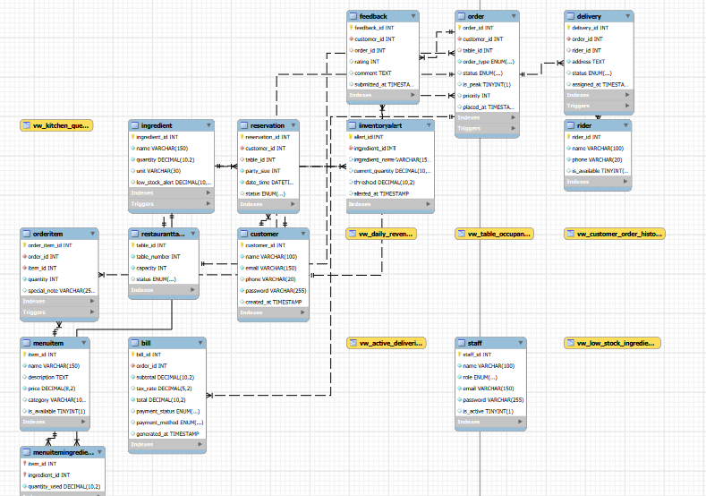

2.2 Tables
Person 1 — Core Entities (Tables 1–5)

Table | Key Columns | Purpose
Customer | customer_id, email, password | Registered users; every order and reservation links back here
Staff | staff_id, role, email | Waiters, chefs, admins — drives role-based access control
Rider | rider_id, is_available | Delivery riders; is_available flag used by AI assign_rider()
MenuItem | item_id, price, category | Single source of truth for the menu
Ingredient | quantity, low_stock_alert | Inventory; triggers deduct stock automatically on order placement

Person 2 — Operations Core (Tables 6–9)

Table | Key Columns | Purpose
MenuItemIngredient | item_id, ingredient_id, quantity_used | Junction table — many-to-many between menu items and ingredients
RestaurantTable | table_number, capacity, status | Physical dining tables; status drives AI table allocation
Reservation | customer_id, table_id, party_size, date_time | Advance bookings; AI assigns table_id via greedy best-fit
Order | order_type, status, priority, is_peak | Central operations table — every bill, delivery, and item references it

Person 3 — Financials & Logistics (Tables 10–14)

Table | Key Columns | Purpose
OrderItem | order_id, item_id, quantity, special_note | Line items inside an order
Delivery | order_id, rider_id, address, status | Delivery logistics; UNIQUE on order_id — one delivery per order
Bill | subtotal, tax_rate, total, payment_status | Auto-generated by trigger when order is served/delivered
Feedback | rating, comment, customer_id, order_id | Customer reviews linked to specific orders
InventoryAlert | ingredient_id, current_quantity, threshold | Audit log of every stock-below-threshold event

2.3 Indexes

Index | Column(s) | Optimises
idx_customer_email | Customer.email | Login — most frequent query, needs O(log n) lookup
idx_staff_email | Staff.email | Staff login lookup
idx_order_status | Order.status | Kitchen dashboard WHERE status = placed
idx_order_priority_status | priority ASC, status (composite) | Kitchen queue ORDER BY two columns — single composite index required
idx_table_status | RestaurantTable.status | AI allocate_table() WHERE status = available
idx_order_placed_at | Order.placed_at | Daily revenue view grouped by date
idx_reservation_datetime | Reservation.date_time | Upcoming reservations sorted chronologically
idx_bill_payment_status | Bill.payment_status | End-of-day unpaid bill collection
idx_order_customer | Order.customer_id | Order history per customer
idx_order_type | Order.order_type | Dine-in vs delivery reporting
idx_menuitem_category | MenuItem.category | Filter menu by category
idx_ingredient_quantity | Ingredient.quantity | Low-stock view query
idx_delivery_order | Delivery.order_id | Delivery lookup by order
idx_delivery_rider | Delivery.rider_id | All deliveries for one rider
idx_feedback_rating | Feedback.rating | Sort/filter reviews by rating
idx_reservation_customer | Reservation.customer_id | Booking history per customer

2.4 Views

View | Description
vw_kitchen_queue | Orders with status placed or preparing, sorted by priority ASC then placed_at ASC. Groups items per order with GROUP_CONCAT. Used by kitchen screen.
vw_low_stock_ingredients | Ingredients where quantity <= low_stock_alert. Includes stock_percentage = (quantity / threshold) x 100.
vw_active_deliveries | Live deliveries (assigned or picked_up). Joins Order, Customer, Rider. Includes minutes_since_assigned via TIMESTAMPDIFF.
vw_customer_order_history | Per-customer aggregates: total orders, total spent, average rating, last order date. LEFT JOIN so customers with no orders appear.
vw_daily_revenue | Daily sales: total orders, dine-in vs delivery split, subtotal, tax, revenue, average order value. Paid bills only.
vw_table_occupancy | All tables with live occupancy: customer name, order_id, occupied_since, minutes_occupied. LEFT JOIN so empty tables show.

2.5 Triggers

Trigger | Fires | Action
trg_generate_bill_after_order_served | AFTER UPDATE on Order | When status changes to served or delivered, calculates subtotal from OrderItems and inserts a Bill row with 10% tax.
trg_deduct_inventory_on_order | AFTER INSERT on OrderItem | Looks up MenuItemIngredient and deducts quantity_used x ordered_quantity from Ingredient.quantity.
trg_prevent_negative_inventory | BEFORE UPDATE on Ingredient | Raises SQLSTATE 45000 if new quantity < 0. Database-level guard — blocks the update even if Python has a bug.
trg_release_table_on_order_complete | AFTER UPDATE on Order | When dine-in order becomes served, sets linked RestaurantTable.status back to available.
trg_free_rider_on_delivery_complete | AFTER UPDATE on Delivery | When delivery becomes delivered, sets Rider.is_available = TRUE for the next assignment.
trg_log_low_stock_alert | AFTER UPDATE on Ingredient | Inserts a row into InventoryAlert when quantity crosses threshold downward. Only fires on the crossing event.

3. Backend — Python Flask API
The backend is a RESTful JSON API built with Flask. All modules use SQLAlchemy ORM over MySQL. JWT tokens are required for all protected routes.

3.1 File Structure

File | Responsibility
db.py | Reads credentials from db.env, builds SQLAlchemy engine, get_db() session generator with try/finally to prevent connection leaks.
models.py | ORM classes for all 14 tables. Relationships with back_populates for Python navigation. uselist=False on Bill and Delivery (one-to-one).
routes/auth.py | POST /register and POST /login. bcrypt password hashing. JWT generation (24-hr expiry). token_required decorator for protected routes.
routes/orders.py | Full order lifecycle: place, list, view, update status, soft-delete. AI priority and inventory deduction integrated atomically.
routes/ai_engine.py | allocate_table(), assign_rider(), prioritize_order(), check_ingredient_availability(), deduct_inventory().
routes/reservations.py | Create, list, update reservations. AI auto-assigns table on creation. Cancellation releases the table.
routes/deliveries.py | Assign rider to delivery orders, update status, manually reassign rider.
routes/menu.py | CRUD for menu items, ingredient stock levels, and low-stock cross-reference report.
routes/tables.py | Live table status with current occupant info, manual status override.

3.2 Authentication
- Passwords hashed with bcrypt.hashpw() using a unique salt — never stored in plaintext.
- Login returns a JWT with user_id, role, and exp (24-hour expiry). Server is fully stateless.
- token_required decorator decodes the Bearer token and injects current_user into protected routes.
- Login failure returns a generic message — never reveals whether email or password was wrong.

3.3 Order Placement — Atomic Transaction Flow
- Validate required fields (customer_id, order_type, items).
- Call check_ingredient_availability() — fail fast with 409 and list of missing ingredients before any DB write.
- Create Order row; call prioritize_order() to set priority and is_peak.
- Insert OrderItem rows (trg_deduct_inventory_on_order fires automatically for each).
- Mark RestaurantTable as occupied for dine-in orders.
- Commit entire transaction — if any step fails, nothing is saved.

3.4 AI Engine

Function | Algorithm
allocate_table(party_size, db) | Greedy best-fit: finds available tables with capacity >= party_size, picks the one minimising (capacity - party_size). Preserves large tables for big groups.
assign_rider(db) | First-available: returns first Rider where is_available = True, marks them unavailable.
prioritize_order(order, db) | Base priority 5. Minus 2 during peak hours (12:00-14:00 or 18:00-21:00). Plus 1 for delivery orders. Lower number = higher urgency.
check_ingredient_availability() | Read-only pre-check. Returns (True, []) if all stock is sufficient, or (False, [missing_list]) to abort the order.
deduct_inventory(items, db) | Iterates MenuItemIngredient, subtracts quantity_used x ordered_quantity per ingredient. Logs alert if threshold is crossed.

4. Frontend
The frontend is four files forming the customer-facing website and ordering interface. All API communication is handled in script.js.

File | Responsibility
home.html | Landing page — hero, about section, menu highlights, reservation form, walk-in queue, testimonials, footer.
index.html | Order page — dine-in/delivery toggle, full menu by category, sticky cart sidebar with totals and confirmation.
script.js | All backend integration: auth modal, login/register, reservation API call, two-step order placement, rider assignment, cart logic, toast notifications.
styles.css | Design system using CSS custom properties (--forest, --gold, --cream). Navigation, hero, cards, cart sidebar, auth modal, toasts, responsive breakpoints.

4.1 Key Technical Points
- BASE_URL = http://127.0.0.1:5000/api — all API calls relative to this constant.
- authFetch() wrapper automatically attaches Authorization: Bearer <token> to every protected request.
- JWT token stored in localStorage for persistence across page navigations.
- Cart stores item_id (database PK) alongside display name and price — required by POST /api/orders/.
- Order placement is two steps: POST /api/orders/ then POST /api/deliveries/assign/<id> for delivery orders only.
- Flask-CORS enabled because HTML files open on file:// and call http://127.0.0.1:5000 (different origin).

5. Work Distribution

Member | Database | Backend Files | Frontend
Person 1 | Tables 1-5, Indexes (email/category/quantity), Views 1-2 (kitchen queue, low stock), Triggers 1-2 (bill, inventory deduct) | db.py, models.py, auth.py | —
Person 2 | Tables 6-9, Indexes (order indexes, table status, reservation date), Views 3-4 (deliveries, customer history), Triggers 3-4 (negative stock, release table) | orders.py, ai_engine.py | —
Person 3 | Tables 10-14, Indexes (delivery/bill/feedback/reservation customer), Views 5-6 (daily revenue, table occupancy), Triggers 5-6 (free rider, log alert) | reservations.py, deliveries.py, menu.py, tables.py | —
Frontend Person | General understanding of full schema | General understanding of API | home.html, index.html, script.js, styles.css

6. Sample Data

6.1 Menu

Item | Price | Category
Mozzarella Sticks | $5.99 | Starters
Nachos | $4.99 | Starters
Stuffed Mushrooms | $6.49 | Starters
Jalapeño Loaded Fries | $7.99 | Starters
Beef Steak | $12.99 | Main Course
Chicken Steak | $14.99 | Main Course
Signature Pizza | $10.99 | Main Course
Alfredo Pasta | $13.49 | Main Course
Club Sandwich | $8.99 | Main Course
Ice Cream | $4.99 | Desserts
Tiramisu | $5.99 | Desserts
Strawberry Cheesecake | $6.49 | Desserts
Lemon Tart | $4.49 | Desserts
Carbonated Drink | $2.99 | Beverages
Iced Latte | $3.49 | Beverages
Iced Mocha | $3.49 | Beverages
Hot Chocolate | $2.49 | Beverages
Cappuccino | $2.99 | Beverages
Dipping Sauces | $1.49 | Extras
Plain Fries | $2.49 | Extras

6.2 Restaurant Tables

Table Number | Capacity
1 | 2
2 | 4
3 | 4
4 | 6
5 | 8
6 | 2
7 | 4

NORMALIZED TABLES:

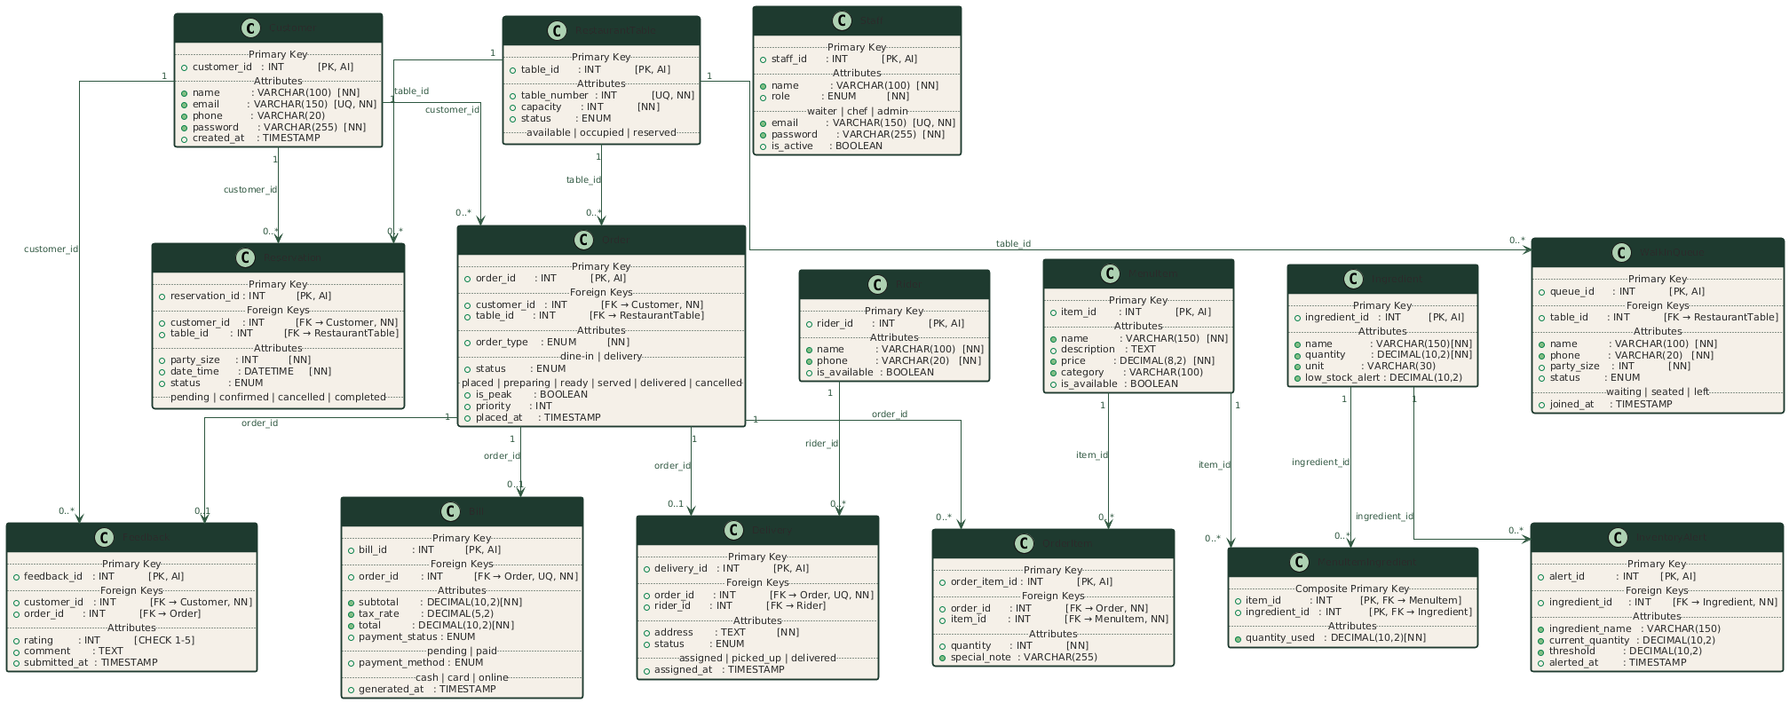

7. Conclusion
DineHub demonstrates the integration of a fully normalised relational database with a modern REST backend and a responsive frontend. Key achievements:
- 14-table MySQL schema normalised to 3NF with InnoDB foreign-key enforcement.
- Six views eliminating repetitive query logic across the application layer.
- Six triggers implementing billing, inventory deduction, stock safety, table release, rider release, and audit logging at the database level.
- Stateless JWT authentication with bcrypt hashing and role-based access control.
- AI algorithms (greedy best-fit allocation, peak-hour prioritisation) running inside atomic transactions.
- Two-page responsive frontend fully integrated with the REST API.

7.1 Potential Enhancements
- Replace first-available rider assignment with proximity-based or rating-based priority queue.
- Add real-time kitchen display updates via WebSockets (Flask-SocketIO).
- Use HttpOnly cookie sessions instead of localStorage for better XSS resistance.
- Extend AI with machine-learning demand forecasting for inventory management.

