INCLUDE Irvine32.inc

.data

menu BYTE 0Dh,0Ah,
'1. Addition 2. Subtraction 3. Multiplication',0Dh,0Ah,
'4. Division 5. Power 6. Factorial',0Dh,0Ah,
'7. Square 8. Cube 9. Percentage',0Dh,0Ah,
'10. Matrix Addition 11. Matrix Multiplication 12. Permutation',0Dh,0Ah,
'13. Combination 14. Trigonometric Functions 0. Exit',0Dh,0Ah,0

msgOpt BYTE "Enter your choice: ",0
msgIn1 BYTE "Enter First number: ",0
msgIn2 BYTE "Enter Second number: ",0
msgArows BYTE "Enter Matrix A Row Size (UPTO 3): ",0
msgBrows BYTE "Enter Matrix B Row Size (UPTO 3): ",0
msgAcols BYTE "Enter Matrix A Column Size (UPTO 3): ",0
msgBcols BYTE "Enter Matrix B Column Size (UPTO 3): ",0
msgCresult BYTE "Resultant Matrix: ",0
msgA BYTE "Enter Matrix A Elements (Row-Wise): ",0
msgB BYTE "Enter Matrix B Elements (Row-Wise): ",0
msgResult BYTE "Answer: ",0
space BYTE " ",0
msgDividend BYTE "Enter dividend: ",0
msgDivisor BYTE "Enter divisor: ",0
msgQuotient BYTE "Quotient: ",0
msgRemainder BYTE "Remainder: ",0
msgError BYTE "Error: Division by zero!",0
invalidMsg BYTE "Matrix multiplication not possible!",0
msgBase BYTE "Enter base: ",0
msgExponent BYTE "Enter exponent: ",0
msgResultPow BYTE "Result: ",0
msgFraction BYTE "Fractional form: ",0
msgDecimal BYTE "Decimal form: ",0
msgOneOver BYTE "1/", 0
msgOne BYTE "1",0
msgNegativeOne BYTE "-1",0
msgOverflow BYTE "Error! Overflow.",0
msgN BYTE "Enter n (total items): ",0
msgR BYTE "Enter r (selected items): ",0
msgResultNPR BYTE "nPr result: ",0
msgResultNCR BYTE "nCr result: ",0
nCrMsg BYTE "nCr result: ",0
msgErrorNPR BYTE "Error: r cannot be greater than n!",0
triMenu BYTE "----- Trigonometric Menu -----",0dh,0ah,
"1. sin(x)",0dh,0ah,
"2. cos(x)",0dh,0ah,
"3. tan(x)",0dh,0ah,
"4. Back to Main Menu",0dh,0ah,
"Enter choice: ",0

angleMsg BYTE "Enter angle in degrees: ",0
perSymb BYTE "%",0

choice DWORD ?
num1 SDWORD ?
num2 SDWORD ?
rowsA DWORD ?
rowsB DWORD ?
colsA DWORD ?
colsB DWORD ?
n_value DWORD ?
r_value DWORD ?
nMINUSr DWORD ?
nfact DWORD ?
rfact DWORD ?
nMINUSrFact DWORD ?
resultNPR DWORD 1
base SDWORD ?
exponent SDWORD ?
temp SDWORD ?
decimalResult REAL8 ?
matrixA SDWORD 9 DUP(0)
matrixB SDWORD 9 DUP(0)
matrixC SDWORD 9 DUP(0)
totalElements DWORD ?
result SDWORD ?
product SDWORD ?
quotient SDWORD ?
remainder SDWORD ?
tempInt DWORD ?
degToRad REAL8 0.017453292519943295
mul_10000 REAL8 10000.0

.code

addProc PROC
mov edx, OFFSET msgIn1
call WriteString
call ReadInt
mov num1, eax

mov edx, OFFSET msgIn2
call WriteString
call ReadInt
mov num2, eax

mov eax, num1
add eax, num2
mov result, eax

mov edx, OFFSET msgResult
call WriteString
mov eax, result
call WriteInt
call Crlf
ret
addProc ENDP

subProc PROC
mov edx, OFFSET msgIn1
call WriteString
call ReadInt
mov num1, eax

mov edx, OFFSET msgIn2
call WriteString
call ReadInt
mov num2, eax

mov eax, num1
sub eax, num2
mov result, eax

mov edx, OFFSET msgResult
call WriteString
mov eax, result
call WriteInt
call Crlf
ret
subProc ENDP

Multiplication PROC
mov edx, OFFSET msgIn1
call WriteString
call ReadInt
mov ebx, eax

mov edx, OFFSET msgIn2
call WriteString
call ReadInt
mov ecx, eax

mov eax, ebx
imul ecx
mov product, eax

mov edx, OFFSET msgResult
call WriteString
call WriteInt
call Crlf
ret
Multiplication ENDP

DivisionOperation PROC

mov edx, OFFSET msgDividend
call WriteString
call ReadInt
mov ebx, eax

mov edx, OFFSET msgDivisor
call WriteString
call ReadInt
mov ecx, eax

cmp ecx, 0
jne PerformDivision

mov edx, OFFSET msgError
call WriteString
call Crlf
ret

PerformDivision:
mov eax, ebx
cdq
idiv ecx

mov quotient, eax
mov remainder, edx

mov edx, OFFSET msgQuotient
call WriteString
mov eax, quotient
call WriteInt
call Crlf

mov edx, OFFSET msgRemainder
call WriteString
mov eax, remainder
call WriteInt
call Crlf

ret
DivisionOperation ENDP

Fact PROC
mov eax, num1 ; load the number for factorial
cmp eax, 0
je FactDone
mov ecx, eax ; counter
mov eax, 1 ; accumulator for result

FactLoop:
imul eax, ecx ; multiply accumulator by counter
loop FactLoop

FactDone:
mov result, eax ; store result
ret
Fact ENDP

sqProc PROC
mov edx, OFFSET msgBase
call WriteString
call ReadInt
mov num1, eax

mov eax, num1
imul eax, eax
mov result, eax

mov edx, OFFSET msgResult
call WriteString
mov eax, result
call WriteDec
call Crlf
ret
sqProc ENDP

CubeProc PROC
push ebp
mov ebp, esp

mov eax, [ebp+8]
mov ebx, eax
mul ebx
mul ebx

mov edx, OFFSET msgResult
call WriteString
call WriteInt
call CrLf
call CrLf

pop ebp
ret 4
CubeProc ENDP

PercentProc PROC
push ebp
mov ebp, esp

mov eax, [ebp+12]
mov ebx, [ebp+8]
mov ecx, 100
xor edx, edx

mul ebx
div ecx

mov edx, OFFSET msgResult
call WriteString
call WriteInt
mov edx, OFFSET perSymb
call WriteString
call CrLf
call CrLf

pop ebp
ret 8
PercentProc ENDP

PowerCalculation PROC
mov edx, OFFSET msgBase
call WriteString
call ReadInt
mov base, eax

mov edx, OFFSET msgExponent
call WriteString
call ReadInt
mov exponent, eax

cmp exponent, 0
jne NotZero
mov eax, 1
jmp DisplayIntegerResult

NotZero:
cmp exponent, 0
jg PositiveExponent

jmp NegativeExponent

PositiveExponent:
mov eax, 1
mov ecx, exponent
mov ebx, base

PosPowLoop:
imul ebx
loop PosPowLoop
jmp DisplayIntegerResult

NegativeExponent:
mov eax, exponent
neg eax
mov ecx, eax
mov ebx, base

; special cases
cmp ebx, 1
je BaseIsOne
cmp ebx, -1
je BaseIsNegOne

mov eax, 1

NegPowLoop:
imul ebx
loop NegPowLoop

mov result, eax

mov edx, OFFSET msgResultPow
call WriteString
call Crlf

mov edx, OFFSET msgFraction
call WriteString

mov edx, OFFSET msgOneOver
call WriteString

mov eax, result
call WriteDec
call Crlf
jmp Done

BaseIsOne:
mov eax, 1
jmp DisplayIntegerResult

BaseIsNegOne:
mov eax, exponent
test eax, 1
jz EvenExp
mov eax, -1
jmp DisplayIntegerResult

EvenExp:
mov eax, 1
jmp DisplayIntegerResult

DisplayIntegerResult:
mov result, eax
mov edx, OFFSET msgResultPow
call WriteString
call WriteInt
call Crlf
jmp Done

Done:
ret
PowerCalculation ENDP

PermutationCalculation PROC
mov edx, OFFSET msgN
call WriteString
call ReadInt
mov n_value, eax

mov edx, OFFSET msgR
call WriteString
call ReadInt
mov r_value, eax

cmp eax, n_value
ja PermError

mov eax, n_value
mov num1, eax
call Fact
mov ebx, result

mov eax, n_value
sub eax, r_value
mov num1, eax
call Fact
mov ecx, result

mov eax, ebx
xor edx, edx
div ecx
mov resultNPR, eax

mov edx, OFFSET msgResultNPR
call WriteString
mov eax, resultNPR
call WriteDec
call Crlf

ret

PermError:
mov edx, OFFSET msgErrorNPR
call WriteString
call Crlf
ret

PermutationCalculation ENDP

CombinationCalculation PROC
mov edx, OFFSET msgN
call WriteString
call ReadInt
mov n_value, eax

mov edx, OFFSET msgR
call WriteString
call ReadInt
mov r_value, eax

; Validate r <= n
mov eax, r_value
cmp eax, n_value
jle ContinueCalc

mov edx, OFFSET msgErrorNPR
call WriteString
call Crlf
ret

ContinueCalc:
; ---------- Calculate n! ----------
mov eax, n_value
mov num1, eax
call Fact
mov eax, result
mov nfact, eax ; store n!

mov eax, r_value
mov num1, eax
call Fact
mov eax, result
mov rfact, eax

mov eax, n_value
sub eax, r_value
mov nMINUSr, eax
mov num1, eax
call Fact
mov eax, result
mov nMINUSrFact, eax

mov eax, rfact
imul nMINUSrFact
mov ecx, eax

mov eax, nfact
xor edx, edx
div ecx
mov resultNPR, eax

mov edx, OFFSET msgResultNCR
call WriteString
mov eax, resultNPR
call WriteDec
call Crlf

ret
CombinationCalculation ENDP

MatrixAddition PROC
mov edx, OFFSET msgArows
call WriteString
call ReadInt
mov rowsA, eax

mov edx, OFFSET msgAcols
call WriteString
call ReadInt
mov colsA, eax

mov eax, rowsA
mul colsA
mov totalElements, eax

mov edx, OFFSET msgA
call WriteString
call Crlf
mov esi, OFFSET matrixA
mov ecx, totalElements

ReadA:
call ReadInt
mov [esi], eax
add esi, 4
loop ReadA

mov edx, OFFSET msgB
call WriteString
call Crlf
mov esi, OFFSET matrixB
mov ecx, totalElements

ReadB:
call ReadInt
mov [esi], eax
add esi, 4
loop ReadB

mov esi, OFFSET matrixA
mov edi, OFFSET matrixB
mov ebx, OFFSET matrixC
mov ecx, totalElements

AddLoop:
mov eax, [esi]
add eax, [edi]
mov [ebx], eax
add esi, 4
add edi, 4
add ebx, 4
loop AddLoop

mov edx, OFFSET msgCresult
call WriteString
call Crlf

mov ecx, rowsA
mov ebx, 0
mov esi, OFFSET matrixC

PrintRows:
cmp ebx, rowsA
jge EndPrintRows
mov ecx, colsA
mov edi, 0

PrintCols:
cmp edi, colsA
jge NextRow
mov eax, [esi]
call WriteInt
mov edx, OFFSET space
call WriteString
add esi, 4
inc edi
jmp PrintCols

NextRow:
call Crlf
inc ebx
jmp PrintRows

EndPrintRows:
ret

MatrixAddition ENDP

matrixMulProc PROC
mov edx, OFFSET msgArows
call WriteString
call ReadInt
mov rowsA, eax

mov edx, OFFSET msgAcols
call WriteString
call ReadInt
mov colsA, eax

mov edx, OFFSET msgBrows
call WriteString
call ReadInt
mov rowsB, eax

mov edx, OFFSET msgBcols
call WriteString
call ReadInt
mov colsB, eax

mov eax, colsA
cmp eax, rowsB
jne invalidMul

mov ecx, 9
mov edi, OFFSET matrixC
xor eax, eax

zeroLoop:
mov [edi], eax
add edi, 4
loop zeroLoop

mov edx, OFFSET msgA
call WriteString
mov esi, OFFSET matrixA
mov ecx, rowsA

readARows:
push ecx
mov ecx, colsA

readACols:
call ReadInt
mov [esi], eax
add esi, 4
loop readACols
pop ecx
loop readARows

mov edx, OFFSET msgB
call WriteString
mov esi, OFFSET matrixB
mov ecx, rowsB

readBRows:
push ecx
mov ecx, colsB

readBCols:
call ReadInt
mov [esi], eax
add esi, 4
loop readBCols
pop ecx
loop readBRows

; multiply
mov eax,0
xor edi, edi
mov ebx,0
iLoop:
cmp ebx, rowsA
jge doneMul
mov ecx,0
jLoop:
cmp ecx, colsB
jge nextI
xor edx, edx
mov esi,0
kLoop:
cmp esi, colsA
jge storeC

mov eax, ebx
imul eax, colsA
add eax, esi
mov eax, [matrixA + eax*4]

mov edi, esi
imul edi, colsB
add edi, ecx
mov edi, [matrixB + edi*4]
imul eax, edi
add edx, eax
inc esi
jmp kLoop
storeC:
mov eax, ebx
imul eax, colsB
add eax, ecx
mov [matrixC + eax*4], edx
inc ecx
jmp jLoop
nextI:
inc ebx
jmp iLoop
doneMul:
; print result
mov edx, OFFSET msgCresult
call WriteString
call Crlf
mov ebx,0
printRows:
cmp ebx, rowsA
jge endPrint
mov ecx,0
printCols:
cmp ecx, colsB
jge nextPrintRow
mov eax, ebx
imul eax, colsB
add eax, ecx
mov eax, [matrixC + eax*4]
call WriteInt
mov edx, OFFSET space
call WriteString
inc ecx
jmp printCols
nextPrintRow:
call Crlf
inc ebx
jmp printRows
endPrint:
ret
invalidMul:
mov edx, OFFSET invalidMsg
call WriteString
call Crlf
ret
matrixMulProc ENDP

TrigonometricCalculation PROC

tri_loop:
mov edx, OFFSET triMenu
call WriteString
call ReadInt
mov ebx, eax

cmp ebx, 1
je do_sin
cmp ebx, 2
je do_cos
cmp ebx, 3
je do_tan
cmp ebx, 4
je tri_done
jmp tri_loop

do_sin:
call ReadAngleToST0
fsin
call PrintFixedFloat
jmp tri_loop

do_cos:
call ReadAngleToST0
fcos
call PrintFixedFloat
jmp tri_loop

do_tan:
call ReadAngleToST0
fptan
fstp st(0)
call PrintFixedFloat
jmp tri_loop

tri_done:
ret
TrigonometricCalculation ENDP

ReadAngleToST0 PROC
mov edx, OFFSET angleMsg
call WriteString
call ReadFloat

fld degToRad
fmulp st(1), st(0)
ret
ReadAngleToST0 ENDP

PrintFixedFloat PROC
mov edx, OFFSET msgResult
call WriteString

fld mul_10000
fmulp st(1), st(0)

fistp tempInt

mov eax, tempInt
mov ebx, 10000
xor edx, edx
div ebx

call WriteDec
mov al, '.'
call WriteChar

mov eax, edx
mov ecx, 4

print_frac:
mov ebx, 10
xor edx, edx
div ebx
push dx
loop print_frac

mov ecx, 4
print_digits:
pop dx
add dl, '0'
mov al, dl
call WriteChar
loop print_digits

call CrLf
call CrLf
ret
PrintFixedFloat ENDP

exitProg PROC
exit
exitProg ENDP

main PROC
mainMenu:
mov edx, OFFSET menu
call WriteString

mov edx, OFFSET msgOpt
call WriteString
call ReadInt
mov choice, eax

cmp choice, 0
JE exitProg

cmp choice, 1
JE doAdd

cmp choice, 2
JE doSub

cmp choice, 3
JE doMul

cmp eax, 4
JE doDivision

cmp eax, 5
JE doPower

cmp eax, 6
JE doFactorial

cmp choice, 7
JE doSquare

cmp eax, 8
je doCube

cmp eax, 9
je doPercentage

cmp choice, 10
JE doMatrixAdd

cmp choice, 11
JE doMatrixMul

cmp choice, 12
JE doPermutation

cmp choice, 13
JE doCombination

cmp choice, 14
JE doTrig

jmp mainMenu

doAdd:
call addProc
jmp mainMenu

doSub:
call subProc
jmp mainMenu

doMul:
call Multiplication
jmp mainMenu

doDivision:
call DivisionOperation
jmp mainMenu

doFactorial:
mov edx, OFFSET msgBase
call WriteString
call ReadInt
mov num1, eax
call Fact
mov eax, result
mov edx, OFFSET msgResult
call WriteString
call WriteDec
call Crlf
jmp mainMenu

doSquare:
call sqProc
jmp mainMenu

doCube:
mov edx, OFFSET msgBase
call WriteString
call ReadInt
push eax
call CubeProc
jmp mainMenu

doPercentage:
mov edx, OFFSET msgIn1
call WriteString
call ReadInt
mov ebx, eax

mov edx, OFFSET msgIn2
call WriteString
call ReadInt

push ebx
push eax
call PercentProc
jmp mainMenu

doPower:
call PowerCalculation
jmp mainMenu

doMatrixMul:
call matrixMulProc
jmp mainMenu

doMatrixAdd:
call MatrixAddition
jmp mainMenu

doPermutation:
call PermutationCalculation
jmp mainMenu

doCombination:
call CombinationCalculation
jmp mainMenu

doTrig:
call TrigonometricCalculation
jmp mainMenu

main ENDP
END main

OUTPUTS:
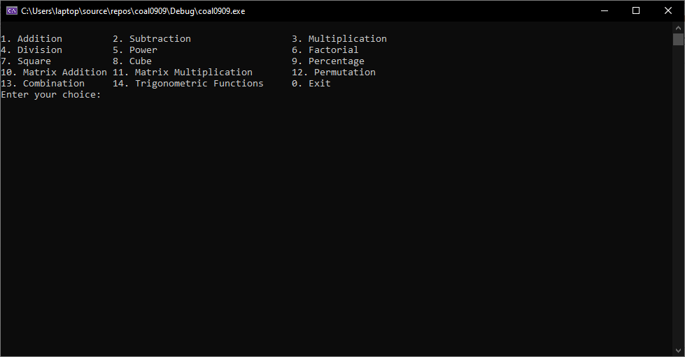

- ADDITION:
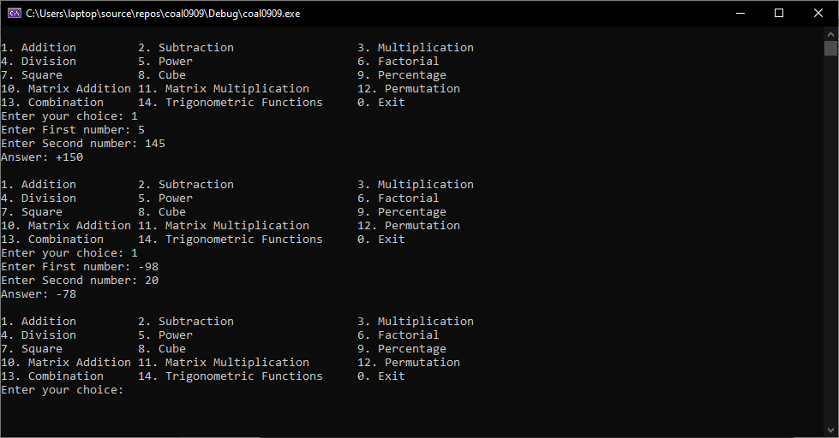

- SUBTRACTION:

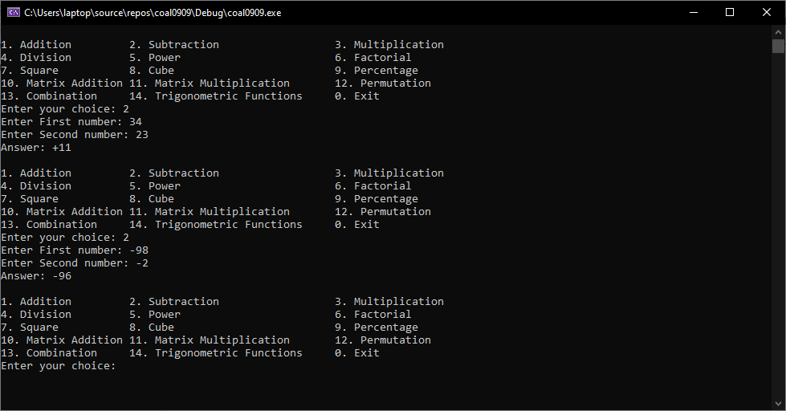

- MULTIPLICATION:
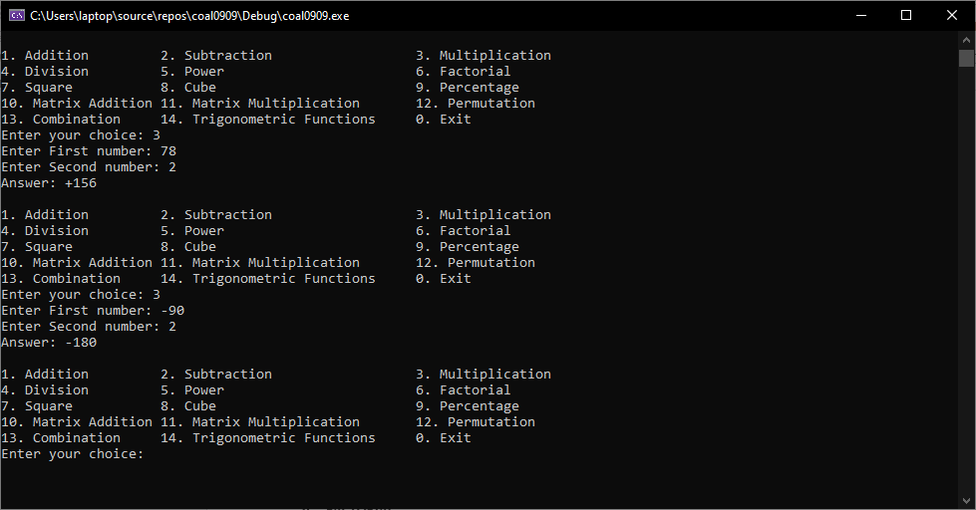
- DIVISON
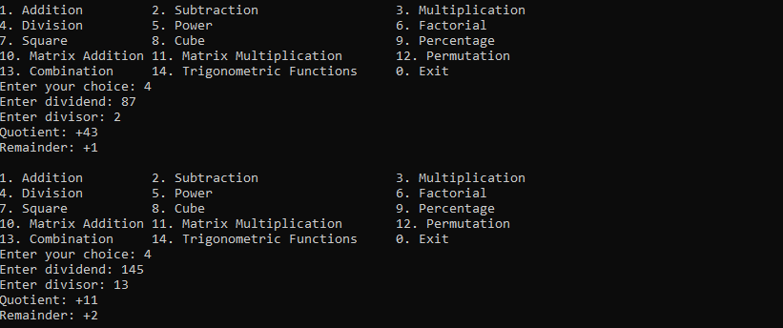
- POWER
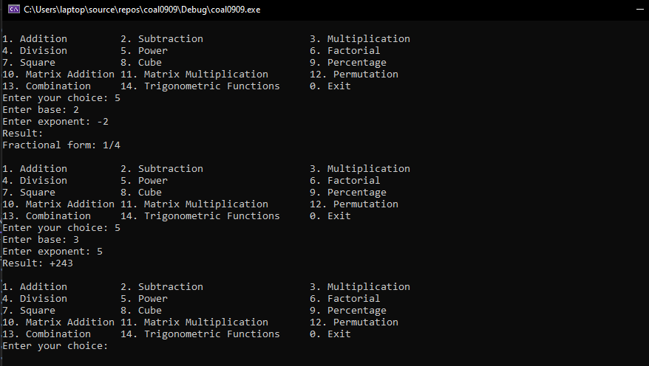
- FACTORIAL
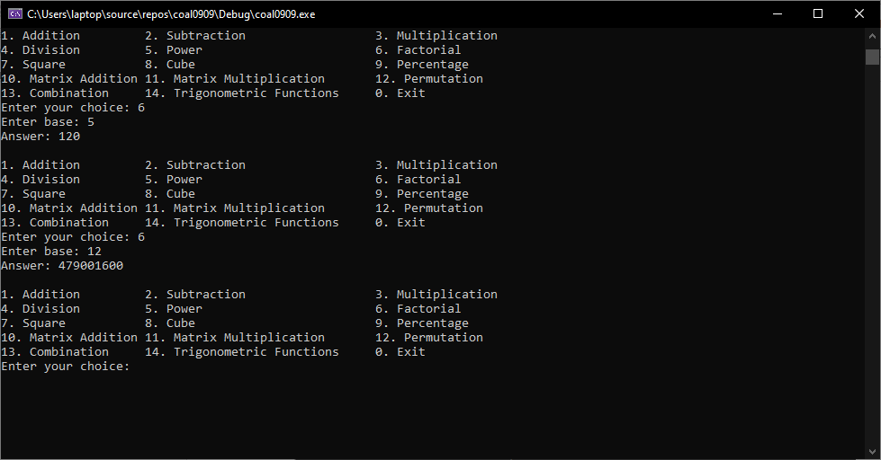
- SQUARE
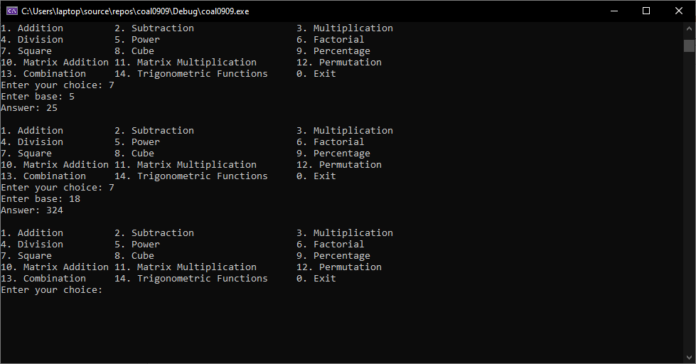
- CUBE
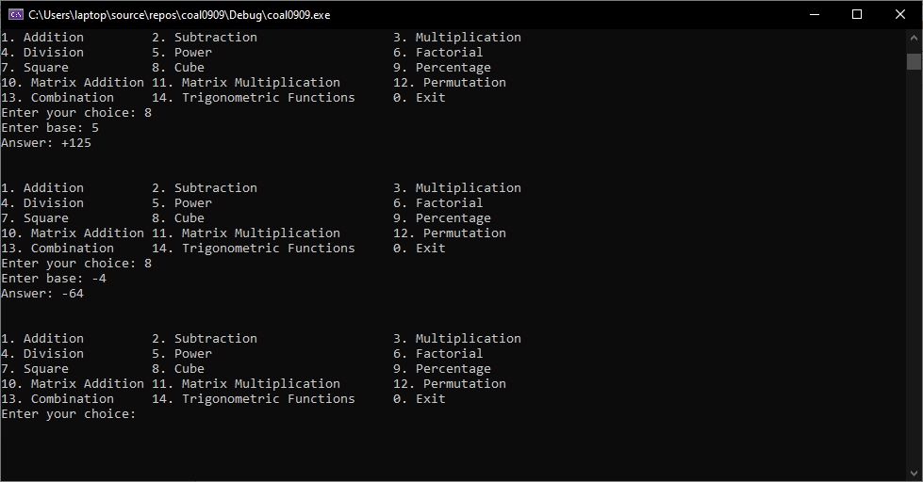
- PERCENTAGE
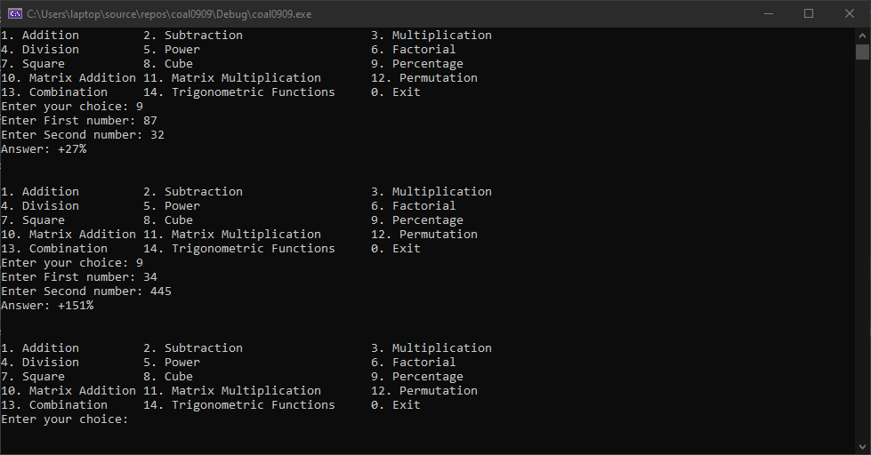
- MATRIX ADDITION
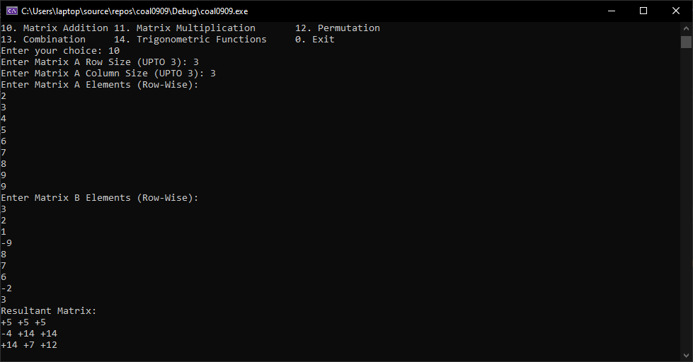
- MATRIX MULTIPLICATION
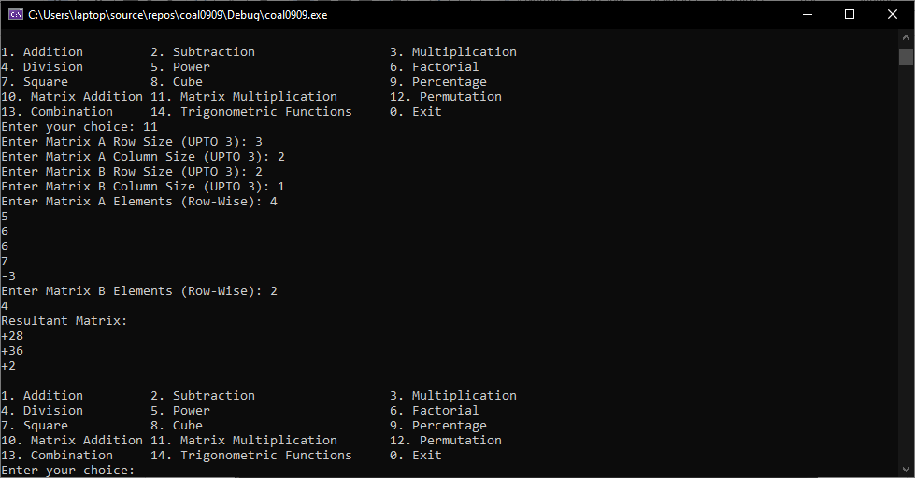
- PERMUTATION
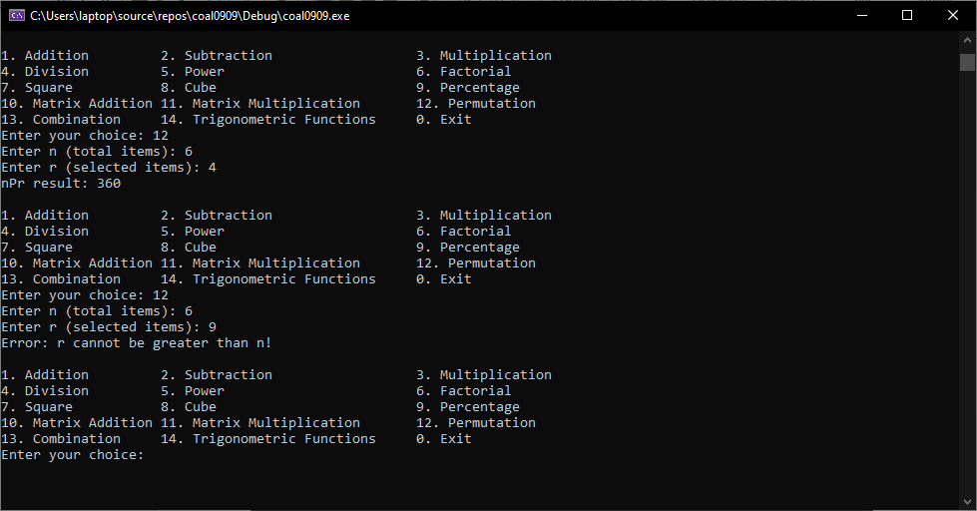
- COMBINATION
- TRIGNOMETRIC FUCNTIONS
