1. Basic Concepts
1.1 What is a Program?
Believe it or not, you've programmed before! When? Every time you've given instructions of some sort. If you've ever given someone directions, you've programmed before. If you've ever told someone how to make toast or boil the kettle, or how to feed the dog or make a phone call, then you've programmed before.
This is because a program is simply a set or sequence of instructions on how to perform a particular task.
If you are telling someone how to boil water in the kettle, to use one of our examples, you are "programming" because you are giving them a sequence of instructions on how to perform the task of boiling water in the kettle:
1.) Fill the kettle with water
2.) Plug the kettle in
3.) Switch the kettle on
4.) Wait for water to boil
Exercise: Can you think of how to make these instructions more precise? What if the kettle is already full of water?
1.2 Okay, but what is a Computer Program?
Similarly, a computer program is a set or sequence of instructions telling the computer how to perform a particular task.
In most cases, this task involves doing something to input data (information that we give the program) in order to produce output data (information that the program gives us)
input --> program --> output
We can imagine a basic program that subtracts one given number from another. This program consists of only two instructions, namely:
1.) Ask for two numbers, x and y
2.) Subtract Number y from Number x
or rather:
1.) Input two numbers, x and y
2.) x - y

Let's think a bit about this program.
- What input does this program need?
Our program needs two numbers as input. 5 and 3, 2 and 1.0, 100 000 000 and 7.5, and 0.125 and 57 are all examples of satisfactory input.
It is important to realise that the program determines what input is satisfactory, and what input will cause error. With our subtraction program, if we give something like "pineapple" or "B" as input, it will cause error. After all, what does it mean to subtract "pineapple" from "B"?
- What does it do with this input (what task does it perform)?
Our program subtracts one given number from another. If we want to perform a different task - to add two numbers together, say - we would have to write a new program, like this:
1.) Input numbers x and y
2.) x + y
- What output does this program produce?
Our original program gives us the difference between the two numbers we gave as input.
Again, if we want our program to produce a different output (the sum of two numbers, for example), we would have to write a new program. We cannot change how the program works (what task it performs) just by giving it different input.
Technically speaking...
The instructions that we give a computer fall into two groups: expressions and statements.
Expressions are instructions that produce a result. For example, the instruction
2 times 5
is an expression because carrying out this instruction produces a result: 10. We say that this expression has a value (of 10). Expressions – or rather the values that they have – are useful in our programs because they give the program more data to work with.
Did you notice? In our program example, instruction (2.) is an expression, since it produces the difference of the two numbers x and y.
In a program, expressions can be combined with other expressions, to form complex expressions. We combine expressions using operators like sum (+), difference (-), product (*), quotient (/), and so on. An example of a complex expression would be
[(2 + 3.5) / 8] * 25
Exercise: Can you break this complex expression into its step-by-step single expressions?
Statements, on the other hand, are instructions that do not produce any result.
For example, the instruction
Display the word "Hello" on the screen
does not produce any result; it simply shows the word "Hello" on our computer screen. No further data or information is produced when this instruction is carried out.

2. Getting Started with Python
Python is a programming language. A programming language is any language that we use to give the computer instructions.
2.1 Starting IDLE
To get started with Python, we shall use a program called IDLE.
- On the Desktop, you will see a link called "Python"
- To open the Python interpreter, click on Run > Python Shell
- This should bring up the Python Shell, which looks something like this:
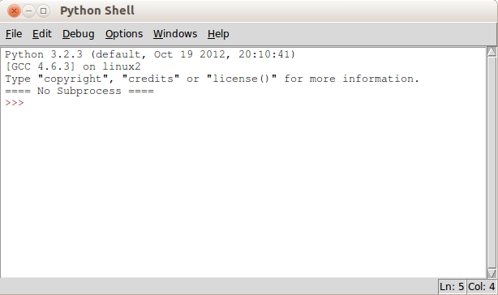
The Python shell is a bit like a calculator. You can enter Python expressions and see their results immediately. Try it now! Use the Python shell to add two numbers together:
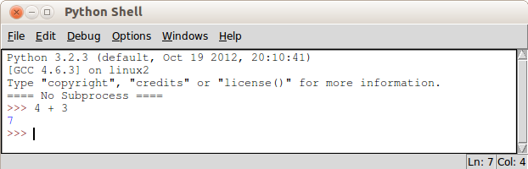
2.2 More than a Simple Calculator
If I told you that x = 5 and y = 7, and asked you to give me the sum of x and y, I'm sure you would know what to do. The Python shell is the same! Look at what happens if we type in x = 5 and y = 7, and then type in x + y:
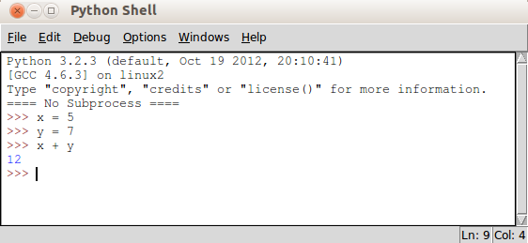
We can also type in longer expressions, for example a = 3 – 1. Try it!
When we tell Python that x = 5, what we are doing is assigning the value 5 to the variable called x. In programming, a variable is a kind of placeholder for a value. We can easily change the value of a variable. Type the following into the Python shell and see what happens:
a = 5
a = 7
b = 2
a + b
The shell returns 9. This means that, when Python calculates a + b, it takes the new value of a, which is 7, and not its old value of 5. This is important. When we change the value of a variable, its old value falls away.
We shall return to variables and assignment in section chapter five.

Did you know? Variable names do not have to be single letters like x or a or b. For example, the following assignment statements are perfectly valid:
name = "Richard"
animal = "dog"
number_of_chairs = 57
asdf = "What?"
2.3 Running a Saved Python Script
The Python shell is fun for trying out quick calculations or simple one- or two-line programs. Still, we have to keep re-entering our program's instructions every time we want to run it.
Instead, we can save our program's instructions in a text file. Let's write our first .py file!
- From the Python Shell, click File > New Window
- Then click File > Save
- Navigate to /home/{username}/Desktop
- Save the file as hello.py
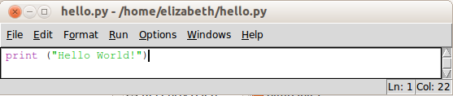
- Type in the following:
- Press F5 or click Run > Run Module
Congratulations! You've just written and run your first Python program!
2.3.1 print()
Remember our earlier x + y program? Let's save those instructions to file. Open a New Window and save it as sum.py
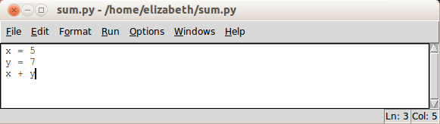
Now, it would be reasonable of us to expect that, if we ran sum.py we would get the same result as before. Python would give us the answer (12). Let's try it. Press F5 or click Run > Run Module to run the program.
What happens?
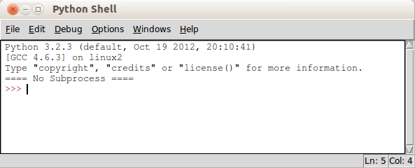
What, no output? Nothing?!
Why did it work before? It worked before because we were typing into the shell itself. When we use the shell to run a Python program (a .py file) things are slightly different.
Here, the difference is that we must explicitly tell the computer to output the result of our x + y program. We must instruct the computer to show us the answer to x + y.
How do we tell the computer to output something? We can do this with a print statement. If you remember, we used one in our Hello World program (hello.py).
Let's modify the code in our sum.py file so that it looks like this:
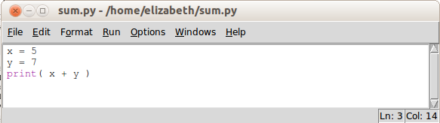
And phew! It works!
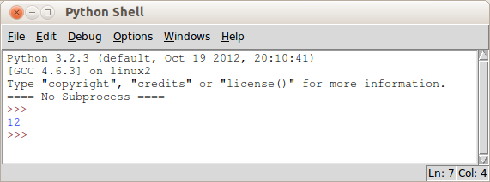
We'll come back to this useful print statement in the next section chapter.
2.4 Two More Things...
There are two quick things for us to note at this point. The first is comments and the second is case sensitivity.
Comments are text that we can put into our program files. We can think of comments as little notes to explain our code and to make it easier for us to understand.
In Python, a comment is any text that starts with a hash symbol: # Therefore, any line that begins with a # will never be run as code.
Here is an example of a program with comments:
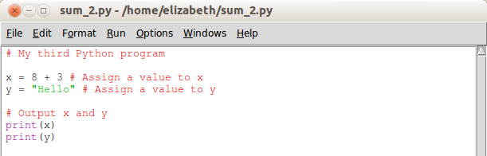
Comments are very useful for making our code more readable to other programmers (and to ourselves). It is a good habit to use comments in our programs.
The second thing to note is that Python is case sensitive. This means that "A" and "a", and "x" and "X", are different things in Python. To illustrate, try out this program:
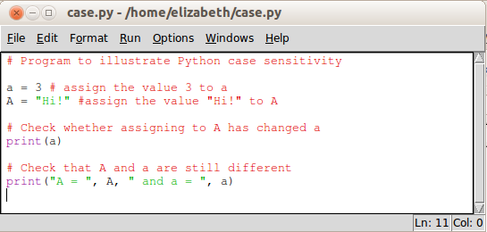
What output does this program produce?
2.5 Exercises
- Start the Python shell
- Use the interpreter to calculate a few simple sums
- Write the Hello World program
- Write a program to add two numbers
- Write your own program that prints out your name
- Look at the following lines of code:
a = 9
b = 3
a/b
6 a.) What is the output if these lines are entered into the Python shell (interpreter)?
6 b.) What is the output if these lines are run from a .py file?
6 c.) Add another line of code to your .py file from (b.) so that it now shows us the output like it did when we entered it into the shell.
3. Strings and Basic Output
3.1 The print() statement
In the previous section, we used print() to display our programs' output on the computer screen. Let's take a closer look at the print statement.
In the Python shell, type the following:
print(1)
print(173 + 92)
print("hello")
Notice that, rather than printing 173 + 92, the print statement outputs 265. That is, the print statement shows us the value of the expression inside its brackets.
But what if we wanted to output 173 + 92?
One way we could do this is to put 173 + 93 inside quotation marks, like so: print("173 + 92"). In programming, we call this kind of value a string.
What is a string?
A 'string' is, quite literally, a string of characters. The string "hello", for example, is a string of the characters "h", "e", "l", "l", and "o". The string "173 + 92" is a string of the characters "1", "7", "3", " ", "+", " ", "9", and "2" (notice the spaces!)
What really matters when we're dealing with strings is that they must be enclosed in quotation marks. Try out the following:
print("173 + 92")
print(173 + 92)
print("hello")
print(hello)
If we print 173 + 92 without quotation marks, we get 265 instead of 173 + 92. If we print hello without quotation marks, we get an error.
Another way we could output 173 + 92 instead of 265 is to use commas, like this print(173, "+", 93). In other words, the print statement can output multiple separate values provided these values are separated by a comma. Type out the following in the shell:
print("Jane has", 7, "apples")
print(5, "plus", 3, "is", 5 + 3)
These examples show us that:
(1.) We can output the values of many expressions using a single print statement, as long as we put a comma between the expressions
(2.) The print statement automatically puts a single space between the expressions we give it
Using print() with multiple, comma-separated values can be very useful. To see why this is, consider the following two programs:
Program A
print("Hello, my name is Benji")
print("Benji is my name")
Program B
name = "Benji"
print("Hello, my name is", name)
print(name, "is my name")
In both cases, the output we get is the same
Hello, my name is Benji
Benji is my name
However, program B is preferable. Think about it: if we want to change the name from Benji to another name, in program A we need to change both print statements:
print("Hello, my name is Georgie")
print("Georgie is my name")
In program B, however, we only need to change one line:
name = "Georgie"
Try out the following in the Python shell:
print("I'm learning Python!")

lang = "Python"
print("I'm learning", lang, "!")

print("Jane has 7 apples")

a = 7
print("Jane has", a, "apples")

print("Jane has 7 + 3 apples")

a = 7 + 3
print("Jane has", a, "apples")
Let's look at another feature of the print statement. Type out the following in the shell:
print("This is on one line")
print("And this is on the next line!")
This shows us that the Python print statement ends on the next line.This is clearly illustrated by an empty print statement:
print("An empty print statement...")
print()
print("...means a blank line!")
One way to stop Python from ending a print statement with a new line is to put end="" just before the closing bracket, like so:
print("This is on one line", end="" )
print("And this is on the SAME line!")
Remember the comma!
3.4 Strings continued...
As we mentioned, Python treats things wrapped in quotation marks as strings. Either double quotation marks " " or single quotation marks ' ' can be used.
3.4.1 Multi-line Strings
All of our strings so far have been one-line strings. Sometimes however we might want to break our string across two or more lines, as in this poem by Lewis Carroll:
Twinkle, twinkle, little bat!
How I wonder what you're at!
Up above the world you fly,
Like a tea tray in the sky.
As such we might prefer a multi-line string. We can form a multi-line string by using triple quotation marks, meaning three double or three single quotation marks to indicate the beginning and the end of the string. For example:
"""This is an
example of a multi-line
string!"""
If we do not use triple quotation marks in this case, we will get an error. Try it and see.
3.4.2 Escape characters
Another way that we can display strings across multiple lines is like so:
"This is an\n example of a multi-line\n string!"
If you print out the above string, you'll notice that the \n does not appear in the output. This is because \n is an escape character. I get a funny Y character, not a back-slash
An escape character is something that we include within a string (within its opening and closing quotation marks) that tells Python how we want it to display the string.
There are many kinds of escape characters. Try out the following:
\t \b \\ \" or \'
e.g.) print("What does test\ttest do?")
3.5 Exercises
HINT ! Is your program not working? Here are two things to check:
1.) Have you put quotation marks around your strings?
2.) Have you closed the parentheses (round brackets) of your print statement?
1.) In the Python shell, do the following:
a.) Print your first name
b.) Print your surname (family name)
c.) Print your first name followed by a space followed by your surname
d.) Create a variable called firstname (Note: no space!) and assign it the value of your first name into it
e.) Create a variable called surname and put your surname into it
f.) Using only the variables you have created, print your first name and surname again, making sure there is exactly one space between your two names
2.) Consider the following code:
print("Much madness is divinest sense,")
print("To a discerning eye;")
print("Much sense the starkest madness")
print("'T is the majority", "In this, as all, prevails")
print("Assent, and you are sane;")
print("Demur, – you're straightaway dangerous",end="")
print()
print("And handled with a chain")
Write out the exact output of the above code, indicating spaces with underscores
3.) Write a program that outputs your favourite piece of poetry, movie quotation, or other prose, over multiple lines
4.) Bonus question: Write a program that outputs your name, age, and height in the following format:
My name is Anne, I am 29 years old and 1.67 metres tall.
NB: Make sure that your age and height are saved as numbers and not simply part of your string
5.) Explain three possible ways to print a string containing an apostrophe, for example the string "the cat's mat"
4. Basic Input
So far, our programs have been quite uninteresting. They consistently produce the same output (give the same results) because they consistently act on the same input.
This is because our input values have been set directly in our programs. In our programs, we have specified, say, that x = 7 or that name = "Benji". When input values are fixed in this way, we say that they are hard-coded.
What if, rather than hard-coding our input values, we could tell our program to get input from somewhere? The simplest place for a program to get input is the keyboard, in the form of text entered by the user.
4.1 input()
In Python, the input statement allows us to get input from the keyboard. Type the following into the Python shell - remembering the quotation marks!:
input("What is your name?")
What happens? Python asks you for your name! Type it in.
But now what? In order to do something with this keyboard input, we need some way to store or remember it so that we can use it later. We can do this with an assignment statement:
name = input("What is your name?")
Here we are assigning the input we get from the keyboard – your name, in this example – to the variable name. Let's check if Python has remembered our name:
print(name)
And voilà! It has.
4.1.1 input() and numbers
Now let's get some numerical input from the user:
age = input("How old are you?")
This asks the user to enter their age. Let's print how old they'll be next year.
print("Next year you'll be", age + 1)
Oh dear! We get an error. This is because Python treats all input as strings. Not to worry, though; we must simply tell Python that this particular input is a number and not a string. We do this like so (note the double closing brackets at the end):
age = int(input("How old are you?"))
Now we can try our print statement again:
print("Next year you'll be", age + 1)
And yay! It works.
By using int() we are casting our input value as a whole number. The int stands for "integer" (a whole number). 3, 57, 1000100 are all integers. For a decimal point number like 0.125 or 57.3 we would use the word float instead of int, like this:
height = float(input("How tall are you in metres?"))

Introducing Functions
You might notice that the input statement is similar to the print statement. Both use parentheses (brackets) in the same way, and both require "quotation marks" around their text. This is because input() and print() are functions.
In programming, a function is a defined set of instructions that performs a particular task. As we know, the print function performs the task of showing output on the screen. The input function performs the task of getting user input.
When we type statements like print("Hello World") or print(), we say that we are calling the print function. Calling a function executes its particular set of instructions.
This will become clearer in section 10, where we write our own functions.
4.2 Exercises
1. a.) Write a program that asks the user for their name and assigns it to the variable username
1. b.) Using the print statement, output “Hello” followed by the user's name
1. c.) Write a program that asks the user for their age and assigns it to the variable age. Remember to use int(input())!
1. d.) Using the print statement, output “Your current age is” followed by the user's age
2. a.) Using the input statement, write a program that prompts (asks) the user for a number and assigns that number to the variable z. Remember, to assign a value to a variable, use the following format: z = …
2. b.) Modify your program so that it outputs z
2. c.) Modify your program so that it outputs z + 1
2. d.) Does your program work as expected? If not, why not? Hint: remember int()!
3. a.) Write a program that asks the user to enter two numbers and prints the sum of those two numbers. Hint: use two input statements and two variables
3. b.) Write a program that asks the user to enter three numbers and prints the sum of those numbers.
3.c) Write a program that asks the user to enter two numbers and prints the product of those two numbers.
4.a) Bonus question: Write a program that converts temperatures from Farenheit (F) to Celcius (C). Ask the user for a temperature in Farenheit and output the Celcius result. Note: 1º F = 9/5 * (1º C + 32). Hint: remember float(input())!
4.b) Bonus question: Write a program that converts distance in miles to kilometres. Ask the user for a distance in miles and output the distance in kilometres. Note: 1km = ~0.62 miles. Hint: remember float(input())!
4.c) Double bonus question: Write a program that asks the user for some text and a number. Then, output the text a number of times equal to the number the user entered. For example, if the user enters "Hello" and 3, your output should be HelloHelloHello. Hint: have a look at section 5.2.2
5. Variables, Assignment and Operators
In the last sections, we have spoken a bit about variables and assignment statements. Here we are assigning the value 56.8 to the variable x:
x = 56.8
The following is another example of an assignment statement:
greeting = "Hello World"
Here, we are assigning the value "Hello World" to a variable called greeting. We have also used an assignment statement to save user input:
name = input("Please enter your name: ")
These examples give us some idea of how assignment statements and variables work. Let's step it up a bit. Can you guess what the following will do?:
name = "James"
name = "Jimbo"
Here we assigned "James" to the variable name, and then assigned "Jimbo" to the same variable name. Let's print name to see what its value is:
print(name)
As we see, the value of name is "Jimbo" and not "James". In fact, "James" has disappeared! This is because assigning a new value to a variable will destroy the previous value of that variable.
We can think of a variable as a kind of 'box' that can only hold one item or value at a time. In our example, we first put "James" into the box. If we then want to put "Jimbo" into the box, before we can do this we must take "James" out.
Visually, when we assign the value "James" to name, we are 'putting' the value "James" into box name:
name = "James" name
"James"
When we later assign the value "Jimbo" to name, we must first 'take out' the value "James" from box name. Only then can we 'put' the value "Jimbo" into box name.
name = "Jimbo" name → name → name
"James" "James" "Jimbo"
Box name now holds the value "Jimbo".
With this in mind, try to guess what the following would produce:
greet = "Hi!"
greet = "Hello"
print(greet)

a = 2
a = 2 + 1
print(a)
Still, is there any way we can assign a new value to a variable but somehow keep the old value? Have a think about the following lines of code:
x = 6
y = x
x = "Hello"
print(x)
print(y)
print("x =", x, "and y =", y)
Here, we have assigned the new value "Hello" to the variable x AND we have managed to keep its old value, 6. Let's look at this step-by-step:
1.) x = 6
We create a new variable, called x, and assign it the value of 6
2.) y = x
We create another new variable, this time called y, and assign it a value of... well what exactly? In programming, variables are taken to be their current values. So x is considered to be 6, as this is its current value. Assigning y the value of x, in this case, assigns y the value of 6.
3.) x = "Hello"
We assign a new value to x.
4.) print("x =", x, "and y =", y)
Here we output the current values of x and y.
Step (2.) is the important step. Here we assign x's current value to a new variable y. This allows us to assign a new value ("Hello") to variable x without losing the old value (6).
5.1 Incrementing variables
Let's look at one more trick with variables. Consider the following:
x = 1
x = x + 1
What is happening here? Well, we are assigning a new value to x. More than this, the new value that we are assigning to x is the old value of x increased by 1. In programming terms, we have increased, or incremented, the value of x by 1.
Incrementing variables is very useful for loops, which we'll get to in a later chapter. For now, type the following into the Python shell:
x = 0
print(x)
x = x + 1
print(x)
x = x + 1
print(x)
x = x + 1
print(x)
Can you see a pattern? Most often, we use incrementation used like this: as a counter. You may have noticed this behaviour in the code above. Each time, x is getting bigger by 1.
Try out these in place of x = x + 1:
x = x + 2
x = x + 5
x = x - 1
In this last example, x = x – 1, we are decreasing the value of x. In programming lingo, we say that we are decrementing x. When we decrement variables, their value gets smaller. We use this if we need to count backwards.
Shorthand for incrementation
Incrementating (and decrementing) variables is very common in programming. For this reason, Python gives us a short way to express incrementation. Instead of writing x = x + 1, we can instead write x += 1. These two statements are equivalent. It is the same for decrementing variables. Instead of x = x – 1, we can write x –= 1
5.2 Operators
Of course, it is not enough to just assign values to variables. We want to do things to these values. For interesting programs, we want to manipulate and change values in our programs. We can do this using the various operators in Python.
5.2.1 Mathematical Operators
To change number values in Python, we can use addition (+), subtraction (-), multiplication (*), and division (/) operators. These operators might look a bit different than what we are used to. For example, to express multiplication in Python we use an * rather than the times sign, x.
Here are some common mathematical operators in Python (assume x and y are integers or decimal point numbers):
Addition: x + y
Subtraction: x – y
Multiplication: x * y
Exponents: x ** y (Raising x to the power of y: xy)
Division: Python has two operators for division, x / y and x // y. Try 5 / 2 and 5 // 2 to see what the difference is.
Modulo: x % y (The remainder of x divided by y)
The rules of BODMAS (Brackets Of Division/Multiplication, Addition/Subtraction) also apply to mathematical expressions in Python.
5.2.2 String Operators
We can also manipulate string values. Here are two common string operators (assume s and t are two strings, and i is any whole number):
Concatenation: s + t
Concatenation joins two strings together. For example: "user" + "name" gives us a new string "username"
Repetition: s * i
This repeats s i number of times. For example: "dog" * 3 gives us the string "dogdogdog"
String Indexing
Recall that a string is simply a string of characters. We can access the individual characters of a string by indexing: for any string s, s[i] gives us the ith character of s.
For example, "Hello"[2] gives us the character "l".
Wait a minute... isn't "e" the second character of "Hello", not "l"? It is, but in programming, we always start counting from 0 rather than 1. The characters in the string "Hello" are indexed as follows:
"H" "e" "l" "l" "o"
0 1 2 3 4
So, to index the character "e" in "Hello" we would use "Hello"[1].
Now, how would we index the character "o" in "Hello"? You'd be right if you answered "Hello"[4]. But there is another way we can index the last character of a string. We can use the index -1, for example "Hello"[-1]. This is especially useful because we can index the last character of a string without knowing how many characters are in the string.
String Slicing
We can also access multiple characters from a string by string slicing: s[i:j]. Here, the numbers i and j are any whole numbers. i gives us the starting index of the slice and j gives us the index of the character just after the stopping point of the slice.
Let's look at the string "Hello World":
"H" "e" "l" "l" "o" " " "W" "o" "r" "l" "d"
0 1 2 3 4 5 6 7 8 9 10
For example, "Hello World"[1:4] gives us the string "ell". You might have expected this to give us the string "ello", but remember j is the index of the character just after the stopping point of the slice. We start at index i and continue to index j – 1.
Look at the following slices on the string "Hello World":
"Hello World"[0:5] gives us "Hello"
"Hello World"[:5] gives us "Hello"
"Hello World"[6:0] gives us "World"
"Hello World"[6:] gives us "World"
"Hello World"[3:-1] gives us "lo Worl"
As you might notice, "Hello World"[0:5] gives us the same slice as "Hello World"[:5]. This shows us that, if i or j is 0, we can just leave them out. The last example shows us that we can use negative indexing in slices.
Try these slices in the shell:
"Hello World"[-5:]
"Hello World"[:-4]
"Hello World"[-5:-3]
"Hello World"[-7:-2]
We can also change the step of the slice. For example, "Hello World"[0:8:2] gives us the string "HloW". This is the slice from index 0 to index 7, "Hello Wo", 'sliced' (or counted) in steps of 2: "Hello Wo".
We can think of string slicing like this: string[start:stop:step]
Try out the following in the shell:
s = "The quick brown fox"
s[4:]
s[4:9:]
s[4:9:2]
s[::2]
s[4:15:3]
5.3 Exercises
1.a.) What does the following statement do?:
x = 75
1.b.) What does the following code output?:
x = "Hello"
print(x)
y = "Potato"
y = x
print(y)
1.c.) What does the following code output?
mystery_number = 7
mystery_number = mystery_number + 1
new_num = mystery_number
mystery_number = 42
print(new_num)
print(mystery_number)
2. a.) If i = 8, what is the value of i / 3? Use the shell if you're not sure!
2. b.) What is the value of i // 3?
2. c.) What is the value of i % 3?
3.) Write a program that asks the user for a number from 1 to 12. Output the times table up to 12 for that number. For example, if the user chooses 3, output 3 6 9 15 ... 36
4.) Write a program that outputs the letter “z” 1000 times on a single line
5. a.) If s is a string with the value "Harry's Hippie Hoedown", what is the value of: s + ": tickets only R5"? Use the shell if you're not sure!
5. b.) Using the same string s, what is the value of: s + ": tickets only R" + "5" * 3?
6. a.) Bonus question: What is the value of "ABBA was a Swedish band popular during the 80s"[0:4]? Try to guess the answer before checking in the Python shell.
6. b.) Bonus question: What is the value of "ABBA was a Swedish band popular during the 80s"[-15:-7]?
6. c.) Double bonus question: If s is a string with the value of "ABBA was a Swedish band popular during the 80s", what is the value of:
"BAAB" + s[4:11] + "Danish" + s[18:24] + "un" + s[24:-3] + "90s"?

6. Conditionals
Often, our day-to-day decisions depend on certain conditions or circumstances. For example, whether or not I study this afternoon might depend on whether or not I have remembered my textbook. Consider the following statements:
If it is Tuesday, I shall go to tennis practice.
If there are more than ten people, it's a party!
If I am tired or if it is past 11pm, I shall go to bed.
As these conditional statements show, we make decisions and change our behaviour based on certain conditions.
In our first example, I shall go to tennis practice if it is Tuesday. This is an if-condition. Whether or not I go to tennis practice depends on - (i.e. is conditional upon) - whether or not it is Tuesday.
We can use similar conditional statements in our programs. With conditional statements, we can tell the computer to perform certain instructions if certain conditions hold. In other words, we can program the computer to make simple decisions.
What do we mean by a 'simple decision'? This would be a yes-or-no decision, for example:
Is it Tuesday today? Answer: yes or no.
Is x greater than 10? Answer: yes or no.
Are you aged twelve or up? Answer: yes or no.
As you can see, yes-or-no decisions all involve statements or conditions that are either true or false. Either it is Tuesday today or it is not; thus, either the statement "It is Tuesday today" is true or it is false.
6.1 Asking the computer a question: Relational operators
How do we ask Python to make a simple yes-or-no decision? We do so using relational comparison operators:
Less than: <
a < b asks the question, is a less than b?
Less than or equal to: <=
a <= b asks the question, is a less than or equal to b?
Greater than: >
a > b asks the question, is a greater than b?
Greater than or equal to: >=
a >= b asks the question, is a greater than or equal to b?
Not equal to: !=
a != b asks the question, is a not equal to b?
Equal to: ==
a == b asks the question, is a equal to b?
Notice the last relational operator, equal to, is not one but two equals signs: == Can you think why this is?
Let's try out these relational operators. Type the following into the Python shell
x = 7
x > 10
x < 10
x == 3
x == 7
As we see, Python answers our simple yes-no questions with either True or False.
In Python, True and False are special words called reserved words. This means that they have been reserved for a particular purpose, and we should not use them for our own variable neames. In 6.2 we shall encounter the reserved words if, elif, and else. The full list of reserved words in Python is:
and del from not with
as elif global or yield
assert else if pass
break except import raise
class exec in return
continue finally is try
def for lambda while
If you have programmed before, you may recognise some of these words like if, else, while, or for.

6.2) if, else, and elif
6.2.1) The if statement
We can use these expressions in our programs. The most common way of doing so is with an if statement. We can ask, if x is greater than 10, then do this. For example:
if x > 10:
print(x, "is greater than 10.")
Notice that the print statement is indented.
If you try to run this program as it is now, you will get an error. This is because we still need to tell Python what x is equal to. Fix the program using assignment and an input statement, like this:
x = int(input("Enter a number: "))
if x > 10:
print(x, "is greater than 10.")
6.2.1) The if-else statement
We can also tell Python to do something if it is not the case that, say, x is greater than 10. We do this using an if-else statement. For example:
x = int(input("Enter a number: "))
if x > 10:
print(x, "is greater than 10.")
else:
print(x, "is less than 10.")
Here we are saying, if x is greater than 10, print that x is greater than 10, otherwise print that x is less than 10.
6.2.2) else-if and elif
Try out the program in 6.2.1. What happens if we give the number 10 as input? Python tells us that 10 is less than 10! That's definitely not right.
To fix this, we can add an if-statement to our else-statement, like this:
x = int(input("Enter a number: "))
if x > 10:
print(x, "is greater than 10.")
else:
if x < 10:
print(x, "is less than 10.")
Here we are saying, if x is greater than 10, print that x is greater than 10, otherwise, if x is less than 10, print that x is less than 10. We are using an extra if-statement to make sure our program only prints that x is less than 10 if (unlike our earlier program) this is actually the case.
Exercise: change the last two lines in the above program to print out that x is equal to 10 when it is the case that x is equal to 10
A simpler way of expressing the lines
else:
if x < 10:
is to use elif, which stands for "else if", like so
elif x < 10:
Exercise: change your program to use elif instead of else: if
6.2.3) if, elif, and else
We can now make our program more complete. Write and run the following program. Remember the double equals sign!
x = int(input("Enter a number: "))
if x > 10:
print(x, "is greater than 10.")
elif x < 10:
print(x, "is less than 10.")
elif x == 10:
print(x, "is equal to 10.")
Here we cover three possible conditions: x being greater than 10, x being less than 10, and x being equal to 10.
Is the last elif really necessary? Let's think about this. The if handles the case where x is greater than 10. The first elif handles the case where x is less than 10. What is left? If x is neither greater than nor less than 10, then x must be equal to 10. We don't need an elif to check this!
Our polished program now looks like this
x = int(input("Enter a number: "))
if x > 10:
print(x, "is greater than 10.")
elif x < 10:
print(x, "is less than 10.")
else:
print(x, "is equal to 10.")
Some of you may wonder if our program needs an elif at all. Indeed, the following program achieves the same result
x = int(input("Enter a number: "))
if x > 10:
print(x, "is greater than 10.")
if x < 10:
print(x, "is less than 10.")
else:
print(x, "is equal to 10.")
Of course, this is not always so. Consider a program like this
x = int(input("Enter a number: "))
if x < 10:
print(x, "is less than 10.")
elif x < 100:
print(x, "is less than 100.")
else:
print(x, "is greater than or equal to 100.")
Would this program achieve the same result as the program below?
x = int(input("Enter a number: "))
if x < 10:
print(x, "is less than 10.")
if x < 100:
print(x, "is less than 100.")
else:
print(x, "is greater than or equal to 100.")
What is the result if we give both programs 9 as input?
This doesn't mean that the if-if-else structure is incorrect, it simply shows that it is not always the same as using if-elif-else.
6.3) Asking many questions at once
6.3.1) Nested ifs
We can modify our program from 6.2 to use Python to make a real-world decision.
Let's say Alice has been invited to a social gathering hosted by Bob. Alice has two rules she likes to live by:
She only goes to gatherings of 10 or more people
She only goes to gatherings held on a Saturday night
Using what we learned from 6.2, let's write a program that will help Alice decide whether or not she should go to Bob's gathering.
Our program might look something like this
x = int(input("How many people are going? "))
day = input("On which day of the week is the event? ")
if x > 10:
if day == "Saturday":
print("Go to the party, Alice!")
else:
print("Alice, stay at home.")
Notice that we use int(input()) for the number of people going, and only input() for the day of the week. Can you remember why this is?
We haven't yet looked at relational operators with string values (like day) but for now we can take it that they work as they do with number values.
String input
Of course, you might notice that our program is not altogether foolproof. If, for example, we enter "saturday" instead of "Saturday", our program does not tell Alice to go to the party regardless of how many people are attending.
This is because Python will only acknowledge day == "Saturday" as true if the string value of day is exactly equal "Saturday". Because Python is case sensitive, it takes "Saturday" and "saturday" as two different values.
How can we tell Python to ignore case when comparing string values? Unlike some programming languages (Java, for one), Python does not have a direct way to ignore case for string comparisons.
A way around this is to simply convert both strings to lowercase before making our comparison. We can do this using the built-in string function lower(). Type the following into the shell:
"Upper".lower()
"HeLLo".lower()
"aBcDe".lower()
Therefore, to make our program for Alice more sturdy, we can replace the line
if day == "Saturday"
with
if day.lower() == "saturday"
6.3.2) Boolean operators
Let's step through our program. First we ask for user input and assign the input values to x (number of people going) and day (the day of the week) respectively. Then we ask, is x greater than 10? If Python answers True, we ask, is the day of the week equal to "Saturday"? If Python again answers True, we tell Alice to go to Bob's party.
We can combine this two-step process into one step using a Boolean operator, like this
x = int(input("How many people are going? "))
day = input("On which day will the event be held? ")
if x > 10 and day == "Saturday":
print("Go to the party, Alice!")
else:
print("Alice, stay at home.")
Can you see where the change is? Instead of
if x > 10:
if day == "Saturday":
we used the Boolean operator and to combine the two simple conditionals into a compound Boolean expression
if x > 10 and day == "Saturday":
Three common Boolean operators in Python are:
not and or
To familiarise yourself with these operators, try out the following in the shell:
x = 5
y = 7
x > 3 and y > 4
x > 3 or y > 11
x < 3 or y > 11
not y > 11
x < 2 or not y < 9
A tricky thing about Boolean operations is that they are not performed from left to right, as we might expect. Instead, their order is something similar to BODMAS in maths. Think about the expression
4 + 2 * 3
Using BODMAS, we know that we must first multiply 2 by 3, and then add 4
4 + 6 = 10
It is the same case for Boolean operators. The BODMAS order for Boolean operations is BODMASCNAO, with the last four letters as Conditionals, Not, And, and Or.
With this in mind, try out the following in the shell:
x = 5
y = 7
x < 2 or not y > 9 and y < 8
x < 2 or (not y > 9 and y < 8)
(x < 2 or not y > 9) and y < 8
x == 5 and y < 12 or y > 16
x == 5 and (y < 12 or y > 16)
As these examples show, one way to keep track of the order of your Boolean operations is with brackets.
This can be quite overwhelming at first, but with time and practice you will become more used to Boolean operators and their ordering.
6.3) Lost in translation
Let's say that Alice changes the rules she likes to live by:
She still only goes to gatherings of 10 or more people
She now only goes to gatherings held on either a Friday night or a Saturday night
How can we modify our program to reflect this change? You might want to write something like this:
x = int(input("How many people are going? "))
day = input("On which day will the event be held? ")
if x > 10 and (day == "Saturday" or "Friday"):
print("Go to the party, Alice!")
else:
print("Alice, stay at home.")
This program might look correct, but it is not. Run the program with the following input:
How many people are going? 12
On which day with the event be held? Monday
And what? Our program tells Alice to go to the party! Try again, now with the following input:
How many people are going? 12
On which day with the event be held? banana!
Still, our program tells Alice to go to the party. What is going on here?!
The reason our program is giving us strange results is because, for our purposes, one of our Boolean expressions is incomplete. Consider this piece of code:
day == "Saturday" or "Friday"
It might look as though this fragment asks, is day either "Saturday" or "Friday"? However, if we put brackets around the conditional statement, we get
(day == "Saturday") or "Friday"
This shows us that, instead of asking if day is "Saturday" is true or if day is "Friday" is true, our code asks if day is "Saturday" is true or if "Friday" is true.
How do we make sense of this last part? Values in Python – numbers, strings, and so on – can be either true or false. Simply, any number that is not 0 is true and any string that is not empty is true. Conversely, the number 0 is false and an empty string, "", is false.
Our program is giving us strange results because "Friday" is always true. If "Friday" is always true then our Boolean or expression is always true, no matter what input we give for day.
To fix this, we must simply use a full conditional statement to ask if day is "Friday", like so:
if x > 10 and (day == "Saturday" or day == "Friday"):
Test the program with our nonsense input from earlier and compare the results.
Programs and scope
As you know, we have to indent our code when using if statements. Understanding indents in Python brings us to an important concept in programming: scope.
In programming, the scope of a variable is the block (or sets of blocks) of code within which the variable is defined and therefore available.
For example, the indented body of code that follows an if statement is called a block of code:
if (word != ""):
length = len(word)
print(word, "has", length, "characters in it!")
The two statements length = len(word) and print(word, "has", length, "characters in it!") form a block that is the indented body of code following our if statement. This body itself could contain a if statement, like so:
if (word != ""):
length = len(word)
print(word, "has", length, "characters in it!")
if (length > 50):
print("Wow! A", length, "character word?!")
Here, the code following our first if statement, length = len(word) and print(word, "has", length, "characters in it!"), forms the outer block of code and the code following our second if statement, print("Wow! A", length, "character word?!"), forms the inner block of code.
Python typically sets the scope of a variable to be the block in which it is defined and all blocks within this block. In our example, we defined the variable length in the blue block. Therefore, we can refer to length in the blue block and in the white block since the white block is a block within the blue block. The white block is an inner block, inside the blue block.
Searching for variables
When Python encounters a variable, it searches for the most recent definition of the variable within the current block. If Python's search is unsuccessful for the current block, it looks to the closest outer block, and so on until it reaches the main block (the global scope). In this way, Python searches outward from the current to the outermost block.
6.4) Exercises
1.) Change the English phrase "If you're not on the VIP list or the staff list, you can't come in" to an equivalent phrase that uses relational and Boolean operators
2.1.) Write a program that asks for a number, checks whether the number is odd or even, and outputs the result. Hint: modulo 2 of an even number is always zero, for example 16%2 = 0
2.2) Write a program that asks for a number and, if the number is even, halves the number and outputs the result. If the number is odd, print a suitable error message.
3.) Write a program that asks the user to enter two numbers x and y. If y is not zero, output the quotient of x and y. Otherwise, output "Can't divide by zero!"
4.) What do the following Boolean expressions equate to? Answer True or False for each expression. Try to figure it out for yourself before entering the expression into the Python shell. Remember BODMASCNAO!
a.) True or not True
b.) True and not True
c.) False and True
d.) not (False and True)
e.) False or (True and not (notTrue))
f.) True and (True or False)
g.) True and not True or (True or False and False) and False == (not True or False)
5.) Write a program that asks for the names and birth-years of two people. Your program must then determine which person is the eldest of the two. Output a suitable message if both people are born in the same year.
6.) Write a program that asks the user to enter three numbers, and outputs the smallest number entered. Hint: remember you can use if-statements inside if-statements like this
if <condition>:
if <condition>:
7.) Bonus question: Ask the user to enter a year (YYYY) and print out whether or not that year was, or will be, a leap year. Hint: a year is a leap year if it is divisible by 4 except if it is divisible by 100 (in which case it is not a leap year) unless it is also divisible by 400 (in which case it is a leap year). Phew!
8.) Double bonus question: Write a program that asks the user for a sentence and a keyword and then tells the user if that keyword is in the sentence. Hint: the expression "tuck" in "Kentucky" returns True
9.) Triple bonus question:
import random
a = random.randrange(10)
print(a)
The above code prints a random number between 0 and 10. Use this code in a program that asks the user to guess a number that the computer is 'thinking of'. Then tell the user if they are right or wrong and, if they guessed incorrectly, whether their guess was too high or too low

