# Correlation Coefficient Matrix Before Removing Co-linearity

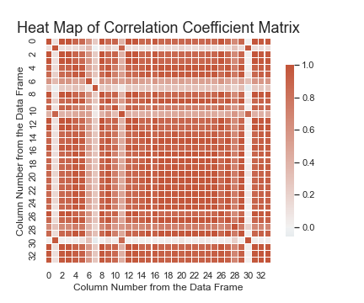

# Correlation Coefficient Matrix After Removing Co-linearity

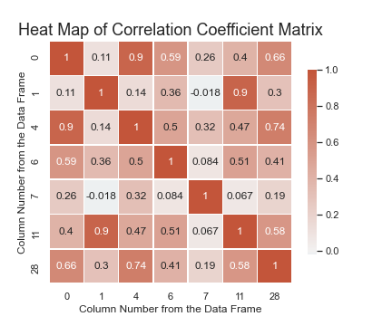

# Confusion Matrix:

|  |  |  |  |
| --- | --- | --- | --- |
|  | Predicted Med | Predicted Post | Predicted Pre |
| Actual Med | 36 | 4 | 0 |
| Actual Post | 9 | 4 | 0 |
| Actual Pre | 0 | 0 | 12 |

Accuracy Rate: 80.0%

**The submission confirmation number is 40439d23-646c-4747-89b9-fa8eb08eb68b**