< Access Form >
Software Requirements Specification

Version 1.0



Group Id: < F25PROJECT2DA7E>
Supervisor Name :< Abdullah Qamar >

Revision History

Date (dd/mm/yyyy) | Version | Description | Author
15/11/2025 | 1.0 | The Access Form project is focused on creating a web-based survey builder that is easy to use for everyone, including people with disabilities. Unlike many standard survey tools, Access Form is designed with accessibility in mind to support users with visual, hearing, motor, or cognitive impairments.  This project follows important international guidelines like WCAG 2.1 and WAI-ARIA to make sure surveys can be navigated using keyboards, screen readers, voice commands, and even SMS messages. This ensures that all users, regardless of their device or ability, can participate equally.  Access Form also provides an accessible analytics dashboard that allows survey creators to view and export results in formats that are easy to understand and use. By focusing on accessibility at every stage, this project aims to make online surveys more inclusive and help gather better data from a diverse group of people. | BC210423727

Table of Contents

- Scope (of the project)
- Functional Requirements Non Functional requirements
- Use Case Diagram
- Usage Scenarios
- Adopted Methodology
- Work Plan (Use MS Project to create Schedule/Work Plan)

SRS Document

Scope of Project:

Access Form is a web-based survey builder application focused on creating surveys that are fully accessible to all users, including people with disabilities such as visual, hearing, motor, or cognitive impairments. The system’s main purpose is to provide a platform where survey creators can easily build and distribute inclusive surveys, ensuring that all respondents can participate equally using various accessible input methods.
The application will enable users to:
- Create customizable surveys through an intuitive drag-and-drop interface.
- Include multiple types of questions such as multiple choice, text input, rating scales, and file uploads.
- Implement accessibility features such as keyboard-only navigation, screen reader compatibility with ARIA attributes, high-contrast themes, and alternative text for images.
- Allow respondents to complete surveys via web browsers, voice input (using speech-to-text technology), and SMS for users with limited internet access.
- Provide an analytics dashboard for form creators that delivers accessible data visualizations and options to export results in multiple formats (CSV, Excel, PDF).
- Manage user roles, including Admins (managing users and accessibility compliance), Form Creators, and Respondents.

Out of Scope:

- The system will not include a mobile application; it will be accessible only through web browsers.
- It will not support multiple users editing the same survey at the same time (no real-time collaboration).
- The system will not provide advanced AI features like predictive analysis of survey data.
- Full multilingual support is not included; the system will primarily support English.
- Offline survey creation and response submission will not be supported; an internet or SMS connection is required.
- Integration with external enterprise software or CRM systems is beyond the scope of this project.

Project Overview:

Access Form is a web-based application designed to help users create and manage surveys that are fully accessible to everyone, including people with disabilities. The main goal of this project is to ensure that surveys built and shared through Access Form can be easily used by individuals with visual, hearing, motor, or cognitive impairments.
Unlike typical survey tools, Access Form focuses on meeting strict accessibility standards such as the WCAG 2.1 guidelines and uses features like keyboard navigation, screen reader support, and high-contrast themes to make surveys inclusive.
The application supports three types of users:
- Admins, who oversee user management and accessibility compliance,
- Form Creators, who design and customize accessible surveys,
- Respondents, who complete surveys via multiple channels such as web browsers, voice commands, or SMS.
Access Form also includes an analytics dashboard that allows survey creators to view responses in accessible formats and export data for further analysis.

Scope Boundaries:

Included in Scope:
- Web-based survey system: Users can create, share, and respond to surveys using a web browser.
- User roles: Different access and capabilities for Admins (manage users and surveys), Form Creators (build surveys), and Respondents (complete surveys).
- Multiple response methods: Surveys can be answered through web browsers, voice input using speech-to-text technology, or SMS for those without internet.
- Accessibility features: The system will support keyboard-only navigation, work well with screen readers, provide high-contrast and dyslexia-friendly themes, and allow alternative text for images.
- Analytics dashboard: Form Creators will get accessible reports and can export survey results in common formats like CSV, Excel, or PDF.
Excluded from Scope:
- No mobile apps: The project will only support use through web browsers, not dedicated mobile applications.
- No real-time collaboration: Multiple users cannot edit the same survey simultaneously.
- No advanced AI: The system will not include smart data analysis like predictions or insights using AI.
- Limited language support: Surveys will mainly be in English, with no full multi-language features.
- No offline use: Creating surveys or submitting responses without internet or SMS will not be possible.
- No external software integration: The system won’t connect to other business tools like CRM or enterprise software.

Functional and non-Functional Requirements:

Functional Requirements:

ID | Requirement | Description
FR1 | User Role Management | Admins can manage users, assign roles, and monitor accessibility compliance.
FR2 | Survey Creation | Form Creators can build surveys with drag-and-drop interface and support multiple question types.
FR3 | Survey Participation | Respondents can complete surveys via web, voice (speech-to-text), or SMS.
FR4 | Accessibility Features | Support keyboard navigation, ARIA attributes, high-contrast themes, alt text, and captioned videos.
FR5 | Analytics and Reporting | Accessible dashboard with screen reader-friendly data visualizations and export options (CSV, Excel, PDF).
FR6 | Security and Authentication | Secure login with role-based access control and protection of sensitive data.

Non-Functional Requirements:

ID | Requirement | Description | How it will be fulfilled
NFR1 | Accessibility Compliance | Follow WCAG 2.1 and ARIA best practices to ensure full accessibility. | Use automated testing tools like axe-core; manual accessibility testing during development.
NFR2 | Performance | Fast page loads (<3 seconds) and response times (<2 seconds). | Optimize front-end code, backend queries, and server resources.
NFR3 | Usability | Intuitive UI with keyboard shortcuts and clear navigation for users with disabilities. | Conduct usability testing with diverse users; provide screen reader support.
NFR4 | Reliability and Availability | 99.9% uptime with data backup and error recovery mechanisms. | Use reliable hosting, implement backups, and handle errors gracefully.
NFR5 | Security | Secure authentication, data encryption, and role-based access control. | Use HTTPS, password hashing, encryption, and access control mechanisms.
NFR6 | Scalability | Support growing user base and survey volume without performance loss. | Design scalable architecture with modular components.
NFR7 | Maintainability | Modular, documented code with version control and automated tests. | Use Git for version control; write documentation and automated unit/integration tests.

Use Case Diagram(s):

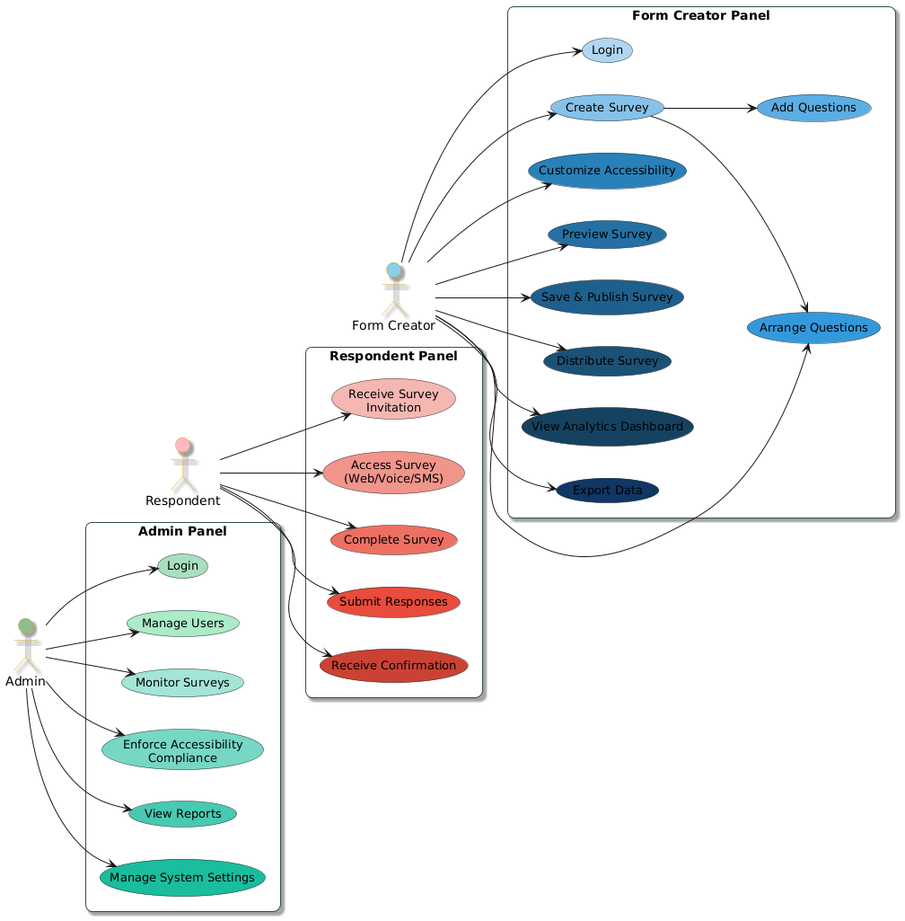

Usage Scenarios:

Use Case: Admin Login

Field | Details
Use Case ID | UC-Admin-01
Title | Admin Login
Actions | Admin enters credentials and logs in
Description | Allows admin to access the admin panel securely
Alternative Paths | Invalid credentials show error message
Preconditions | Admin has a registered account
Postconditions | Admin is logged in successfully
Exceptions | Account locked after multiple failed attempts

Use Case: Manage Users

Field | Details
Use Case ID | UC-Admin-02
Title | Manage Users
Actions | Admin adds, edits, or deletes users
Description | Admin manages user accounts and permissions
Alternative Paths | Warning if trying to delete users with active surveys
Preconditions | Admin is logged in
Postconditions | User accounts updated successfully
Exceptions | Cannot delete users with ongoing surveys

Use Case: Monitor Surveys

Field | Details
Use Case ID | UC-Admin-03
Title | Monitor Surveys
Actions | Admin views survey status and accessibility compliance
Description | Tracks survey usage and ensure accessibility compliance
Alternative Paths | None
Preconditions | Admin is logged in
Postconditions | Survey status and compliance viewed
Exceptions | Survey data unavailable if server offline

Use Case: Enforce Accessibility Compliance

Field | Details
Use Case ID | UC-Admin-04
Title | Enforce Accessibility Compliance
Actions | Admin reviews report and sends alerts
Description | Ensures surveys meet WCAG and ARIA guidelines
Alternative Paths | Request fixes if surveys are non-compliant
Preconditions | Admin is logged in
Postconditions | Compliance ensured or flagged
Exceptions | Survey creator ignores compliance requests

Adopted Methodology:

The development of the Access Form project adopts a hybrid methodology combining the Waterfall and Spiral models to leverage the advantages of both approaches, ensuring a systematic yet flexible software development process.

Waterfall Model

The Waterfall model is a traditional, linear software development process where each phase flows sequentially to the next. It begins with requirement analysis, where all system goals and constraints are defined in detail. This is followed by system and software design, which lays out the architecture and design specifications.

Next, the project moves to implementation and unit testing, where the software components are developed and individually tested. Afterward, integration and system testing ensure that the entire system works as expected. Finally, the project enters the operation and maintenance phase, where the system is deployed and maintained, including fixing bugs and implementing enhancements.

Each phase requires approval before moving forward, creating a disciplined and well-documented workflow. However, the Waterfall model’s sequential nature means client feedback typically comes late in the process, increasing the risk of costly revisions if requirements were misunderstood.

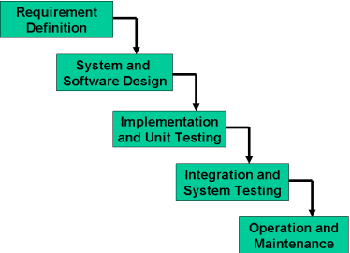

Spiral Model

To address the limitations of the Waterfall model, especially regarding risk and late feedback, the Spiral model is adopted alongside it. Developed by Barry Boehm, the Spiral model introduces risk-driven, iterative development with repeated cycles.
Each cycle in the Spiral model involves:
- Defining objectives, alternatives, and constraints.
- Performing detailed risk analysis to identify and mitigate potential problems.
- Developing and verifying the next version or prototype of the system.
- Planning the next phase based on evaluation.
This iterative approach enables early detection and resolution of risks, continuous refinement of requirements, and frequent user feedback, which is critical for ensuring the accessibility and usability features in Access Form meet the standards and user expectations.

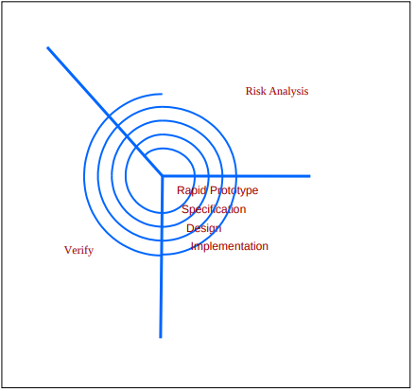

As can be seen, a Spiral Model has two dimensions. Radial dimension represents the cumulative cost to date and the angular dimension represents the progress through the spiral. Each phase begins by determining objectives of that phase and at each phase a new process model may be followed.

Key Characteristics:
- Iterative Cycles (Spirals):
Development proceeds in repeated cycles (spirals). Each spiral represents a phase of the software process — from planning, risk analysis, engineering, to evaluation.
- Risk-Driven Approach:
At the start of each cycle, risks are identified and analyzed thoroughly. The project team develops strategies to mitigate these risks before moving forward. This reduces chances of project failure due to unexpected problems.
- Four Main Activities in Each Cycle:
- Determine objectives, alternatives, and constraints: What needs to be done? Are there multiple ways to approach it? What are the limits?
- Identify and resolve risks: What could go wrong? How to prevent or handle it?
- Develop and test: Build a prototype or increment, then verify and validate it.
- Plan the next phase: Decide the scope and goals for the next iteration based on current findings.
- Flexibility and Adaptability:
Unlike rigid models (e.g., Waterfall), the Spiral model allows revisiting and refining requirements and designs based on feedback from each iteration.
- Seamless Development and Maintenance:
There is no strict separation between development and maintenance phases — both occur continuously through iterative spirals.

When to Use the Spiral Model:
- Projects with high risks or uncertain requirements
- Large, complex systems requiring ongoing risk assessment
- Projects where user feedback and iterative refinement are critical
- Software that involves new technologies or innovative features

Advantages:
- Early identification and reduction of risks
- Better control over project progress and budget
- Continuous refinement improves product quality
- Enhanced user involvement during development

A full version of the Spiral Model:

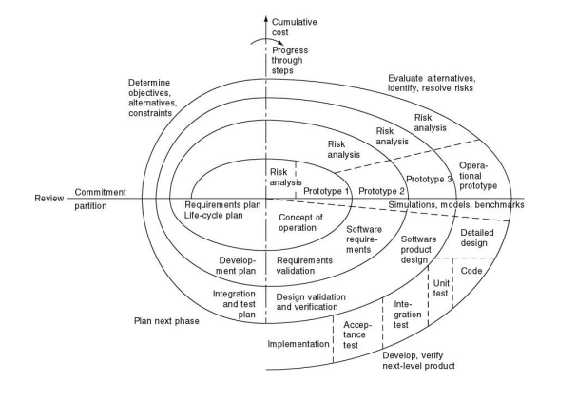

The Spiral Model's key advantage lies in its strong focus on risk management. Its iterative spiral structure allows for effective assessment of testing needs throughout the development process. Additionally, it seamlessly integrates development and maintenance activities without a clear division between the two. However, this model is best suited for large-scale software projects, typically developed internally within organizations.

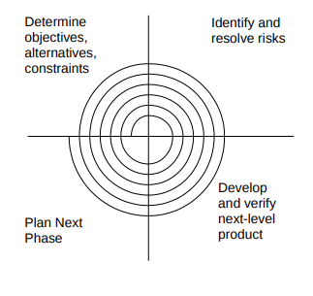

VU Process Model

VU Process Model:

The VU Process Model integrates the structured, sequential flow of the Waterfall Model with the flexible, risk-aware iterative cycles of the Spiral Model to provide a balanced software development approach. This combination allows careful planning and documentation while managing risks through continuous feedback and refinement.

How It Works:
- Structured Phases (Waterfall Core):
- The project progresses through clear stages:
    - Requirements Gathering
    - System and Software Design
    - Implementation and Unit Testing
    - Integration and System Testing
    - Deployment and Maintenance
- Each phase produces deliverables and documentation to keep the project organized.
- Iterative Risk Analysis and Refinement (Spiral Loops):
  - At the end of each major phase (or after deployment), the project enters a spiral cycle where:
    - Risks are assessed and managed.
    - Prototypes or increments may be developed to explore solutions or gather feedback.
    - Feedback is evaluated to decide if changes or improvements are needed.
  - This loop helps catch issues early and adapt to changes before moving forward.
- Feedback Integration:
- If issues or risks are identified during spiral cycles, the project may revisit earlier Waterfall phases to update requirements, redesign, or retest as necessary.
- This makes the process flexible and less prone to costly mistakes discovered late.
- Documentation and Quality Focus:
- Throughout, comprehensive documentation ensures clarity and maintains academic rigor, aligning with Virtual University project standards.

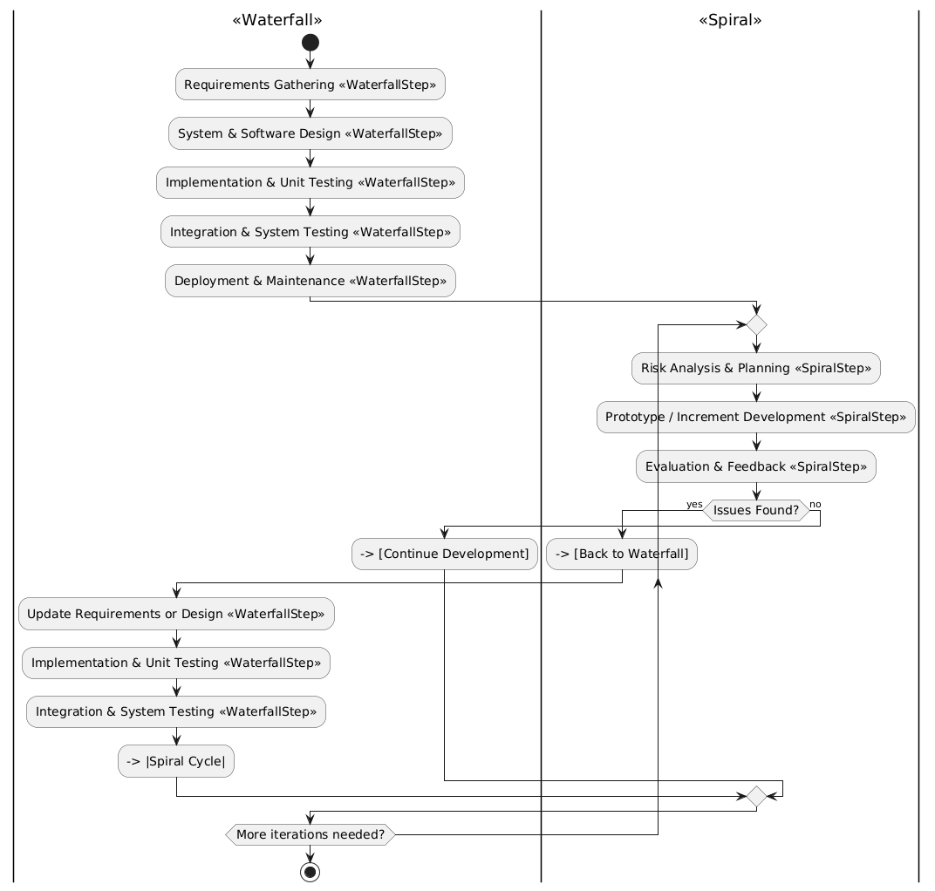

Work Plan
