# Automatic bottle filling

# introduction

**Automatic Bottle Filling Machines** are most commonly used in beverages and soft drink industries. These machines use a conveyor belt which is an economical and fast way to fill bottles. Mostly PLCs are used for Automatic bottle filling machines, but you can make a very basic and versatile **bottle filler using an Arduino**. You can program the Arduino to automatically detect the bottle using IR or ultrasonic sensor and allow the bottler to fill by stopping the conveyer belt for some time. Then again move the belt and stop when the next bottle is detect

**Components Required**

* Arduino Uno
* Relay
* Solenoid Valve
* IR Sensor
* A4988 Motor Driver
* Battery

circuit diagram

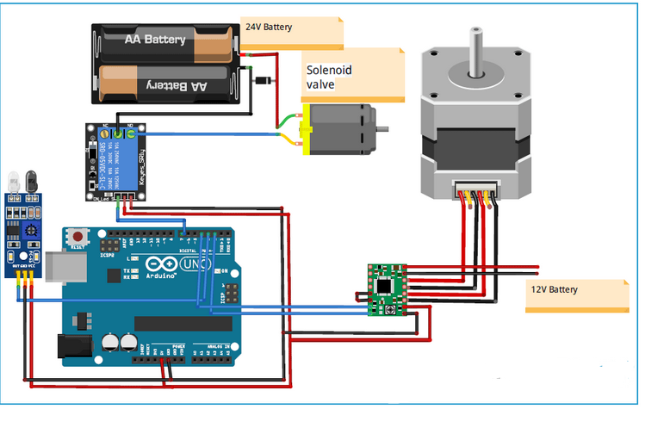

**Automatic Bottle Filling Machines** are most commonly used in beverages and soft drink industries. These machines use a conveyor belt which is an economical and fast way to fill bottles. Mostly PLCs are used for Automatic bottle filling machines, but you can make a very basic and versatile **bottle filler using an Arduino**. You can program the Arduino to automatically detect the bottle using IR or ultrasonic sensor and allow the bottler to fill by stopping the conveyer belt for some time. Then again move the belt and stop when the next bottle is detected.

Here we are going to design a prototype for **Automatic Bottle Filling Machine using Arduino Uno**, conveyor belt, solenoid valve, IR sensor, and Stepper motor. Belt conveyor is driven by a stepper motor at a constant preset speed. The stepper motor will keep driving the belt until an IR sensor detects the presence of a bottle on the belt. We used the IR sensor as an external trigger. So whenever the IR sensor goes high it sends a trigger to Arduino to stop the motor and turn on the solenoid valve. A preset required delay is already entered in the code for bottle filling. The Arduino will keep the solenoid valve on and stepper motor off until that specified time. After that time, the solenoid valve turns off the filling, and the conveyor starts moving so that the next bottle can be filled.

Code

#include <Stepper.h>

#define STEPS 200

#define motorInterfaceType 1

Stepper stepper(STEPS, 2, 4);

int relay=7;

int step_num =700;

void setup() {

  Serial.begin(9600);

  pinMode(relay,OUTPUT);

  stepper.setSpeed(500);

  pinMode(4,OUTPUT);

  pinMode(2,OUTPUT);

 attachInterrupt(digitalPinToInterrupt(3),IR_detected,RISING);

}

boolean solenoid_on = false;

void loop() {

  if (solenoid_on)

  {

    delay(6000); //wait for 6 sec

    solenoid_on = false;

  }

  digitalWrite(relay,LOW);    // now relay is off condition (and motor is on  condition)

  stepper.step(step_num);

  }

void IR_detected()           //ISR function excutes when IR sensor goes high.

{

  Serial.println ("Interrupt Detected");

  stepper.step(150); //To run the stepper motor few steps before it stops

  digitalWrite(relay,HIGH); //to turn on solenoid

  stepper.step(0); //to stop the stepper motor

  solenoid_on = true;

  }

The video how the project can be used and installed as a circuit, is in the following link:

https://youtu.be/zAufuYySk7w