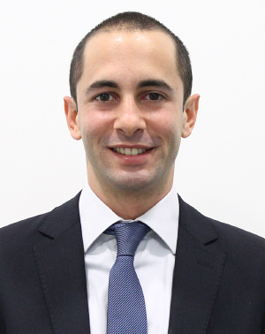**Umut Alihan Dikel**

Birthday 04.01.1992

Birth Place İzmir

Address Alageyik Sk., Mine Apt. 5/1, Kadıköy

İstanbul

Mobile +90 537 207 19 16

Mail umut_alihan.dikel@daimler.com

[alihandikel@gmail.com](mailto:alihandikel@gmail.com)

Personal Portfolio <https://github.com/UmutAlihan>

**Work Experience**

**RPA Developer   
at Mercedes-Benz Turk,   
Global IT Solutions Delivery Center** (**Shared Service Center** for Daimler AG)

*May 2019 – Current*

* **Identifying & Implementing end-to-end RPA solutions** to automatize business processes across Daimler entities **using Blue Prism & UiPath**
* **Initiated RPA Marketplace** as a global sharing and collaboration platform for the community
* Dedicated to continuously **learn new automation technologies** and concepts with passion

**Non-Cash Risk Management Specialist   
at Mercedes-Benz Turk, Finance Dept.**

*May 2017 – May 2019*

* Issued letters of guarantee in coordination with banks and supported departments in situations, such as participation to public tenders or litigation avoidance.
* **Identified and implemented automations** **using VB, Powershell, .Net** for repetitive, non-cognitive tasks to optimize daily performance and focus on value-added tasks.
* Monitored and managed letter of guarantee transactions **using SAP FICO**

**Education**

2011 – 2015 Sabancı University, Turkey

BS, Business Administration, School of Management

2013 – 2014 University of Amsterdam, Netherlands

Social Sciences, Faculty of Social Sciences

2006 – 2011 Sankt Georgs Kolleg Istanbul, Turkey,

**Skills:**

**Information Systems:**

- Implementing robotics automations using **UiPath and BluePrism**

- Comprehensive **understanding about algorithms**, data types, object-oriented programming

- Passionate about **Machine Learning**. **Training neural network models** in scope of Natural Language Processing

- Ability to learn, understand and start developing software using any language   
 (Currently: Python, JavaScript, Bash, Powershell, VB, .Net)

**Languages:**

- English (Advanced)

- German (Advanced)

- Turkish (Native)

**Extracurricular Activities**

*2020 - current* Initiated international “Learn2Teach” colleague-to-colleague self-learning sessions and thought Quantum Computing

*2019 – current* Built a team of 8 volunteer colleagues to organize Programming workshops for high school students/interns

*2017 – current* Continuously learning Computer Science through online courses and side-projects

*2016 – 2017* Mentor, Programming education for kids, Coderdojo İskele47

*2012 – 2014* Chair of Student Union Executive Committee, Sabanci Univ.

*2005 – 2007* Rowing Team Member, Fenerbahce Sports Club

**Military Service:** Completed (2016)