Software Design Document
Ordered Network Analysis for Sequenced Learning Activities



Submitted by
Umyma Mohsin
F22BINFT1M01278

Submitted to
Dr.Mustafa Hameed

Department of Information Technology
Faculty of Computing
The Islamia University of Bahawalpur

Summary
This Software Design Document describes the detailed system design of the Ordered Network Analysis (ONA) Model for Sequenced Learning Activities, a web-based educational planning system. The system is designed to assist instructors and curriculum designers in organizing learning activities using a dependency-driven, structured sequencing approach.
The document explains the overall system architecture, internal components, database schema, and user interface design decisions. It outlines how learning activities are collected, processed, analyzed, visualized, and exported using modern web technologies and graph-based algorithms. The design focuses on modularity, clarity, scalability, and ease of use, ensuring that the system can be maintained and extended in future iterations. This SDD serves as a technical blueprint for implementing the requirements defined in the Software Requirement Specification (SRS).

Contents
1. Application Architecture 5
1.1 Overall Architectural Design 5
1.2 Architectural Pattern: MVC 6
Model 6
View 6
Controller 7
1.3 Frontend Architecture 7
Technologies Used 7
Responsibilities 7
Frontend Components 7
1.4 Backend Architecture 8
Technologies Used 8
Backend Controllers 8
Core Backend Responsibilities 8
1.5 External Libraries and Their Role 8
NetworkX 8
Pandas 9
Cytoscape.js 9
1.6 Coding Standards and Conventions 9
2. Data Model Schema 9
2.1 Database Design Overview 9
2.2 Entity Descriptions 10
Entity: Activity 10
Entity: Prerequisite 10
Entity: Dataset 10
Entity: Analytics 10
Entity: Export_Log 11
2.3 Entity Relationship Description 11
2.4 ER Diagram (Conceptual Description) 11
3. User Interface Design 12
3.1 Design Philosophy 12
3.2 Screens and Functional Pages 13
Dashboard 13
Upload Dataset Page 13
Manual Activity Entry Page 13
Network Graph Page 13
Learning Sequence Page 14
Analytics Dashboard 14
3.3 Input Constraints and Validation 14
Conclusion 14

1. Application Architecture

1.1 Overall Architectural Design
The Ordered Network Analysis System follows a client–server architecture based on the Model–View–Controller (MVC) design pattern. This architectural approach separates concerns between data storage, business logic, and user interaction, resulting in a maintainable and scalable system.
The system consists of three major layers:
- Presentation Layer (Frontend)
- Application Layer (Backend / Controllers)
- Data Layer (Database / Models)
Each layer performs a distinct role while communicating through well-defined interfaces and RESTful APIs.
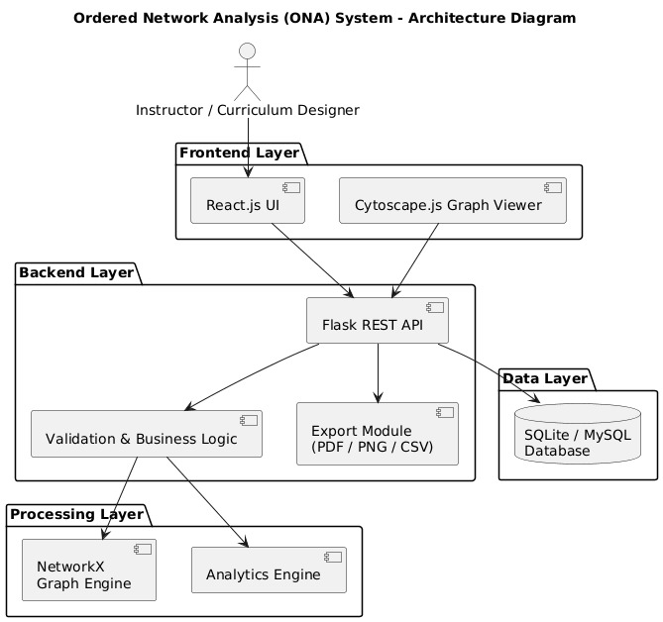
Figure 1: High-Level System Architecture of the Ordered Network Analysis System

1.2 Architectural Pattern: MVC

Model
The model layer represents the data structures and database entities of the system. It manages learning activities, prerequisite relationships, datasets, analytics results, and export logs.

View
The view layer is responsible for rendering user interfaces, displaying learning sequences, network graphs, analytics dashboards, and export options.

Controller
The controller layer contains the system’s core logic. It processes user requests, validates inputs, builds network graphs, computes optimized sequences, and coordinates communication between the view and model.

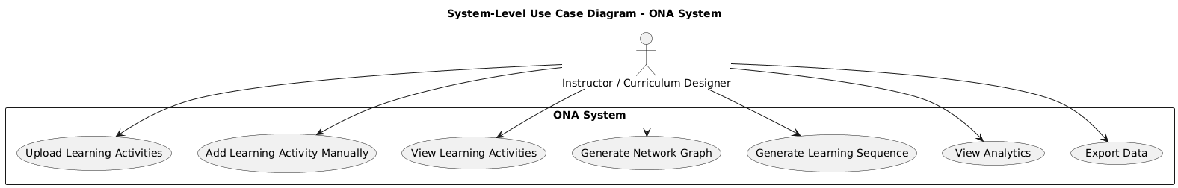

Figure 2: System-Level Use Case Diagram of the ONA System

1.3 Frontend Architecture

Technologies Used
- React.js
- Tailwind CSS
- Cytoscape.js
- Chart.js
- JavaScript (ES6)

Responsibilities
- Accept CSV file uploads and manual activity inputs
- Display lists of learning activities
- Render interactive dependency graphs
- Display optimized learning sequences
- Visualize analytics such as cycles and bottlenecks
- Handle export requests

Frontend Components
- Dataset Upload Component
- Manual Activity Entry Form
- Network Graph Visualization Component
- Learning Sequence Display
- Analytics Dashboard
- Export Interface

1.4 Backend Architecture

Technologies Used
- Python Flask
- Flask-RESTful
- NetworkX
- Pandas

Backend Controllers
Controller | Purpose
Activity Controller | Manages CRUD operations for learning activities
Dataset Controller | Handles CSV uploads and bulk processing
Graph Controller | Builds and returns dependency graphs
Sequence Controller | Generates optimized learning sequences
Analytics Controller | Detects cycles, bottlenecks, and orphan nodes
Export Controller | Generates downloadable files

Core Backend Responsibilities
- Validate input data
- Parse CSV datasets
- Construct directed graphs using NetworkX
- Perform topological sorting
- Detect structural issues in learning paths
- Generate analytics summaries
- Prepare data for visualization and export

1.5 External Libraries and Their Role

NetworkX
- Represents learning activities as nodes
- Represents prerequisites as directed edges
- Detects cycles and invalid dependencies
- Performs graph traversal and ordering

Pandas
- Reads and validates CSV datasets
- Cleans and structures data before database insertion

Cytoscape.js
- Renders interactive network graphs
- Supports zooming, panning, and node inspection

1.6 Coding Standards and Conventions
- Python code follows PEP-8
- Clear API naming conventions
- Modular and reusable components
- Inline documentation for critical logic

2. Data Model Schema

2.1 Database Design Overview
The database is designed using a relational model to efficiently represent learning activities and their prerequisite relationships. The schema supports dependency analysis, analytics computation, and export tracking.

2.2 Entity Descriptions

Entity: Activity
Attribute | Description
Activity_ID (PK) | Unique identifier for each activity
Name | Title of the learning activity
Description | Detailed explanation
Category | Type or level of activity
Created_At | Timestamp

Each activity represents a node in the learning network.

Entity: Prerequisite
Attribute | Description
Prerequisite_ID (PK) | Unique identifier
Activity_ID (FK) | Dependent activity
Required_Activity_ID (FK) | Prerequisite activity

This entity represents directed edges in the network.

Entity: Dataset
Attribute | Description
Dataset_ID (PK) | Dataset identifier
File_Name | Uploaded CSV name
Upload_Date | Timestamp

Used for bulk activity management.

Entity: Analytics
Attribute | Description
Analytics_ID (PK) | Record identifier
Analysis_Type | Cycle, bottleneck, orphan
Details | Analysis description

Stores computed insights.

Entity: Export_Log
Attribute | Description
Export_ID (PK) | Export identifier
Export_Type | PDF, PNG, CSV
Export_Date | Timestamp

Tracks export operations.

2.3 Entity Relationship Description
- One dataset contains many activities
- One activity may have multiple prerequisites
- One activity may be a prerequisite for multiple activities
- Analytics are derived from activities and prerequisites
- Export logs record system output actions

2.4 ER Diagram (Conceptual Description)
Dataset ───< Activity ───< Prerequisite >─── Activity
|
└───< Analytics
|
└───< Export_Log
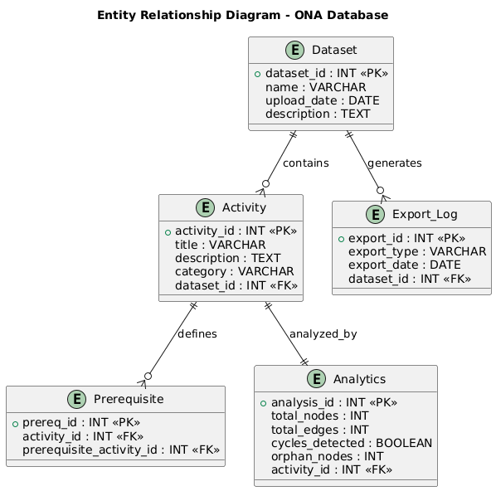

Figure 3: Entity Relationship Diagram of the ONA System Database
3. User Interface Design

3.1 Design Philosophy
The user interface is designed with simplicity and clarity in mind. Since the target users are instructors and curriculum designers, the interface avoids unnecessary complexity and technical jargon.
Key design principles include:
- Clean layout
- Minimalistic academic theme
- Clear visual hierarchy
- Responsive design for desktop and tablet devices

3.2 Screens and Functional Pages

Dashboard
- System overview
- Quick access buttons
- Summary statistics
Controls: Buttons, info cards

Upload Dataset
- File selector
- Upload button
- Validation messages
Constraints: CSV format only

Manual Activity Entry
- Text fields for name and description
- Dropdown for category
- Multi-select prerequisites

Network Graph
- Interactive graph visualization
- Zoom and pan controls
- Node hover details

Learning Sequence
- Ordered list of activities
- Cycle warnings if detected

Analytics Dashboard
- Bottleneck indicators
- Orphan node alerts
- Summary charts

3.3 Input Constraints and Validation
- Activity name is mandatory
- No circular self-dependencies
- CSV file structure validation
- Error messages for invalid input

Conclusion
This Software Design Document provides a complete and structured design blueprint for the Ordered Network Analysis System. The architecture, data schema, and interface design collectively ensure that the system fulfills all functional and non-functional requirements defined in the SRS. The design enables educators to visualize, analyze, and optimize learning sequences effectively, making curriculum planning more structured, logical, and data-driven.

