1) Illustrate Positioning property of CSS (absolute, relative).

POSITION ABSOLUTE

<CODE>

<!DOCTYPE html>

<html lang="en">

<head>

    <meta charset="UTF-8">

    <meta http-equiv="X-UA-Compatible" content="IE=edge">

    <meta name="viewport" content="width=device-width, initial-scale=1.0">

    <title>Homework</title>

    <link rel="stylesheet" href="firstcss.css">

</head>

<body>

    <nav class="navbar">NAV</nav>

    <div class="first">

       HI

    </div>

    <div class="second">

        Hello

    </div>

</body>

</html>

CSS

*{

    padding: 0;

    margin: 0;

}

.navbar{

    height: 30%;

    width: 100%;

    background-color: brown;

    position: absolute;

    text-align: center;

}

.first{

    height: 50%;

    width: 20%;

    background-color: red;

    color: green;

    position: absolute;

    left: 0;

}

.second{

    height: 50%;

    width: 20%;

    background-color: black;

    color: red;

    position: absolute;

    right: 0;

}

OUTPUT

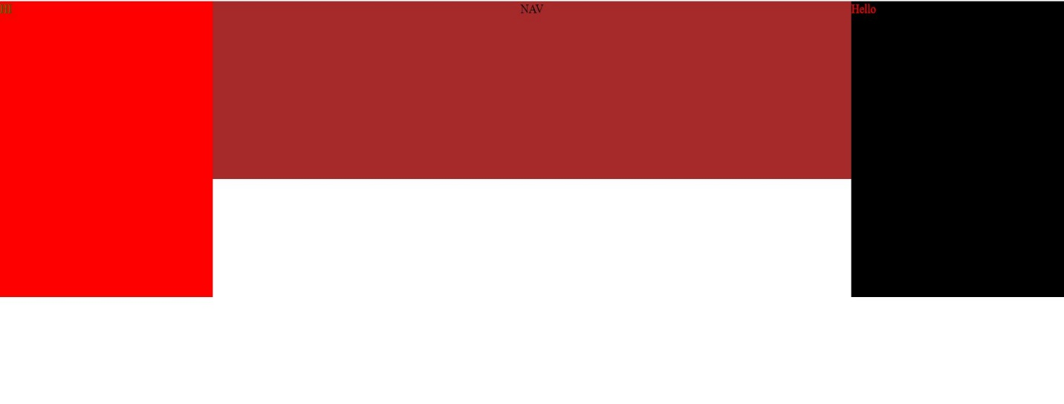

POSITION RELTIVE

<CODE>

<!DOCTYPE html>

<html lang="en">

<head>

    <meta charset="UTF-8">

    <meta http-equiv="X-UA-Compatible" content="IE=edge">

    <meta name="viewport" content="width=device-width, initial-scale=1.0">

    <title>Homework</title>

    <link rel="stylesheet" href="firstcss.css">

</head>

<body>

    <nav class="navbar">NAV</nav>

    <div class="first">

       HI

    </div>

    <div class="second">

        Hello

    </div>

</body>

</html>

CSS

*{

    padding: 0;

    margin: 0;

}

.navbar{

    width: 100%;

    background-color: rgb(0, 0, 0);

    position: relative;

    text-align: center;

    color: white;

    font-size: 50px;

}

.first{

    height: 50%;

    width: 20%;

    background-color: red;

    color: rgb(255, 255, 255);

    position: absolute;

    left: 0;

    font-size: 50px;

}

.second{

    height: 50%;

    width: 20%;

    background-color: rgb(255, 0, 0);

    color: rgb(255, 255, 255);

    position: absolute;

    right: 0;

    font-size: 50px;

}

OUTPUT

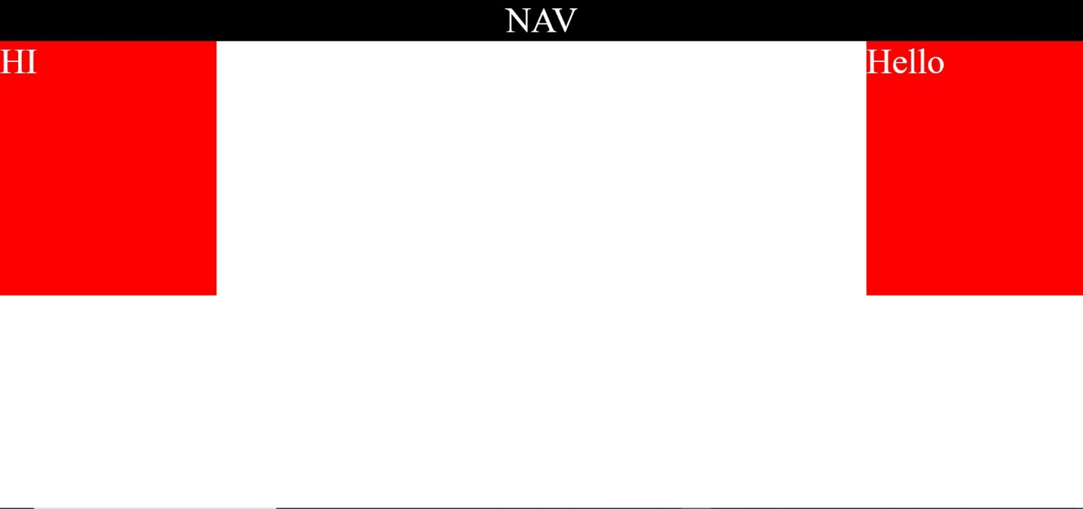

2) Make use of z-index with positioning attributes

<code>

<!DOCTYPE html>

<html lang="en">

<head>

    <meta charset="UTF-8">

    <meta http-equiv="X-UA-Compatible" content="IE=edge">

    <meta name="viewport" content="width=device-width, initial-scale=1.0">

    <title>Homework</title>

    <link rel="stylesheet" href="firstcss.css">

</head>

<body>

    <nav class="navbar">NAV</nav>

    <div class="first">

       HI

    </div>

    <div class="second">

        Hello

    </div>

</body>

</html>

CSS

*{

    padding: 0;

    margin: 0;

}

.navbar{

    height: 30%;

    width: 100%;

    background-color: brown;

    position: absolute;

    font-size: 30px;

    text-align: center;

    z-index: 10;

}

.first{

    height: 50%;

    width: 20%;

    background-color: red;

    color: green;

    position: absolute;

    left: 0;

    font-size: 30px;

    text-align: center;

}

.second{

    height: 50%;

    width: 20%;

    background-color: black;

    color: red;

    position: absolute;

    right: 0;

    font-size: 30px;

    text-align: center;

    z-index: 20;

}

**OUTPUT**



**3) Model Question Section B no. 8**

**QUESTION: Write a HTML script containing use of media query for changing the background color of HTML page to black if the viewport is 600 px wide or more than that otherwise if the viewport is less than 500 px the background color should change to red.**

**<CODE>**

<!DOCTYPE html>

<html lang="en">

<head>

    <meta charset="UTF-8">

    <meta http-equiv="X-UA-Compatible" content="IE=edge">

    <meta name="viewport" content="width=device-width, initial-scale=1.0">

    <title>Homework</title>

    <link rel="stylesheet" href="firstcss.css">

</head>

<body>

</body>

</html>

**CSS**

*{

    margin: 0;

    padding: 0;

}

body{

    background-color: black;

}

@media(max-width:500px){

    body{

        background-color: red;

    }

}

**OUTPUT**