About the program:

This program allows you to create and delete a list of tasks and projects, as well as create users and assign them to projects.

Programming language: Java.

To run the program, open the file: task.iml

Then follow the prompts.

1. Testing the program under normal conditions:

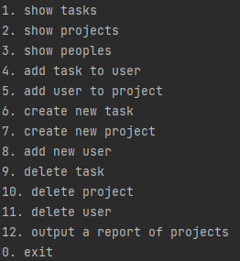

Pic.1.1-main menu

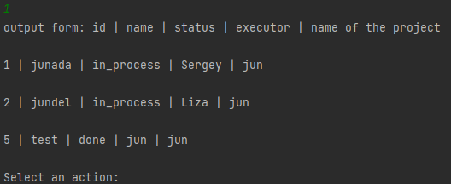

Pic.1.2- command 1

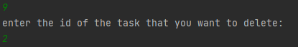

Pic.1.3-command 9

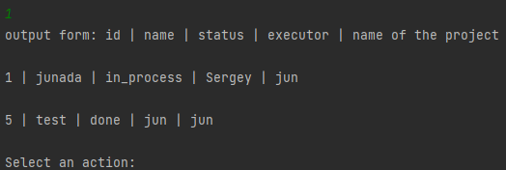

Pic1.4- result of command 9



2. Testing the program in exceptional situations:

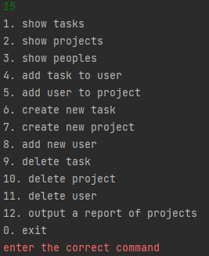

Pic.2.1-not correct command

3.Testing the program in extreme conditions:

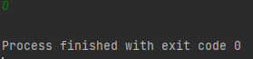

Pic. 3.1 – command 0

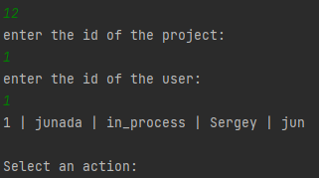

Pic. 3.2 -command 12