Fay’s Geography Notes

Year 10

Tectonic Plates, Volcanoes, Earthquakes and All That
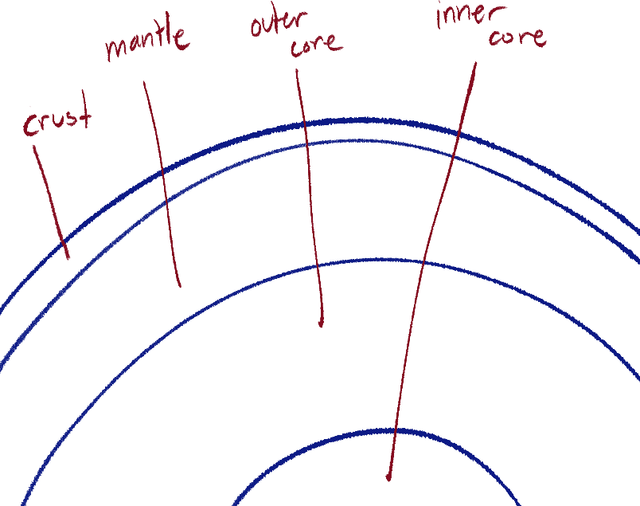
Tectonic plates
The Earth’s crust is broken up into pieces. These pieces are called tectonic plates.
These plates slowly move due to convection currents of the mantle, which is made out of liquid rock; magma. Because of this, plates can move apart or move into each other, and we usually refer to said events happening on the plate boundaries.
There are three types of plate boundaries:

- Divergent / constructive
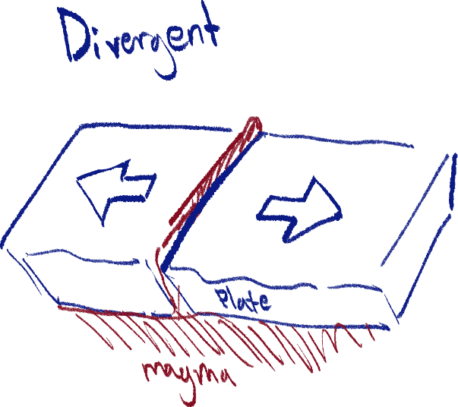
A boundary of a tectonic plate where it and another plate separate/spreads.
This boundary is constructive as it creates more crust as the magma moves out of the opening between plates. This also creates ridges/rifts.

- Convergent / subductive
A boundary of a tectonic plate where another plate is being pushed under it. This is known as subduction.
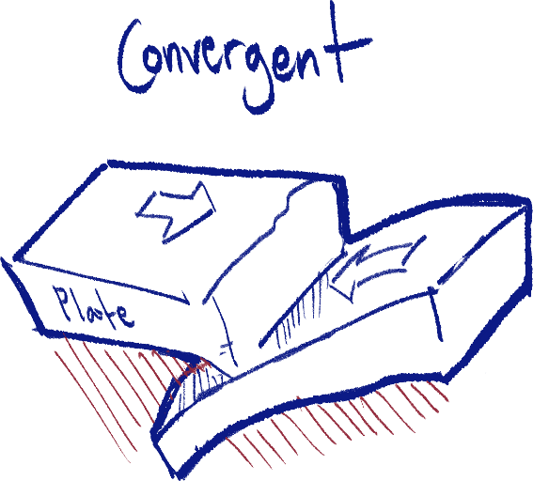
This boundary is destructive as it destroys the part of the plate pushed under when it goes into the mantle. This also creates trenches.
- Transformative
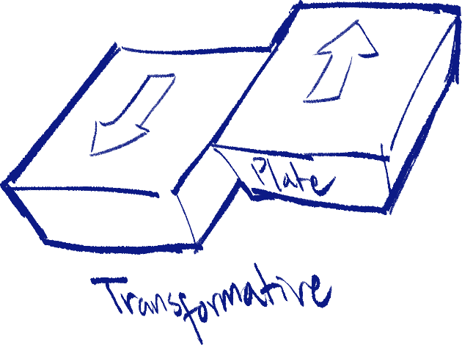
A boundary of a tectonic plate where it and another plate slides next to each other.
This boundary is conservative as it does not cause any destruction nor creation to the crust. As the name implies, it only transforms the land on the plates.

Earthquakes
Earthquakes are caused by tectonic plate movement, but not ordinary movement, as ordinary tectonic plate movement is very slow. Instead, they are caused by plates grinding together and building up pressure until they slip and release said pressure.

Parts of an earthquake
- The focus
The point below ground where the earthquake started.
- The epicenter
The point directly above the focus on the surface.

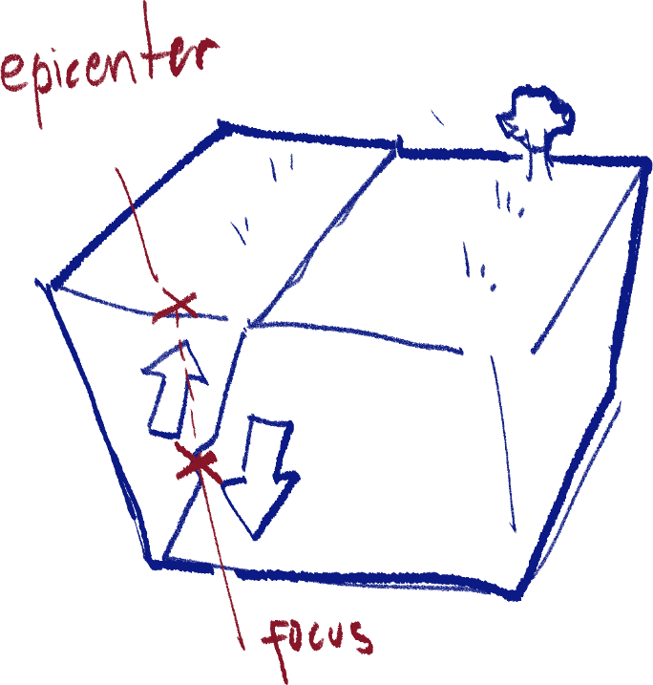

Measuring the magnitude of an earthquake
A seismometer measures the vibrations and movement of the ground by graphing it, and is used for measuring the intensity of earthquakes, volcanic eruptions, and explosives.
The Richter scale is used to compare the magnitude of earthquakes by determining the size of the waves recorded by seismographs.
Seismic waves
When an earthquake occurs, three different seismic waves are released at once. But, they all travel at different speeds, so they reach the surface at different times. The following waves will be introduced in order:
- The primary wave / P-wave
The first detected. They have forward and back compressions.
- The secondary wave / S-wave
Oscillates the ground perpendicular to the direction of wave travel. (Up and down)
- The love wave / L-wave
Moves side to side.

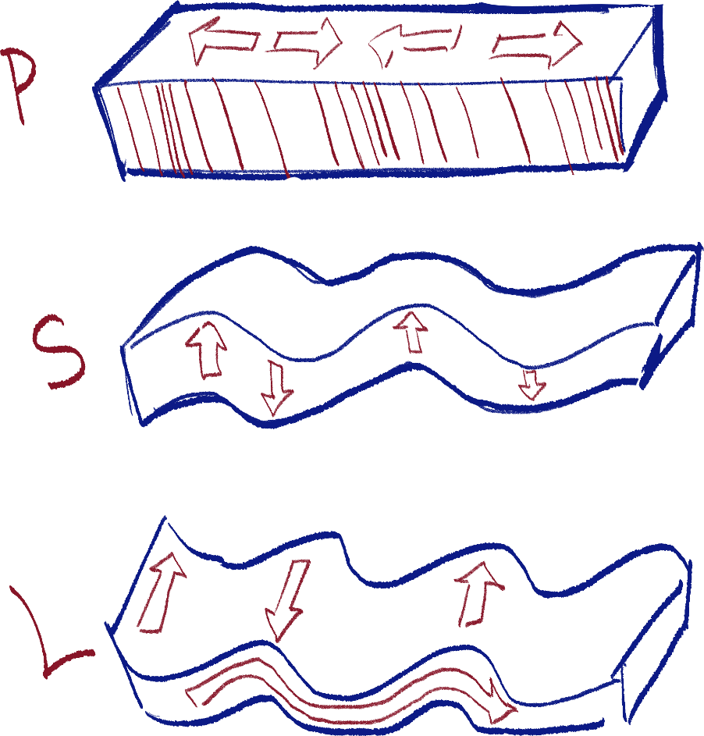

Earthquake safety
There is no way to predict an earthquake, so preparing for one is important. This includes;
- Securing furniture to avoid falling
- Check the strength of house and walls
- Retrofitting
- Prepare firefighting equipment
- Follow fire prevention methods
- Prepare emergency supplies such as water, canned food, batteries, radio
- Discuss emergency plans with family
During an earthquake, the best way to protect oneself is by exiting any building you’re in and finding open, empty land or clearing. When that is not possible, ducking under a desk or doorway may be the next best option.
After an earthquake, there are still some measures that should be taken to protect yourself. Checking for fires that can be extinguished, exit routes in case of an aftershock or more earthquakes, staying away from collapsible walls, and turning off any possible firestarters can help prevent any further injury or damage.
Volcanoes, in general
There are two types of volcanoes; strato-volcanoes and shield volcanoes.

A strato-volcano is formed from subduction boundaries, and they are formed when sea water enters the mantle through the subduction zone and, now mixed with magma, rises up through the Earth’s crust to allow magma to flow through the cracks of the crust.
It is also called a composite or andesic volcano because the mixture of magma and water makes its lava, when solid, andesite. Andesitic lava is sticky, and its volcanoes are very explosive. These volcanoes are built out of layers of ash and rock from eruptions, but they don’t happen very often.

A shield or basaltic volcano is formed from diverging boundaries, where lava from the plate gap flows into the surface. The lava is basaltic and very liquid, because it is pure. The lava spreads out from the constructive boundary to form a flat mound of rock, which is the volcano.
This type of volcano’s eruptions is frequent but not explosive, and it is usually formed under the sea.
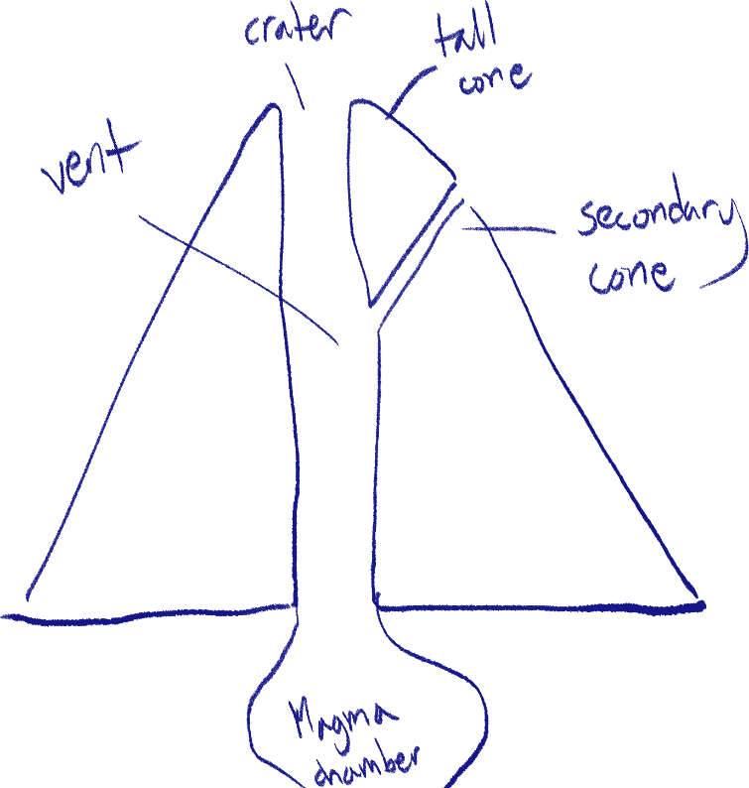
hl shqdc

Negative effects of earthquakes and volcanoes
I’m bunching them all up because they’re pretty similar.
I will be listing them as branches of other effects.
- Kills people and wildlife
  - Kills people with many years worth of experience and skills
  - Kills people with important jobs so they cannot help others; for example, a surgeon
  - Destroys habitats and ecosystems
- Destroys/damages property and buildings
  - Loss of money; buildings cost a lot, and some items of high value may be lost
  - Cost of rebuilding is expensive
  - Cost of cleaning the rubble and flattening land is expensive
  - Some important heritage sites or items may be destroyed
  - Underground systems such as sewers or piping will be destroyed
    - Electricity can become unusable/cause fires
    - Water is inaccessible/dirty
      - Diseases can spread due to infected water
  - Important facilities such as schools or hospitals cannot be used, and food will be harder to get if stores are not operational
  - Workplaces can be destroyed; people will lose their jobs due to that
- Tsunamis can be created
  - This has the mostly the same consequences added on
- Long term recovery cost

For volcanoes specifically, ash and dust can pollute the air and disrupt air traffic, because airplanes cannot process volcanic ash and continue operating normally.

The positive effects of volcanoes
Earthquakes basically have no positive side effects.

- Volcanoes can be used as a hotspot for geothermal power.
- Attracts tourists
  - Provides locals with jobs in the tourism industry
  - Same with transportation and flights
- Minerals such as sulfur, silver, gold, bronze and lead are brought to the surface, which can be sold
  - Provides more jobs and helps local economy
- Lava and ash lead to fertile soil
  - Animals and plants thrive
  - Locals can grow their own food and livestock to eat
  - They can also sell it for a living as a farmer

Case studies: Haiti and Mt. Sinabung
I’m not going to thoroughly explain the impacts of the events for each case if they’re not exclusive to these instances because I’ve already listed down the possible effects.
Haiti’s earthquake
Haiti – not about the earthquake
Haiti, a country in North America next to the Dominican Republic to the south of the Atlantic Ocean and to the north of the Caribbean Sea (sorry I just had to dump it out like that), is frequently attacked by hurricanes, high winds and floods. The country sits near the boundary between the North American plate and the Caribbean plate.
Haiti – about the earthquake
On January 12, 2010, the first major earthquake of Haiti in 200 years occurred. The epicenter of the earthquake was only 16km southwest of the capital city, Port-au-Prince, and the focus was very shallow – only 10km below the surface. The magnitude was 7.1 on the Richter scale.
- 220,000+ killed
- 250,000+ houses destroyed
- 3 million+ displaced
- 1300+ schools destroyed
- All orphanages destroyed
- Cholera caused by dirty water

Mt. Sinabung’s eruption
Mt. Sinabung is a volcano on North Sumatra of Indonesia, a country in South East Asia. Indonesia itself is has an abundance of other volcanoes as it lies on a part of the Ring of Fire. (A line formed of volcanoes due to the Pacific plate’s subduction boundaries.)
In late August 2010, the formerly 400-year dormant Mt. Sinabung erupted, prompting the government to warn the people to move away from the area.
This occurred again on September 2013, and the volcano continued to erupt for several months, but when the government allowed people to move back in on February 2014, it erupted with flying rock, toxic gas and ash, killing at least 16 people in the process.

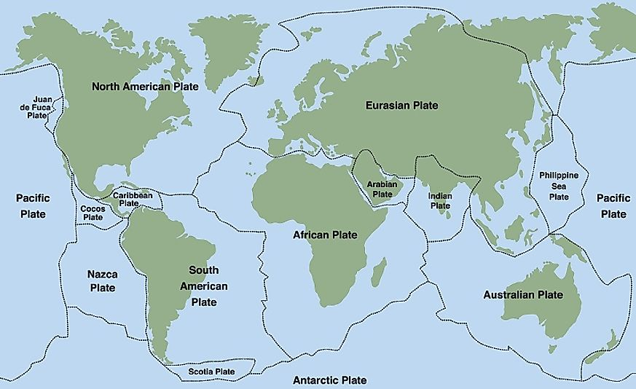

Population
Natural population change
A population will always have a birth rate and death rate, and natural population change is just accounting for those two values to find how much the population has either increased or decreased.
Birth and death rate is the average number of births/deaths per 1000 people in the population. To find the natural population change, we just need to subtract the birth rate by the death rate:
birth rate – death rate = natural population change
(all per 1000 people)
Net migration
Separate from natural population change, migration is another factor in the increase and decrease of a country’s population, depending on immigration and emigration.
The formula for net migration is simply:
immigrants – emigrants
(all per 1000 people)

Overall population change
Just the population change but this time accounting for the migrants.
natural population change + net migration (keeping negative sign if there are more emigrants)

Other numbers
- GDP per capita (gross domestic income per person)
GDP of a country divided by population. Used to measure the economic wealth of a country compared to its population size.
- Fertility rate
Births per woman in the population, used as a factor in population growth. Factors such as the average age of marriage for women, culture and education affect this.
- Infant mortality rate
The number of infant deaths per 1000 infant births. Used to see how advanced the country’s healthcare system is along with other factors. Often, a high fertility rate is associated with a high infant mortality rate, as people birth more children with the expectation that some will die.
- Life expectancy
Basically, the average age a person is expected to live until in a population.
- Literacy rate
The percentage of people in a population that are able to read and write. Helps understand the effectiveness of the country’s education system and stuff.
- Population density
Number of people per area unit in the country, usually km².

Factors that affect population
- Government policy
Government policies are the strictest of ways to artificially increase or decrease the growth rate of a population. A famous example of this is China’s previous one child policy. These policies are often not used due to the great repercussions in human rights and ethics.
- Government incentives
Incentives are rewards for following a certain criteria the government wants, so it still gives the person the right to decide. Incentives are often used in developing countries where the population growth rate is too high, and rewards are given to those who have a lower amount of children.
However, incentives are also used in highly developed countries where the growth rate is minimal and the population is small. Rewards are given to people who have more children. Usually, the reward is more financial support for raising the child.
- Education
The education of the people of a country play a great role in how its population grows. LEDCs usually have a higher population growth rate and density as people are uneducated on the consequences of having too many children, and are not sex educated, not knowing to use birth control and family planning. General health and hygiene education also reduces health problems.
- Religion
To certain religions, birth control, family planning and abortion are not allowed, which can increase the population and its growth rate.
- Healthcare
A MEDC with better healthcare; better hospitals, improved medicine and a better availability of doctors can reduce the number of deaths by preventable diseases, and infant mortality rates will also go down. Overall, life expectancy increases which decreases the death rate and improves the growth rate.
But, when LEDCs with a previous pattern of high fertility and growth rates and high death rates improve their healthcare, this can result in a very big increase in population as the death rate has decreased significantly while the growth rate has stayed high.
- Women’s age of marriage and careers
When women are married at a younger age, they have more childbearing years, so the fertility rate is often higher when this happens, increasing growth rate. This can happen due to culture, religion or lack of education.
Where women aren’t educated, they can’t have a proper career, which leads them to be only housewives, so they have more children than they would have if they had a job.
As you can see, these instances happen most often in LEDCs, where there is little education, especially for women.
- Children as a source of labor
Many families in LEDCs have many children to work and support their families, mostly in agricultural societies or

Factors affecting population density
Although many reasons can overlap with the previous section, this section is dedicated solely to population density; why some areas of a country have a denser population than others, or why some countries have a denser population than others.
- Resources of the area
An area with fertile soil gives way to agricultural activities and farming, supplying the people with jobs and a way of sustaining their food needs, so more people will live on fertile land.
An area rich in rock minerals can become a hotspot for mining and extraction, so people live in that area to work and sell the products.
- Facilities in the area
If the area has more schools and hospitals, more people will want to live there. This also applies to facilities which present job opportunities, and facilities that supply food and similar needs.
- Bodies of water
Nearby bodies of water also affect agricultural activities and also act as a source of water for many other uses. Fishing provides jobs and a source of food. Water bodies also work as a transportation route. Because of this, population is usually most dense on the coast or on riversides.
- Weather and climate
An area with a more suitable climate for living (non-extreme temperatures, few natural disasters, fresh air, etc) and good weather will usually have a denser population.
- Topography
More level land will be easier to build on. The land needs to be solid, too – marshy areas and sandy deserts are hard to build foundations on. Mountains’ steepness also makes it hard to live there.
Consequences of overpopulation
There will not be enough resources for everyone due to the unfit ratio of resources to people, and there will be a higher rate of poverty (low GDP per capita), which also contributes to crime rates, decrease of literacy rates due to lack of education, and lack of proper healthcare.
Waste management, air and water pollution becomes nearly impossible to handle as the population produces so much of it each day. Lack of sanitation stemming from this affects the health of the people.
Population density will rise, and it will be harder to build enough housing for everyone in the country as there is not enough area. Because people are living so close to each other, this can also cause increased disease levels and faster spread of illnesses.
Consequences of underpopulation
When a country is underpopulated with a low birth rate, this can lead to underlying problems of high dependency, especially when the older age group is not in balance with the younger age group. On a small scale, this can be that a single child has to financially support multiple other people – their parents, grandparents, their children and other members in the dependant group. Without much other people to carry the financial and working burden, it makes life poor and difficult.
Without enough people in the workforce of a country, this can significantly affect the country’s economy. Education and healthcare are also negatively affected due to the lack of doctors and teachers. Every industry will be affected due to the lack of workforce. This also results in underutilization of the land’s resources, such as coal and minerals, because there are not enough people working to extract them. This often leads to the country depending on imported labor.
One More Case Study and I Will End It All
Nigeria – overpopulation
Numbers
- Population of 175 million people in 2013
- Over 60% of people living off less than 1 dollar a day
- Incredibly dense – area is only 3% of Africa, but is home to over 15% of its people
Australia – underpopulation (it’s the vegemite)
Numbers
- Population of less than 25 million people
- Area approx. 8 million km²
- Export value : $259 billion
- Import value: $239 billion

- Agricultural products
  - Wheat
  - Barley
  - Cattle
  - Sheep
  - Poultry
  - Sugarcane
- Industries:
  - Mining
  - Transporta-tion equipment
  - Chemicals
  - Food processing
  - Steel
  - Oil production

Niger – high natural growth rate
A country in West Africa, named after Niger river.
Features:
- Land-locked
- Climate is hot and dry
- Besides ethnic groups, people are mostly nomadic
- Work is usually as sedentary farmers or by raising livestock
Numbers
- In 1960, population was 1.7 million
- In 2013, population was 17 million
- In same year, more than half of the population was 15 years old.
- Growth rate of 3.4%
- Expected to reach 56 million by 2030
- High fertility rate – over 7 births/woman

High growth rate especially caused by healthcare improvements while the fertility rate stays high.

Russia – decline in population
Numbers
- In 2013, population was 143 million
- In 1991, when the USSR collapsed, Russia’s population was at its peak, but decreased due to the higher death rate than birth rate.
- Male life expectancy is 64 years
Features
- High number of alcohol-related deaths
- High levels of HIV/AIDS, heart disease and tuberculosis
- Women are highly educated, do not want children
- Many emigrants, looking for a better lifestyle
Qatar – international migrants everywhere
General
- Before 1930, Qatar was poor and working mostly in pearl fishing.
- The Japanese started making artificial pearls, collapsing Qatar’s main source of income.
- In 1935, Qatar started receiving income from selling oil.
- The oil peak was after WWII, and the country became independent in 1971.
- GDP per capita of $92501
- Lots of imported labor
  - Locals don’t want to work, especially low-income service work.
  - The indigenous population do not have the education or skills.
  - Locals don’t find the need to work.

Italy – high dependency
Numbers
- Population is more than 60 million
- Population density of 201/km²
- Most dependants are 0-14 years because few people reach 64 or over.

Japan – high population density
Japan has a very high population density of 350/km², and the people are not spread evenly, living mostly concentrated in urban areas and high-density rural areas as well. This is due to the fact that Japan has many mountainous areas, and the population mostly resides along the flat coasts.

Republic of Namibia – low population density
General
- South-west of Africa, along the Atlantic coast
- Gained independence in 1990
- Low GDP per capita of $7900
- Population density of 2.6/km²
- Mostly desert
- Dry and hot climate, little rainfall
- Economy based off extracting and processing minerals such as diamond and uranium
- Only 3% of population are in aforementioned industry
- Half the population rely on subsistence agriculture
China – government policy
The one-child policy was placed by the Chinese government from the early 1970s to the late 1980s, which outlawed having more than one child. Done to decrease China’s massive population by decreasing the birth rate, it was technically effective, but many consequences came after it:
- Due to Chinese culture, sons were always preferred over daughters, so people would often abort their fetus after finding out its a girl. Other times, they would orphan, abandon, or even kill the baby if it was a girl.
- This resulted in a very large percentage of the new generation to be boys, with very little girls.
- Sometimes, sterilization was forced upon women to stop them from giving birth.
- Exceptions for this policy were if the parent gave birth to twins, or if the firstborn child was handicapped.

Developed in 1935 by Charles F. Richter
Also, andesite is acidic and basalt is basic
Can also be called mortality rate
People migrating into the area
People migrating out of the area
Infants being children under a year old.
Less economically developed countries
More economically developed country
by the age of 30, ability to give birth starts to decline
Dependants (young children and old people) are not in the workforce and are economically dependant on the working force (working parents) to support them.
Sedentary farming is done without rotating fields, so it happens all in one place, usually grown year by year. Because of this, the field soil becomes less nutrient rich.
Subsistence agriculture is farming only for one’s food needs, without selling anything.
Future repercussions on how the next generation will arrive

