4/8/2019

Niklesh Shakya

Expense Tracker

User Manual

Contents

**1** **Installation Guide** 2

**1.1** **Provided Material** 2

**1.2** **Steps to Setup** 2

**2** **User Manual** 3

**2.1** **Registration** 3

**2.2** **Log In** 4

**2.3** **Dashboard** 4

**2.4** **Expense Category** 8

**2.5** **Daily Expense** 10

**2.6** **Report** 11

**2.7** **Change Password** 13

**2.8** **Logout** 15

INTRODUCTION

Expense Tracker system is developed for the purpose of tracking the day to day expenses of the System user. We expend our money on daily basis, the expenses might be big or small. Once we expend the money we might even forget the amount of expenses made.

Expense tracker is developed as a solution to this problem. You can record your daily expenses on the basis of category and generate reports to view total amount of money expended and the no of expenses made. You can even get the information on which category you are expending most of your money.

# **Installation Guide**

Process to install the application.

## **Provided Material**

* Expense tracker application zip file
* Database backup and script

## **Steps to Setup**

* Restore the backup of the database or run the script file by creating the database
* Unzip the application file
* Change the database settings in the webconfig file
* Host the application file in IIS server or open the application using visual studio and run the application.
  + For reference please check this:- <https://www.youtube.com/watch?v=IwbKquNBNgQ>

# **User Manual**

Guide to run the software from starting.

## **Registration**

You must be registered in the system to keep track of your daily expenses.

* **To create a new user,** click on the register button on the login form.

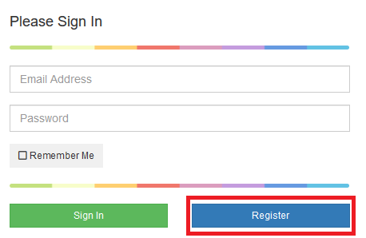

* After clicking the register you will be redirected to the register page.

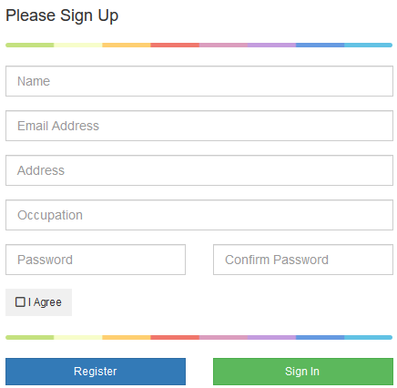

* Fill up the required fields and click register. Once the registration is successful you will be redirected to the dashboard.

## **Log In**

* **To Log in,** insert the registered user name and password and click sign in. Once the sign in is successful you will be redirected to the dashboard.

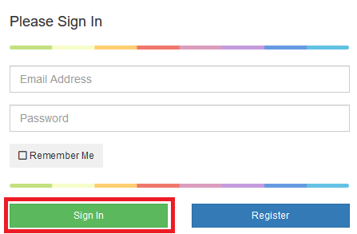

## **Dashboard**

The dashboard consists of various components to help you keep track of your expenses.

* **Expense Limit: -** Expense Limit can be added to the system, so that the system can keep track of your expenses and alert you in case, you have exceeded your expense limit for a day.



You can add expense limit by clicking **Add Limit.**



Once the expense limit is exceeded you will be alerted with above notification. You can review your expenses, to figure out where you have expended your money by clicking on **Review Your Expense.** 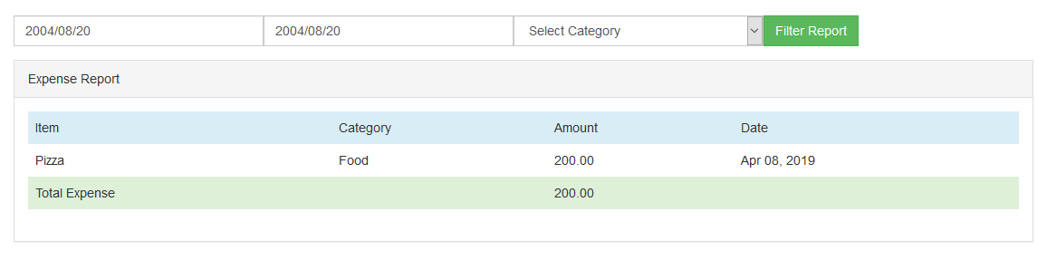

You can later change your expense limit by clicking on **settings** on the side menu .

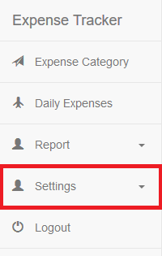

Once the Settings is expanded click on **Expense Limit** to update your limit.

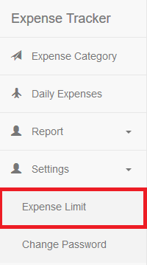

* **Counter: -** The application consist of various counter to provide you with numerical data so that you can keep track of your expense, Total expense and no of expense done today.

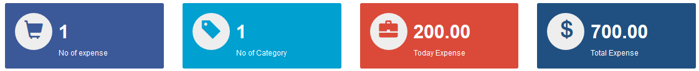

* **Charts: -** The application consist of Pie chart and Line Chart.

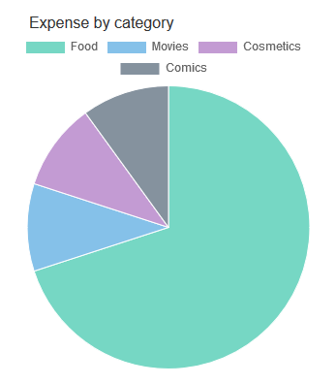

The pie chart displays the total no expenses on category basis. By looking at this chart you can figure out on which category you have expended your money most.

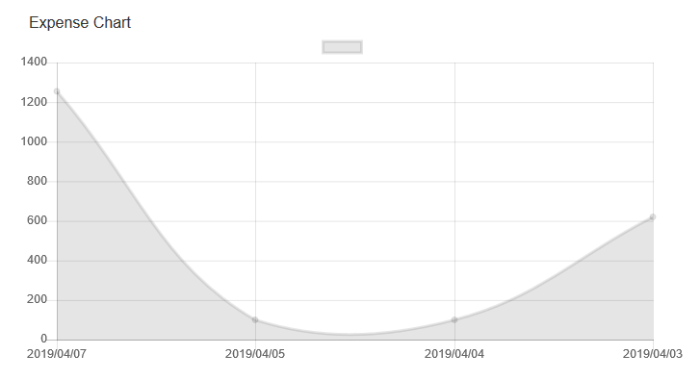

The line chart displays your total amount expense on daily basis. By looking at this chart you can figure out on which day you have expended your money most.

* **Recently Added Category: -** This module displays the recently added 5 categories, you can also view all the categories by clicking on **View More**

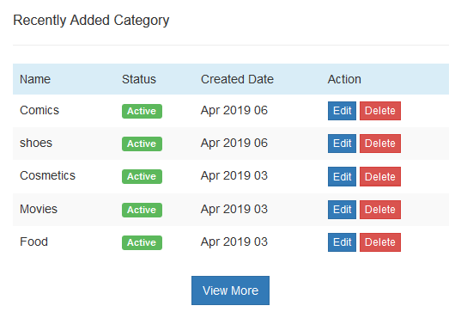

* **Recently Added Expense:-** This module displays the recently added 5 expenses, you can also view more expenses by clicking on **View More**

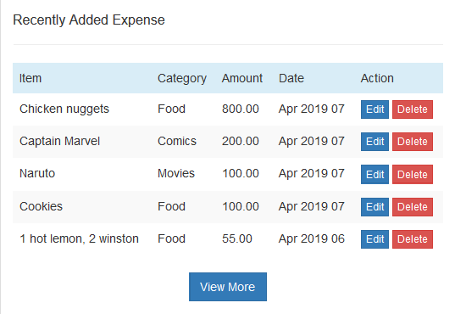

## **Expense Category**

Expense category is one of the most important setup for expense tracker. You can create your expenses on the basis of expense category. Expense category can be anything like Food, Movies, Shoes, and Medicine etc.

* **To open expense category,** Click on **Expense Category** on the side menu. 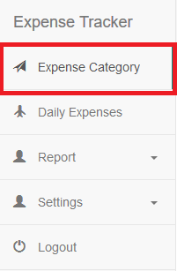
* After clicking Expense Category you will be redirected to the **Expense Category** page which consist of category list, search and filter by status, once you are on the **Expense Category** page click on create to start creating category.

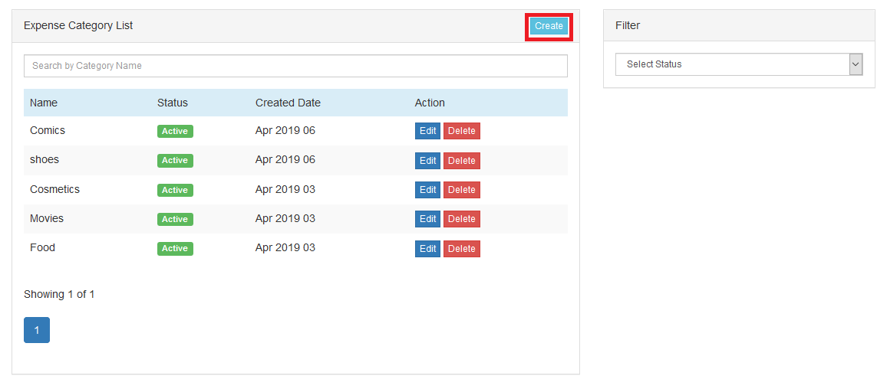

* After clicking Create you will be redirected to the **Expense Category form** where you can create your category.

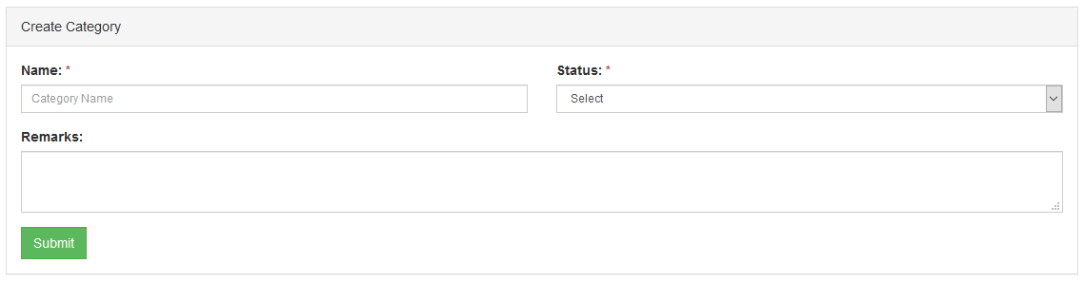

* **Expense Category list,** consist of Ajax search, Ajax pagination and Ajax filter. You can Search category on the basis of category name and filter the list on the basis of status.

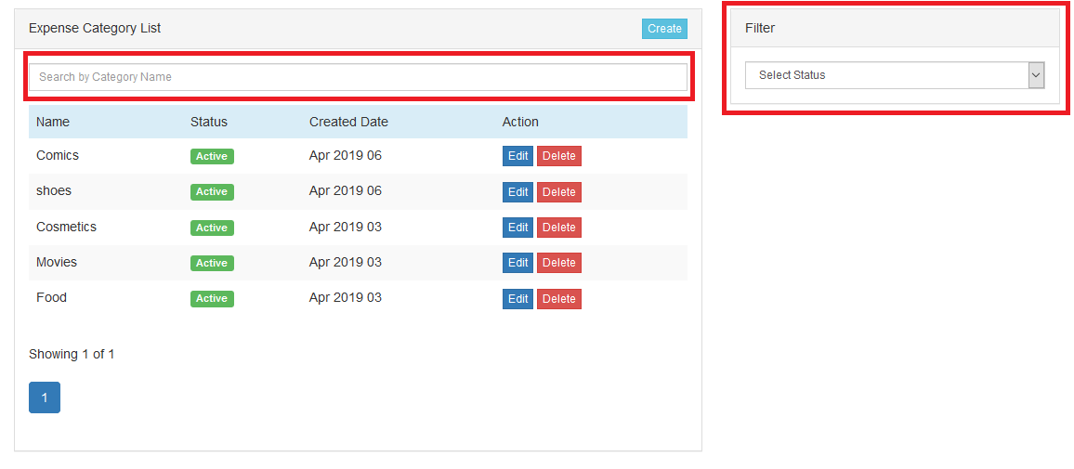

## **Daily Expense**

Daily expense is the core module of our application. Here you can add you daily expenses based on the category. Expenses can be added on the base of item name, amount, category, date of transaction, description.

* **To open Daily Expense,** Click on Daily Expense on the side menu.

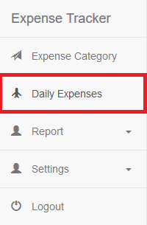

* After clicking Daily Expense you will be redirected to the **Daily Expense** page which consist of Expense list, search and filter by date range, once you are on the **Daily Expense** page click on create to start creating category.

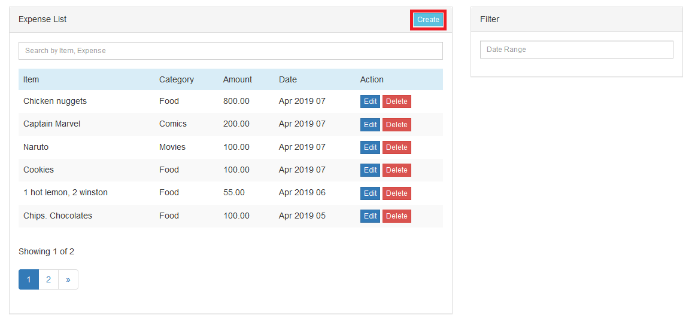

* After clicking Create you will be redirected to the **Daily Expense form** where you can create your Expenses.

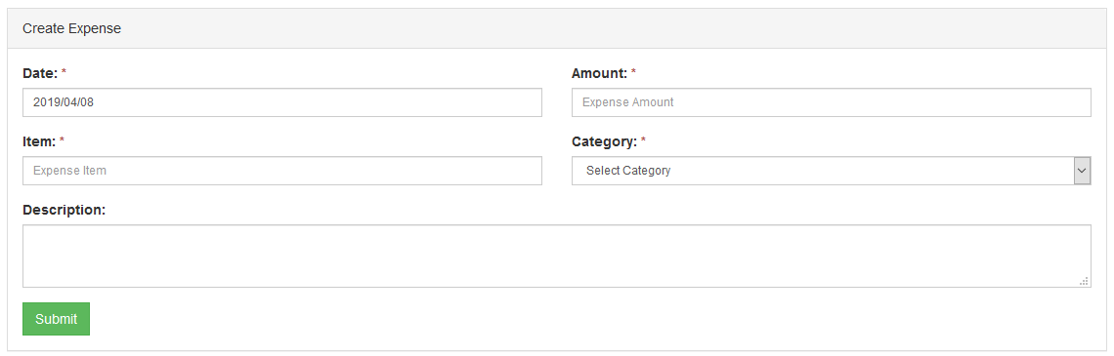

* **Daily Expense list,** consist of Ajax search, Ajax pagination and Ajax filter. You can Search expenses on the basis of category name, item name and filter the list on the basis of date range.

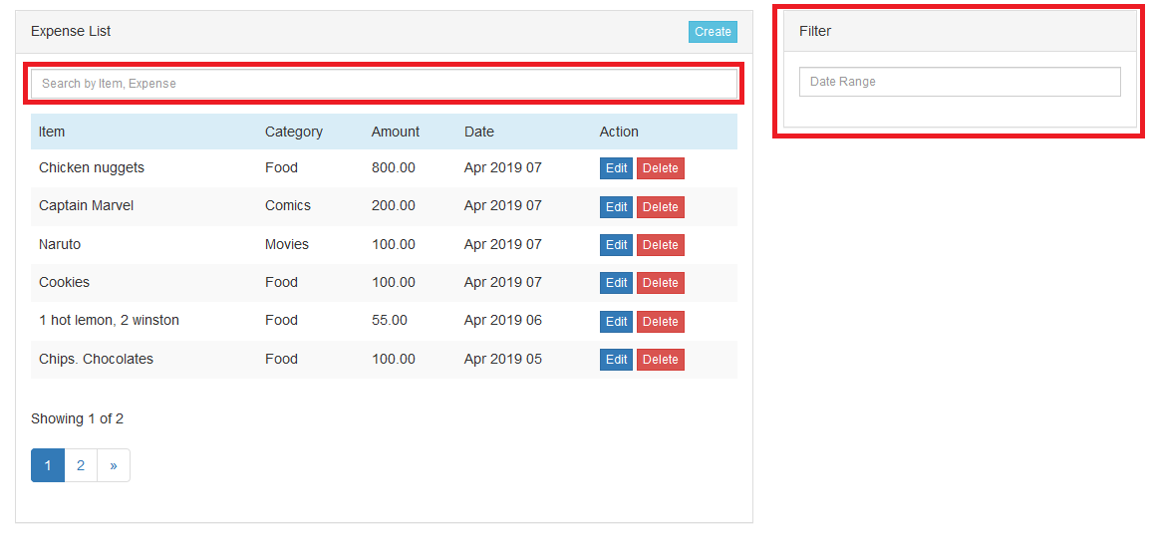

## **Report**

The system generates report on the basis of expenses. The report provides you the information about the total expense. The report can be generated on the Basis of Start date, End date and category. To generate report it is not mandatory to select all of them. We can also generate report individually by only selecting category, Start Date or End Date.

* **To open Report,** Click on Report on the side menu.

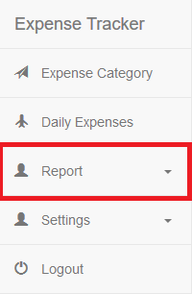

* After clicking on report the menu will expand, then click on **Expense Report** to view Report. Expandable menu is used so that in future we can add more reports.

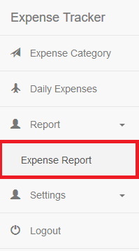

* **Expense Report** provides us the information about the total expenses made. We can use the filters to get daily total expense, monthly total expense, yearly total expense and expenses on category basis.

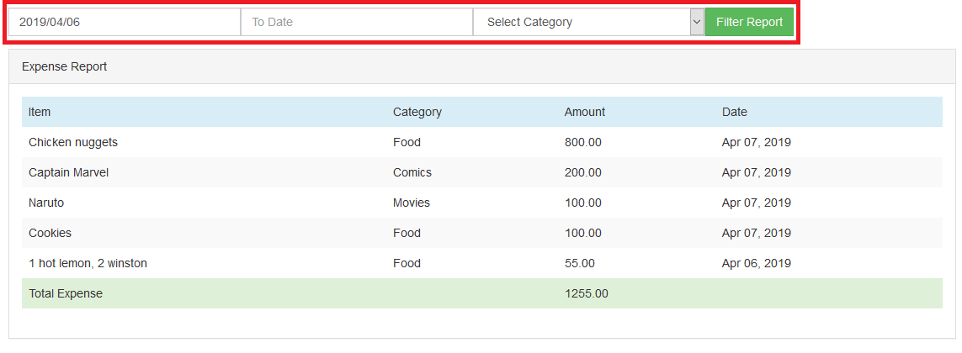

## **Change Password**

You can change your password whenever they want. For security basis it is recommended to change the password once a month.

* **To open change password,** Click on Settings on the side menu.



* After clicking the settings and choose **change password,** you will be redirected to the change password page.

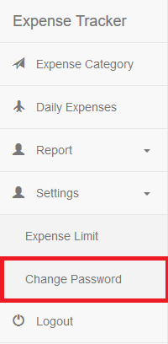

* **Change the password,** by putting your current password, new password and confirm password.

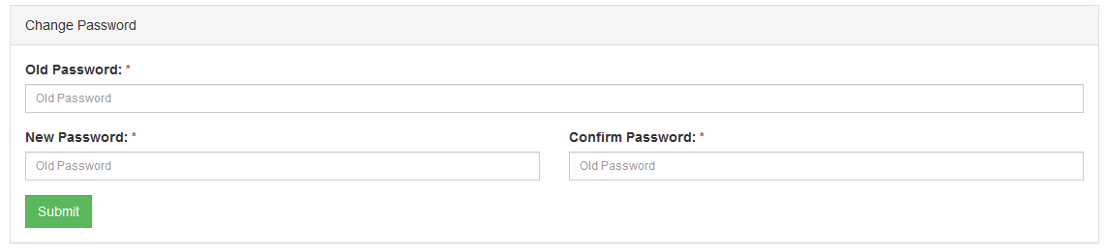

## **Logout**

You need to logout from the system once you are finished using the system.

* **To Logout,** Click on the logout option on the side menu.

