Question 1 : Elaboration MCD
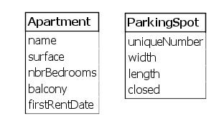
Surface in meter^2
Balcony is a boolean

Width and length in meters
Closed is a boolean

Question 2 : Traduction MCD
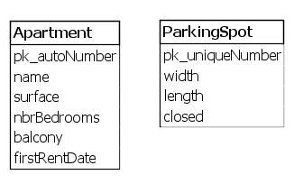
Pk_autoNumber is a surrogate key

Question 3 :
b)
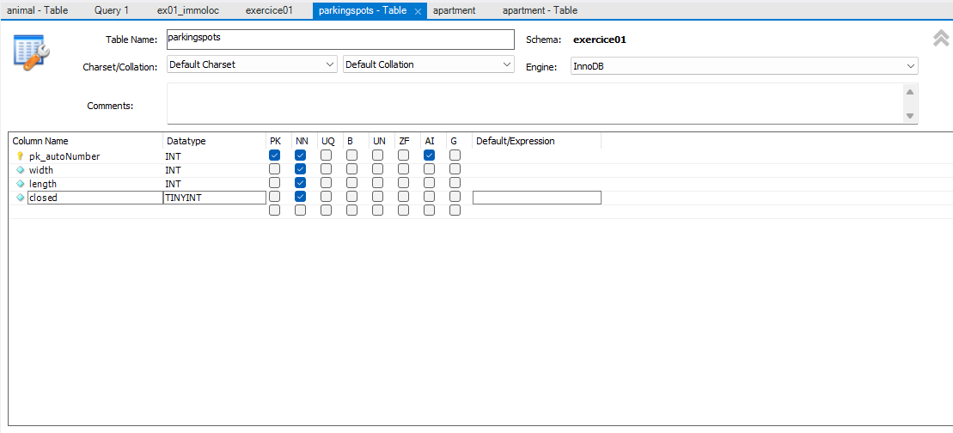

Question 4 :
There’s nothing to validate…? (Button “Apply” to apply changes of a table

Question 5 :
- Tinyint: 0 false; 1 true
- Type: date; dekimited: yyyy-mm-dd

Question 6 :
No, everything is already respecting the camelCase naming convention.

Question 7 :
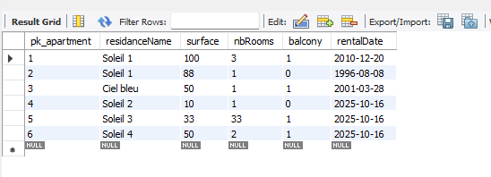

Question 8 :
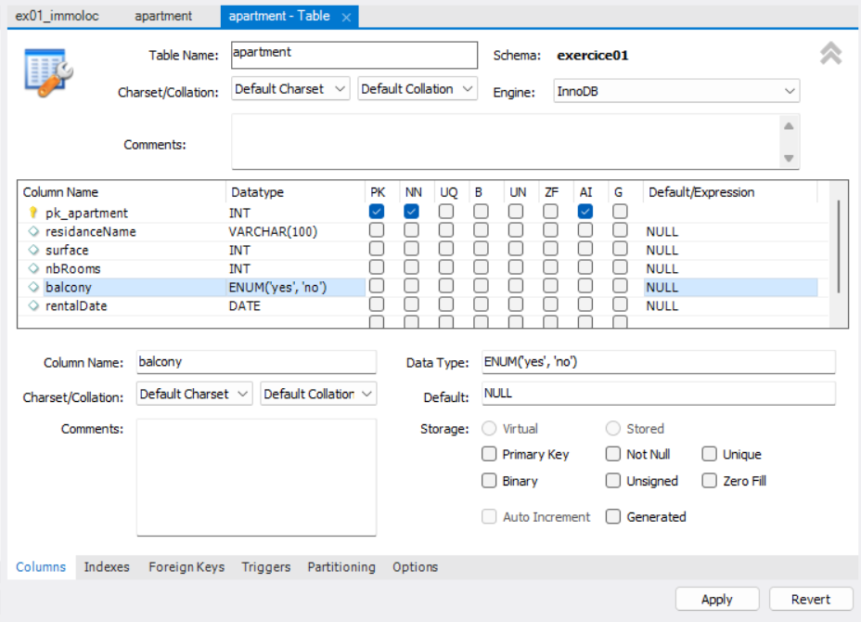
ENUM(‘yes’,’no’)
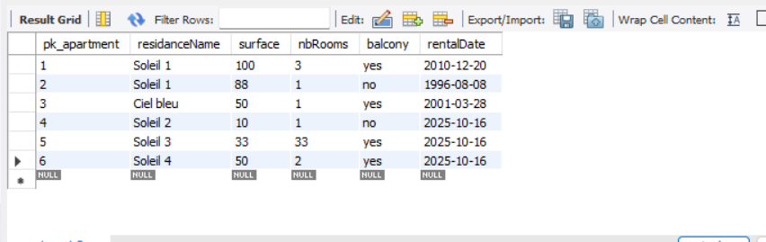

Question 9 :

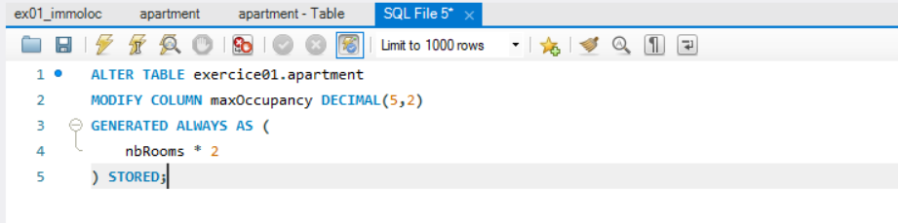
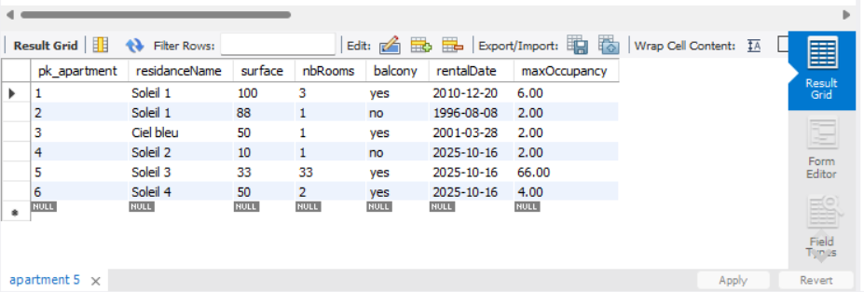

Question 10 :
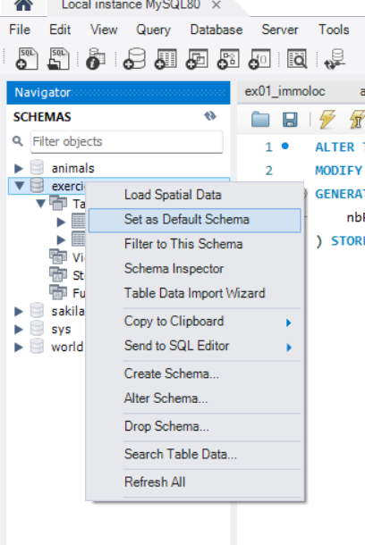

Question 11 :
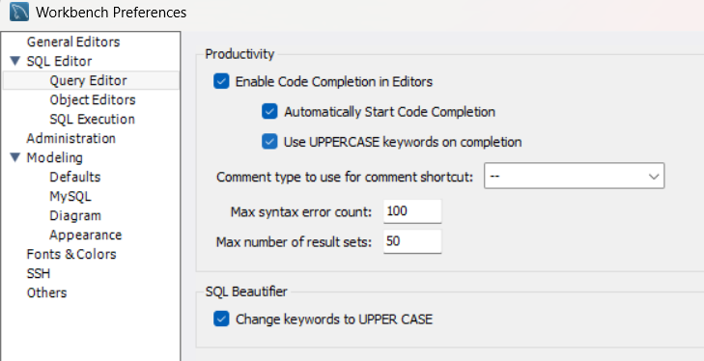

Question 12 :
- Query
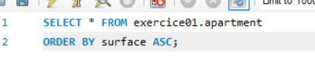
Output
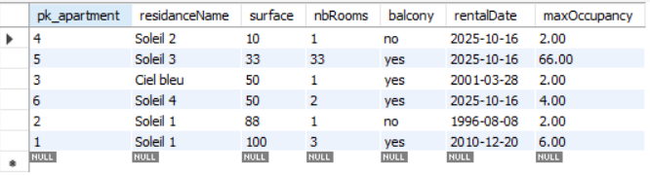

- Query
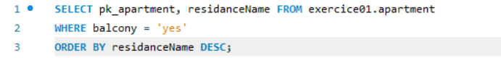
Output
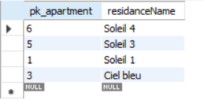
- Query
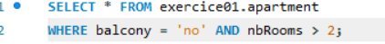
Output
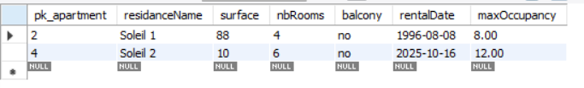
- Query

Output
