!= verbessert mysql kucken

Question 1:
Either it’s null or it’s an empty string “”

Question 2:
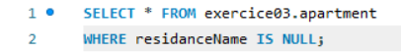
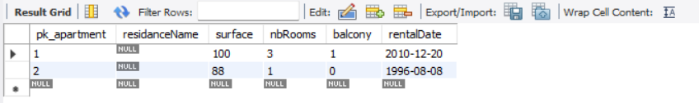
Pay attention to? IS NULL not = NULL

Question 3:
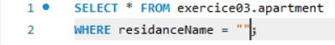
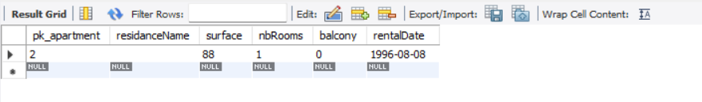
- Look for “”, not for null value

Question 4:
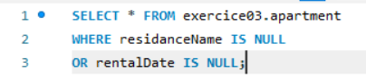
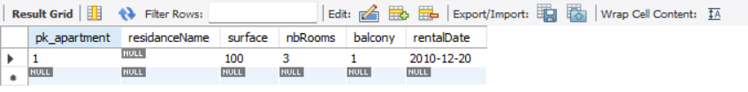

Question 5:
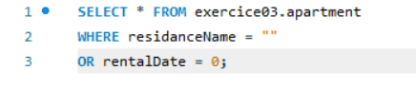
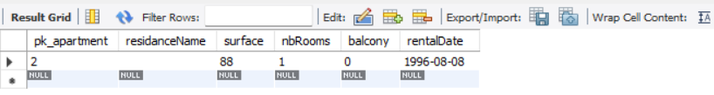

Question 6:
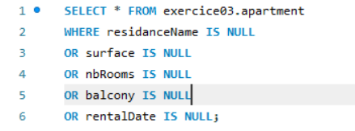
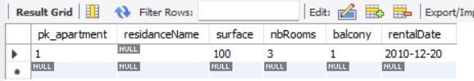

Question 7:
