Question 1:
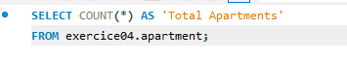
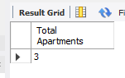

Question 2:
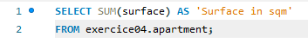
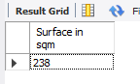

Question 3:
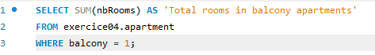
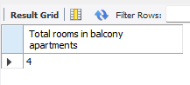

Question 4:

Question 5:

Question 6:

Question 7:

