Python Visualization Libraries Guide
Matplotlib & Seaborn

nk

Introduction
Matplotlib and Seaborn are among the most commonly used Python libraries for data visualization, particularly within data science and analytics workflows. In this guide, I will introduce both libraries through practical, beginner-friendly examples, explain where each of them fits best, and demonstrate frequently used plot types with clear code snippets to help build an intuitive understanding of their usage.

Matplotlib Overview

Matplotlib is one of the core plotting libraries in Python and serves as the foundation for many other visualization tools. It is highly flexible and capable of producing almost any type of 2D visualization, along with support for certain 3D plots. The library provides a low-level but powerful interface that allows you to control figures, axes, and individual visual elements with a high degree of precision.

Key Features:
- Offers fine-grained control over every component of a plot, including axes, ticks, markers, colours, and layout
- Supports multiple coding styles, such as the object-oriented approach (fig, ax = plt.subplots() ) and the pyplot style (plt.plot(...))
- Works seamlessly across environments including Jupyter notebooks, Python scripts, and GUI applications, with support for exporting figures in various image formats

Typical Use Cases:
- Creating customized scientific and engineering visualizations
- Designing publication-ready figures where precise formatting and layout are important
- Embedding plots inside dashboards, GUI tools, or interactive applications

Seaborn Overview

Seaborn is a high-level statistical data visualization library that is built on top of Matplotlib. It is designed to work primarily with tabular datasets, especially pandas DataFrames, and enables users to create visually appealing and insightful statistical plots with relatively concise and readable code.

Key Features:
- Provides a dataset-oriented API, where variables are passed directly from DataFrame columns (for example, data=df, x="col", y="col2")
- Includes built-in support for statistical estimation, confidence intervals, regression plots, and distribution-based visualizations
- Offers integrated themes and color palettes, allowing plots to look polished and consistent without requiring extensive styling

Typical Use Cases:

- Performing exploratory data analysis (EDA) using structured datasets
- Visualizing variable distributions and relationships across multiple dimensions
- Quickly generating complex, multi-facet visualizations with minimal code effort

Matplotlib: Common Graph Types

Line Plot
A line plot connects individual data points with straight lines, making it useful for visualizing how a variable changes continuously over time or distance. It is commonly used to highlight patterns, trends, and fluctuations in sequential data.

Typical Use Cases:
- Visualizing time-series data such as stock prices, temperature variation, or sensor readings
- Plotting mathematical functions or continuous relationships between variables

Code Example:
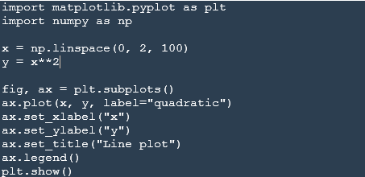

Output:
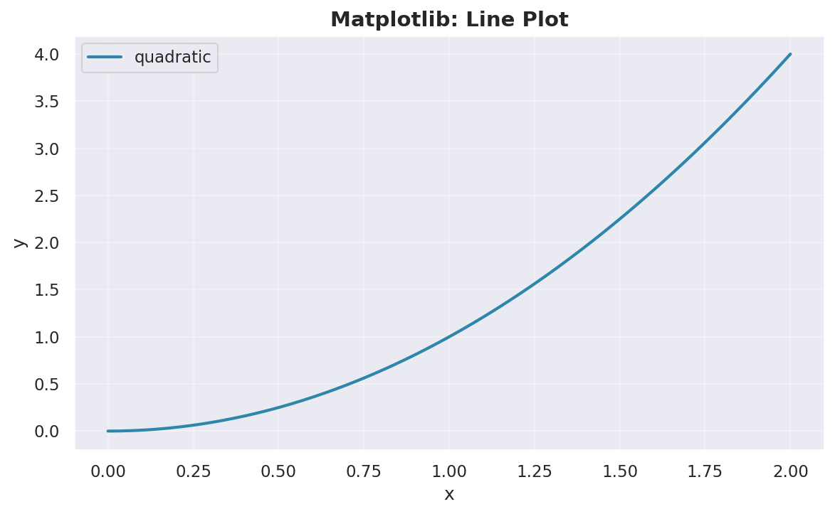

Scatter Plot

A scatter plot represents individual data points using markers, allowing you to visually examine the relationship between two numerical variables. It is particularly effective for identifying patterns, clusters, and potential correlations within the data.

Typical Use Cases
- Exploring correlations between variables
- Detecting clusters or data groupings
- Observing trends or anomalies in paired datasets

Code Example:
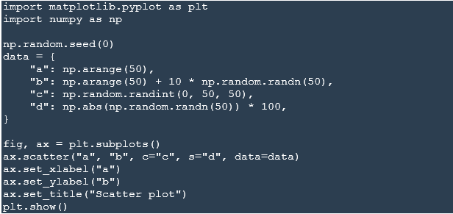

Output:
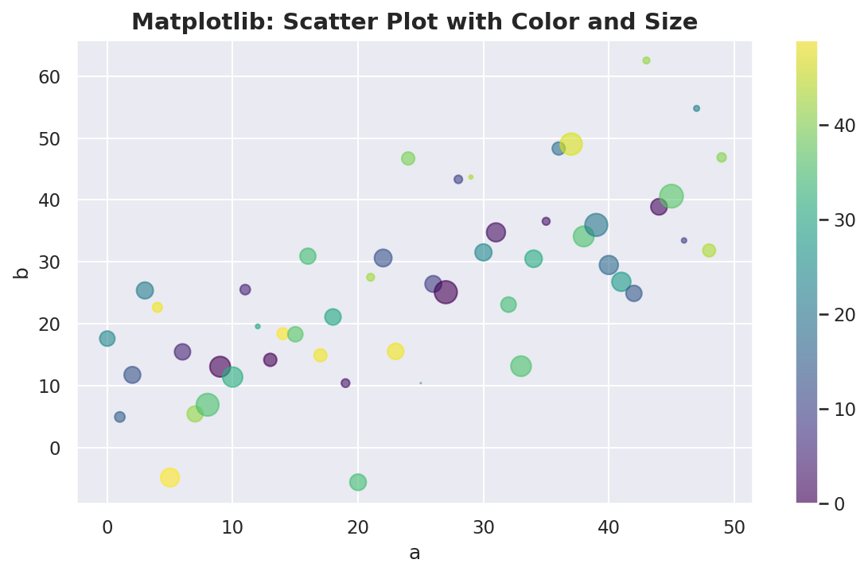

3. Bar Chart
A bar chart displays data using rectangular bars, where the height (or length) of each bar corresponds to the value of a specific category. It is well-suited for comparing quantities across discrete groups or labels.

Typical Use Cases
- Comparing sales or revenue across different products or regions
- Visualizing category-wise counts or frequencies
- Summarizing grouped or aggregated data

Code Example:
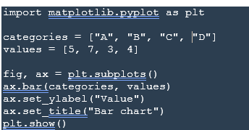

Output:

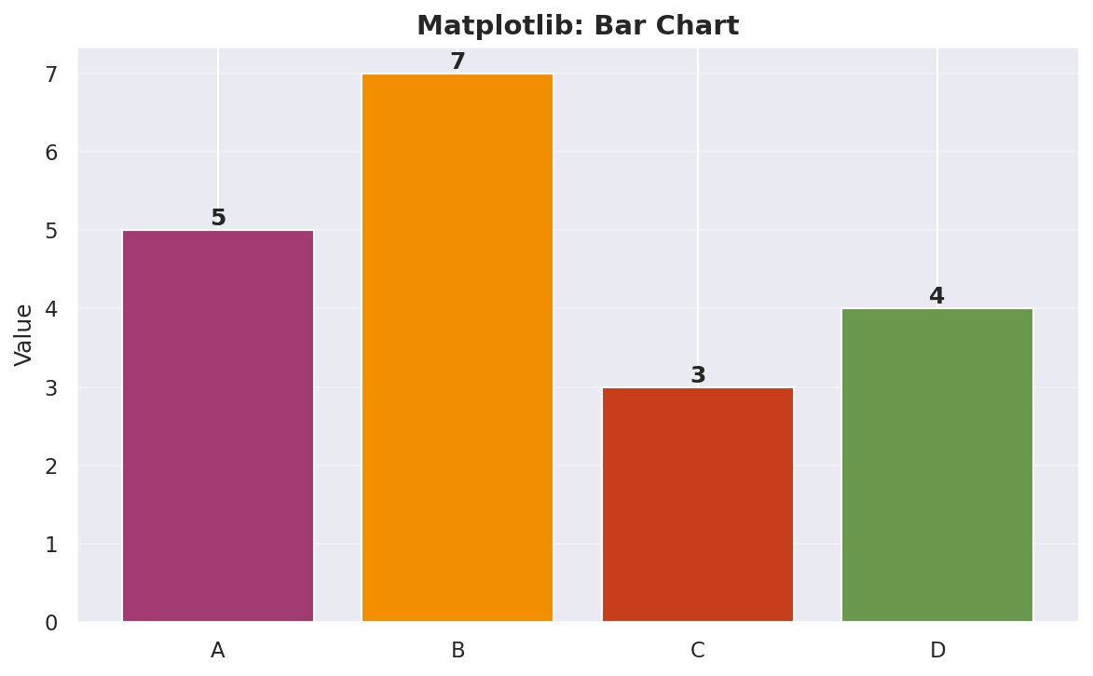

4. Histogram
A histogram divides a continuous variable into intervals (bins) and displays how many data points fall within each range. It is commonly used to understand the underlying distribution, spread, and concentration of values in a dataset.

Typical Use Cases
- Examining the distribution of exam scores, ages, or measurements
- Understanding ranges and frequency patterns in numerical data
- Identifying skewness, outliers, or concentration zones within a dataset

Code Example:
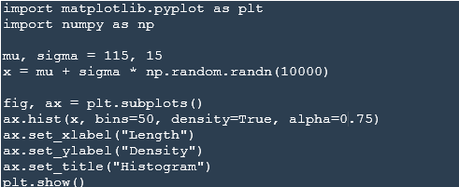

Output:
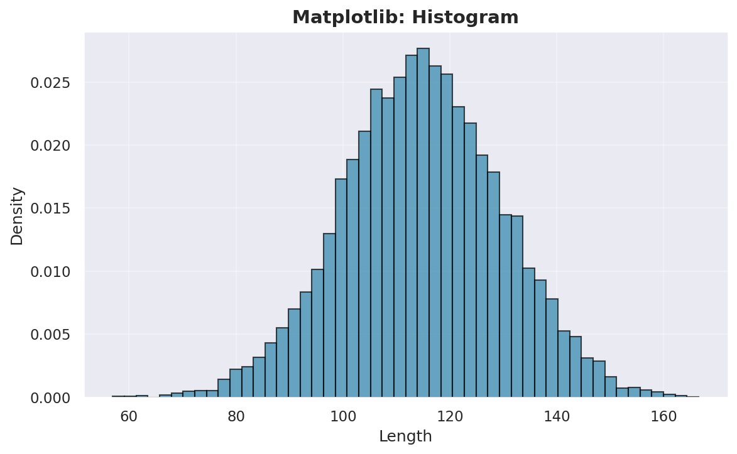

5. Pie Chart
A pie chart represents data as slices of a circular chart, where the size of each slice corresponds to its proportion of the total. It is best suited for illustrating how a dataset is divided among a small number of categories.

Typical Use Case
- Showing percentage or proportion breakdowns
- Comparing contribution of categories to a whole
- Presenting simple categorical distributions with limited groups

Code Example:
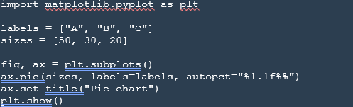

Output:

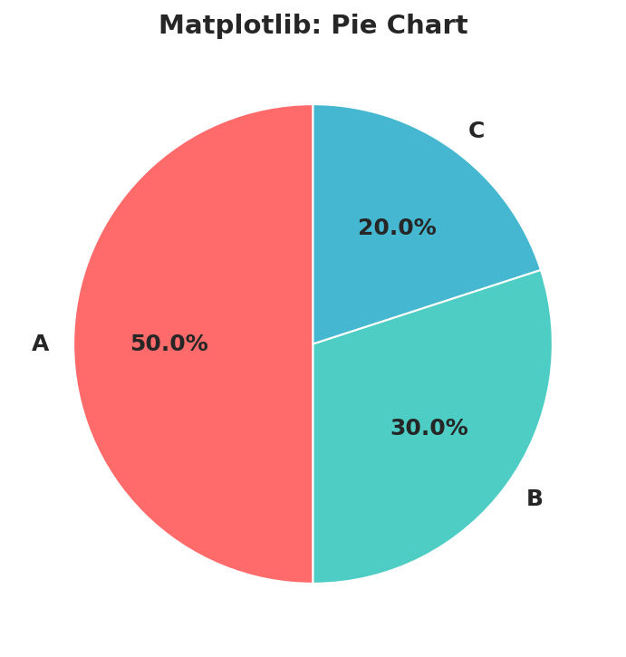

6. Heatmap / 2D Color Plot
A heatmap represents values on a two-dimensional grid, where colors are used to indicate the intensity or magnitude of each value. It helps in quickly spotting patterns, variations, and dense regions within structured data.

Typical Use Cases
- Visualizing correlation matrices in data analysis
- Representing image-like or matrix-based data
- Displaying function values or measurement intensity across a grid

Code Example:
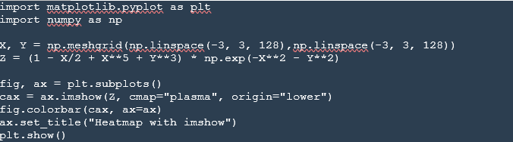

Output:
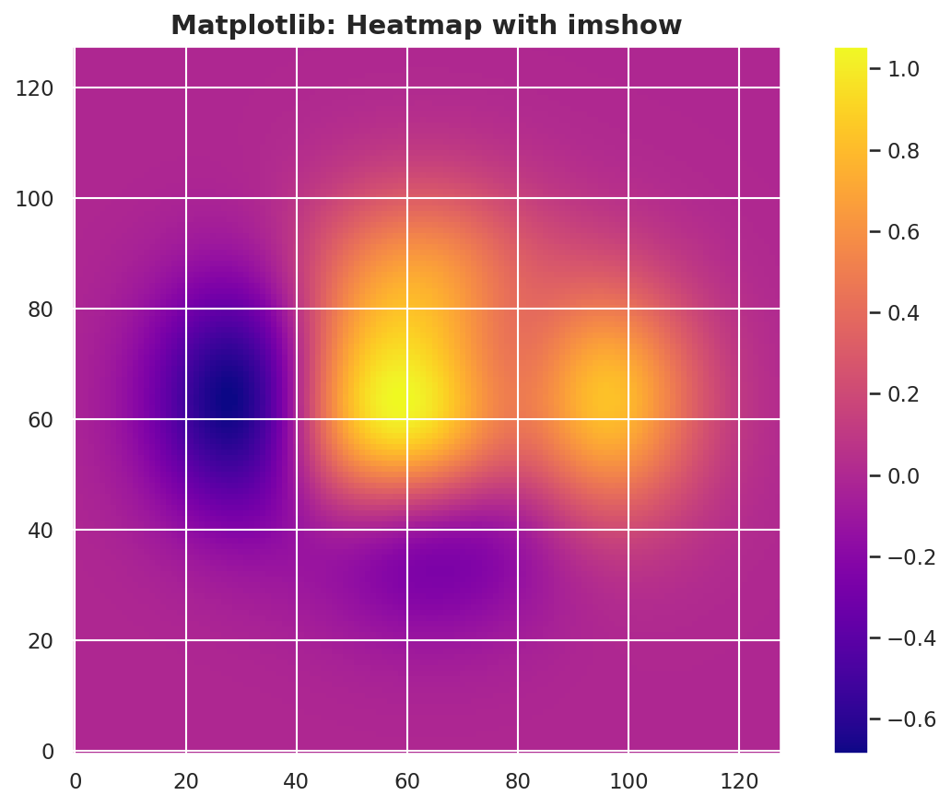

Comparison: Matplotlib vs Seaborn

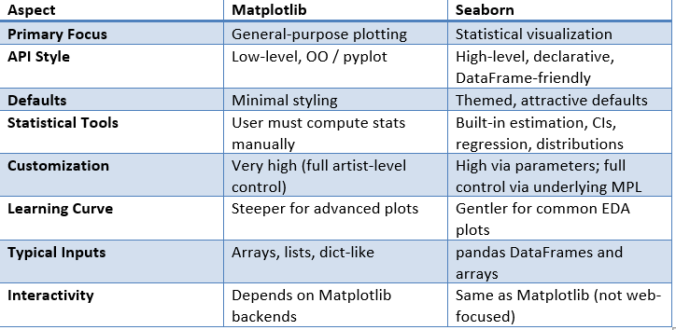

Ease of Use
Seaborn is generally more convenient for exploratory data analysis with pandas Data Frames, since you can directly pass the dataset (data= df) and map columns to semantic roles such as x, y, hue, or col. This makes it easier to create meaningful statistical plots with minimal code. Matplotlib, on the other hand, feels more intuitive when working with mathematical functions or when you prefer to think in terms of figures, axes, and explicit plot elements.

Customization
Matplotlib offers the highest level of control over a visualization. You can customize every aspect of a figure, including layout, annotations, scales, tick formatting, and multiple axes, which makes it particularly suitable for publication-quality graphics. Seaborn provides elegant defaults and high-level style options, but relies on Matplotlib underneath for deeper fine-tuning when needed.

Interactivity
Both libraries share Matplotlib’s rendering backends, meaning that interactivity depends more on the execution environment (such as Jupyter notebooks or GUI applications) than on the library itself. Neither Matplotlib nor Seaborn is primarily designed for rich, web-based interactivity, where tools like Plotly or Bokeh are usually more appropriate.

Performance with Large Datasets
Matplotlib can handle large numerical arrays effectively but may slow down when rendering a very high number of individual graphical elements, such as millions of scatter markers. Seaborn performs additional statistical grouping and aggregation, so it may introduce extra overhead on very large datasets. In such cases, it is often more efficient to pre-aggregate or sample the data in pandas before plotting.

Key Takeaways
- Use Matplotlib when you require fine-grained control, custom layouts, or highly polished, publication-quality figures.
- Use Seaborn when performing exploratory data analysis with pandas DataFrames and you want to generate statistical visualizations with minimal code.
- Both libraries work well together — Seaborn functions return Matplotlib axes objects, allowing you to apply additional customization within the same workflow.
- For beginners, it is often helpful to start with Seaborn to create quick visualizations, and then gradually learn Matplotlib to gain deeper control over styling and presentation.

Resources

- Matplotlib Quick Start Guide — https://matplotlib.org/stable/users/explain/quick_start.html
- Seaborn Introduction Tutorial — https://seaborn.pydata.org/tutorial/introduction.html
- Matplotlib Gallery — https://matplotlib.org/stable/gallery/index.html
- Seaborn Example Gallery — https://seaborn.pydata.org/examples.html

This guide is primarily intended for beginners who are getting started with data visualization in Python. For more advanced concepts, customization techniques, and in-depth functionality, learners are encouraged to explore the official documentation of each library.

