Sharing App on Ethereum

The following QR codes can be used with our smart contract based sharing app. Download the source code here:

https://github.com/UnSciPreneur/sharingDApp

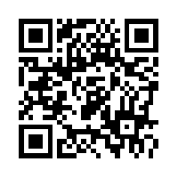

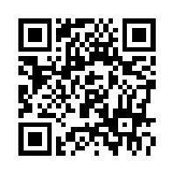
http://localhost:8080/?objId=23456
http://localhost:8080/?objId=12345

