English project
Group 4

Groupmate:
吴林洋_U202414639_task3
谢嘉枫_U202414642_task4
阮云轩_U202490035_task5
项威_U202414641_task2

Content
- task-2
- Sub-disciplines of Computer Science and Technology
- Research Areas
- Research object
- Research Methods
- Research significance
- Intersection with other displines
- task-3
- task-4
- task-5
  - Variety Fields which relate with Computer Science
  - Currently situation/challenge
  - Conclusion
  - Reference

Task 2
- Sub-disciplines of Computer Science and Technology
Artificial Intelligence

2. Research Areas
Including machine learning ,deep learning ,natural language processing, computer vision, intelligent robots, expert systems, pattern recognition and other sub-fields.

3. Research object
Mainly various intelligent algorithm ,models and intelligence systems,
as well as their performance in different application scenarios.

4. Research Methods
A data-driven approach, which means training artificial intelligence by collecting , analyzing and leveraging large amounts of data, is adopted to train intelligence algorithms and models through a large amount of data, so that they can automatically learn and extract features and rules in the data.

- Research significance
Artificial intelligence has important application value in the fields of medical care, transportion, finance ,education, security, etc.it can bring great changes and development to human society.
- Intersection with other displines
The intersection with various disciplines is very close, and statistics ,such as mathematics and theoretical physics and biophysics. They are inspiring artificial neural network theories and models, which are not only one of the most important theoretical foundations of modern artificial intelligence, but also have achieved significant and extensive application results in many scientific fields in the past two years, and are changing or even subverting the research paradigm of many disciplines.
Task3
leading figures
"We noticed two leading figures in the field of computer science who received the Nobel Prize this year."
John J. Hopfield
The 2024 Nobel Prize in Physics was awarded to John J. Hopfield from Princeton University and Geoffrey E. Hinton from the University of Toronto for their groundbreaking work in artificial neural networks, which has significantly advanced the field of machine learning.
So, we have become curious about Hopfield. As we know, he is a scholar from the field of machine learning, engaged in artificial intelligence research. Therefore, questions arise, “Is this Nobel Prize a Physics Prize or a Mathematics Prize?” These voices are incessant, as if this award, which has always symbolized the highest honor in science, has suddenly become somewhat unfamiliar. However, if we set aside these surface-level debates, we can discover that behind this award lies a deeper scientific transformation and interdisciplinary exploration. The Nobel Prize in Physics may reveal a new direction for future scientific development through this controversy: perhaps it is in the technology related to computer science that you and I are currently learning or engaging in, such as the currently hot topic of artificial intelligence.

Let’s take a look at his achievements. As early as the 1980s, John J. Hopfield proposed the famous Hopfield Network. At that time, artificial intelligence was still in its infancy, and scientists were trying to make machines simulate the workings of the brain, but progress was slow. While observing how neurons work together, Hopfield discovered an interesting phenomenon: the interactions between neurons could be compared to the interactions in a physical spin system.

This idea inspired him. Based on his research into how the brain extracts and stores memories, he proposed the Hopfield Network model. In this network, it can store and retrieve data patterns, such as images or other types of patterns, utilizing the energy minimization principle from physics for data recovery. This model laid the early theoretical foundation for neural networks and has been widely applied in machine learning and artificial intelligence. It not only brought new ideas to neural network research but also introduced concepts from physics into the realm of artificial intelligence.

Undoubtedly, Hopfield’s work provided a foundation for the intersection of contemporary artificial intelligence and neuroscience. His research has not only advanced the development of machine learning but also influenced our understanding of how the biological brain works. By integrating physics, computer science, and biology, he made immeasurable contributions to the early development of artificial intelligence and neural networks.

The awarding of the 2024 Nobel Prize in Physics once again demonstrates that the boundaries of science are constantly expanding. The success of John J. Hopfield showcases how computer science can combine with various fields to create a new direction for research. His success reminds us that innovation often arises at the intersection of different disciplines, and combining diverse ways of thinking may lead to groundbreaking results.

Geoffrey E. Hinton
Another awardee, Geoffrey Hinton, has also captured our attention. This scholar has made an indelible contribution to the field of artificial intelligence and is known as the "father of deep learning." He is one of the pioneers of the backpropagation algorithm and developed the well-known "restricted Boltzmann machine" model. His research has helped drive the widespread application of deep learning in areas such as computer vision and speech recognition. Thus, we consider him a leading figure in our field of computer science.
Hinton was born in 1947 in London, England. He obtained degrees in psychology and computer science from the University of Cambridge and earned his Ph.D. in computer science from the University of Edinburgh in 1975, focusing on neural networks and machine learning. Since then, Hinton has persistently explored this field, even when many scientists lost interest in it during the 1990s.
Let’s take a look at his achievements. Hinton made groundbreaking contributions to the training of multilayer feedforward neural networks, particularly with the deep belief networks proposed in 2006 with his students, marking the revival of deep learning. In the same year, he and his colleagues developed a method for pre-training networks using a series of stacked restricted Boltzmann machines. This pre-training provided a better starting point for connections within the network. In 2012, AlexNet, invented by Hinton and two of his students, won the ImageNet computer vision competition with overwhelming superiority, creating a milestone in the development of deep neural networks and inspiring extensive research adopting convolutional neural networks (CNNs) and graphics processing unit (GPU) acceleration for deep learning. This technology is now widely used in fields such as computer vision and natural language processing.
Subsequently, the DNNResearch he founded was sought after by tech giants like Google, Apple, and Baidu, ultimately being acquired by Google for $44 million. In 2018, Hinton shared the highest award in computer science, the Turing Award, with Yoshua Bengio and Yann LeCun, together known as the "deep learning trinity" or the "godfathers of AI." This underscores his significant standing in the field of computer science.
In summary, Hinton has dedicated his life to the continuous effort in neural networks and deep learning, achieving important breakthroughs at various stages. He inspires us to pursue deep learning, maintain our exploration, and strive for excellence in our respective fields.
Interestingly, they both have achieved interdisciplinary integration and research. This further underscores the importance of interdisciplinary collaboration. As university students, promoting innovation through interdisciplinary approaches allows us to combine knowledge from different fields, generate new ideas and solutions, and seamlessly switch between various domains to tackle multiple problems, thereby stimulating creative thinking. Engaging with diverse disciplines enhances our critical thinking skills, which is especially vital in today's information age.

Task4
China
1.Computer Simulation
2.Journal of computer science
3.Computer measurement and control
4.Small microcomputer system
5.Journal of computer aided designed and graphics
6.Computer engineering and science
7.Computer science(Journal of china computer federation)
8.Computer application research
9.Computer applications
10.Computer engineering
international
1.IEEE Transactions on Pattern Analysis and Machine Intelligence
2.IEEE Communications Magazine
3.IEEE Transactions on Image Processing
4.IEEE Communications Surveys and Tutorials
5.IEEE Transactions on Wireless Communications
6.IEEE Journal on Selected Areas in Communications
7.IEEE Internet of Things Journal
8.Pattern Recognition
9.IEEE Transactions on Neural Networks and Learning Systems
10.ACM Computing Surveys

Journal of Computer Science(monthly)
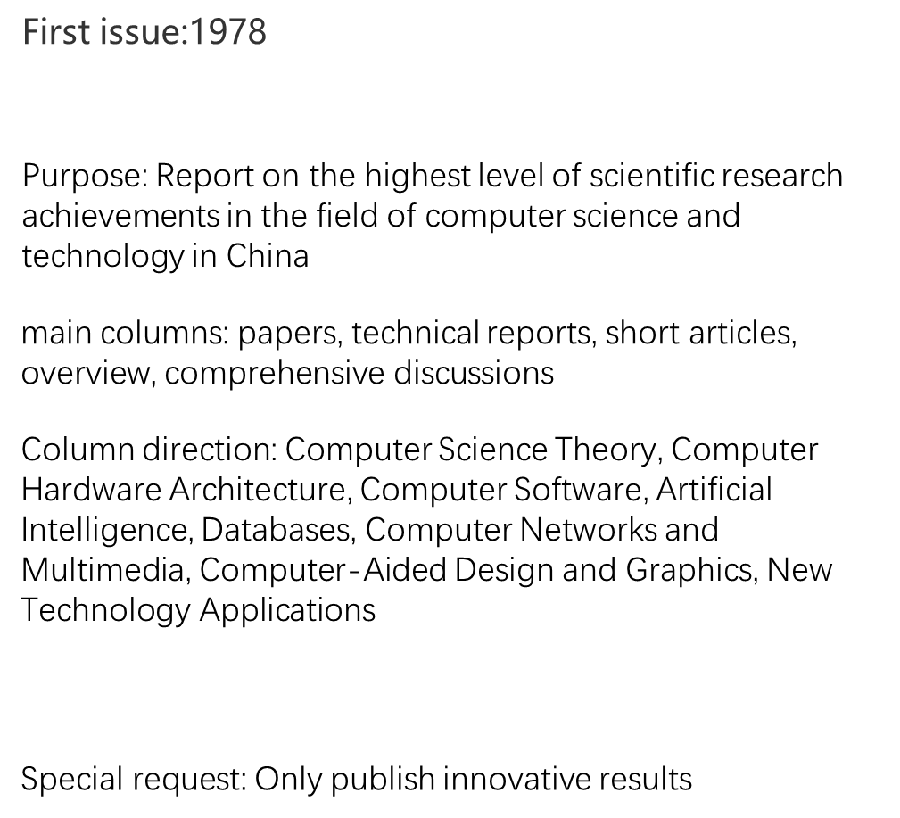
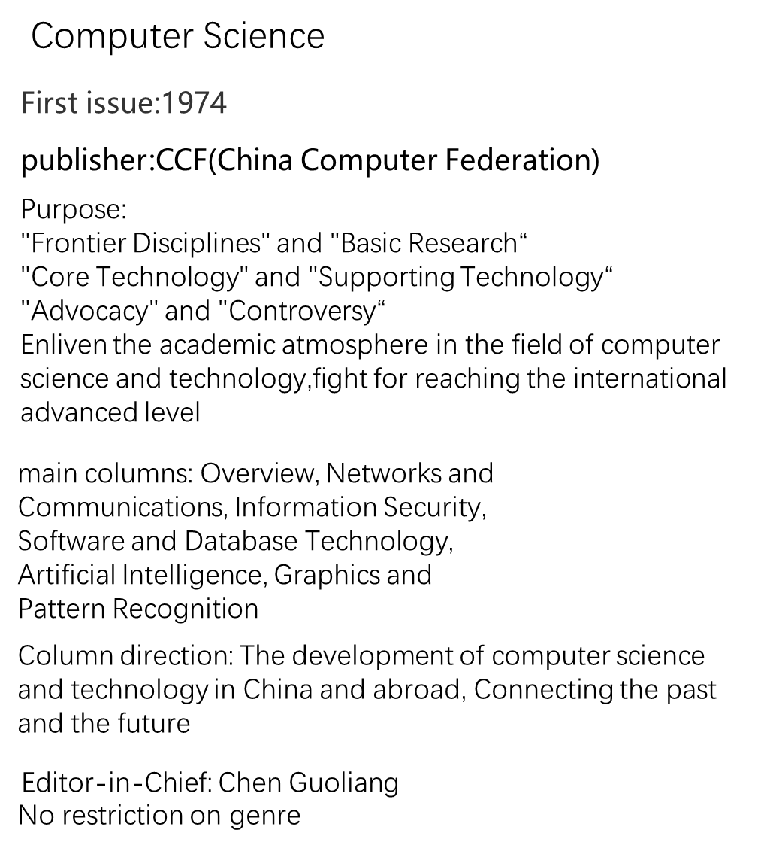

Task 5
1.Variety Fields which relate with Computer Science
1. Artificial intelligence
Role: Machine Learning Engineer
Requirements: Bachelor’s degree in computer science, information technology, or a related field; a master’s degree in machine learning can enhance career options.
Description: Machine learning engineers create and improve machine learning models, ensuring they run efficiently and provide accurate information. Proficiency in programming languages is essential for developing and testing these models.
Relative product/technics:
- GPS
- Map
- Online consultation
- Smart identification

2.Data Structures and Algorithms
Role: Data Scientist
Requirements: Bachelor’s degree; some employers may prefer a graduate degree or relevant experience.
Description: Data scientists analyze and interpret complex data to help organizations make informed decisions. They build algorithms, troubleshoot problems, and present data findings to stakeholders.
Relative product/technics:
- Optimization
- GPS(route-planning)
- Network connection

3.Computer Networks
Role: Network Architect
Requirements: Bachelor’s degree in computer science; proficiency in networking programs (e.g., Cisco, CompTIA) and relevant certifications may be needed.
Description: Network architects design and implement computer networks for organizations, ensuring they meet business needs and function efficiently.
Relative product/technics:
- Virtual Operations
- Large-scale integration
- Data security

4.Computer Security
Role: Cybersecurity Analyst
Requirements: Bachelor’s degree and relevant certifications
Description: Cybersecurity analysts protect organizations from data breaches and cyber threats. They monitor systems, implement security measures, and respond to incidents.
Relative product/technics:
- Antivirus software
- Networks security

5.Databases
Role: Database Administrator
Requirements: Bachelor’s degree in computer science or a related field; strong knowledge of SQL and NoSQL.
Description: Database administrators manage and maintain databases, ensuring they are functional and accessible to users. They are responsible for database design, implementation, and troubleshooting.
Relative product/technics:
- Cloud drive
- AI processing (NLP)
- Cloud service

6.Human-Computer Interaction
Role: User Experience (UX) Designer (implied)
Requirements: Typically a bachelor’s degree in a related field; strong understanding of user-centered design principles.
Description: Professionals in this field study how users interact with technology and work to improve the usability and accessibility of software and applications. They focus on creating intuitive interfaces that enhance user satisfaction.
These careers in computer science highlight the diverse opportunities available in the field, each requiring a unique set of skills and educational backgrounds.
Relative product/technics:
- Human-machine chip* (Not accomplished yet)

2.Currently situation/challenge
Challenges:
1.Rapid technological change:
The field is evolving at an extremely fast pace, making it difficult for professionals to keep up with the latest tools, languages, and frameworks. Have to constant learning and upskilling.

2.Cybersecurity threats:
As our reliance on digital systems grows, so do the risks of cyberattacks. Computer scientists need to develop robust security measures to protect sensitive data and systems.

3.Ethical considerations:
With the increasing power of technology comes the responsibility to ensure its ethical use. Issues such as privacy, algorithmic bias, and the impact of automation on employment need to be addressed.

Situations:
1.Growing importance of data science and analytics:
The ability to collect, analyze, and make sense of large amounts of data is becoming crucial for businesses and organizations. Computer scientists with skills in data science are in high demand.

2.Emergence of new technologies:
Technologies like artificial intelligence, quantum computing, and the Internet of Things are presenting new opportunities and challenges for the field.

3.Industry convergence:
Computer science is intersecting with other fields such as healthcare, finance, and transportation, creating new interdisciplinary career opportunities.

4.Regulatory environment:
Governments around the world are implementing regulations to address issues such as data privacy and security. Computer scientists need to be aware of these regulations and ensure compliance.
*(e.g. fake information generated by ai, Personal informs

3.Conclusion
In short, Computer Science’s project involved to many field you could imagine or not, it leading to the live to become more convenient as the growth rapidly.
However, Computer Science is facing different obstacles on the way. Scientists must tackle it as technology development.

4.Reference
- 7 Careers in Computer Science Fields | Coursera
- AI Software: 17 Most Popular Products for 2024 - viso.ai
- Real-life Applications of Data Structures and Algorithms (DSA) - GeeksforGeeks
- 什么是计算机联网？- 计算机联网简介 - AWS (amazon.com)
- Database and Cloud Database Products A-Z | Oracle

