Research of Computer Science

Group_4
Group member
项威_U202414641_1
吴林洋_U202414639_2
谢嘉枫_U202414642_3
阮云轩_U202490035_4

Content
- Sub-disciplines of Computer Science and Technology 6
- Abstract
- The Origin and Development of Aritificial Intelligence
  - The Origin of Aritificial Intelligence
    - Turing test
    - Dartmouth Conference
  - The Development of Aritificial Intelligence
- Brief Introduction of Aritificial Intelligence
- Definition and core idea of artificial intelligence
- Definition of Artificial Intelligence
- The basic ideas and research content of artificial intelligent
- Knowledge representation
- Automatic Reasoning
- Machine learning
- Natural language processing
- Computer vision
- Robotics
- Widespread application of artificial intelligence
  - The application of artificial intelligence is extremely wide-ranging, touching almost every area of life. Here are some examples of key AI applications:
    - Smart manufacturing
    - Smart Home
    - Fintech
    - Smart Healthcare
    - Autonomous driving
  - Summary

- Summary
- The leaders in the field of computer science 13
- Abstract
- The leaders we keep a watchful eye on
- The understanding of John J. Hopfield and Geoffrey E. Hinton
  - John J. Hopfield
  - All his life
  - Prize
  - Achievement
  - Summary
  - conclusion and inspiration
  - Geoffrey E. Hinton
  - All his life
  - Prize
  - Achievement
  - Summary
- Conclusion and the inspiration for us
  - Conclusion
  - The inspiration for us
- Journal of Computer Science 18
      - Abstract
        - What is journal?
        - What is the role of journals?
      - Top Ten Journals
- Top Ten Computer Journals in China
- Top Ten Computer Journals in world
      - Introduction
- Chinese Journal of Computers《计算机学报》
- Computer Science《计算机科学》
      - Summary
- Branch application of Computer Science 25
- Abstract
- Variety Fields which relate with Computer Science
        - Artificial intelligence
          - Main role on society
          - Description
          - Related product or technic
        - Data Structures and Algorithms
          - Main role on society
          - Description
          - Related product or technic
        - Computer Networks
          - Main role on society
          - Description
          - Related product or technic
        - Computer Security
          - Main role on society
          - Description
          - Related product or technic
        - Databases
          - Main role on society
          - Description
          - Related product or technic
        - Human-Computer Interaction
          - Main role on society
          - Description
          - Related product or technic
- Currently challenge of Computer Science
        - Rapid technological change
        - Cybersecurity threats
        - Ethical considerations
        - Data Management and Privacy
- The prospect of Computer Science’ development
        - Technological Innovation
          - Advancement in Computing Power
          - Quantum Computing
          - Biological Computing
          - Neural Computing and Artificial Intelligence
        - Expansion of Application Fields
          - Healthcare
          - Finance and Business
          - Education
          - Smart Cities and the Internet of Things (IoT)
        - Data Science and Big Data
          - Data-Driven Decision Making
          - Data Privacy and Security
        - Interdisciplinary Collaboration
          - Integration with Other Sciences
          - Human-Computer Interaction (HCI)
- Summary
- Conclusion 40
- Analysis
- Reflection
- Reference 41
Paper
Website

The Sub-disciplines of Computer Science——Aritificial Intelligence

.Abstract
The term artificial intelligence was proposed in 1956, and after more than half a century of development, it has penetrated various fields. This article will give a brief introduction to the discipline of artificial intelligence.

The Origin and Development of Aritificial Intelligence

- The Origin of Aritificial Intelligence

- Turing test
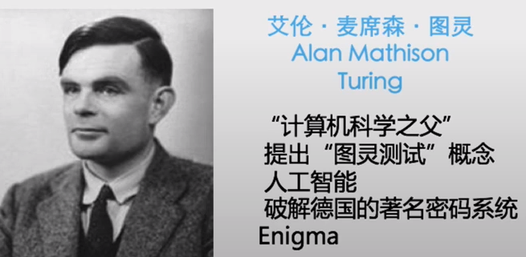
With the subject and the subject (one person and one machine) gasping, the subject walks through a number of devices (e.g., keyboards) and asks random questions to the subject.
After multiple tests (usually within 5 minutes), if more than 30% of the testers are not sure whether the subject is a human or a machine, then the machine passes the test and is considered to have human intelligence.

- Dartmouth Conference
In August 1956, at Dartmouth College, a quiet town in Hannos, United States,
John · McCarthy
Mar·vin Minsky (Artificial Intelligence and Cognition Expert)
Claude Shannon (founder of information theory)
Allen Newell (Computer Scientist) ·
Scientists such as Herbert · Simon (Nobel laureate in economics) are gathering to discuss a completely non-cannibalistic theme:
Machines are used to mimic human learning and other aspects of intelligence
The meeting lasted for two months, and although there was no general consensus, it gave a name to what was discussed:
artificial intelligence
Therefore, 1956 became the first year of artificial intelligence.
- The Development of Aritificial Intelligence
- The first is the initial development period: 1956-early 60s of the 20th century.
- The second is the period of reflective development: the 60s to the early 70s of the 20th century.
- The third is the application development period: the early 70s to the mid-80s of the 20th century.
- The fourth is the period of sluggish development: the mid-80s to the mid-90s of the 20th century.
- The fifth is the period of steady development: the mid-90s of the 20th century to 2010.
- The sixth is the period of vigorous development: 2011 to the present.
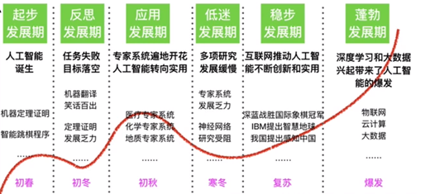

Brief Introduction of Aritificial Intelligence
- Definition and core idea of artificial intelligence

- Definition of Artificial Intelligence
Artificial intelligence (AI) is a branch of computer science that aims to understand the essence of intelligence and produce an intelligent machine that reacts in a manner similar to human intelligence. Since the term "artificial intelligence" was formally proposed at the Dartmouth Conference in 1956, artificial intelligence has developed into a comprehensive discipline that encompasses several research fields such as robotics, language recognition, image recognition, natural language processing, and expert systems.
- The basic ideas and research content of artificial intelligence
The basic idea of artificial intelligence is to simulate human cognitive processes, including perception, learning, reasoning, memory, thinking, decision-making, and action, among others. Research in this area is extensive, covering the following areas
- Knowledge representation: The study of how knowledge is encoded and stored in a form that is understandable to a computer.
- Automatic Reasoning: Simulates the process of human logical reasoning, enabling machines to solve problems and make decisions.
- Machine learning: Enables computer systems to learn data to improve performance, including supervised learning, unsupervised learning, reinforcement learning, and more.
- Natural language processing: Enables computers to understand and generate human language, including language translation, sentiment analysis, and more.
- Computer vision: Enables computers to recognize and process information from images or multidimensional data, perform tasks such as image recognition, scene reconstruction, and more.
- Robotics: Research and design of intelligent robots that can perform tasks, including navigation, manipulation, and interaction.
- The development of artificial intelligence depends not only on the progress of algorithms and theories, but also on the improvement of computing power, the accumulation of large amounts of data, and the support of policies. With the continuous advancement of technology, artificial intelligence has shown a wide range of application potential in many fields, from medical diagnosis to autonomous driving, from smart home to industrial automation, artificial intelligence is gradually becoming an important force to promote social development.
- Neural Networks and Deep Learning
As one of the core technologies of artificial intelligence, the development of neural networks has gone through multiple stages. Initially, inspired by biological neural networks, attempts were made to build network models composed of artificial neurons. These models mimic the way the human brain processes information through mechanisms such as weighted summation and activation functions.
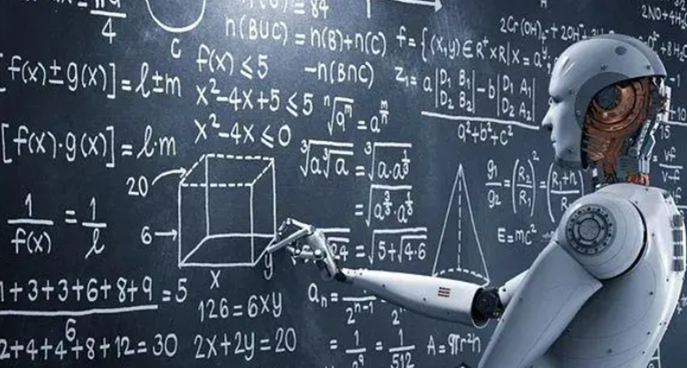

Widespread application of artificial intelligence
- The application of artificial intelligence is extremely wide-ranging, touching almost every area of life. Here are some examples of key AI applications
- Smart manufacturing: AI technologies play an important role in improving production efficiency and quality, including smart devices, automated factories, and services.
- Smart home: Combine IoT technology, smart hardware, software and cloud platform to create a smart home ecosystem and realize home automation.
- Fintech: AI helps in financial services such as risk assessment, fraud identification, robo-advisory, and customer service.
- Smart healthcare: AI aims to improve the quality and efficiency of medical services in areas such as assisted diagnosis, personalized treatment, medical image analysis, and patient monitoring.
- Autonomous driving: AI is responsible for environmental awareness, decision-making, and path planning in autonomous vehicles.
- Summary
These applications show how AI can penetrate into every corner of our lives, not only improving work efficiency but also greatly improving our quality of life. With the continuous advancement of technology, the application of AI will become more extensive and deeper.

Summary
Artificial intelligence has important application value in the fields of medical care, transportation, finance, education, security, etc.it can bring great changes and development to human society.

The leading figures in the field of computer science

Abstract
As we know, throughout the history of development in the field of computing, many renowned figures have laid its foundations and driven technological innovation. Their contributions not only transformed computer technology itself but also deeply influenced various aspects of modern society. For instance, Alan Turing, known as the "father of computer science," introduced the concept of the Turing machine, establishing the theoretical basis for modern computers. Similarly, John von Neumann proposed the famous "von Neumann architecture," a foundational design of modern computers that includes the concept of stored programs. It is through the contributions of these individuals that computing technology moved from laboratories to the public, gradually transforming our daily lives.

The leaders we keep a watchful eye on

With the announcement of the 2024 Nobel Prize, We noticed two leading figures in the field of computer science who received the Nobel Prize this year. “The 2024 Nobel Prize in Physics was awarded to John J. Hopfield from Princeton University and Geoffrey E. Hinton from the University of Toronto for their groundbreaking work in artificial neural networks, which has significantly advanced the field of machine learning.

The understanding of John J. Hopfield and Geoffrey E. Hinton
- John J. Hopfield

- All his life
John J. Hopfield, born on July 15, 1933, in Chicago, Illinois, USA, obtained his Ph.D. from Cornell University in 1958 and is currently a professor at Princeton University in the USA.

- Prize
As we know, he is a scholar from the field of machine learning, engaged in artificial intelligence research. Therefore, questions arise, “Is this Nobel Prize a Physics Prize or a Mathematics Prize?” These voices are incessant, as if this award, which has always symbolized the highest honor in science, has suddenly become somewhat unfamiliar. However, if we set aside these surface-level debates, we can discover that behind this award lies a deeper scientific transformation and interdisciplinary exploration. The Nobel Prize in Physics may reveal a new direction for future scientific development through this controversy: perhaps it is in the technology related to computer science that you and I are currently learning or engaging in, such as the currently hot topic of artificial intelligence.
- Achievements
Let’s take a look at his achievements. As early as the 1980s, John J. Hopfield proposed the famous Hopfield Network. At that time, artificial intelligence was still in its infancy, and scientists were trying to make machines simulate the workings of the brain, but progress was slow. While observing how neurons work together, Hopfield discovered an interesting phenomenon: the interactions between neurons could be compared to the interactions in a physical spin system.

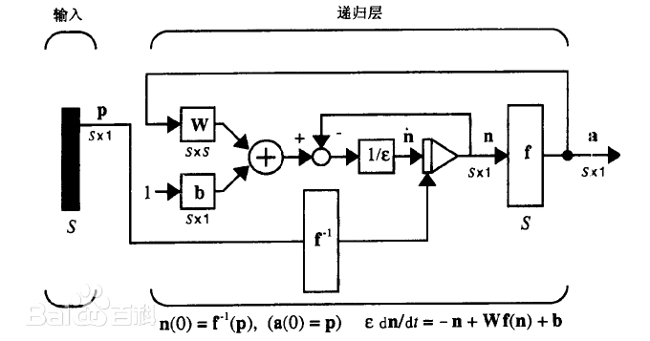
This idea inspired him. Based on his research into how the brain extracts and stores memories, he proposed the Hopfield Network model. In this network, it can store and retrieve data patterns, such as images or other types of patterns, utilizing the energy minimization principle from physics for data recovery. This model laid the early theoretical foundation for neural networks and has been widely applied in machine learning and artificial intelligence. It not only brought new ideas to neural network research but also introduced concepts from physics into the realm of artificial intelligence.
- Summary

Undoubtedly, Hopfield’s work provided a foundation for the intersection of contemporary artificial intelligence and neuroscience. His research has not only advanced the development of machine learning but also influenced our understanding of how the biological brain works. By integrating physics, computer science, and biology, he made immeasurable contributions to the early development of artificial intelligence and neural networks.

- Conclusion and inspiration
The awarding of the 2024 Nobel Prize in Physics once again demonstrates that the boundaries of science are constantly expanding. The success of John J. Hopfield showcases how computer science can combine with various fields to create a new direction for research. His success reminds us that innovation often arises at the intersection of different disciplines, and combining diverse ways of thinking may lead to groundbreaking results.
- Geoffrey E. Hinton
- All his life
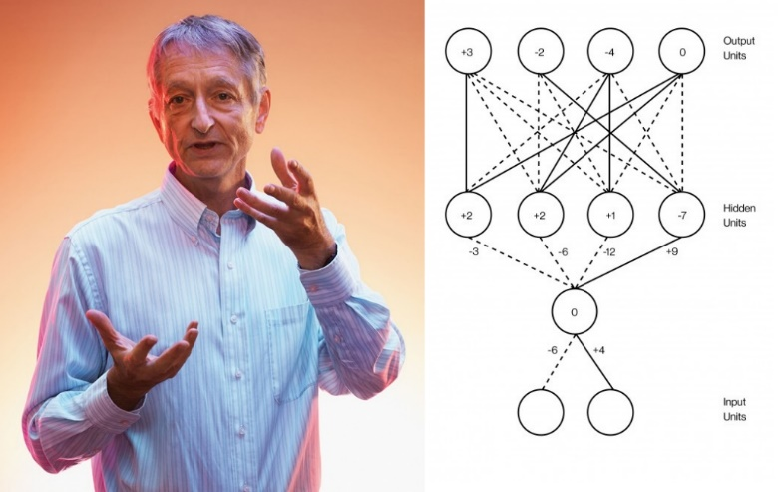
Geoffrey E. Hinton was born in 1947 in London, England. He obtained degrees in psychology and computer science from the University of Cambridge and earned his Ph.D. in computer science from the University of Edinburgh in 1975, focusing on neural networks and machine learning. Since then, Hinton has persistently explored this field, even when many scientists lost interest in it during the 1990s.
- Prize
Geoffrey Hinton has made an indelible contribution to the field of artificial intelligence and is known as the "father of deep learning." He is one of the pioneers of the backpropagation algorithm and developed the well-known "restricted Boltzmann machine" model. His research has helped drive the widespread application of deep learning in areas such as computer vision and speech recognition. Thus, we consider him a leading figure in our field of computer science.
- Achievements
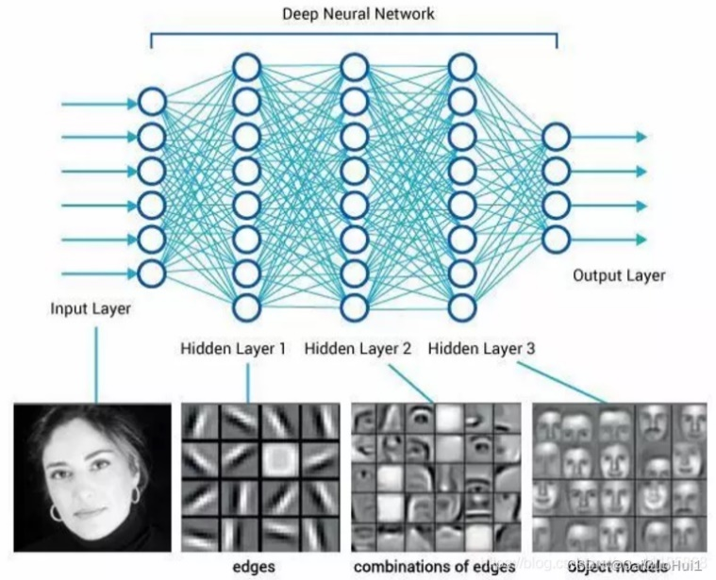
Let’s look at his achievements. Hinton made groundbreaking contributions to the training of multilayer feedforward neural networks, particularly with the deep belief networks proposed in 2006 with his students, marking the revival of deep learning. In the same year, he and his colleagues developed a method for pre-training networks using a series of stacked restricted Boltzmann machines. This pre-training provided a better starting point for connections within the network. In 2012, Alex Net, invented by Hinton and two of his students, won the ImageNet computer vision competition with overwhelming superiority, creating a milestone in the development of deep neural networks and inspiring extensive research adopting convolutional neural networks (CNNs) and graphics processing unit (GPU) acceleration for deep learning. This technology is now widely used in fields such as computer vision and natural language processing.

Subsequently, the DNN Research he founded was sought after by tech giants like Google, Apple, and Baidu, ultimately being acquired by Google for $44 million. In 2018, Hinton shared the highest award in computer science, the Turing Award, with Yoshua Bengio and Yann LeCun, together known as the "deep learning trinity" or the "godfathers of AI." This underscores his significant standing in the field of computer science.
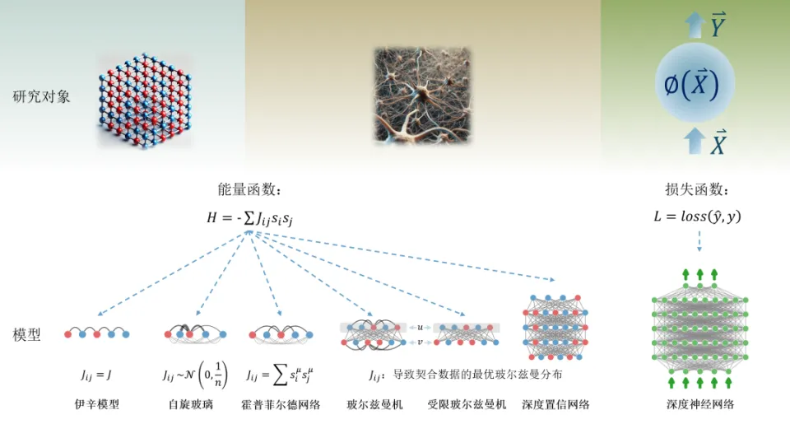

- Summary
In summary, Hinton has dedicated his life to the continuous effort in neural networks and deep learning, achieving important breakthroughs at various stages. He inspires us to pursue deep learning, maintain our exploration, and strive for excellence in our respective fields.

Conclusion and the inspiration for us
- Conclusion
Thanks to the work of John Hopfield and Geoffrey Hinton since the 1980s, they laid the foundation for the machine learning revolution that began around 2010. The developments we see now are due to the vast amounts of data available for training networks and the tremendous increase in computing power. Interestingly, they both have achieved interdisciplinary integration and research. This further underscores the importance of interdisciplinary collaboration. Physics provides tools for the development of machine learning, and it is noteworthy that as a field of study, physics itself is also benefiting from artificial neural networks. This also once again proves to us the importance of interdisciplinary studies in today's era. Perhaps this is also the reason why the Nobel Prize in Physics was awarded to these two scientists this year.
- The inspiration for us
For us ,as university students, promoting innovation through interdisciplinary approaches allows us to combine knowledge from different fields, generate new ideas and solutions, and seamlessly switch between various domains to tackle multiple problems, thereby stimulating creative thinking. Engaging with diverse disciplines enhances our critical thinking skills, which is especially vital in today's information age.

Journal of Computer Science

Abstract
- What is journal
Academic journals are periodical publications specifically designed to publish original research findings, reviews, commentaries, and related academic content. They typically cover specific disciplines or fields and ensure the quality and reliability of published research through a peer review process.

- What is the role of journals?
Academic journals are important platforms for publishing research findings, helping researchers share their discoveries and theories. It offers a place for researchers from different fields to exchange ideas. Through open discussion and review, academic journals encourage the emergence of new ideas and methods, driving the progress and innovation of disciplines.
Now, let’s have a look for the top ten journals in computer science.

Top Ten Journals
- Top Ten Computer Journals in China
By maigoo (overall consideration)
1.Computer Simulation（计算机仿真 ）
2.Journal of computer science（计算机学报）
3.Computer measurement and control（计算机测量与控制）
4.Small microcomputer system（小型微型计算机系统）
5.Journal of computer aided designed and graphics（计算机辅助设计与图形杂志）
6.Computer engineering and science（计算机工程与科学）
7.Computer science （计算机科学）
8.Computer application research（计算机应用研究）
9.Computer applications（计算机应用）
10.Computer engineering （计算机工程）

By JCR
1.Journal of Computer Science（计算机学报 ）
2.Computer Integrated Manufacturing Systems（计算机集成制造系统 ）
3.Computer Science and Exploration（计算机科学与探索 ）
4.Computer Engineering and Applications（计算机工程与应用）
5.Computer Research and Development（计算机研究与发展 ）
6.Computer Engineering（计算机工程 ）
7.Systems Engineering and Electronic Technology（系统工程与电子技术）
8.Small and Microcomputer Systems（小型微型计算机系统 ）
9.Computer Science（计算机科学 ）
10.Journal of Xi'an University of Electronic Science and Technology（西安电子科技大学学报）

By Total Citations
1.Computer Engineering and Applications （计算机工程与应用）
2.Computer Engineering (计算机工程)
3.Journal of Computer Science (计算机学报)
4.Computer Science (计算机科学)
5.Computer Research and Development (计算机研究与发展)
6.Computer Engineering and Design (计算机工程与设计)
7.Computer Integrated Manufacturing Systems （计算机集成制造系统）
8.Microcomputer Information (微计算机信息)
9.Systems Engineering and Electronic Technology (系统工程与电子技术)
10.China Management Informationization (中国管理信息化)

- Top Ten Computer Journals in World
By maigoo (overall consideration)
1.IEEE Transactions on Pattern Analysis and Machine Intelligence
2.IEEE Communications Magazine
3.IEEE Transactions on Image Processing
4.IEEE Communications Surveys and Tutorials
5.IEEE Transactions on Wireless Communications
6.IEEE Journal on Selected Areas in Communications
7.IEEE Internet of Things Journal
8.Pattern Recognition
9.IEEE Transactions on Neural Networks and Learning Systems
10.ACM Computing Surveys

By JIF
1.IEEE Access
2. Information Sciences
3.IEEE Internet of Things Journal
4.Electronics
5.Journal of Chemical Information and Modeling
6.IEEE Transactions on Information Theory
7. Multimedia Tools and Applications
8.MIS Quarterly
9.IEEE Communications Surveys and Tutorials
10.IEEE Transactions on Knowledge and Data Engineering

By JCI
1.IEEE Communications Surveys and Tutorials
2.Applied Computing and Informatics
3.Foundations and Trends in Information Retrieval
4.IEEE Transactions on Services Computing
5.IEEE Wireless Communications
6.IEEE Transactions on Knowledge and Data Engineering
7.Information & Management
8.IEEE Transactions on Dependable and Secure Computing
9.IEEE Transactions on Multimedia
10.IEEE Internet of Things Journal

By Total Citations
1. IEEE Access
2.information sciences
3. IEEE Internet of Things Journal
4. Electronics
5. Journal of Chemical Information and Modeling
6. IEEE Transactions on Information Theory
7. Multimedia Tools and Applications
8. MIS Quarterly
9. IEEE Communications Surveys and Tutorials
10. IEEE Transactions on Knowledge and Data Engineering

Introduction
- Chinese Journal of Computers《计算机学报》

- Impact Factor
Composite Impact Factor: 5.787
Combined Impact Factor: 3.199
(2023)
- Publish information
First issue:1978
publisher: science press
It's a monthly journal (from 1987)
Editor-in-Chief: Sun Ninghui
- Journal Content
Purpose
Report on the highest level of scientific research achievements in the field of computer science and technology in China
Main columns
papers, technical reports, short articles, overview, comprehensive discussions
Column direction
Computer Science Theory, Computer Hardware Architecture, Computer Software, Artificial Intelligence, Databases, Computer Networks and Multimedia, Computer-Aided Design and Graphics, New Technology Applications
- Special request
Only publish innovative results
Only receive online contribution

- Computer Science《计算机科学》

- Impact Factor
Composite Impact Factor: 2.914
Combined Impact Factor: 1.502
(2023)

- Publish information
First issue:1974
publisher: CCF (China Computer Federation)
Editor-in-Chief: Chen Guoliang
It’s a monthly journal (from 1999)

- Journal Content
Purpose
"Frontier Disciplines" and "Basic Research “
"Core Technology" and "Supporting Technology “
"Advocacy" and "Controversy “
Enliven the academic atmosphere in the field of computer science and technology, fight for reaching the international advanced level

Column direction
The development of computer science and technology in China and abroad, Connecting the past and the future

Main columns
Overview, Networks and Communications, Information Security, Software and Database Technology, Artificial Intelligence, Graphics and Pattern Recognition

- Special request
No restriction on genre

Summary
Chinese Journal of Computers is a journal for innovation, and it means that it has the highest standard.
By contrast, Computer Science is a journal that combines junior and senior, which means it suits new researchers.

Branch application of Computer Science

Abstract
Nowadays, the branch applications of computer science are integral to numerous fields, driving innovation and efficiency across sectors. This essay will talk about these fields such as artificial intelligence, data structures and algorithms, computer networks, cybersecurity, databases, and human-computer interaction. Division introduces their role on society, general description of the branch and their application on lives. Moreover, the discussion extends to current challenges, including rapid technological change, cybersecurity threats, and ethical considerations, highlighting the constant need for adaptation and skill development. Moreover, the essay will point out the importance of data science, the emergence of new technologies, industry convergence, and regulatory impacts.
By analyzing these factors, the study demonstrates how computer science continues to transform and enhance various industries, while also navigating significant challenges in its progression.

Variety Fields which relate with Computer Science
- Artificial intelligence
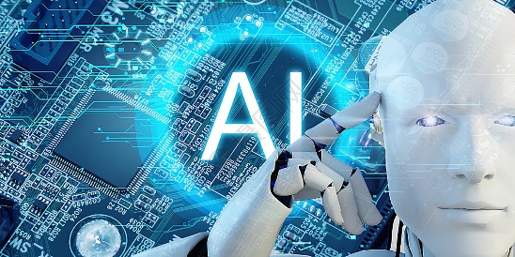
- Main role on society
Artificial intelligence plays an important role in several fields who help people to deal with complex problems and issues. It mainly works on human-languages systems and identify the key words in your speech.
- Description
Artificial intelligence (AI) refers to the development of computer systems that can perform tasks that typically require human intelligence. These tasks include learning, problem-solving, decision-making, natural language processing, speech recognition, and visual perception.
AI systems use algorithms and data to learn from experience and improve their performance over time. They can analyze large amounts of data quickly and accurately, identifying patterns and making predictions.
There are different types of AI, including narrow or weak AI, which is designed to perform specific tasks, and general or strong AI, which would have the ability to understand, learn, and perform any intellectual task that a human being can.
AI is being applied in various fields such as healthcare, finance, transportation, education, and customer service. It has the potential to improve efficiency, productivity, and quality of life, but also raises concerns about job displacement, ethical implications, and potential misuse.
- Related product or technic
- NLP ( Natural Language Processing)
Developed powerful language models such as GPT-4. It can generate high-quality text and is widely used in fields like intelligent writing, intelligent customer service, and language translation. The company's technology has promoted the development of natural language processing and provided strong support for the application of artificial intelligence.
Frontier company
1.Open AI
2.Google
- Intelligent chatbots
Intelligent chatbots are computer programs that simulate conversation with humans. They use AI techniques like natural language processing. They can answer questions, provide info, and are used in customer service, e-commerce, healthcare, and more. Some can learn from interactions and adapt to users.
Frontier company
1.Open AI
2.Google
3. Xiaodu

- Data Structures and Algorithms

- Main role on society
Data Structures and Algorithms play a ultimate essential role on a program even a company, it respond to tackle the information you give with the high efficiency and low cost of times has to rely on a flexible and intelligent algorithm.
- Description
Data structures are ways of organizing and storing data in a computer so that it can be accessed and manipulated efficiently while Algorithms are step-by-step procedures for performing specific tasks or solving particular problems.
In Everyday Life, Efficient apps and services: They ensure that the apps and software we use daily, such as search engines, navigation apps, and social media platforms, run smoothly and respond quickly. This leads to a better user experience and saves time. Personalized recommendations: Power recommendation systems that suggest products, movies, music, and other content based on our preferences and past behavior. This helps us discover new things and saves us the effort of searching through large amounts of data.
In Science and Technology, Scientific research: Used in various scientific fields for tasks such as simulating complex systems, analyzing experimental data, and solving optimization problems. This can lead to new discoveries and advancements in areas such as medicine, physics, and engineering. Technology innovation: Drive the development of new technologies and applications, such as self-driving cars, smart homes, and personalized healthcare. These innovations can improve our quality of life and solve some of the world's most pressing problems.
- Related product or technic
  - Optimization
For optimization, there's index optimization (creating indexes on query fields), query optimization (avoiding full table scans), storage optimization (choosing proper engines and data types), and cache optimization (using database and application caches). In algorithms, sorting algorithms are used for query results. Index construction algorithms like B-trees and B+ trees are crucial. Join algorithms (nested loop join, hash join, etc.) are used for multi-table joins. Data compression algorithms save storage space.
Frontier Company
      - Oracle
      - Microsoft
      - IBM

  - Programming Language Compilers
Compilers use various data structures and algorithms for parsing source code, optimizing code generation, and managing symbol tables. For example, compilers for languages like C++, Java, and Python.
Frontier Company
      - JetBrain
      - Dev C++
  - Search Engines
Search engines employ complex data structures and algorithms for indexing web pages and quickly retrieving relevant results. For instance, Google uses algorithms like PageRank and data structures like inverted indexes.
Frontier Company
      - Google
      - Baidu
Computer Networks
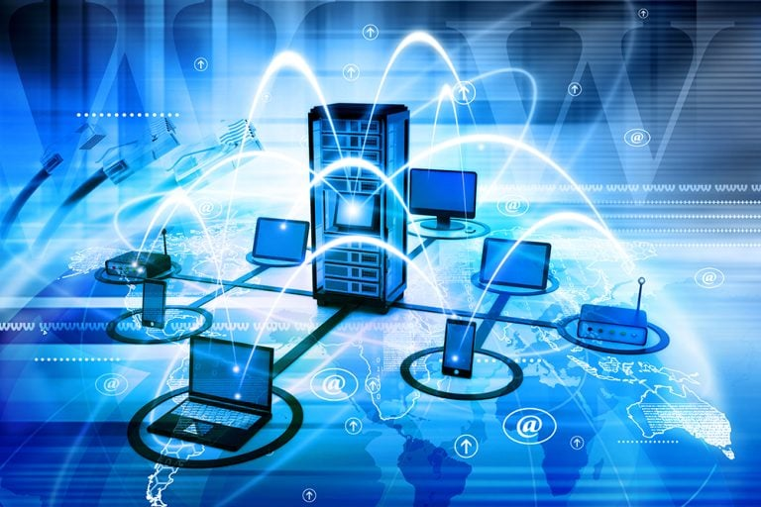
- i. Main role on society
With no doubts, Computer Networks is the crucial part of this era. Computer Networks help people connect to the internet so that people can chat together without face to face. Along with the development of computer networks, it actually has different functions to out lives not only online chatting.
- ii. Description
First, there are several types of networks often been used
Local Area Networks (LANs): Cover a small geographical area, such as a home, office, or school. LANs are typically owned and managed by a single organization or individual. They can be wired or wireless and are designed for high-speed data transfer within a limited area.
Wide Area Networks (WANs): Cover a large geographical area, such as a country or the entire world. WANs are often composed of multiple LANs connected by routers and other network devices. The internet is the largest WAN. WANs typically use a variety of transmission media, including satellite links, fiber optic cables, and copper wires.
Metropolitan Area Networks (MANs): Cover a city or metropolitan area. MANs are often used by businesses and government organizations to connect multiple locations within a city. They are similar to LANs in some ways but cover a larger area and may use different types of transmission media.
Personal Area Networks (PANs): Connect devices within a person's immediate vicinity, such as a smartphone, tablet, and laptop. PANs can be wired or wireless and are typically used for personal use. Examples include Bluetooth networks and infrared connections.
And what are their functions work?
Resource Sharing: Computer networks allow users to share hardware resources such as printers, scanners, and storage devices. They also enable the sharing of software resources such as applications and databases. This reduces costs and increases efficiency by allowing multiple users to access the same resources.
Data Communication: Networks facilitate the exchange of data between nodes. This can include text messages, emails, files, and multimedia content. Data communication can be synchronous (real-time) or asynchronous (delayed). For example, video conferencing is synchronous communication, while email is asynchronous.
Distributed Computing: Networks allow multiple computers to work together on a single task, distributing the workload and increasing processing power. This is used in applications such as scientific research, weather forecasting, and financial modeling. Distributed computing can also improve reliability by providing redundancies in case of hardware failures.
Remote Access: Users can access network resources from remote locations. This is useful for telecommuting, accessing files from home or while traveling, and providing support to remote users. Remote access can be achieved through virtual private networks (VPNs), which create a secure connection over the internet.
- Related product or technic
- Routers
Devices that forward data packets between computer networks. For example, Cisco routers are widely used in enterprise networks for their high performance and reliability. Linksys routers are popular for home and small office networks.
Frontier Company
      - ASUS
      - Huawei
      - TP-link
  - Firewalls
Protect networks from unauthorized access and malicious attacks. Fortinet and Palo Alto Networks are prominent firewall vendors.
Frontier Company
      - FortiNet
      - Microsoft
      - IBM
- Wireless Access Points (WAPs)
Provide wireless connectivity in an area. Ubiquiti and Aruba are known for their enterprise-grade WAPs.
- Computer Security

- i. Main role on society
Computer Security decide the safety when we are going to browsing online, it certainly ensures our personal information to some extent, is the base condition for us to using the internet. A safe cybersecurity not only can protect your information, it also take the irreplaceable role on a national security.
- ii. Description
Computer security is the practice of protecting computer systems, networks, and data from unauthorized access, use, disclosure, disruption, modification, or destruction. It involves a combination of technical, administrative, and physical measures to ensure the confidentiality, integrity, and availability of information. Now I am going to point out some methods which can increase our cyber security.
In Technical measures, it includes the use of firewalls, antivirus software, encryption, access controls, and intrusion detection systems. Firewalls act as a barrier between a computer network and the outside world, blocking unauthorized access. Antivirus software detects and removes malicious software such as viruses, worms, and trojans. Encryption protects data by converting it into a code that can only be read by authorized users. Access controls limit who can access a computer system or network and what they can do once they are in.
For Administrative measures, in include policies and procedures for managing computer security. These may include user access policies, password policies, data backup and recovery plans, and incident response plans. User access policies determine who can access a computer system or network and what they can do. Password policies ensure that users choose strong passwords and change them regularly. Data backup and recovery plans ensure that important data is backed up regularly and can be recovered in the event of a disaster.
In generally, Computer security is essential in today's digital age. With the increasing reliance on computer systems and the internet, the risk of cyber-attacks and data breaches has never been greater. A security breach can result in the loss of sensitive data, financial losses, damage to reputation, and legal consequences. Computer security helps to protect against these risks and ensure the confidentiality, integrity, and availability of information.
- Related product or technic
- Antivirus software
Antivirus software is a program designed to detect, prevent, and remove malicious software (malware) from computers and other digital devices.
Malware can include viruses, worms, trojans, spyware, adware, and ransomware. Antivirus software works by scanning files, programs, and the computer's memory for patterns and signatures that are characteristic of known malware.
When malware is detected, the antivirus software can take several actions. It may quarantine the infected file to prevent it from spreading, delete the malware, or repair the infected file. Some antivirus programs also offer real-time protection, which monitors the computer's activities and blocks malware before it can infect the system.
Frontier Company
- Bitdefender
- Avira
- McAfee
- Networks security
Network security involves measures to protect computer networks. It includes firewalls, intrusion detection/prevention systems, VPNs, access control, encryption, patch management, and security policies/training. It safeguards data and resources from unauthorized access and cyber threats.
Frontier Company
- Netsurion
- Nomic Networks
- SHI
- Databases

- i. Main role on society
Databases, which records every events on the library since the day database build up, include your browser history, pay records. But along with the technology develop, there is much more data have to be storage per day, so that we have to find out the new storage technology and raise up the storage efficiency. The numerous data processing be doomed that it will be a hard obstacle.
- Description
A database is an organized collection of data that is stored and managed in a computer system. It is designed to allow for efficient storage, retrieval, and manipulation of large amounts of data.
Databases consist of one or more tables, which are made up of rows and columns. Each row represents a single record or entity, while each column represents a specific attribute or field of that entity. For example, a database of customers might have a table with columns for customer name, address, phone number, and email address. Each row in the table would represent a specific customer.
Databases are managed by a database management system (DBMS), which provides tools for creating, modifying, and querying the database. The DBMS also ensures the integrity and security of the data by enforcing constraints and access controls.
There are several types of databases, including relational databases, which store data in tables with defined relationships between them; NoSQL databases, which are designed to handle large amounts of unstructured or semi-structured data; and object-oriented databases, which store data as objects rather than tables.
Databases are used in a wide variety of applications, including business management, scientific research, healthcare, and entertainment. They are essential for organizations that need to manage large amounts of data and make it available to multiple users or applications.
- Related product or technic
  - Cloud drive
A cloud drive is a storage service provided by cloud computing providers. It offers storage space, accessibility from anywhere with an internet connection, sharing and collaboration features, can act as a backup, and has security measures. Popular services include Google Drive, Dropbox, OneDrive, and Amazon Drive.
Frontier Company
- Google
- Amazon
- Dropbox
- Human-Computer Interaction
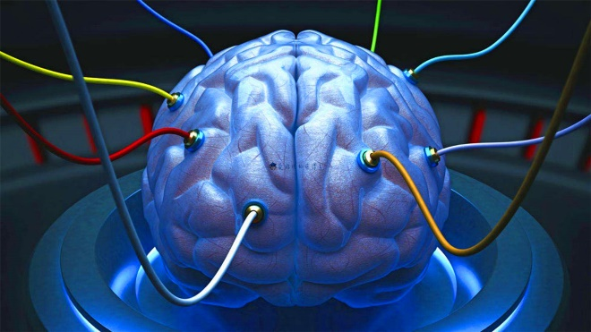
- Main role on society
The field of human-computer interaction, which encompasses the study of technology between humans and computers, has the potential to be applied in a variety of contexts, including health and daily life. It represents a novel concept within the broader field of technology and society.
- Description
Human-computer interaction (HCI) is the study and practice of how people interact with computers and computing systems. It encompasses the design, evaluation, and implementation of interactive technologies to ensure they are useful, usable, and enjoyable for humans.
HCI involves understanding human capabilities and limitations, such as perception, cognition, and motor skills, and applying this knowledge to create interfaces and systems that are intuitive and efficient. This includes the design of graphical user interfaces (GUIs), touchscreens, voice commands, and other input/output methods.
HCI also involves evaluating the usability and user experience of interactive systems through methods such as user testing, surveys, and analytics. This helps to identify areas for improvement and ensure that systems meet the needs and expectations of users.
In addition to traditional computing devices such as desktop computers and laptops, HCI also extends to emerging technologies such as mobile devices, wearables, virtual reality, and augmented reality. As these technologies become more widespread, HCI plays an increasingly important role in ensuring that they are accessible and useful for a diverse range of users.
Overall, human-computer interaction is a multidisciplinary field that combines elements of computer science, psychology, design, and engineering to create interactive technologies that enhance human productivity and creativity.
- Related product or technic
  - Traditional device
    - Mouse and keyboard
    - Touchpad
    - Touchscreen
    - Digitizer tablet
    - Voice input device
both of them are input devices for human-computer interaction. HCI focuses on making computers user-friendly, and these devices are crucial for input and receiving feedback.
Frontier Company
- ASUS
- Lenovo
- Apple

  - Human-machine interface (Not matured yet)

Currently challenge of Computer Science
- Rapid technological change
The field is evolving at an extremely fast pace, making it difficult for professionals to keep up with the latest tools, languages, and frameworks. Have to constant learning and upskilling.
Keeping up with the pace of technological innovation is a major challenge. New programming languages, frameworks, and tools emerge constantly, requiring continuous learning and adaptation. For example, the shift towards cloud computing, containerization, and serverless architectures demands that developers quickly acquire new skills and knowledge.
Ensuring the interoperability and compatibility of different technologies can also be difficult. As new systems are developed and integrated, ensuring that they work seamlessly with existing ones is crucial but often complex.
- Cybersecurity threats
As our reliance on digital systems grows, so do the risks of cyberattacks. Computer scientists need to develop robust security measures to protect sensitive data and systems.
The increasing sophistication of cyber-attacks poses a significant challenge. Hackers are constantly finding new ways to breach security systems, steal data, and disrupt operations. This requires continuous investment in security measures such as firewalls, encryption, and intrusion detection systems.
Protecting sensitive data, such as personal information and financial records, is also a major concern. With the growth of online services and the Internet of Things (IoT), the amount of data being generated and shared is enormous, making it difficult to ensure its security.
- Ethical considerations
With the increasing power of technology comes the responsibility to ensure its ethical use. Issues such as privacy, algorithmic bias, and the impact of automation on employment need to be addressed.
As computer science plays an increasingly important role in society, ethical issues become more prominent. For example, the use of artificial intelligence and machine learning algorithms can lead to biases and discrimination if not properly designed and tested.
The development of autonomous systems, such as self-driving cars and drones, raises questions about liability and safety. Ensuring that these systems make ethical decisions and operate safely is a complex challenge.
- Data Management and Privacy
The volume of data being generated is growing exponentially, making it difficult to manage and analyze. Big data technologies such as Hadoop and Spark have emerged to address this challenge, but they require specialized skills and infrastructure.
Protecting the privacy of data is also a major concern. With the increasing use of data analytics and machine learning, ensuring that personal information is not misused or exposed is crucial.

The prospect of Computer Science’ development
- Technological Innovation
- Advancement in Computing Power
The continuous development of semiconductor technology will continue to enhance the processing power of computer chips. New architectures and technologies, such as multi-core processors, high-performance GPUs, and specialized accelerators, will enable computers to handle more complex tasks and large-scale data processing with even greater efficiency.
- Quantum Computing
Quantum computing is expected to make significant breakthroughs. It has the potential to solve problems that are currently intractable for classical computers, such as complex optimization problems and cryptographic challenges. As research progresses, quantum computers may become more accessible and have a profound impact on various fields like finance, chemistry, and logistics.
- Biological Computing
Biological computing uses biological molecules, such as DNA, to perform computations. This field is still in the early stages of development but holds great promise for creating highly efficient and energy-saving computing systems. It could lead to the development of new types of bio-inspired computers with unique capabilities.
- Neural Computing and Artificial Intelligence
The development of artificial intelligence and neural computing will continue to accelerate. AI algorithms will become more intelligent, capable of understanding and generating human-like language, recognizing complex patterns, and making autonomous decisions. This will drive the growth of intelligent systems in areas such as robotics, autonomous vehicles, smart homes, and healthcare.
- Expansion of Application Fields
- Healthcare
Computer science will play an increasingly important role in healthcare. It will be used for medical imaging analysis, disease prediction and diagnosis, drug discovery, and personalized medicine. Wearable devices and remote monitoring systems will enable continuous health monitoring, and AI-powered medical assistants will help doctors make more accurate diagnoses and treatment plans.
- Finance and Business
In the financial sector, computer science will be used for risk assessment, algorithmic trading, fraud detection, and blockchain-based financial systems. It will also help businesses optimize their operations, improve supply chain management, and enhance customer experience through data analytics and intelligent decision-making systems.
- Education
The education field will see further integration of computer science. Online education platforms will become more intelligent and personalized, providing students with customized learning paths. Virtual reality and augmented reality technologies will be used to create immersive learning experiences, and educational software will assist teachers in teaching and assessment.
- Smart Cities and the Internet of Things (IoT)
Computer science will be the backbone of smart city initiatives, enabling the integration of various systems such as transportation, energy, and public safety. The IoT will continue to expand, connecting billions of devices and generating massive amounts of data that need to be processed and analyzed for efficient management and control.
- Data Science and Big Data
- Data-Driven Decision Making
As the amount of data generated continues to grow exponentially, the importance of data science and big data analytics will increase. Organizations will rely on data-driven insights to make informed decisions, optimize their processes, and gain a competitive edge. Advanced data analytics techniques, such as machine learning and deep learning, will be used to extract valuable information from large and complex datasets.
- Data Privacy and Security
With the growing concern for data privacy, there will be a greater focus on developing robust data security measures. This includes encryption technologies, access control systems, and data anonymization techniques to protect sensitive information. Additionally, regulations and standards for data protection will become more stringent, driving the development of compliant
- Interdisciplinary Collaboration
- Integration with Other Sciences
Computer science will increasingly collaborate with other scientific disciplines, such as biology, chemistry, physics, and materials science. This will lead to the emergence of new interdisciplinary fields, such as computational biology, computational chemistry, and materials informatics. These fields will use computer modeling and simulation to accelerate scientific research and discovery.
- Human-Computer Interaction (HCI)
The field of HCI will continue to evolve, aiming to create more intuitive and natural interfaces between humans and computers. This includes the development of touch interfaces, voice recognition, gesture control, and brain-computer interfaces, which will enhance the user experience and make technology more accessible to people of all ages and abilities.

Summary
In short, Computer Science’s project involved many fields you could imagine or not, leading to life becoming more convenient as the growth rapidly. Meanwhile, the computer science has branch for more major since the day we pass, all of them can gain the progression of our technology and apply to different fields benefit our lives, such as brain-computer interface is one of the newest research which aimed to help Vegetative state to turn back their lives. How ever, along with the number of technology has been mature, there are many problems been appeared such as cybersecurity and the reality of information online, not only these issue which is easily to been seen, but also there are some of potential obstacles has too been remarked like the ethical problem and data storage technology.
Computer Science is facing many challenge on the era, it’s the serious question that we have to think discreetly, because their could bring the huge change for our lives, for example, if Ai are promised to gain the self-intelligence, it may let our live with a stronger helper, but we can’t deny their potential at the same time cause it own their own action may do the dangerous action after their judge.
Above all, all we need to do is master or promote the way how we protected our personal information on internet and nurture the critical thinking to deal with the message online.

Conclusion
- Analysis
项威：AI technologies, like machine learning and natural language processing, rely heavily on algorithms and data structures developed through computer science principles.The interplay between computer science and AI not only showcases the power of technology but also highlights the need for interdisciplinary approaches to tackle complex challenges.
吴林洋：Influential figures like John J. Hopfield and Geoffrey E. Hinton have shaped the field of computer science. Their contributions not only advanced technology but also set the stage for future innovations. That's just our future goals.
谢嘉枫：Computer science combines logic, creativity, and problem-solving to develop solutions that can have a huge impact on the world. From algorithms and software development to artificial intelligence and data science, there's so much potential for innovation and exploration.
阮云轩：Computer science can raise important ethical questions. As technology advances, issues like data privacy, algorithmic bias, and the digital divide become increasingly significant. It's crucial to consider how these advancements affect society and individuals. Balancing innovation with responsibility is a key challenge.
- Reflection
During our research,we realize that computer science still have several key issues today.
Many research results lack sufficient reproducibility, which raises questions about the reliability of findings. There is a need to promote open-source code, data sharing, and detailed experimental records to enhance reproducibility.And some high-impact journals tend to favor publishing positive results, leading to negative findings and replication studies being overlooked.
In many technological studies, ethical and social implications are not adequately considered. Researchers should incorporate ethical considerations into research design and evaluation.
As new teens of computer science, we should help foster a healthier research ecosystem to achieve a better future.

Reference
- Paper
- Hongkun Luo, Chi Guo, Yang Liu, Zengke Li, SuperVINS: A visual-inertial SLAM framework integrated deep learning features. 31 Jul 2024. ·
URL: https://cs.paperswithcode.com/paper/supervins-a-visual-inertial-slam-framework
- Joar Skalse, Alessandro Abate. Misspecification in Inverse Reinforcement Learning, Vol. 37 No. 12: AAAI-23 Special Tracks / AAAI Special Track on Safe and Robust AI. 2023-06-26
URL: https://ojs.aaai.org/index.php/AAAI/article/view/26766
- Yihan Hu, Jiazhi Yang, Li Chen, Keyu Li, Chonghao Sima, Xizhou Zhu, Siqi Chai, Senyao Du, Tianwei Lin, Wenhai Wang, Lewei Lu, Xiaosong Jia, Qiang Liu, Jifeng Dai, Yu Qiao, Hongyang Li; Proceedings of the IEEE/CVF Conference on Computer Vision and Pattern Recognition (CVPR), 2023, pp. 17853-17862
URL: https://openaccess.thecvf.com/content/CVPR2023/html/Hu_Planning-Oriented_Autonomous_Driving_CVPR_2023_paper.html
- John Kirchenbauer, Jonas Geiping, Yuxin Wen, Jonathan Katz, Ian Miers, Tom Goldstein Proceedings of the 40th International Conference on Machine Learning, PMLR 202:17061-17084, 2023.
URL: https://proceedings.mlr.press/v202/kirchenbauer23a.html
- Petr Hruby, Timothy Duff, Anton Leykin, Tomas Pajdla; Proceedings of the IEEE/CVF Conference on Computer Vision and Pattern Recognition (CVPR), 2022, pp. 5532-5542 URL:https://openaccess.thecvf.com/content/CVPR2022/html/Hruby_Learning_To_Solve_Hard_Minimal_Problems_CVPR_2022_paper.html
- Aaron Defazio, Konstantin Mishchenko Proceedings of the 40th International Conference on Machine Learning, PMLR 202:7449-7479, 2023.
URL: https://proceedings.mlr.press/v202/defazio23a
- Barry Brown, Mathias Broth, Erik Vinkhuyzen, CHI '23: Proceedings of the 2023 CHI Conference on Human Factors in Computing Systems Article No.: 12, Pages 1 – 14, 19 April 2023 Publication History
URL: https://dl.acm.org/doi/full/10.1145/3544548.3581045
- ImageNet classification with deep convolutional neural networks | Communications of the ACM
- Yin lizi:Research on the stability of neural networks based on dynamic models. 2011
URL: https://lib.hust.edu.cn/asset/detail/0/20428195168
- CICIR Artificial Intelligence and National Security Taskforce;Li Yan：A New Age of Artificial Intelligence Has Arrived.2024-34-2
URL: https://lib.hust.edu.cn/asset/detail/0/2031308749089
- CCID Think Tank Artificial Intelligence Industry Situation Analysis Research Group:Outlook of China's artificial intelligence industry in 2024.2024-2
URL: https://lib.hust.edu.cn/asset/detail/0/2031265775440
- Tan tieniu:The history, current situation and future of artificial intelligence. 18th Februry 2019
URL:https://www.cas.cn/zjs/201902/t20190218_4679625.shtml

- Website
- https://www.coursera.org/articles/computer-science-fields
- https://viso.ai/deep-learning/ai-software/
- https://www.geeksforgeeks.org/real-time-application-of-data-structures/
- https://aws.amazon.com/cn/what-is/computer-networking/
- https://www.oracle.com/database/products-a-z/
- https://www.maigoo.com/top/428121.html
- https://www.maigoo.com/top/428122.html
- ttps://navi.cnki.net/knavi/journals/JSJA/detail?uniplatform=NZKPT
- https://navi.cnki.net/knavi/journals/JSJX/detail?uniplatform=NZKPT
- http://cjc.ict.ac.cn/index.htm
- https://www.jsjkx.com/CN/column/column1.shtml
- https://jcr.clarivate.com/jcr/browse-category-list
- The Nobel Prize in Physics 2024 - Popular science background - NobelPrize.org
- Press release: The Nobel Prize in Physics 2024 - NobelPrize.org
- John Hopfield – Facts – 2024 - NobelPrize.org
- Geoffrey Hinton – Facts – 2024 - NobelPrize.org

