Guarany

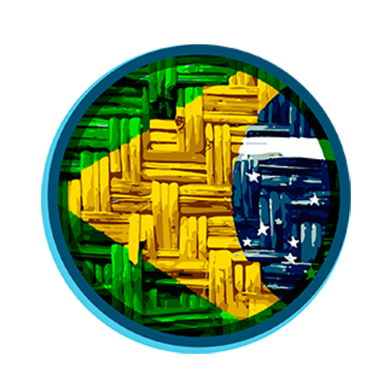

**Overview**

Guarany focus is to joint the Brazilian coins created before but that not have a huge value, as well as charities, whilst also providing new innovative ideas that can be implemented into the real world. This whitepaper will help provide investors with facts, sponsorship ideas, programs to get involved and information to learn more. It’s easy to make a difference while gaining experience with successful Altcoin & Crypto-Currency management.

Guarany plans to use the Altcoin to support environmental conservation and community of altcoin crypto with bank programs, commerce and more. We encourage others to get involved by learning about available programs in their region of interest. There’s many ways to get involved; the GUARANY team is establishing other business relationships to provide excellent resources for the public.

Guaranny has plans to add new wallet features and enhancements to the community in general as time goes on. This includes new games, faucets, giveaways and more. We’re constantly working on expanding the Guarany community and welcome new friends. We want to bring back the real-world use of an alt-coin rather than having a mere pump & dump coin. Over time our investors will be rewarded with a stable yet highly valued coin.

As our network infrastructure expands, we plan on partnering with several different business and organizations. This will include environmental sustainability groups, international fair trade organizations, community music and art festivals, creative individuals and anyone with a passion for shared interests.

The Guarany team are currently situated in Brazil. As the community and team grows, we hope to have people based all around the world. Plankton plans on being the first non-profit crypto organization that will be registered in Brazil.

**Specifications**

Coin Suffix: GUA

Algorithm: Scrypt POW/POS

No IPO, no ICO

1% Premine used in swap*

Transaction Fee: No Fee

​Confirmations: 4, Maturity: 150

PoW Period: All blocks

PoW Ends: Block 9899985

PoS Min: After Maturity

PoS Max: 7 Days

PoS Interest: 1% Annually

Transaction Confirmation: 4 Blocks/10 Minutes

Target Spacing: 2.5 Minutes

Difficulty Retarget: Each block

Block Reward: 1

Total Coins: 10,000,000

Block Halving: Never

P2P port: 8745

RPC port: 8744

Guarany.conf :

rpcuser=<rpcusername>

rpcpassword=<rpcpassword>

rpcport=8744

server=1

listen=1

daemon=1

gen=0

rpcallowip=127.0.0.1

addnode=seed1.guarany.co

addnode=seed2.guarany.com

**History**

Guarany begans with need to joint the old Brazilian coins that don’t have interest from public, with automatic swap on Bleutrade Exchange, and was created and launched by community/users that like BrCoin and SambaCoin. He envisioned Guarany as a community driven crypto-currency with a focus on the commerce.

We want to do a cryptocurrency that can be used for real and by real people,

as commerce currency to buy some items on internet or not, we plan to add a magnetic card to pay or receive payments based on shops and webshops.

Guarany never set out to be a crypto-currency with crazy new features or false promises for merely a pump and dump coin, and we, the new developers, plan to follow suit.

The following white paper will clarify the details of GUARANY and establish a detailed pathway for investors, miners, and community members. The public will have materials, updates and enhancements delivered in a timely fashion because we believe that having honesty, integrity and transparency, as well as creating real world applications of crypto-currency, is the only way to a sustainable future.

So if this sounds like a crypto-currency that you would like to join in on, strap yourself in and enjoy the following read and together as a community, we will create a top 10 market cap coin.

**Road Map**

Guarany road map has been setup with three main streams; Technical Aspects, Marketing and Adaption, and Crypto Fun. These will be the initial stepping stones to getting Guarany back on track and headed in the right direction.

This will be broken down to three phases that will be completed;

**Phase One**

Guarany Wallet launch

Guarany Website launch

Social Media & Marketing Campaign

**Phase Two**

Swap

Guarany Paper & Online Web Wallet (Exchange can be the web wallet too)

Setup a Multi-Pool

Partner with a e-commerce and phisical commerce

Launch our Blockchain

**Phase Three**

Stable the prices to commerce use

Partnerships with an Online store Company

Guarany Game Development

**Conclusion**

A lot of research and time has been spent to ensure that the Guarany community thrives once more. Guarany sets out to be a non-profit organisation that will provide the crypto world with a coin that sets itself out from all others. The Guarany team will work tirelessly to meet deadlines and provide all aspects that have been set out in this white paper. Guarany aims to be the helper of the community by partnering with organisations to support environmental conservation and crypto community programs. The team also plans on delivering features never seen before to help create a strong company that will invite investors to invest in CRYPTO.

We see Guarany as a community coin and if you feel as if there should be something added to the Roadmap, shoot us a message and we will discuss whether this could be a potential asset to be introduced.

The team would like to thank you for your time in reading through our White Paper created for the Guarany Community.

The journey has just started!

**Information**

Guarany can be swapped for Sambacoins and Brcoins

Guarany is a community coin, without a centralized developer

We have the support from Bleutrade Exchange to do this good Project

All questions about bugs need be posted on github and forum

**Exchange**

[Bleutrade](http://www.bleutrade.com)