**Cookies Recipes**

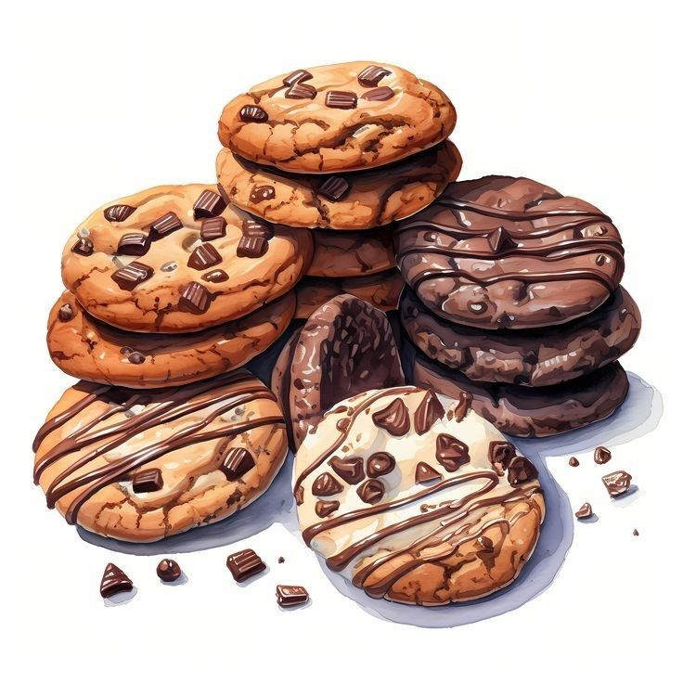**For Dummies**

## Top class bakery menu in the world

## Classic Chocolate Chip Cookies

### Ingredients:

- 2 ¼ cups (280g) all-purpose flour  
- 1 tsp baking soda  
- ½ tsp salt  
- 1 cup (225g) unsalted butter, softened  
- ¾ cup (150g) granulated sugar  
- ¾ cup (150g) brown sugar, packed  
- 1 tsp vanilla extract  
- 2 large eggs  
- 2 cups (340g) semi-sweet chocolate chips  
- Optional: 1 cup chopped nuts (e.g., walnuts or pecans)

### Instructions:

1. Preheat the oven to 375°F (190°C) and line baking sheets with parchment paper.  
2. In a bowl, whisk together the flour, baking soda, and salt. Set aside.  
3. In a separate bowl, cream the butter, granulated sugar, and brown sugar until light and fluffy.  
4. Add eggs one at a time and stir in vanilla extract.  
5. Gradually mix the dry ingredients into the wet ingredients.  
6. Fold in chocolate chips (and nuts, if using).  
7. Scoop dough onto baking sheets, spacing them 2 inches apart.  
8. Bake for 8-10 minutes, or until edges are golden. Let cool on the baking sheet for 5 minutes before transferring to a wire rack.

## Peanut Butter Cookies

### Ingredients:

- 1 cup (250g) peanut butter (creamy or crunchy)  
- ½ cup (100g) granulated sugar  
- ½ cup (100g) brown sugar  
- 1 large egg  
- 1 tsp vanilla extract  
- ½ tsp baking soda  
- Optional: Chocolate chips for a twist

### Instructions:

1. Preheat the oven to 350°F (175°C).  
2. Mix peanut butter, granulated sugar, brown sugar, egg, vanilla, and baking soda until combined.  
3. Scoop tablespoons of dough and roll into balls. Place them on a lined baking sheet.  
4. Use a fork to create a crisscross pattern by pressing down on each ball.  
5. Bake for 8-10 minutes until golden. Let cool on the baking sheet for 5 minutes before transferring to a wire rack.

## Classic Butter Cookies

### Ingredients:

- 1 cup (225g) unsalted butter, softened  
- ¾ cup (150g) granulated sugar  
- 1 large egg  
- 2 tsp vanilla extract (or almond extract for a twist)  
- 2 cups (250g) all-purpose flour  
- ¼ tsp salt

### Instructions:

1. Preheat the oven to 350°F (175°C). Line baking sheets with parchment paper.  
2. Cream the butter and sugar until light and fluffy.  
3. Mix in the egg and vanilla extract until fully incorporated.  
4. In a separate bowl, whisk together the flour and salt.  
5. Gradually add the flour mixture to the butter mixture, mixing until a soft dough forms.  
6. Use a piping bag with a star tip to create shapes, or roll the dough into small balls and flatten them.  
7. Bake for 10-12 minutes, or until edges are lightly golden. Let cool on the baking sheet for 5 minutes before transferring to a wire rack.

## Double Chocolate Cookies

### Ingredients:

- 1 cup (225g) unsalted butter, softened  
- 1 cup (200g) brown sugar  
- ½ cup (100g) granulated sugar  
- 2 large eggs  
- 1 tsp vanilla extract  
- 1 ¾ cups (220g) all-purpose flour  
- ½ cup (60g) cocoa powder  
- 1 tsp baking soda  
- ½ tsp salt  
- 1 ½ cups (270g) semi-sweet or dark chocolate chips

### Instructions:

1. Preheat the oven to 350°F (175°C) and line baking sheets with parchment paper.  
2. Cream butter, brown sugar, and granulated sugar until smooth.  
3. Add eggs and vanilla, mixing well.  
4. In a separate bowl, sift together flour, cocoa powder, baking soda, and salt.  
5. Gradually add the dry ingredients to the wet mixture and mix until just combined.  
6. Fold in chocolate chips.  
7. Scoop dough and place on baking sheets, spacing 2 inches apart.  
8. Bake for 9-11 minutes or until edges are set but centers are soft.  
9. Cool on baking sheets for 5 minutes before transferring to a wire rack.

## Peanut Butter Cookies

### Ingredients:

- 1 cup (250g) peanut butter (creamy or crunchy)  
- ½ cup (100g) granulated sugar  
- ½ cup (100g) brown sugar  
- 1 large egg  
- 1 tsp vanilla extract  
- ½ tsp baking soda  
- Optional: Chocolate chips for a twist

### Instructions:

1. Preheat the oven to 350°F (175°C).  
2. Mix peanut butter, granulated sugar, brown sugar, egg, vanilla, and baking soda in a bowl until combined.  
3. Scoop tablespoons of dough and roll into balls. Place them on a lined baking sheet.  
4. Use a fork to create a crisscross pattern by pressing down on each ball.  
5. Bake for 8-10 minutes until golden.  
6. Let cool on the baking sheet for 5 minutes before transferring to a wire rack.

## Oatmeal Raisin Cookies

### Ingredients:

- 1 cup (225g) unsalted butter, softened  
- 1 cup (200g) brown sugar, packed  
- ½ cup (100g) granulated sugar  
- 2 large eggs  
- 1 tsp vanilla extract  
- 1 ½ cups (190g) all-purpose flour  
- 1 tsp baking soda  
- 1 tsp ground cinnamon  
- ½ tsp salt  
- 3 cups (240g) old-fashioned rolled oats  
- 1 cup (150g) raisins  
- Optional: ½ cup chopped nuts (e.g., walnuts)

### Instructions:

1. Preheat the oven to 350°F (175°C) and line baking sheets with parchment paper.  
2. Cream the butter, brown sugar, and granulated sugar until fluffy.  
3. Mix in eggs and vanilla extract.  
4. In a separate bowl, whisk together flour, baking soda, cinnamon, and salt.  
5. Gradually mix dry ingredients into the wet mixture.  
6. Fold in oats, raisins, and nuts (if using).  
7. Drop spoonfuls of dough onto baking sheets, spacing them 2 inches apart.  
8. Bake for 10-12 minutes or until golden brown.  
9. Cool on the baking sheet for 5 minutes, then transfer to a wire rack.