Multiple Dose

Single Dose

IV Injection

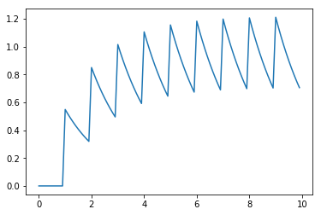

**Concentration**

**Time**

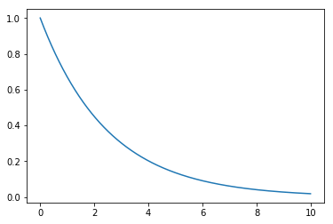

Blood

$$k$$

$$Injection$$

Oral Administration (PO)

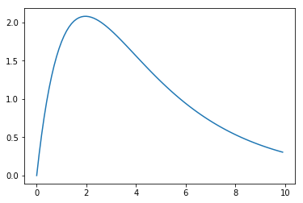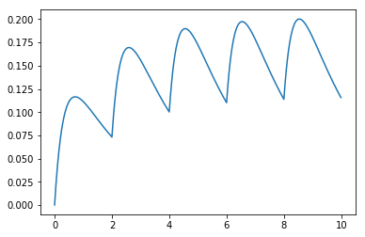

${D*ka/(ka-k)*(e}^{-ka}-e^{-ka}$)

Intestine

$$Dose$$

Blood

$$k$$

$$ka$$

$$Absorbtion$$

IV Infusion

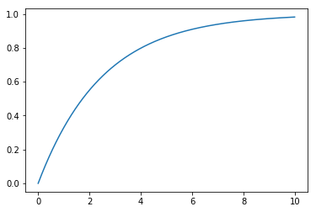

$${D*(1-e}^{-k})$$

Blood

$$k$$

$$Infusion$$

**CPSC 532M Project Proposal**

**Prompt**

The proposal should be a maximum of 2 pages (and 1 page or half of a page is ok if you can describe your plan concisely). The proposal should be written for the instructors and the TAs, so you don't need to introduce any ML background but you will need to introduce non-ML topics. The projects must be done in groups of 2-3. If you are doing your assignment in a group that is different from your project group, only 1 group member should include the proposal as part of their submission (we'll do the merge across assignments, and this means that assignments could have multiple proposals). Please state clearly who is involved with each project proposal.

**1. What problem you are focusing on.**

“All things are poisons, for there is nothing without poisonous qualities. It is only the dose which makes makes a thing poison.” - Paracelsus

Dose is critical in pharmaceutical practice. Technically every drug is poison, but it is the dosage make the difference. Therefore, the pharmacokinetics(PK) analysis whose goal is to unravel the time and dosage relationship is of critical value.

The compartment model is the most utilized model in PK. The simple 1 compartment model is shown below, from which scientist can get some useful information like the half life of the drug, the clearance, the drug distribution volume of the drug in patient body. There are models that are more complicated with more than 1 compartment       .

[Picture]

Derived from the differential equation in the compartment model. We can get the Drug-concentration vs time exponential equation.

[Equation]

Different way of administration

[Picture : Equation]

Multiple dosage

[Picture]

Nonlinear Kinetics:

[Picture]

It is crucial to detect the nonlinear clearance, it indicate some event like the enzyme induction or organ failure occurs.

* How the analysis is usually done?

Current pharmaceutical practicing have to manually analyze the data using the to determine the PK model of the patient for the decision making - time consuming.

Current drug monitoring in hospital only monitor the current concentration. The PK analysis is not performed, no prediction is made, It may cause the over-under dosing and won’t able to detect the special event.

* The goal to achieve

Automated tools for PK analysis. Automatically generated the parameter for compartment model. Can be real time analysis.

Nowadays only limited types of drugs are monitored because of the cost of analysis.

Faster model fitting. The objective function of the model fitting is so easy to get trapped in the local minimum.

Identify the special event: Outlier detection.

**2. What you plan to do.**

The first step of our project design will be to create an automated tool, given the patient data of their drug effects concentration over time, to identify the method of drug injection used on a patient by determining the PK model used. Specifically, we will be distinguishing between methods of injection, infusion, and oral administration.

The method of machine learning implemented will be K-nearest neighbours. To perform this step, we will be creating simulated training data, which will then be used to train our machine learning model. The model of the training data can be determined using machine learning via the equations proposed in the above section. The test data will be processed and fitted to determine the method used. By using K-nearest neighbours, we can also determine a suitable set of values for parameters *k* and *ka* (if applicable) based on the shape of the dataset. The performance of our model will be evaluated comparing the error of the predicted parameter values to the actual parameter values.

The second part of our project is to rewrite the OLS function for model fitting.

The Third part of our project, if time allows, will be to determine outliers in multiple dosage. One possible method to determine the outliers will be to determine the maximum concentration threshold value acceptable in the dataset, and having data values beyond that curve would be determined as an outlier. Alternatively, we can calculate the maximum distance error accepted using least squares, and data points where the distance error exceeds the accepted range will be considered an outlier.

**3. What will be the “contribution"**

Our project creates a new application and advantages current technology in the pharmacokinetics field. The proposed design will assist to the clinical personnel in this area by significantly saving the amount of manual workload and time they spend in determining PK models. Additionally, the model can be used to determine special events of patient conditions based on the detected outliers.

Furthermore, currently the personnel do not collect and analyze the entire dataset; they only view and record values of concentration levels which are important for the situation it is used. Our model provides the entire analyzed dataset, which can potentially be further used by researchers in advancing current methods and technologies.