**Group 5: Interactive Campus Map**

**Team Members:** Justin Gaskins gaskij@rpi.edu 516-459-8347

Sebastien Boulas boulas@rpi.edu 978-809-8214

Christopher Pence pencec@rpi.edu 914-263-7593

Pengqin Wu wup9@rpi.edu 901-335-8472

**Table of Contents:**

|  |  |
| --- | --- |
| **Section** | **Page** |
| Introduction | 2 |
| Project Summary | 2 |
| Proposed Users/Stakeholders | 2 |
| Technologies | 2 |
| Project Goals | 3 |
| Requirements | 3 |
| Project Timetable | 3 |
| Site Map | 4 |
| Wireframes | 5 |
| Conclusion/Future Plans | 7 |

**Introduction:**

This is a term project for the ITWS-2110 class, taught by Professor Thilanka Munasinghe. We must create a website that is supported by most mainstream web browsers and makes use of a database, server and client side programming, authentication, moderation, and easy use for clients and expandability for future developers. Our group has determined that our final project idea will be an interactive campus map, to be used in place of the current basic map of campus that is available.

As RPI students, we understand the struggle that is finding buildings on campus; especially true for freshman, transfer students, guests, etc. It is clear from this that there is a demand for this product, and our goal when designing this interactive campus map is to make life easier for our stakeholders by them saving valuable time.

**Project Summary:**

On top of providing an exact location of every building on campus, what would set our web application apart would be its ability to provide an interactive experience for the user. This would include a search bar where anyone can type the name of a certain location or building name on campus that they would like to get to and in return, our web application would show a pin on the map where it is located. This would facilitate building recognition, without ever seeing it in person, and would also allow users to get contact information, or information about the facilities or services on offer at that location. Upon further inspection, it would provide a combination of pictures, descriptions, and reviews of that specific building or location on campus. It is important to consider that in order to upload pictures and reviews of the various locations, users will be required to log in with a valid RCS ID and password.

**Proposed Users/Stakeholders:**

Our primary stakeholders would be RPI students and we predict that most of our users would be freshman. However this product can certainly benefit new faculty members, transfer students, and temporary visitors to our campus as well.

**Technologies:**

Technologies included:

* JavaScript will be used to animate the map and allow us to make locations clickable.
* PHP will be used to facilitate our database and allow us to create our search bar function. It will also allow us to create a secure user login and authentication.
* MySQL will be used as our database to store: users, locations, photos, and comments. The database will be searchable from our search bar so users can search for a location.
* Apache Web Server will be used to host the web server and allow us to run MySQL/PHP.
* Bootstrap will be used to add minimal styling to the webpage and help format the comments section. This will add a nice elegant look to the webpage.

**Project Goals:**

Our users should be able to:

* View a standard overhead map of RPI and click on a location to learn more
* Search a location by name or nickname
* Leave reviews or advice comments on a location
* Upload their own photos of locations
* Users able to securely login

**Requirements:**

To meet our Project Goals, these functional and non-functional requirements must be met:

Functional:

* Login made available with RPI email address
* A large overhead map of RPI
* Easy to read comments and review section
* Search bar that works with nicknames of buildings as well

Non-Functional:

* Initial photos of buildings to upload to the site
* Some general information about each building

**Project Schedule:**

|  |  |
| --- | --- |
| Date | Task/Objective |
| 9/18/18 | Project Proposal due by midnight. |
| 10/2/18 | Have basic HTML fleshed out for each of the main pages. |
| 10/16/18 | Have all pictures taken and collected of campus buildings and facilities. |
| 10/30/18 | Have server/database integration working. |
| 11/13/18 | Have completed styling/javascript integration. |
| 11/27/18 | Have a working demo available, begin work on presentation. |
| 12/7/18 | Final Project Materials due on LMS by midnight. |

**Site Map:**

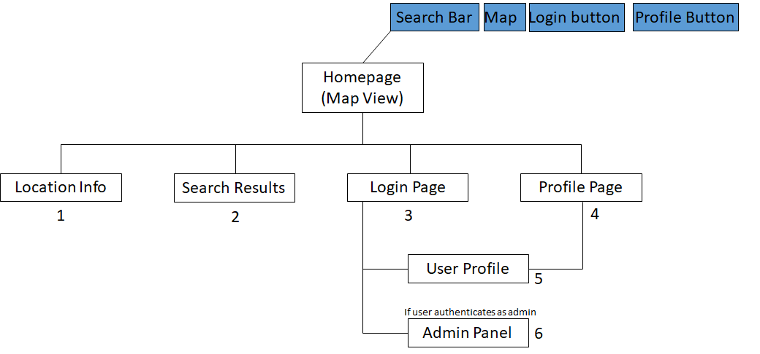

1. **Location Info:** This page will load after the user selects a location either from Search Results (2) or by clicking on a location found on the homepage. It will display information about the building or location the user has selected. It will also display user comments and photos. Finally, it will give signed in users the ability to upload their own photos or comments.
2. **Search Results**: This page will display the results from the search parameters entered on the homepage. It will be similar to a standard internet search.’’
3. **Login Page**: This page will allow users to login into the website after clicking the “Login” button found on any page. Once the user is logged in, this button will be replaced with “Log Out” and “Profile” buttons on all pages. This is the page where users will enter their username and password to login. If they are a new user, they will also have the option to create an account.
4. **Profile Page**: This page will allow users to update information about themselves and change their password. It can be accessed by clicking the “Profile” button found on any page after the user has logged in.
5. Same as Profile Page (5).
6. **Admin Panel**: This is where an admin will be directed after logging in and clicking the “Profile” button. It will allow them to access admin features such as: deleting comments, deleting photos and more.

**Wireframes: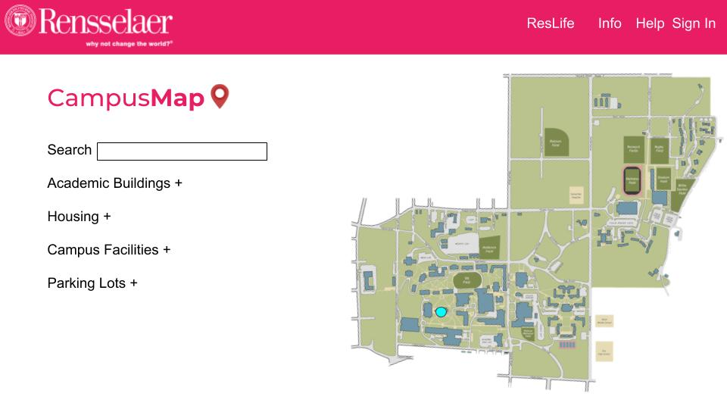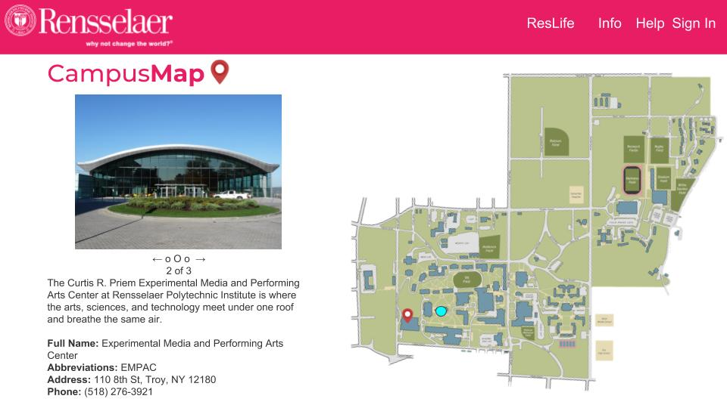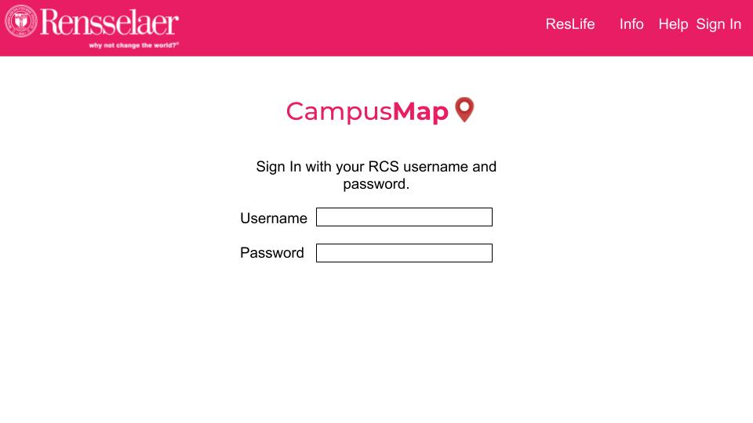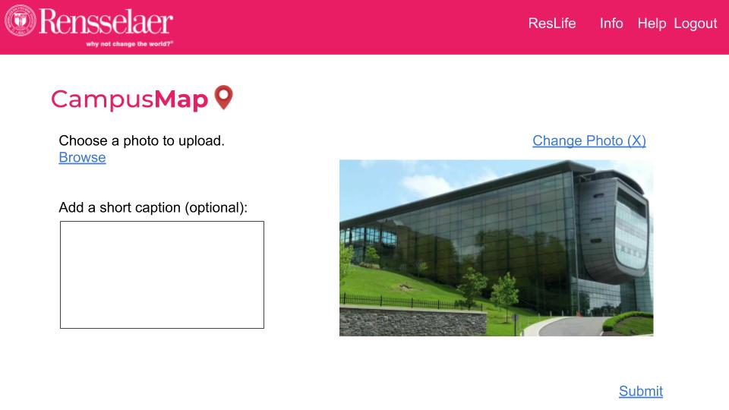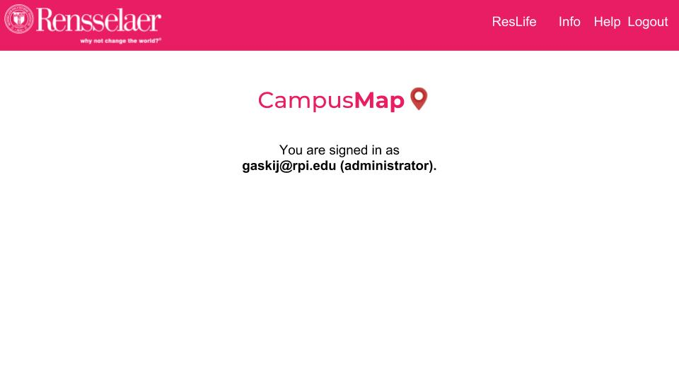Conclusion/Future Plans:**

If this project is successful, our hope is that it will be as widely used and accepted by RPI, just as the Shuttle Tracker and YACS web applications are. We would love to have our project recognized by the Rensselaer Center for Open Source (RCOS), so that developers all over campus will be able to make constant updates and improvements to our code. They would also be able to support it into the future, adding to it anything that members of the RPI community feel is necessary. It is our belief as a team that this project has the potential to become one of the longest lasting projects from RPI and even merge with others in the future.

In terms of our responsibility and management of the project in the future, we plan on making the four of us group members administrators of the webpage where we can periodically review content. If we notice that any kind of bullying, harassment, or spam is taking place, one of the administrators will have the ability to remove content.

On top of providing an excellent platform, a big priority of ours is to provide users with the confidence that their information will be secure. We plan on doing this by using a form of encryption that will allow us to verify logins securely and keep our database secure.