Visual Programming

# *Name: Unaiza Faheem*

*Class: BSCS(B)*

*Roll No: 233787*

***Lab_2***

***Exercise:1***

*Develop a console based application using visual c# to print your name, address and registration number*.

***Input:***

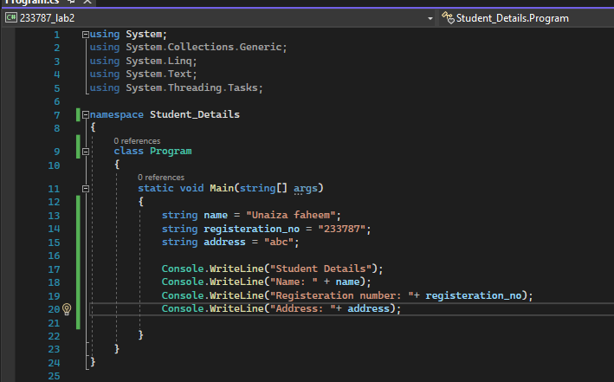

**Output:**

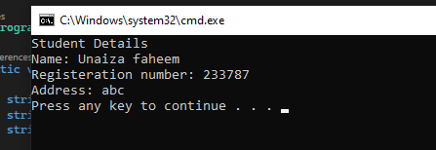

***Exercise:2***

*Develop a console based application which takes command line arguments and print them on console:*

***Input:***

