

**PROJECT TITLE: SIMULTANEOUS EQUATIONS**

**GROUP MEMBERS: RABIA IMRAN (21/F-BSAI-40)**

**UNAIZA KHALID (21/F-BSAI-11)**

**SUBJECT: OBJECT ORIENTED PROGRAMMING**

**SUBMITTED TO: SOFIA HAJANO**

**Final Report**

**INTRODUCTION:-**

We are creating a program in java language by using an “Eclipse ide” in which, solving the two linear equations also called

Simultaneous Equations. Furtherly, we are using GUI in it and creating a logic to solve the two linear equations.

**WORKING:-**

Firstly, we create the package which named as “eqn” and then select the class that would be named as simultaneous equation solver. We initialize the panels, labels, text-field and buttons like that:

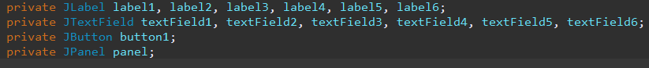

And then, we are creating the labels in it for the purpose to indicate the value of x and y and making the third column for the constant same as equation 2 the written form given below.

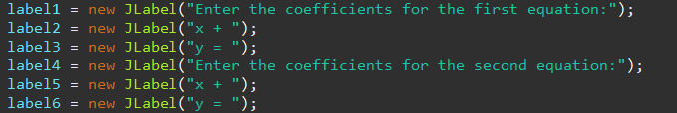

then creating the text-fields where the user insert the values of coefficients and then click on the solve and get the answer in the form next tab where the answer is given in the form of Solution Set(x , y) which is exactly our intersecting point of x and y co-ordinate the written form like that:

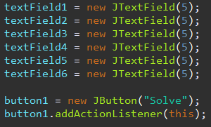

Then, we create panel sequence the labels and their text as per required and also set the grid layout or set that it will be visible to us which are given below:

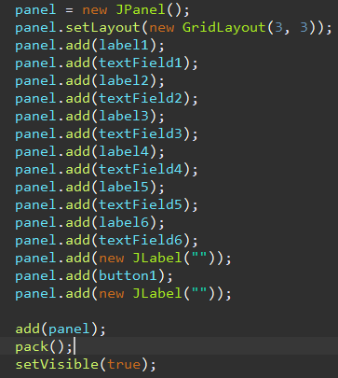

The logic is to solving both equations which are given below:

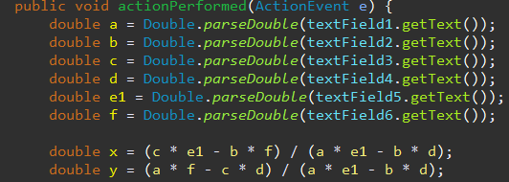

Further On, we create the dialogue box for the solution and set the conditions like that:



and creating the panels also, we using the double where the answer would be given in the form of points and at last we create the main method where we call the equation app given below:



**Output:-**

Output declares as that we insert the coefficients of x and y and then our program solve it by the logic which we used in it and then the answer is shown in the form of solution set in a dialogue box.

Here’s the result given below:

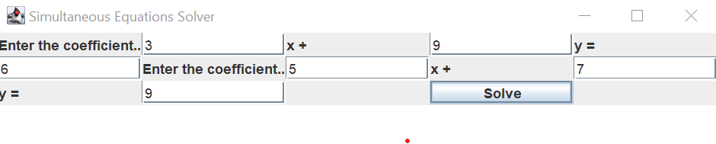

And here the dialogue box shows the output.

