**Bilkent University**

**Department of Computer Engineering**



Database Project

# **Project Specifications Report**

### 

**Group Members**

Doren Calliku

Hamza Saeed Khan

Usama Saqib

Unas Sikandar Butt

## **Instructor**

Asst. Prof. Shervin R. Arashloo

## **Teaching Assistant**

Arif Usta

# **Table of Contents**

**Table of Contents** 2

**1. Introduction** 4

**2. Project Description** 5

**3. Requirements** 6

**3.1 Functional Requirements** 6

**Patient** 6

**Pharmacy** 6

**Doctor** 6

**3.2 Non-Functional Requirements.** 7

**3.2.1 User-Friendliness** 7

**3.2.2 Accurate Data Distribution** 7

**3.2.3 Reliability** 7

**3.2.4 Privacy** 7

**3.3 Limitations** 8

**Implementation** 8

**Scope** 8

**Time frame** 8

**Language** 8

**4. Entity-Relationship Diagram** 9

**5. Conclusion** 11

**6. Website** 11

# **1. Introduction**

The healthcare industry is one of the largest industries in the world. That being so, a typical medical center today goes through tremendous amount of data each day e.g. patients, doctors, staff, treatments, expenses, etc. To aid institutions dealing with this data traffic, this project will aim to design and implement a database system. The main aim of our project will be to automate the process by creating an interface for each patient and lead the patient through the steps necessary for her or him to reach the medical care the patient needs.

In the following sections this report will state the project description, discuss the requirements (functional and nonfunctional) of the project and introduce the entity-relationship (ER) diagram of the proposed database.

Progress of this project will be tracked using progress reports at different phases of the project.

The project will start with the Project description which describes the scope and the properties of the Database that we are creating. It will continue with the question of why do we need a database, and what are some principle assumptions for this case.

The report continues with the requirements. Functional requirements represent what the system will look like, what will be the functionalities the user will be able to use, how will the graphical user interface with the functionalities itself. In non-functional requirements we think that the main emerging requirements for the system would be usability, performance, reliability and privacy.

After these requirements we provide with the starting case for the ER diagram. This will create the basis for our database. Still, we are conscious that it is just a starting step as it will most probably change depending on the problems and the solutions that we will find, however it will shape our work along the way.

# **2. Project Description**

This project aims to create a Patient Medical Treatment Tracking System (PMTTS). The PMTTS will be a web application which would serve 3 target clients; patients, doctors and pharmacists. This project hopes to provide an interface to the clients which could serve as a better alternative to today’s medical centers’ processes. It will aim to reduce most of the paperwork, the booking and the drug buying process. This project will be patient-oriented, as required from the assignment, so we will simplify some of the use cases which are related to the doctors, hospital and pharmacies. Still, depending on the way our work goes we can later include further functionalities. One of them might be to include the different types of Examinations that might be needed in the hospital.

For the patients the PMTTS will provide an interface which could be used for instant treatment bookings, doctor/specialist selection, location of treatment and medical history input. This system will also provide the patients with the capability of requesting prescribed medicine from the pharmacy. Through this we hope to save the patients’ valuable time and provide a pleasant treatment process.

For the doctors, the PMTTS hopes to provide a valuable assistant which would keep track of all the appointments and provide a particular patient’s medical history instantly. This will enable the doctors to perform their treatments without needing additional unnecessary paperwork.

For the pharmacists, the PTMMS will provide a reliable and easy-to-update inventory. This would aid the pharmacist in checking for the availability of a particular drug and perhaps recommend an alternative drug if the prescribed drug is unavailable. Through these capabilities the PTMMS will aid patient-pharmacy interaction.

**2.1 Why do we need a database for this problem?**

The aim of databases is to regulate the information flow so that operations like querying, insertion, deletion and following of the data can be done as easily as possible. This system does need a database in its nature. The presence of different actors, each of them in need of being informed about the process of patient medical process, and also the need to be as efficient as possible require a database system which will provide everybody with what they want accurately and by not allowing confusion in an important process like the one about caring about human beings.

# **3. Requirements**

# **3.1 Functional Requirements**

PTMMS supports mainly the patient as a user and Doctor and Pharmacy are included as potential future users. All the patients will have to authenticate themselves in the beginning, and we plan to distribute the permissions and the functionalities the users will be able to use according to the type of user.

## **Patient**

* The patient will provide his or her symptoms to the system.
* Patient can look up different doctors, treating their symptoms.
* The patient should be able to view the different time slots available for each doctor.
* The patient should be able to see the doctors bio, which includes the doctors address, the doctor’s department and the doctor’s speciality.
* The patient can book an appointment with the desired doctor.
* The patient should be provided with a unique identifier, after the booking.
* The patient should be able to view their booking details using this identifier.
* The patient gets a prescription detailing the drugs needed to cure the patient.

## **Pharmacy**

* The pharmacy will check if the drug is available in their repository.
* If the drug is not available pharmacy will check if they have any drugs with same active ingredient.
* The pharmacy will provide the patient with the appropriate medicine.

## **Doctor**

* The doctor should be able to view the booked time slots.
* The doctor should be able to look up the symptoms of the booked patients.
* The doctor should be able to view the treatment history of each booked patient.

# **3.2 Non-Functional Requirements.**

These are the emerging properties that we expect our system to have. We want the user experience to have priority, of course added to privacy and reliability of the system.

## **3.2.1 User-Friendliness**

* The system should be able to provide fast responses to the user requests for doctor information, and time slots.
* The system will be easy to use. This will depend on the front end design and how easy the booking process is for the user.

## **3.2.2 Accurate Data Distribution**

* This will be managed through clean and efficient database design.
* The system should not allow overbooking by blocking multiple appointments requests by the same IP address.

## **3.2.3 Reliability**

* The systems should prevent patients personal history from being leaked.
* There should not be problems related to the data’s transfer.

## **3.2.4 Privacy**

* The system should allow permission management from the administrator, which is us in this case.
* Each user will have different level of permissions.
* There will be requirements for the sign-up and log-in credentials of the patients and the other users.

# **3.3 Limitations**

## **Implementation**

* MySQL will be used to construct the database. MySQL is an open-source relational database system as it supports cross-platform support. This database system is used by some of the most successful companies in the market.
* JavaScript will be used for the frontend of the web application. The main reason why we will be using Javascript is because it is one of the best options in creating interactive web pages and web applications. It has also the option of the server-side, but we will use mostly its functionality related to the server-side.
* PHP might be used for the backend requirements related with the data connection between different pages.

## **Scope**

* The functionality is limited to providing a doctor appointment and drug prescription system.
* Other functionalities, like taking care of the Examination, re-appointment and the hospital’s management of facilities might be added later according to the work-progress.

## **Time frame**

* The expected date of completion of the project is 25th December 2018.

## **Language**

* English will be the language of the application.
* The reports will be the Project Specification Report, the Analysis Report and the Design report.

# **4. Entity-Relationship Diagram**

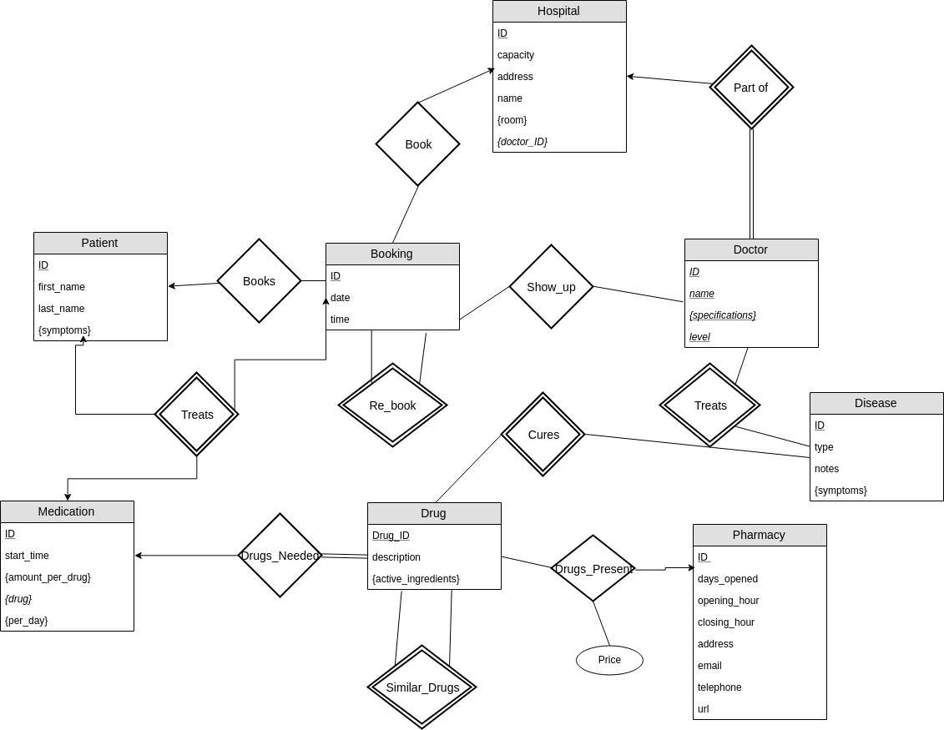

There are several points to be noted regarding the assumptions of the ER Diagram.

* First, this is not the final version. This is the basic start with some added functionalities. We still have some conceptual problems to solve, and we are working on them.
* The main use case of the system will be represented with booking a meeting and then the result of the meeting/booking will create a receipt with the drugs this person needs to take. So, the user will be presented with a list of symptoms he/she has, the user will select, and then the list of doctors with the specialization for the Diseases with these kind of symptoms will be provided, and the Hospital name they are working in.
* The meeting will be booked for a time, depending on the capacity of the Hospital. Assumption: each doctor will use only one room.
* The drugs will be prescribed in a Receipt, and the user will be provided with the pharmacies that have these drugs, or similar kind, and their address. To be added functionality is the Treatment functionality, where the system will take care of the amount of the prescribed medicine and the time of the consumption of this medicine.

Notation: In case the relation is part of another relation, like Patient has Receipts, the notation is to write the attributes in dotted underline, but was not present in the tool so we used italic underlined.

# 

# **5. Conclusion**

The PMTTS will be a database management system that will hold important information regarding patients, doctors and pharmacy. The main object of the system is to provide a convenient management system that would perform tasks regarding the patient treatment process instead of the patients, doctors or pharmacists.

This report serves as a proposal to the PMTTS. PMTTS was described and introduced in this report. Furthermore, the functional requirements, nonfunctional requirements and limitations of the PMTTS were stated. The ER diagram of the PMTTS was displayed and explained as well.

# **6. Website**

The repository for this project is available at:

https://github.com/Unassikandar/PMTTS