ABOT · IEEE R10-HTC 2026 · TALK SCRIPT
Results and Analysis
The spoken part that follows Design and Implementation. Six results, strongest claim first, then what they add up to and the limits.
1,835 words, about 12 minutes 763 words in the 5-minute version
HOW TO READ THIS SCRIPT
Spoken text | Read aloud. Paragraphs with a blue bar form the 5-minute version: read only those to cut the section short.
Spoken text | Read aloud in the full version only.
ON SCREEN | On screen: what the slide shows. Not read aloud.
CAREFUL | Careful: wording to avoid. Not read aloud.

Words in bold are the ones to stress.
SHORT ON TIME?
Read only the paragraphs with a blue bar: about 763 words, roughly 5 minutes. They cover Results 1 to 5 and every framing rule: simulation only (Opening), no delivery claim (Result 1, Taken together, Limits), the AI is exploratory (Result 2), and the stuck loop isn’t caused by damage (Result 3).
In the short version, skip the right pair of bars on Chart A (or crop the chart to the left pair), let Chart B’s numbers speak for themselves, and keep the gossip table and Fig. 2 as backup slides.
OPENING

Six results, strongest first
ON SCREEN
Section slide: “Results”, listing the six result titles.
# | Result | Its slide shows
1 | Using live link scores changes which routes get picked | Chart A
2 | The AI route-finder is in the same range as the classic methods | Chart B + Table II
3 | Making the damage worse barely changes the outcome | Damage-sweep figure
4 | Our fast simulator makes AI training practical | One line: “up to 7.3×”
5 | Sharing learned values between radios makes no difference | Gossip table
6 | The radio model behaves sensibly | Fig. 2

Now to our results. Everything I’ll show comes from simulation; no real radios were used. We have six results, and I’ll take them from the strongest claim to the weakest.
One fact runs through all six. In every test, a route-finder, the method that picks each next hop, builds a route from a starting radio to a safe zone, our stand-in for a rescue point. Almost every trip arrives. So we compare route-finders on how many hops they take, where a hop is one radio-to-radio jump. Fewer is better.
RESULT 1 · Paper V-C

Using live link scores changes which routes get picked
ON SCREEN
Chart A: static vs dynamic Dijkstra, average link-quality score.
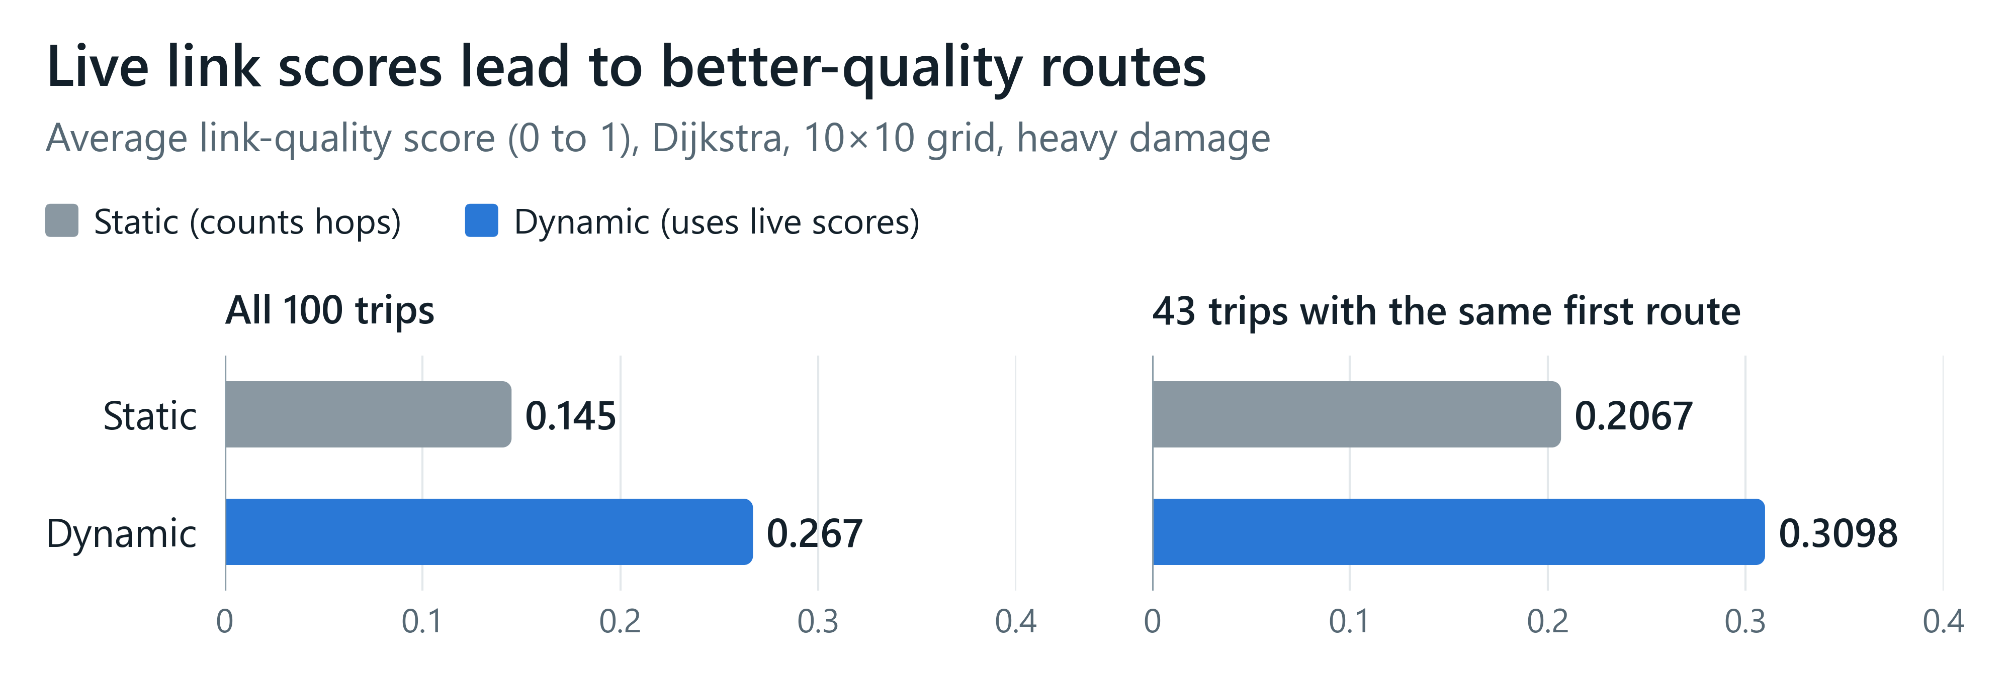

WHAT WE TESTED
First, our strongest result. We ran Dijkstra, the classic shortest-route method a sat-nav uses, in two versions on the same 100 trips. The static version counts hops. The dynamic version also weighs each link by a live link-quality score, and re-plans if the route ahead gets worse.
A link-quality score is a number from 0 to 1 that each radio keeps for how well its links have worked recently. We average it over the radios a route passes through. Read it as a relative score for comparing route-finders, not as the share of messages delivered.
WHAT HAPPENED
Look at the left pair of bars. Without live scores, the average link-quality score is 0.145. With them, it’s 0.267. That’s about 1.8 times higher. Across the damage levels, the gap is about 1.8 to 1.9 times from intact to heavy, and about 1.5 times at severe and extreme.
Is that just because the routes differ in length? The dynamic version does take longer routes: 3.23 hops on average, against 2.17. But longer routes tend to score lower, not higher. If we compare only trips of the same length, the gap widens, to between 1.9 and 2.6 times.
The right pair is a supporting check. In 43 trips, both versions planned the same first route, so only re-planning differs. There, the scores are 0.2067 against 0.3098. That’s 1.5 times higher, with a p-value of 0.0057. A p-value is the chance of seeing a gap this big if there were really no difference. So chance is very unlikely to explain it.
We also tested the A-star pair, a close cousin of Dijkstra, the same way. It re-planned in only 3 of 100 trips, so it shows almost no gap, 1.03 times, and tells us nothing either way.
WHY IT MATTERS
A route-finder that listens to live link quality ends up on better-scoring links than one that only counts hops. That’s the result the paper stands on. But our claim is narrow. The dynamic route-finder chooses its routes using this same score, so a higher score is partly expected. So we claim that live link-quality scores change which routes get picked. We don’t claim that more messages arrive.

CAREFUL Say “link-quality score”, never “delivery rate” or “more messages delivered”. Call the 43-trip result a supporting check, and don’t put “250 episodes per preset” next to 0.267 vs 0.145.
RESULT 2 · Paper V-A, Table II

The AI route-finder is in the same range as the classic methods
ON SCREEN
Chart B: average hops by route-finder, beside the simplified Table II.
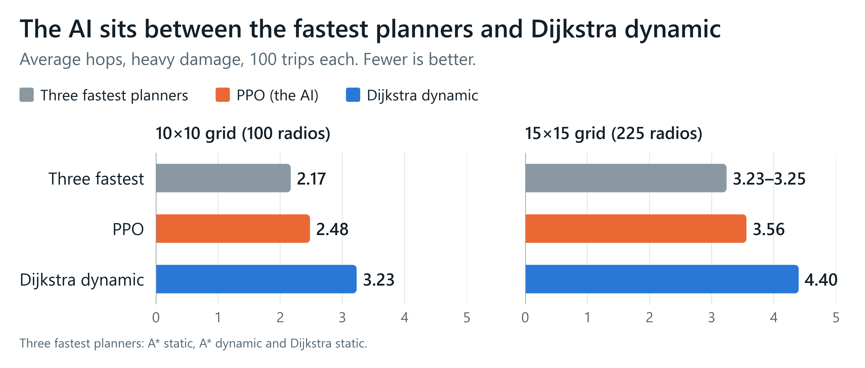
Grid | Compared with | Result | Adjusted p
10×10 | Dijkstra dynamic | PPO better | 0.000025
10×10 | A* dynamic, A* static, Dijkstra static | PPO slightly worse | 0.047
15×15 | Dijkstra dynamic | PPO better | 0.0019
15×15 | A* dynamic, A* static, Dijkstra static | No difference | 0.255

WHAT WE TESTED
Second, our AI route-finder, trained with PPO, a trial-and-error method that learns from points for good moves and penalties for bad ones. We compared it with the four classic route-finders, Dijkstra and A-star, each static and dynamic, on two grid sizes, 100 trips each.
All five ran at the default damage level, heavy. The chart shows average hops. We use averages because hop counts are whole numbers, so the middle values often tie.
WHAT HAPPENED
On the 10-by-10 grid, the three fastest classic methods, A-star static, A-star dynamic and Dijkstra static, average 2.17 hops. The AI averages 2.48, and Dijkstra dynamic 3.23. On the 15-by-15 grid, it’s 3.23 to 3.25 for the three fastest, 3.56 for the AI, and 4.40 for Dijkstra dynamic.
In the table, the p-values are adjusted because we made several comparisons at once. The AI takes fewer hops than Dijkstra dynamic on both grids, with p-values well below the usual 0.05 bar. Against the three fastest, it’s slightly worse at 10-by-10, with an adjusted p-value of 0.047, just under the bar. At 15-by-15 there’s no significant difference: p is 0.255.
WHY IT MATTERS
So the AI is in the same range as the classic methods: slightly behind the fastest at 10-by-10, no significant difference at 15-by-15, and better than Dijkstra dynamic at both. It learned a sensible way to route, but on this task it doesn’t beat simple shortest-route methods. That’s why we call the AI part exploratory.

CAREFUL Don’t say “PPO matches the classic planners”: at 10×10 it is measurably behind the fastest. Don’t lean on the paper’s “lower bound” argument.
RESULT 3 · Paper V-B

Making the damage worse barely changes the outcome
ON SCREEN
Damage-sweep figure. Relabel the left axis and title “link-quality score”, and replace the “n=” labels with level names.
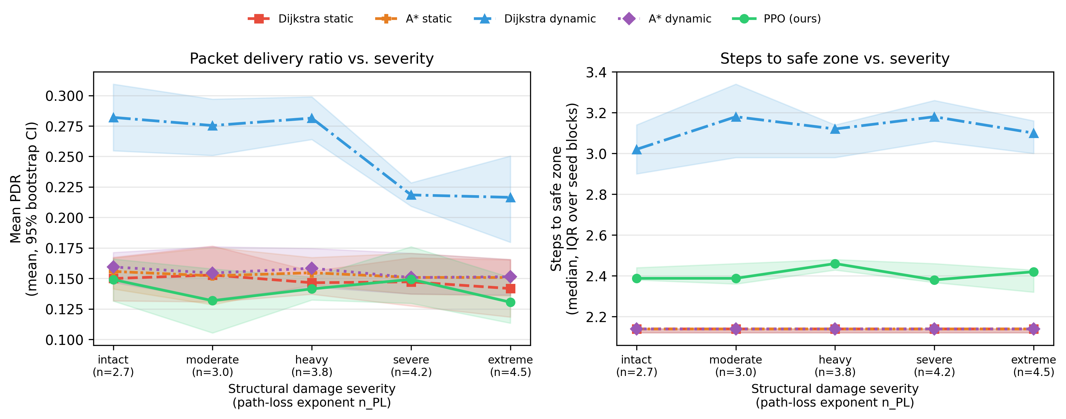

WHAT WE TESTED
Third, we made the damage worse, across five damage levels from intact to extreme. More damage makes radio signals fade faster with distance, as rubble would. Every route-finder ran 250 trips at each level, in five groups of 50.
WHAT HAPPENED
As damage gets worse, only one line on the left moves: Dijkstra dynamic. Its score sits near 0.28 from intact to heavy, then drops to 0.218 at severe and 0.216 at extreme. That’s a single drop of 23 percent at one step, not a gradual slide. Every other route-finder moves by less than 0.02. On the right, hop counts stay roughly flat for everyone.
Why at severe? Our radio model, which I’ll show last, explains it. At heavy, a link works half the time at about 2 kilometres, beyond our 1.5-kilometre radio range. At severe, that point moves inside the range, to about 1 kilometre. So severe is the first level where links within range fail often.
The AI doesn’t get worse as damage grows. It reaches a safe zone in 99.6 percent of trips at every level, which is one trip in 250. Each trip also earns a points score, called reward, and a normal trip scores just over 100. Four of the AI’s five groups average 101.4 to 102.2. The fourth averages only about 17 from intact to heavy, and about 23 at severe and extreme.
WHY IT MATTERS
The AI’s one weak spot is a livelock, a stuck loop. In one test scenario, it keeps picking a neighbour that has died. Each try is rejected with a penalty, the situation looks almost the same, so it picks that neighbour again. The cause is its fixed list of eight neighbours, where dead ones stay listed. It happens at every damage level, including intact. So the weak spot is how the AI’s choices are set up, not the damage.
So in our setup, damage weakens the long links, but it doesn’t stop trips. Success stays near 100 percent. This sweep compares route-finders under rising stress. It isn’t proof that the network is robust to damage.

CAREFUL Don’t repeat the abstract’s “limitations of RL-based routing under extreme network collapse”. Near-100% success is not evidence of robustness. The figure on file still says “Packet delivery ratio”: fix it, or say aloud that it shows the link-quality score.
RESULT 4 · Paper IV

Our fast simulator makes AI training practical
ON SCREEN
One line on the slide. Keep fig_scalability as a backup slide.
Up to 7.3× faster than our own reference simulator

WHAT WE TESTED
Fourth, the simulator itself. Our first simulator handles each radio transmission as a separate event. That’s accurate, but too slow for AI training, which needed 200,000 practice steps per run. So we built a faster one that moves all the radios forward together, one time step at a time, using the same models for radio links, failures and collisions. A collision is when two radios send at once and garble each other.
WHAT HAPPENED
Our fast simulator, with collisions switched on as in every result here, runs up to 7.3 times faster than our own reference simulator. “Up to” matters. That figure is from our smallest grid, and the gain is smaller on bigger grids. It’s also measured against our own reference, not against standard network simulators in general.
Do the two simulators agree? A statistical check called a KS test says they agree on how many radios stay alive, with a p-value of 0.98 over 20 matched runs. They disagree on traffic figures, with p below 0.001, because they handle collisions differently.
WHY IT MATTERS
The fast simulator makes AI training practical. It’s reliable for which radios are alive, which is what the AI learns from. But its absolute traffic numbers shouldn’t be read as real-world figures.

CAREFUL Always “up to”, always “than our own reference simulator”. Leave out 303× (collisions off, a setting no result uses). If asked about 10×10: about 4.7×, from the project files, not the paper.
RESULT 5 · Paper IV-A

Sharing learned values between radios makes no difference
ON SCREEN
The three-row gossip table.
Measure | Gossip on | Gossip off | p
Reached a safe zone | 100% | 100% | –
Average hops | 2.487 | 2.497 | 0.842
Average reward | 101.42 | 101.27 | 0.826

WHAT WE TESTED
Fifth, gossip. Gossip means radios passing information to their neighbours, who pass it on, like a rumour. Here, radios share the AI’s estimates of how good each position is. We ran the AI with gossip on and off, with three training runs and 300 trips for each setting.
WHAT HAPPENED
Both settings reached a safe zone in every trip. Average hops were 2.487 with gossip and 2.497 without, with a p-value of 0.842. Average reward was 101.42 against 101.27, with a p-value of 0.826. Both are far above 0.05.
WHY IT MATTERS
So gossip made no difference. Its merge step, where a radio would combine the values it receives with its own, isn’t connected yet, and both settings already solve this task. This shows the system works without gossip, not that gossip helps.

CAREFUL Don’t say gossip helps, or that its airtime cost was measured. The line is “Gossip made no difference; its merge step isn’t connected yet.”
RESULT 6 · Paper V-D, Fig. 2

The radio model behaves sensibly
ON SCREEN
Fig. 2, captioned “Link success vs distance (channel model)”. Drop “timestep backend” from the caption.
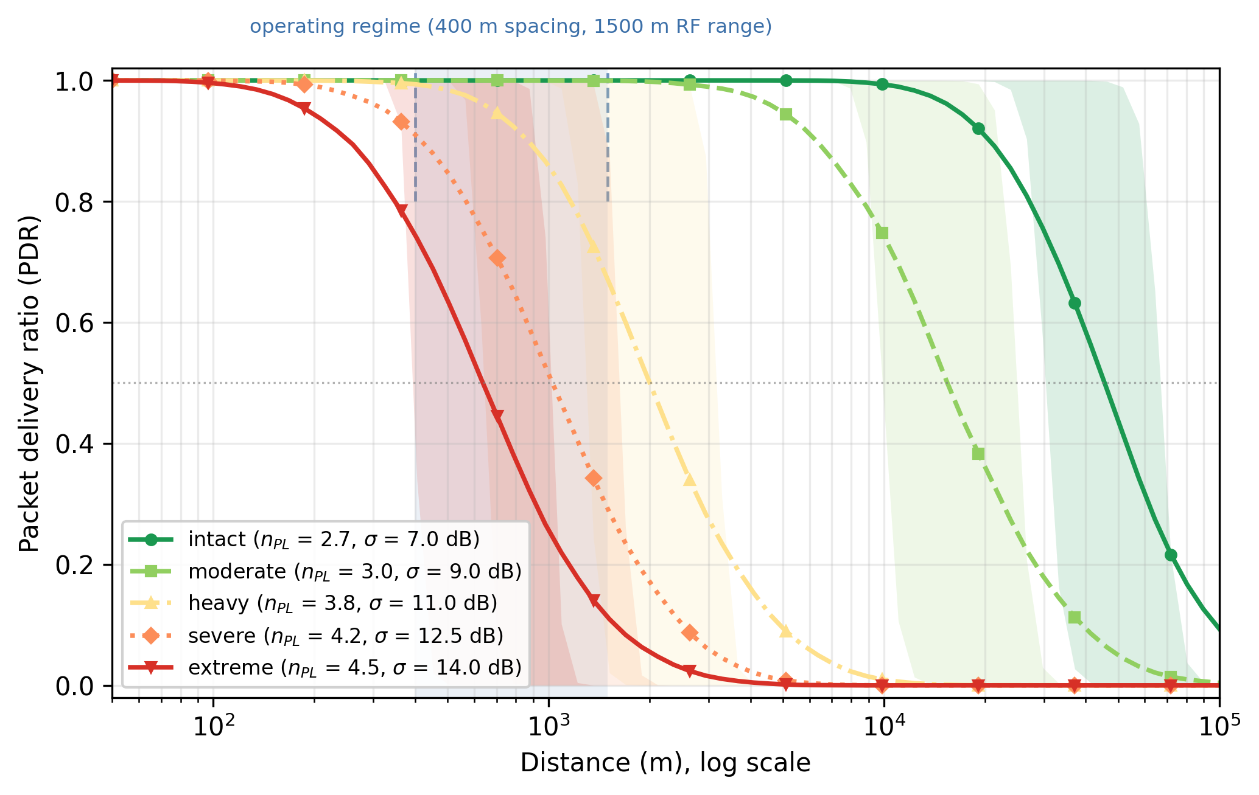

WHAT WE TESTED
Last, the radio model underneath it all. This plot shows how often a single link gets a message through as distance grows. That’s called the packet delivery ratio, or PDR. The distance axis is a log scale, so each labelled gridline is ten times further. The band between the dashed lines, from 400 metres to 1.5 kilometres, is where our mesh operates.
WHAT HAPPENED
Each curve is one damage level, a relative stress setting, and more damage shifts the curve left. At heavy, a link works half the time at about 2 kilometres. At severe, about 1 kilometre. At extreme, about 640 metres. At 1.5 kilometres, links succeed 66 percent of the time at heavy, 29 percent at severe and 11 percent at extreme. At 400 metres, the nearest neighbours, they stay above 73 percent at every level.
WHY IT MATTERS
The radio model behaves the way the standard model predicts: more distance and more damage mean more failures. That shows internal consistency, not agreement with real radios. It also explains the damage result: severe is where the halfway point moves inside our radio range.

CAREFUL Say “internal consistency”, never “validated”. Don’t quote the intact level’s 45.5 km.
AFTER THE RESULTS

Taken together
ON SCREEN
Three takeaways, plus one line: “Not yet measured: whether an SOS reaches a rescuer.”

So what does this add up to? First, a route-finder that uses live link-quality scores picks different routes, over links that score about 1.8 times higher. Second, the AI routes sensibly, in the same range as the classic methods but not ahead of the fastest. Third, we now have a simulator fast enough to train AI route-finders on a LoRa mesh.
And what we don’t claim. We measured link-quality scores along routes. We did not measure whether an SOS actually reaches a rescuer, or how long it takes. So we don’t claim that more messages get through. That end-to-end test is our next experiment.
AFTER THE RESULTS

Limits and next steps
ON SCREEN
The five limits as bullets, then “Next steps”.

Finally, the limits we state in the paper. Everything is simulation, at up to 900 radios, with no hardware measurements. Beacons, the short “I’m here” messages each radio sends every 30 seconds, take about 4.4 percent of its airtime. That’s high, and a gentler schedule would shift every beacon-based result. And the AI picks from only 8 neighbours, when radios have about 31.
The AI’s training didn’t fully settle either. The part that judges how good a situation is scored minus 0.67, 0.18 and 0.71 across three training runs, where 1 is perfect and below zero is worse than guessing the average. And a mesh only exists if people carry the devices.
We also want to be upfront about one thing. In this version, a hop succeeds whenever the next radio is still working. A weak link never makes a hop fail. That’s why every route-finder arrives. So our next steps are hops that can fail on weak links, meshes with radios further apart, and measuring whether each SOS reaches a rescuer, and how fast. Then comes firmware for the LoRa boards the Meshtastic community already uses, to check the simulator against real radios.
NOTES

Every number, and where it is in the paper
Where | Number as spoken | Paper section
Opening | Almost every trip reaches a safe zone | V-A
Result 1 | 0.145 vs 0.267, about 1.8× | V-C
Result 1 | 1.8–1.9× intact to heavy; about 1.5× severe and extreme | V-C
Result 1 | 3.23 vs 2.17 hops; 1.9–2.6× when matched on length | V-C
Result 1 | 43 trips, 0.2067 vs 0.3098, 1.5× (1.50×), p = 0.0057 | V-C
Result 1 | A-star pair: 3 of 100 trips, 1.03× | V-C
Result 2 | 100 trips per route-finder per grid | V-A, Table II caption
Result 2 | 2.17 / 2.48 / 3.23 and 3.23–3.25 / 3.56 / 4.40 hops | V-A
Result 2 | Adjusted p 0.047 and 0.255; “well below 0.05” = 2.5×10⁻⁵ and 1.9×10⁻³ | Table II
Result 3 | 250 trips per level, five groups of 50 | V-B
Result 3 | About 0.28, then 0.218 / 0.216; a 23% drop; others move < 0.02 | V-B
Result 3 | Half-success distance about 2 km (heavy), about 1 km (severe, 1.03 km) | V-D
Result 3 | 99.6% success (0.996). “One trip in 250” is our arithmetic: (1 − 0.996) × 250 | V-B
Result 3 | Reward 101.4–102.2 in four groups; about 17 (≈16.9) and about 23 (≈22.9) in the fourth | V-B
Result 3 | Eight neighbours to choose from | III (action space), VI
Result 4 | 200,000 training steps per run | III (RL environment)
Result 4 | Up to 7.3× faster with collisions on | IV
Result 4 | 20 matched runs; p = 0.98 alive radios; p < 0.001 traffic figures | IV
Result 5 | 3 training runs, 300 trips each; 100% both; 2.487 / 2.497, p 0.842; 101.42 / 101.27, p 0.826 | IV-A
Result 6 | 400 m spacing, 1.5 km range | III (action space), V-D
Result 6 | About 2 km / 1 km / 640 m (637 m) half-success distances | V-D
Result 6 | 66% / 29% / 11% at 1.5 km (0.664 / 0.286 / 0.109); above 73% at 400 m | V-D
Limits | Up to 900 radios | V (intro), VI
Limits | 30 s beacons; about 4.4% airtime | III (packets), VI
Limits | 8 neighbours vs about 31 (30.7) | III, VI
Limits | −0.67, 0.18, 0.71 | VI
Charts A and B are not figures in the paper, but every number on them comes from V-C and V-A.
NOTES

Sentences that rest on project files, not the paper
These help the audience follow, but none of them is a published result. If someone asks, say where they come from.
Where | Sentence | Source
Result 1 | “We average it over the radios a route passes through.” | The paper never says how its “mean link PDR” is calculated. darwinV2/src/train/runner.py:103-104; src/sim/timestep.py:720-733 (context.md §21).
Result 3 | “On the right, hop counts stay roughly flat for everyone.” | The damage-sweep figure is not in the paper. results_rev2/figures/damage_severity, from results_rev1/damage_severity.csv and results_commaware/commaware_severity_episodes.csv.
Results 3 and 6 | “Why at severe?” and “It also explains the damage result” | Every number is in V-D; linking them to V-B’s drop is our reading. ABOT-results-explained.html, result 3; context.md §15.
Result 4 | “That figure is from our smallest grid, and the gain is smaller on bigger grids.” | results_rev1/scalability.csv; results_rev1/logs/scalability.log:91 (context.md §12).
Taken together; Limits | “We did not measure whether an SOS actually reaches a rescuer.” | The paper doesn’t say this, and its abstract and conclusion suggest the opposite. Per-trip result files hold only success, hops, reward and the link score (context.md §11, §16).
Limits | “A hop succeeds whenever the next radio is still working.” | darwinV2/src/nav/env.py:311-313 (context.md §11, §15; triage answer 1).
LEFT OUT ON PURPOSE
- 45.5 km at the intact level (triage rule 7). Drop it from any damage table on the slides too.
- 303×, which is with collisions switched off, a setting no result uses (rule 6).
- The ETSI 1% comparison, a European rule (rule 9).
- “Lower bound”, and “the comparison is conservative against PPO” (rule 4).
- “Steps identical on all 100”, and “250 episodes per preset” beside 0.267 vs 0.145 (rule 11).
- The abstract’s “improved packet delivery” and “extreme network collapse” lines (rules 2 and 3).
- The test setup, which the Design and Implementation section already covers.

