# Methodology

## Data Cleaning

Original animal shelter data comes from [Dallas OpenData](https://www.dallasopendata.com/). The names and headings of each CSV were edited so they could be merged into a single continuous data frame in a ‘for loop.’ This was then filtered to include only meaningful columns. This includes:

* Animal ID
* Animal Type (Cat, Dog, etc)
* Animal Breed (Corgi, Pug, etc)
* Animal Origin (Field, Over the Counter)
* Census Tract (GeoData)
* Chip Status (Chip, No Chip, Unable to Scan)
* Intake Date
* Outcome Date
* Intake Condition (Health status)
* Outcome Condition
* Outcome Type (Adopted, Euthanized, etc)

Each animal’s length of stay was calculated by subtracting the Intake Date from the Outcome Date. Because some animals had stays approaching 2 years, outliers were filtered out. Outliers were defined as any stay greater than 60 days. While this range was well above the 75th percentile + 1.5*IQR (20 Days), we felt that 2 months was an unusual but reasonable amount of time to spend in a shelter.

The responses for each column were then limited to reduce the number of categories by using the .str.contains() function in python.

* Animal Origin
  + Field
  + Over the Counter
* Chip Status
  + Chip
  + No Chip
  + Unable to Scan
* Intake Condition
  + Healthy
  + Contagious
  + Rehabilitable Non-Contagious
  + Manageable Non-Contagious
  + Untreatable Non-Contagious
* Outcome Type
  + Adopted
  + Euthanized
  + Returned to Owner
  + Transferred

Intake types of untreatable & contagious, and dead on arrival were removed, as they would not be considered release.

Was split into two more data frames, one for cats, and one for dogs. Other types of animals that were excluded for study are ‘birds, wildlife, livestock.’ As much as we would like to know more about the scorpion that was dropped off at a shelter, it is outside the scope of this study.

Of the cat and dog breeds from each data frame, they were combined into broader categories. Cats were split into categories based off of their hair length. Dogs were organized to include broader breeds that include ~5000 animals. Corgi’s and Pug’s were included because they are the class mascots. All other dog breeds were grouped as ‘Other.’

* Cat Breeds
  + Short Hair
  + Medium Hair
  + Long Hair
* Dog Breeds
  + Chihuahua
  + Corgi
  + Hound
  + Pitbull
  + Pug
  + Retriever
  + Shepherd
  + Terrier
  + Other

## Modeling

To create predictive models for both the cat and dog data, we first established what we would like to predict: outcomes. Dallas Shelters took in 211,216 animals between 2015 and July 2020. To help determine how resources should be allocated, early knowledge of whether an animal is likely to be adopted or euthanized could be helpful. This is why we chose to predict outcome type.

To predict outcome type, this column was encoded with the following labels:

1. Adopted
2. Euthanized
3. Returned to Owner
4. Transferred or Fostered

The features for our model were largely categorical. To prevent limit bias, we encoded these categories using ‘One-Hot Encoding.’ This encoding was used for these columns:

* Animal Breed
* Origin
* Chip Status
* Intake Condition

The resulting new columns were joined with our only quantitative variable, length of stay. These values of both the categorical and quantitative variables were then scaled using sklearn’s StandardScaler.

The cat and dog data were then split using sklearns train_test_split, and passed through the following machine learning models:

* Logistic Regression
* K-Neighbors Classifier
* Decision Tree Classifier
* Bagging Classifier
* Random Forest Classifier
* Ada Boost Classifier
* Gradient Boost Classifier
* eXtreme Gradient Boost Classifier

While each model has its strengths and weaknesses, we believe that, for both cats and dogs, the Gradient Boost Classifier works the best. It had similar accuracy scores (0.58 for cats, 0.59 for dogs) with the other tree ensemble models but had better F1 scores than the rest of the models. It also falsely predicted euthanization at lower rates than the other models. While it did predict more euthanized animals would be adopted than other models those models had lower F1 scores for predicting euthanization.

Cat Gradient Boost Classification Analysis Report

|  |  |  |  |  |
| --- | --- | --- | --- | --- |
| Outcome | Precision | Recall | F1-Score | Support |
| Adopted | 0.60 | 0.50 | 0.55 | 3511 |
| Euthanized | 0.74 | 0.40 | 0.52 | 2585 |
| Returned to Owner | 0.31 | 0.03 | 0.06 | 159 |
| Transferred | 0.53 | 0.75 | 0.62 | 4710 |

Cat Confusion Matrix

|  |  |  |  |  |
| --- | --- | --- | --- | --- |
| Actual Outcome | Predict Adopted | Predict Euthanized | Predict Return | Predict Transfer |
| Adopted | 1770 | 45 | 2 | 1694 |
| Euthanized | 210 | 1024 | 6 | 1345 |
| Returned to Owner | 68 | 22 | 5 | 64 |
| Transferred | 883 | 300 | 3 | 3524 |

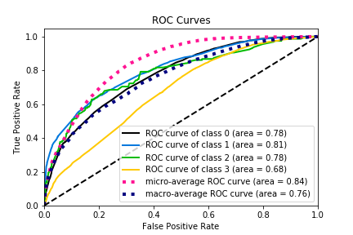Cat ROC Curves

Dog Gradient Boost Classification Analysis Report

|  |  |  |  |  |
| --- | --- | --- | --- | --- |
| Outcome | Precision | Recall | F1-Score | Support |
| Adopted | 0.54 | 0.85 | 0.66 | 12416 |
| Euthanized | 0.60 | 0.51 | 0.55 | 7366 |
| Returned to Owner | 0.76 | 0.66 | 0.71 | 7920 |
| Transferred | 0.43 | 0.09 | 0.15 | 6374 |

Dog Confusion Matrix

|  |  |  |  |  |
| --- | --- | --- | --- | --- |
| Actual Outcome | Predict Adopted | Predict Euthanized | Predict Return | Predict Transfer |
| Adopted | 10570 | 967 | 566 | 313 |
| Euthanized | 2690 | 3756 | 642 | 278 |
| Returned to Owner | 1909 | 638 | 5229 | 144 |
| Transferred | 4496 | 862 | 459 | 557 |

Dog ROC Curves

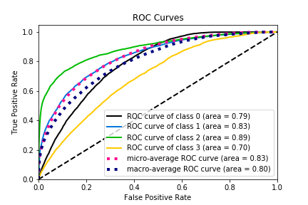

Model features varied in importance between cats and dogs. While length of stay was the most important feature for both (0.26 for cats, 0.40 for dogs), the origin of a dog seems to matter more than its health, and the opposite for cats. Breed matters more for dogs, while breed was the less important feature for cats.