Tuklas: System UI Design Progress
Oct 1, 2026
Documentation of today's agenda: the design of the system UI. Project target completion: 1st week of November 2026.

Summary
Design Progress Today
The team has started the system UI design for Tuklas, the academic engagement hub described in the Aug 31 meeting. The first screen (Login / Role Select) and the color palette with role accents are now designed in Figma.
Brand and Direction
The design presents Tuklas under the tagline "From Defense to Discovery" as a research and academic engagement hub for students, educators and administrators. A purple and gold palette sets the visual identity.
Next Design Work
Remaining screens (public portfolio, community feed, adviser posting and admin views) and the alternate appearance options requested at the Aug 31 meeting.

Design Progress
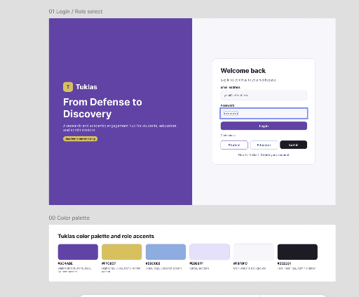
01 Login / Role Select and 00 Color Palette (Figma)

Decisions
Aligned
- Split-layout login screen. A purple brand panel on the left carries the logo, tagline and description; the login form sits on the right in a light card titled "Welcome back."
- Role selection at entry. Below the Login button, a "Continue as" row offers Student, Educator and Admin, so each user type is identified from the first screen.
- Purple and gold brand palette. Six colors with defined uses and role accents: deep purple, gold, soft blue, light lavender, off-white and near-black (Admin accent).
- Account creation link. New users are directed to "Create your account" from the login card.

Next steps
- [Jun Mari Manla] Present design options: Provide multiple appearance options for the academic platform portfolio and social media styles (carried over from the Aug 31 meeting).
- [The group] Design the remaining screens: Public-facing portfolio profile, community feed, adviser research posting flow, academic event ads and admin approval view.
- [The group] Confirm style direction: The current screen is clean and modern, while the client referenced early-to-mid 2000s LinkedIn as inspiration. Decide whether to adjust or present both options.
- [The group] Finalize naming: The design uses "Educator" while the meeting notes refer to "Research Advisers." Confirm they are the same role.
- [The group] Continue bi-weekly progress reviews until the first week of November.

Details
- Login Screen – Brand Panel: Tuklas logo (yellow "T" badge), headline "From Defense to Discovery," a short description of the platform for students, educators and administrators, and a small gold badge.
- Login Screen – Form: Card with "Welcome back" and the prompt to log in to the workspace. Fields for email address and password (the password field is shown in its focused state with a highlighted border), followed by a purple Login button.
- Login Screen – Role Buttons: "Continue as" buttons for Student, Educator and Admin. The Admin button uses the dark accent to stand apart from the other two.
- Login Screen – Footer: "New to Tuklas? Create your account" link.
- Content Priorities for Upcoming Screens: Research and literary works are the primary focus on profiles and the feed, followed by an "Academic Background" section (diplomas and degrees) and a "Honors & Awards" section (awards, grants and certifications).
- Platform Rules to Reflect in the UI: Student research appears only after approval by a research adviser or academic panel. Advertisements are limited to academic events such as research colloquiums, school innovations and the C.P. Garcia event.
- Development Approach: Incremental, from basic functionality to more complex features, with the public-facing portfolio built first.

Color Palette and Role Accents

Color | Used for
 | Brand color: left brand panel, primary buttons, focus states
 | Highlights: logo badge and small accent badge
 | Secondary accent
 | Soft backgrounds and cards
 | Page and form-side background
 | Text and the Admin role accent

