THE BUSINESS OF ONLINE DATING


The online dating market size is projected to surpass around USD 23.8 billion by 2032 from USD 10.1 billion in 2022 and it is poised to reach a registered CAGR of 9.2% from 2023 to 2032.
Online dating is still so popular that there are countless new startups in the space. Often, young founders will start businesses in the online dating niche because of their own experiences with more widely known apps like Bumble, OkCupid and Match.com. While there is plenty of room for growth in the market, I also know that some challenges need to be addressed. Five problems, in particular, are not necessarily apparent to new founders, but they can be the difference between success and failure in a competitive industry. Here are the five non-obvious issues I have experienced while reviewing dating companies as an investor.

- Dating apps are transactional by nature.

The primary goal of an online dating app or website is to help users find a perfect match. Of course, this means that the best apps have the highest turnover rates because they've fulfilled their purpose, and people no longer need their services. So, here's the paradox: The better the company is at its mission, the faster its users stop delivering value. On the surface, this can suck away a founder's motivation to do well at their job of matchmaking. After all, the purpose of any business is to grow and be profitable. Founders should consider other avenues for retention when developing a business plan. For example, an option to search for platonic matches or non-date hangouts would give users a reason to keep returning.

- Lack of interesting content.

If you've ever used a dating app, you know how quickly it can become boring, especially if you don't have any new matches or messages. Many founders don't think about a common problem: chats often become meaningless, and there's no other content to view on the platform. To combat this, many new startups are incorporating alternative content such as celebrity webinars, AR features, AI dating assistants, games and even educational videos.

- Most dating apps have limited scalability due to geography.

Dating apps typically base matches on a user's GPS location. Since most people hope to find a match close by, this makes sense. Companies like Tinder, Badoo and Bumble all operate this way. However, from a business standpoint, this model is nearly impossible to scale in a meaningful way. Companies have to launch city by city, which requires a substantial amount of time, effort and capital.
An alternate approach would be to consider ideas such as international dating. People are increasingly interested in virtual hangouts. This means there's potential for an app that connects people internationally with no immediate intention of meeting in person. This could also help people with social anxiety and similar struggles ease their way into making meaningful connections.

- High rates of scammers across the industry.

An unfortunate problem that the online dating industry faces is the issue of scammers and spammers. Recent reports say anywhere from 10-20 percent of online dating profiles are fake. In addition, online daters reported losing $547 million in romance scams in 2021 alone.

These scammers not only harm the overall user experience but substantially worsen the metrics for investors. Some of the less trustworthy platforms will leave these fake profiles in order to bolster their numbers and give the appearance of more user activity. However, the best companies often mitigate the issue by hiring moderation teams specifically to monitor and delete these profiles.

How has online dating in Russia developed over the past 20 years?
Russia is one of the largest dating services markets worldwide, with its revenue estimated at over 38 million U.S. dollars in 2022. The country's large population, together with high internet and smartphone penetration rates, offer favorable conditions to the industry. Generally, online dating is less popular in Russia than in many other countries. In 2021, only four percent of Russian singles used dating services, compared to 22 percent in Brazil and 20 percent in India. The number of dating users in Russia reached approximately 11 million in 2022, representing nearly eight percent of all residents.
Online dating in Russia first developed hand-in-hand with social media platforms. When networks like OK (Odnoklassniki) and VK (Vkontakte) first appeared in the 2000s, their users utilized them to connect with friends and search for partners. At that time, there were no smartphones in the country, so Russians mostly used these platforms from desktop devices. Besides social networks, dating portals like Loveplanet and Mamba emerged in that decade.
In the 2010s, users started using dating apps from their mobile devices; however, desktop platforms have not lost popularity. The coronavirus (COVID-19) pandemic accelerated the market growth in 2020 and 2021, with two in 10 dating app users reporting that they started using such products due to social distancing. Matchmaking was the largest market segment, followed by online dating and casual dating.

Key players in the Russian dating market

LEADING RUSSIAN DATING APPS

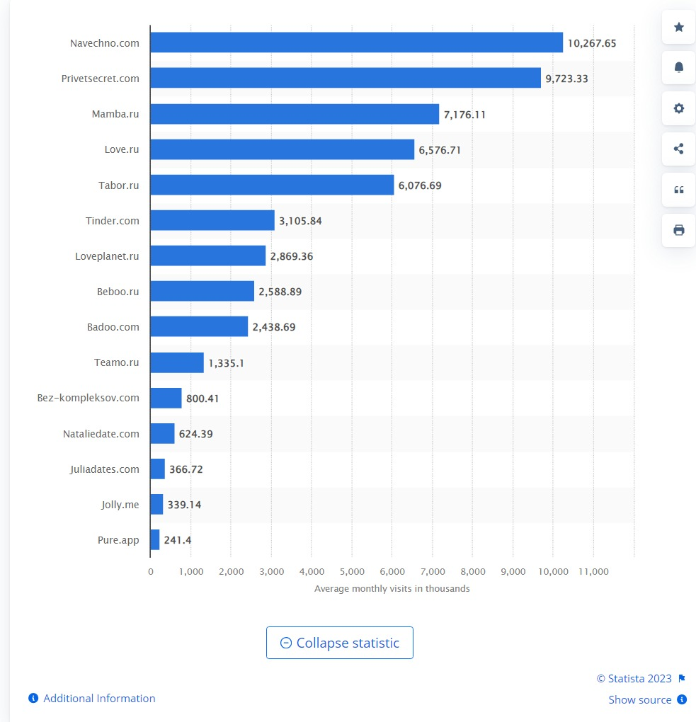
The Russian dating service Navechno was the most popular in terms of web traffic, with nearly 10.3 million average monthly visits between September 2021 and September 2022. Navechno operates both as a website and a mobile app. Based on new downloads, the leading dating app was Tinder, headquartered in the United States (US). Tinder was the country's primary foreign provider of dating services, having earned the largest in-app revenue of nearly 5.4 million U.S. dollars in 2022. In May 2023, Tinder announced its plans to exit the Russian market by the end of June 2023. Furthermore, Badoo and Bumble blocked new app downloads in the country in 2022.

OTHER PROBLEMS TO CONSIDER
I’ve been online dating on and off for years now, so I’m well aware of the problems with online dating. It treats people like commodities. It takes a lot of time and effort only to wind up on a bad date. It can become overrun with scammers and liars. It’s just not always what you want. Online dating can be a real pain in the ass — there’s no doubt about it. But there’s also no doubt that it’s one of your best options for finding a date these days. Before online dating, I’d go one date every couple months, maybe. Once I started swiping with purpose, I could land two or three dates a week. It wasn’t always easy and fun, but I did meet the guy of my dreams online and now we’re getting married, so I’d say all the problems were well worth it.

1. It Costs Money
I know that old song says the best things in life are free, but that’s not necessarily true. Yes, most dating websites are 100% free or offer free trials or free memberships, but the best of the best require some kind of subscription payment if you want full access to everything. In many cases, communication or chatting features will be restricted to paid members only — that’s actually a good thing because it means only serious and authentic singles can reach out to each other. Having said that, expensive doesn’t mean first-rate. We’ve seen some sites charge almost $200 for luxury online dating services, but we wouldn’t recommend them to our family and friends, which means we wouldn’t recommend them to you.

2. People Can Easily Lie About Themselves
It’s online dating — you’re alone with a laptop or smartphone, not face to face with a new person. This makes it easier for some people to add a few inches to their height, take a few years off their age, or lie about something worse. More than half of online dating users admit to lying about something on their profiles. It could be they’re lying about their age or weight, or they could be hiding a relationship, a criminal history, or other skeletons in the closet. That’s why it’s important to vet people online and don’t get attached until you meet offline.

3. You’re Facing More Rejection More Frequently
In the real world, people typically face rejection one person at a time, but in online dating, that rejection can be multiplied with every swipe and message. There’s a reason ghosting has become so common in the dating scene. It’s easy to disappear on people you’ve never met and don’t really know — and leave a trail of broken hearts.

4. Two Words: Dick Pics
You can’t talk about online dating without talking about dick pics. Several friends of mine have received unsolicited photos of an online match’s private parts. One was even just replying to a good morning text he’d sent! I’m sure you know someone or know someone who knows someone who’s also gotten a little more than they asked for, to put it kindly. Numerous studies and think pieces address why men do this, but I’m here to simply say it’s a problem.

5. It Can Take a Decent Amount of Time
Plenty of people have found that special someone within weeks or days of online dating, but a majority of the time, it takes longer. One woman shared her story and advice after dating online for more than three years. Online dating can sometimes feel like a part-time job — the average single spends 10 hours a week online dating — except your efforts don’t always pay off right away. On my first foray on a dating site, I found a boyfriend within six dates. The next time I fired up my dating profile, it took me over a year to find someone I wanted to commit to, but, let me tell you, it was so worth the wait.

6. Scams Abound
In 2016, the FBI received almost 15,000 romance scam complaints — ranging from identity theft to fake emergencies and business investments. It’s no secret that the horrible people in the world who want to hurt the good ones — especially if they’re in a vulnerable situation such as being single and feeling lonely — ruin everything for them.

7. Stalkers, Pedophiles, Murderers & Other Predators
In addition to financial dangers you could face on a dating site, there have been reports of physical dangers as well, including stalking and murder. Also, according to Phactual.com, 10% of sex offenders use dating websites to meet people. While a lot of dating websites verify their members in some way and/or conduct background checks, some do not, leaving all of the investigating to the members.

8. People With Baggage Flock to It
Singles who have unresolved issues from a past relationship tend to be drawn to online dating to ease the pain. It’s so easy to get started in a new romance. This is especially true on sites like Tinder, where you could meet someone within minutes. You’ll even notice it in profiles and messages. In fact, the general image of online dating carries a certain stigma of “Why can’t you find someone in the real world? What is wrong with you?”.
SURVEY FINDINGS
Generally two trends seem to be in store for the future. Rising Demand for Niche Dating Apps: Niche dating apps that cater to specific interests, lifestyles, and preferences are becoming more popular among users who are looking for more targeted dating experiences.
Globalization of Dating: With the rise of online dating, it is now easier than ever for people to connect with potential partners from all over the world. This has led to a globalization of dating, with more people seeking partners from different countries and cultures.

1 Three-in-ten U.S. adults say they have ever used a dating site or app, identical to the share who said this in 2019.
2 Younger women who have used dating sites or apps stand out for experiencing unwanted behaviors on these platforms
3 One-in-ten partnered adults – meaning those who are married, living with a partner or in a committed romantic relationship – met their current significant other through a dating site or app.
4 About half of those who have used dating sites and apps (52%) say they have come across someone they think was trying to scam them.
5 Online dating users are somewhat divided over whether their experiences on these platforms have been positive or negative.
6 Roughly a third of online dating users (35%) say they have ever paid to use one of these platforms – including for extra features – but this varies by income, age and gender.
7 Women who have used online dating platforms in the past year are more likely to feel overwhelmed by the number of messages they get, while men are more likely to feel insecure about a lack of messages.
8 When asked why they’ve turned to dating sites or apps in the past year, 44% of users say a major reason was to meet a long-term partner and 40% say a major reason was to date casually.
9 About four-in-ten U.S. adults overall (42%) say online dating has made the search for a long-term partner easier.
10 Most U.S. adults are skeptical or unsure that dating algorithms can predict love.
11 Americans are split on whether online dating is a safe way to meet people, and a majority support requiring background checks before someone can create a profile.

DISCUSSION
- What do you think of online dating? Does it make things easier or is there something weird about it? Would you do it?
- Summarizing your attributes, likes, dislikes and physical appearance and then advertising this to find a partner – is this like shopping? What is the difference between shopping for a sweater and shopping for a partner? In other words, is this the commodification of relationships?
- Why is online dating not doing as well in Russia as it is in other countries? (In 2021, only four percent of Russian singles used dating services, compared to 22 percent in Brazil and 20 percent in India.) Which Russian app has the most potential?
- Online dating sites have some problems. Is it a good idea to include an option to search for platonic matches or non-date hangouts? Does this defeat the entire point of a dating website? Is there a better way to prevent scams, pedophiles, sexual predators and unwanted nude pics?
- The sites can be boring – is it a good idea to have celebrity webinars, AR features, AI dating assistants, games? What would you do to make the sites more interesting?
- Two upcoming trends are – Niche dating and International dating. What niche would be best to focus on? Will international dating work? Would you want to meet someone in virtual reality?
- Think of your own dating app. How would you do it? What would you do to make it unique? Think of the following possible features:
- Subscription costs?
- Free features available without subscription ?
- Profile filters ?
- Bonus features such as a “Super Like” or “Go Back” feature?
- Ability to display certain details on your profile ?
- Photo verification option ?
- A way to block or report other users ?
- Measures to verify user identities ?
- A secure messaging platform ?
- Search filters with the ability narrow down user profiles ?
- ??????

