EXPERTS WARN: BRAIN-COMPUTER INTERFACES WILL USHER IN THE SINGULARITY
THEY "COULD CHANGE US IRREVOCABLY."
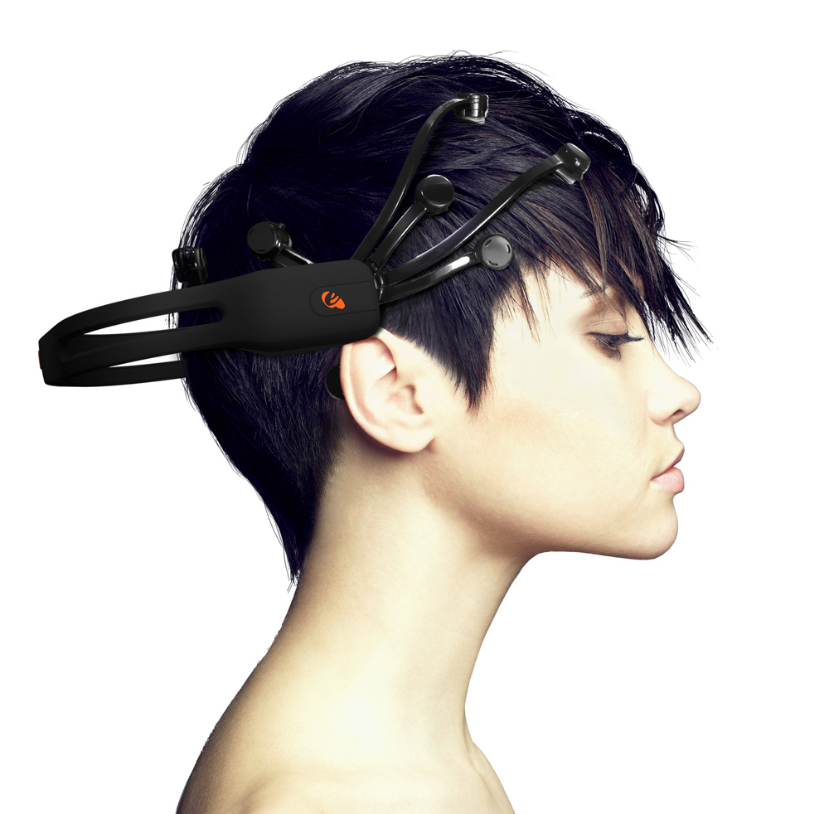
In an editorial that operates more as a stark warning than an explainer, a pair of philosophers sounded the alarm on the dystopian future they see being ushered in by brain-computer interface (BCI) technology. Writing for The Conversation, University of New England philosophers Sandy Boucher and John Kendall Hawkins said that we're rapidly approaching what's known as "the singularity," in which the division between human and machine becomes obsolete — and BCIs are the "first step" on that path.
This theoretical moment "would mark the dawn of our inseparability from machines," the pair wrote. "From that moment on, we won’t be able to live without them without ceasing to function as human beings." And considering that most people cannot live without their smartphones, this does not sound that implausible.
Mind Machine
While artificial intelligence invariably gets most of the attention when it comes to concerns about a singularity, futurists are equally worried about BCI implants. "BCIs are a natural beginning to the singularity in the eyes of many futurists," they wrote, "because they combine mind and machine in a way no other technology so far can. "Be it Elon Musk's Neuralink or the BCI startup Synchron, these technologies are poised to revolutionize the way people who suffer from paralysis and other debilitating illnesses are able to live. For instance, Syncron "has created a minimally invasive implant that allowed a patient with amyotrophic lateral sclerosis (ALS) to send emails and browse the internet using his thoughts," they added.
It Begins
As welcome as this kind of technological advancement is from a medical perspective, it also could "arguably be considered the first stages of a tumbling towards the postulated singularity, in which human and machine become one." "This need not imply machines will become 'sentient' or control us," the philosophers wrote. "But the integration itself, and our ensuing dependency on it, could change us irrevocably. "Reaching singularity is, of course, a major concern for philosophers, futurists, and laypeople alike. But as Hawkins and Boucher note, the fact that we're not only going along with the industry's pace of advancement but in many cases welcoming it is definitely enough to give one pause.

First human brain-to-brain interface allows remote control over the internet, telepathy coming soon
The first human-to-human, brain-to-brain noninvasive interface has been created by researchers at the University of Washington. The system allows one researcher to remotely control the hand of another researcher, across the internet, merely by thinking about moving his hand. The researchers are already looking at a two-way system, to allow for a more "equitable" telepathic link between the two human brains, and the telepathic communication of complex information.
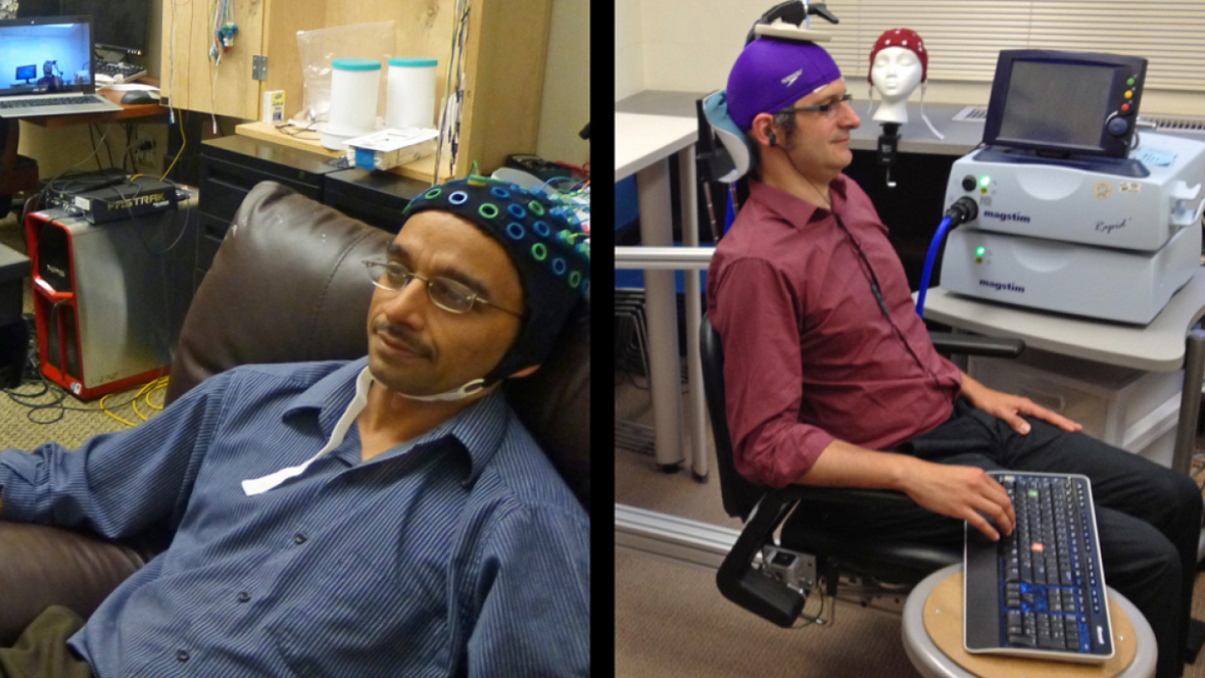
Despite the massive and mostly-not-understood complexity of the human brain, the UW brain-to-brain interface is actually quite simple, relying on tools that are regularly used in the fields of medicine and brain-computer interfaces (BCIs). The first human brain (the sender) is connected to a computer via an EEG-based BCI. The second human brain (the receiver) is connected to another computer via a Magstim transcranial magnetic stimulation (TMS) machine -- the same kind of TMS setup that has been somewhat successful in treating depression, and other mental maladies. When the sender plays a game and thinks about firing a cannon at a target, the EEG picks it up, sends the signal across the internet to the second computer, and the TMS stimulates the region of the receiver's motor cortex that controls hand movement. This causes the receiver's index finger to twitch, firing the cannon and blowing up the target. This process is almost instantaneous.
TMS is a lot like transcranial direct current stimulation (tDCS), which we have written about extensively. Where tDCS passes an electrical current through your brain, affecting the neurons that the electrons travel through, TMS uses electromagnetic induction to create a similar effect. Both tDCS and TMS can be used to either stimulate regions of the brain, useful for brain-to-brain interfaces or increasing the activity of regions of the brain associated with depression, or to reduce the activity of a region, which might help with the treatment of other conditions, such as Parkinson's. Like tDCS, TMS is completely noninvasive, and so far it appears to be completely safe.
The University of Washington (UW) researchers, led by Rajesh Rao and Andrea Stocco(Opens in a new window), have basically connected two quite simple and well-understood systems into a novel and slightly terrifying human-to-human interface. It is very similar to Harvard's human-to-mouse interface, except they used focused ultrasound (FUS) instead of TMS to trigger the motor cortex. That the UW setup works isn't all that surprising -- the main thing is that that, for the first time, a human is on the receiving end, which raises some interesting ethical and moral issues.
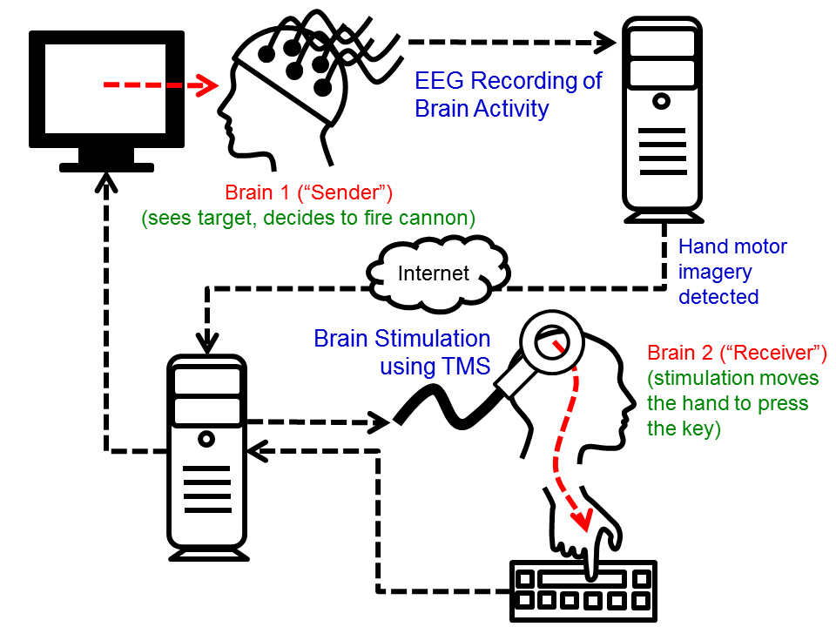
Chantel Prat, another researcher involved with the work, is quick to try and dispel any concerns. "I think some people will be unnerved by this because they will overestimate the technology," Prat says. "There’s no possible way the technology that we have could be used on a person unknowingly or without their willing participation." This is an overly simplistic way of looking at it, though. Yes, the current setup requires both users to be fully consenting -- but in the future, it's not hard to imagine wireless implants that allow for full telepathy and perhaps a limited range of remotely triggered actions. As always with technology, we don't need to worry so much about the hardware itself -- but rather how it might be subverted, once a significant number of people have brain-to-brain interfaces installed.
Moving forward, Rao and Stocco are now working on transmitting more complex information between two human brains. This could be done fairly simply with encoded pulses -- think brain-to-brain Morse code -- or they could go the complex route and try to stimulate the brain into creating actual images and thoughts. There's still a lot of work to be done to decode the human brain, so it will be very interesting to see how future human-to-human brain-to-brain interfaces are implemented.

In the future, will we all be linked telepathically?
International researchers are reporting that they have built the first human-to-human brain-to-brain interface, allowing two humans — separated by the internet — to consciously communicate with each other, with no additional sensory cues. One researcher, attached to a brain-computer interface (BCI) in India, successfully sent words into the brain of another researcher in France, who was wearing a computer-to-brain interface (CBI). In short, the researchers have created a device that enables telepathy. In the future, rather than vocalizing speech — or vainly attempting to vocalize your emotions — your friend/lover/family member might just pluck those words and thoughts right out of your head.

Over the last few years, researchers have started to get quite good at reading your brain activity — your thoughts. Commercial brain-computer interfaces that you can plug into your computer’s USB port have been around for a good four or five years now, and in the last couple of years we’ve seen advanced BCIs that can be implanted directly into your brain. To create a brain-to-brain connection (i.e. telepathy) you also need the other side of the equation, however: You need to be able to take some data and input it into someone else’s brain — and that, as you can imagine, is proving to be a bit harder.

Still, even if it does seem a little bit like hard work, there’s no denying that this is a conscious, non-invasive brain-to-brain connection. While the recipient isn’t going anywhere fast (the TMS is bulky), it’s not hard to imagine a small, lightweight EEG that allows the sender to constantly stream thoughts back to the receiver. I’m sure we’re not more than a few years away from a setup that allows the receiver to walk around, too — at which point, assuming we make some progress in decoding the brain’s activity, you basically have a persistent brain-to-brain link that would allow you to always know what your friends/family/loved ones are thinking. You might use such a telepathy system for sending simple thoughts from a distance — I love you — or maybe it could be useful for truly getting inside someone’s head when they’re struggling to voice their emotions.

THE INVASIVE OPTION

While noninvasive technology appears to have potential, the truly scary alternative, which is what Musk, before his recent meltdown, was working to create. Wireless technology has come so far since the first cell phones that it is not hard to see how chips planted inside the head could be more efficient and produce better faster results than the above noninvasive approaches. Musk says the technology has been tested on pigs and could become a reality in the next 50 years. The question is, given the obsession that people have with their smartphones today – constantly staring at them; feeling uneasy when the device is out of reach; would this be a good thing? Would we all end up staring into space like zombies instead of staring down at our phones?
Well, think of the positive possibilities. You could send the taste of the dish you are eating to your friend. Instead of sending a picture or posting one on Instagram, you could send your friend the image in your head, with its sounds and smells. The basic telepathy above would be replaced by conversations that move naturally and must faster than your little thumbs can text.
You could watch a movie, and your friend sitting a hundred miles away could watch it with you, with comments, through a strong 5G streaming connection.
Alternatively, as stated above, this could be the end of humanity. With no need for actual human contact, or human social skills, a new type of human would develop. Languages as we know them today, would disappear, as thoughts and feeling could be sent without the intermediary necessity of words and grammar. Children would grow up in each other’s and their parents’ heads. We can already see how excessive smartphone use and the lack of ability to talk face to face is affecting people’s social skills. BCI technology would make it 1000 times worse.

- Which is a better option or is more realistic and likely to happen, invasive or noninvasive? Compare them in terms of………
- Which possibility mentioned in the article was the most interesting to you? Why? What else could be done with whatever your choice was?
- How would it disrupt industry specifically? What industries would be most affected? How would economics, education, psychology, medicine, sociology etc, change specifically?
- Considering how much time people spend using smartphones, computers and social networks to share experiences and information, what would this mean for how humans relate to each other? How families relate? How husbands relate to their wives and vice versa? Would it be better or worse?
- Right now, humans solve problems, like building a bridge or a computer, by sharing information and then acting. Clearly, many people sharing information is good for solving problems. If this is true, then a Hive Mind, with millions of people connected into one large brain would be good for humanity. Do you agree?
- If this system exists in the future, should children be implanted at birth? This would allow them to learn more quickly. What age would be good? Should it be optional?
- Would this be the end of humanity as we know it? Is that ok?

