The story of the ‘Ural’, the USSR’s most popular motorbike everywhere… except Russia!
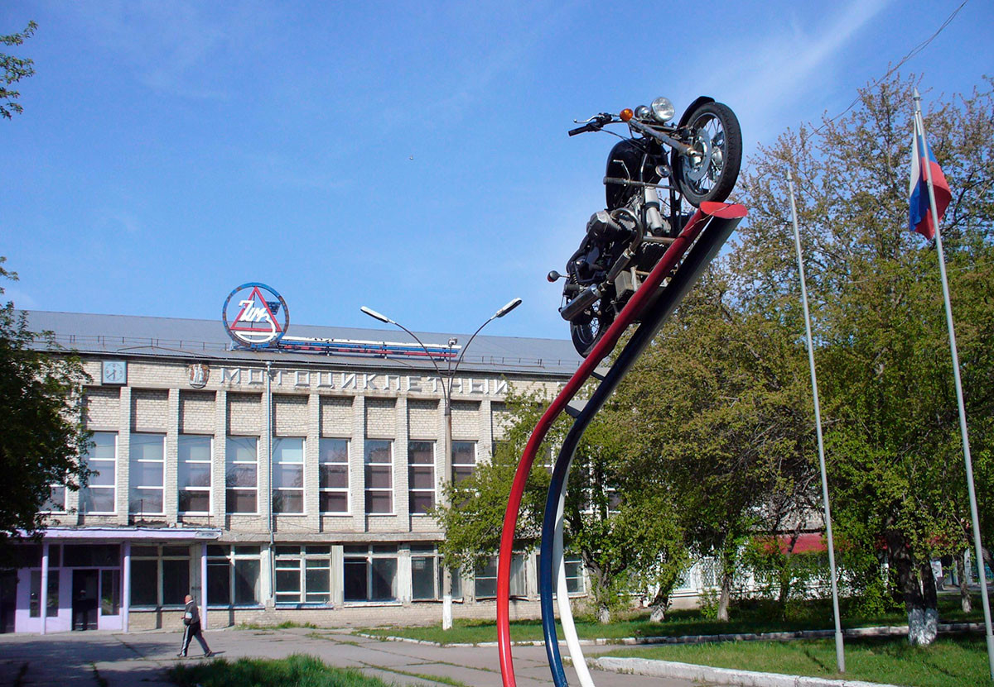

A small factory one and a half kilometers (about one mile) outside of Moscow produces just five to six bikes with sidecars per day. Riders include celebrities like Brad Pitt and Steven Tyler. Oddly enough, these bikes sell terribly in Russia. We’ll tell you how that happened…On the road somewhere in California, a shiny, red motorcycle speeds by as if it were straight out of a classic romance movie. Riding it is a big man with a beard and, next to him, in the sidecar, is Gracie the dog. She’s not wearing a helmet, but she’s got her goggles on. Gracie’s already eight years old, so she’s experienced enough to sit up straight in her seat without fidgeting. “Hey Gracie, wanna fly?” the man asks and, for just a few seconds, he tips the motorcycle to one side, riding on just the bike’s wheels. At first, Gracie’s a bit anxious, but within a few seconds, she seems happy once again. This is how eight-year-old Australian Cattle Dog Gracie spends her rides on a Ural – the most famous Russian motorcycle in the world - except for Russia!

Before the 1990s, the factory successfully produced 130,000 motorcycles per year for Soviet citizens, with around 10,000 people working there. After the dissolution of the Soviet Union, a crisis occurred in the factory. Its name changed several times, but at the beginning of the 21st century, the factory fell into bankruptcy.
Kakha (Kakha Bendukidze, the former factory owner, became its proprietor in 1998, - editor’s note.) decided to sell the factory, but the only buyers willing to buy it turned out to be the then senior managers of the factory. “Me and my colleagues Vadim Tryapichkin and Dimitri Lebedinski,” said Ilya Khait, one of the factory’s current joint owners, in an interview with Afisha Daily.
By 2015, the new owners adjusted production and in that same year, they had already managed to produce 1,755 motorcycles; however, they were all shipped for export - to Japan, USA, Europe, Canada and Australia. “We immediately realized that the Russian market wasn’t promising for these kinds of [bikes] and we wanted to compete with global brands. But, for that, we had to nearly change our production process entirely. The current Ural [models] don’t have any features of the old motorcycle. It’s all about the demands the foreign markets make,” explained Khait.
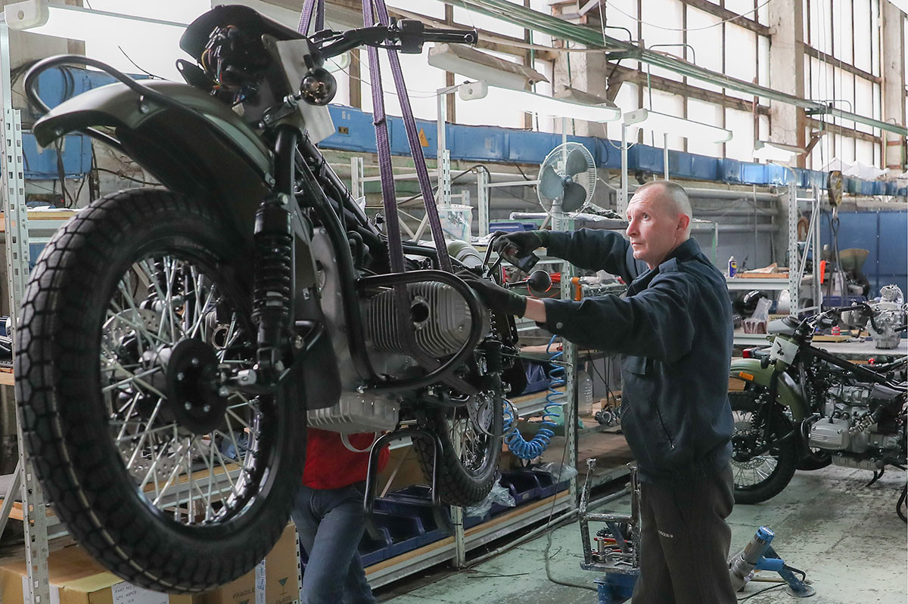
A worker of the assembly shop of the Irbit motorcycle factory during the assembly of motorcycles "Ural"
Workers manufacture the body parts, chassis and engines at the factory, according to Vladimir Kurmachev, executive director of the Irbit Motorcycle Factory (IMZ). Brakes, gearboxes and other components have to be bought from abroad.
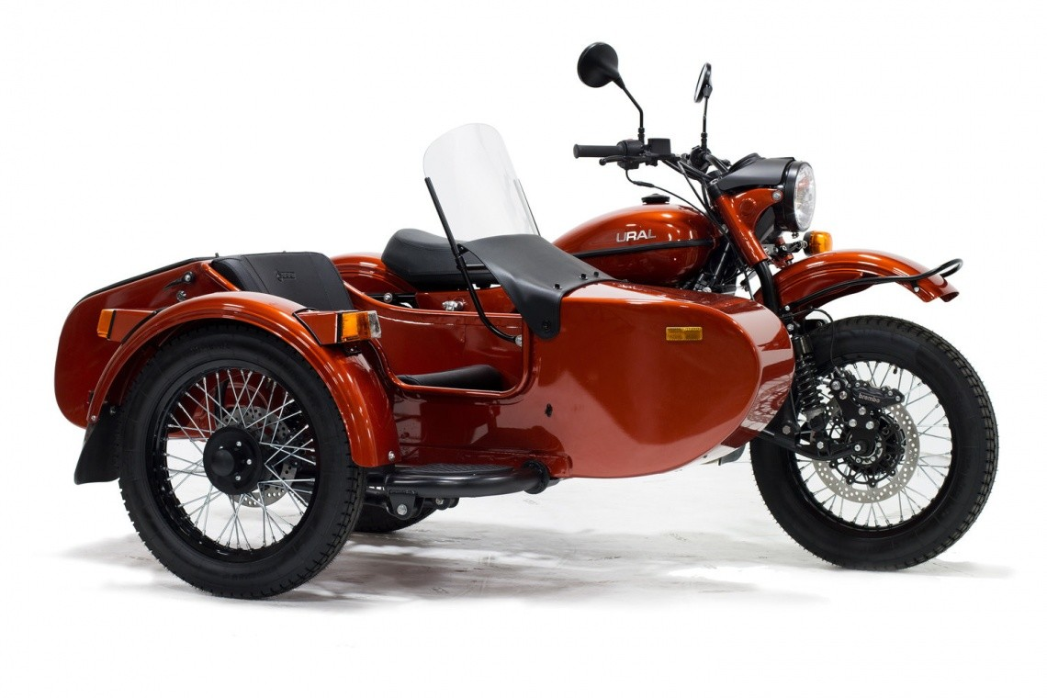
Ural City 2021
The manufacturing volume of Ural motorcycles has also decreased significantly. Today, just 150 people work in the factory assembling about five to six tailored-made bikes per day.
The factory produces two classic bike models: the ‘Ural CT’ and ‘Gear Up’. Also, every year, the company releases limited collections of their bikes. For example, Ural motorcycles in the color of Lake Baikal and the desert, or motorcycles inspired by the nature of Yamal Peninsula in Russia’s Far East.
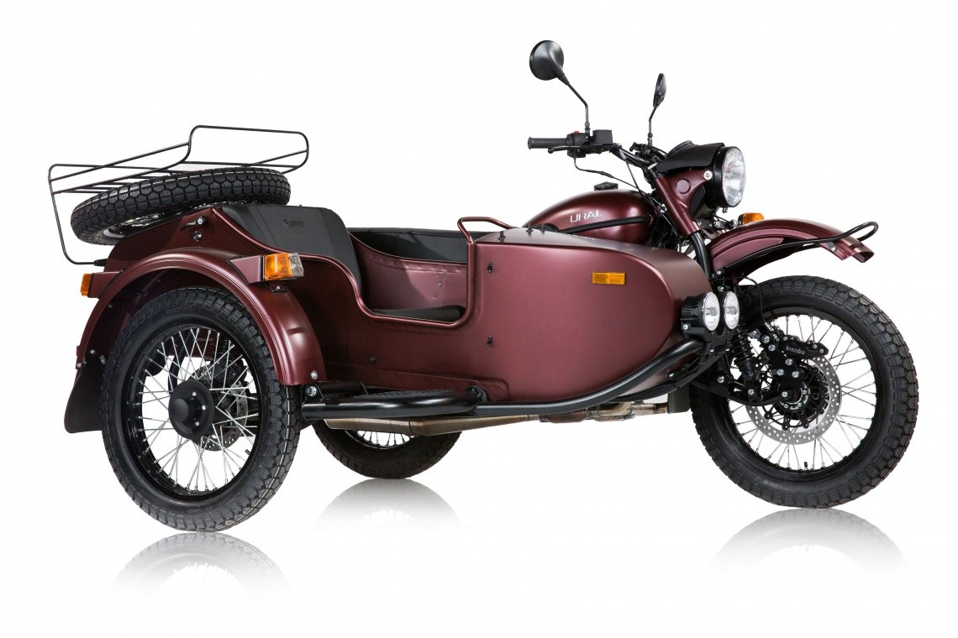
Ural GEAR UP 2021
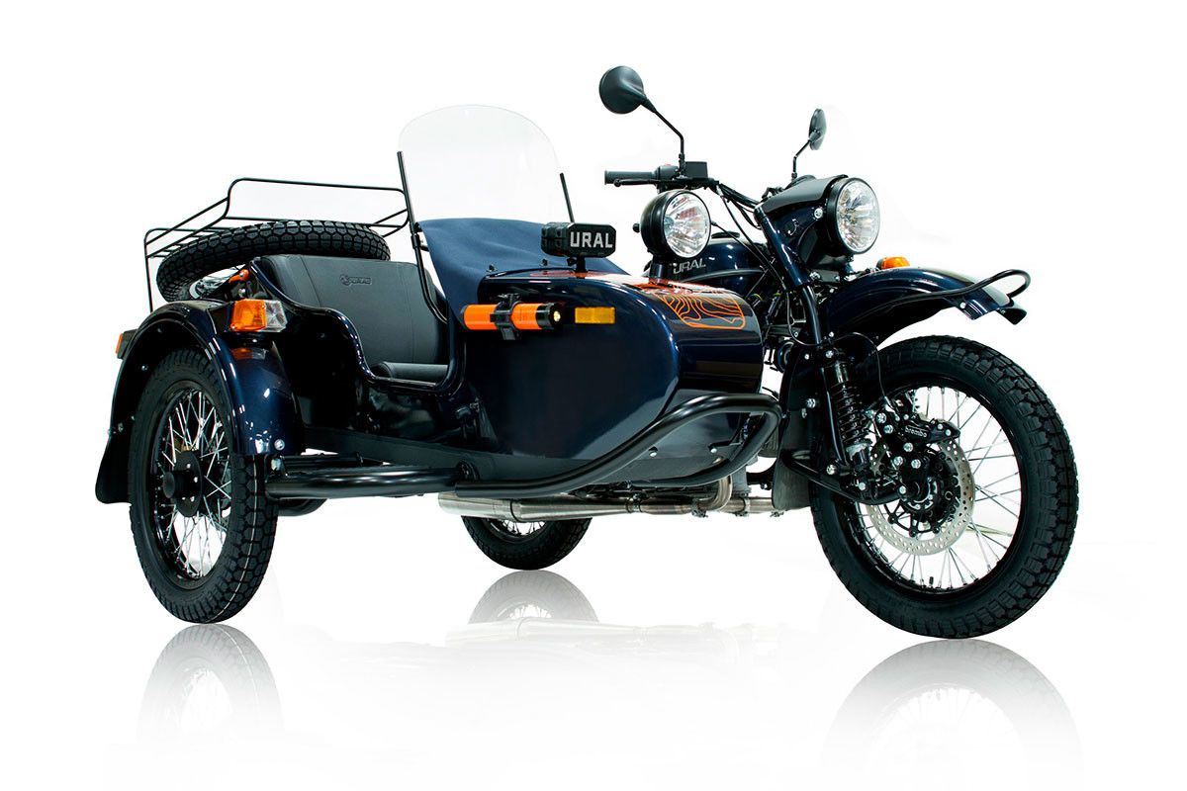
Ural Baikal LE, released in a limited edition in 2017

The ‘Gear Up’ and Ural City have almost the same features, with the exception of its wheel size. Regardless, it’s considered the flagship model, as it is the only all-wheel drive bike in the world. Per customer request, the transmission can be attached to the sidecar during assembly, making the motorcycle the ideal choice for off-roading. The ‘Ural CT’ sells for 821,000 rubles (approx. $10,800), while the ‘Gear Up’ will set you back 962,000 rubles (approx. $12,700).

Global Popularity
Ural has a total of four dealers in Russia - and around 50 in the USA. In the 2010s, paparazzi noticed actor Brad Pitt and Aerosmith soloist Steven Tyler riding Urals.
According to Vladimir Kurmachev, actor Ewan McGregor, who played in Star Wars, has two Ural motorcycles, one with a sidecar and one without. “Ninety-nine percent of our motorcycles are exported; In 2019 we sold a total of just 45 domestically,” Kurmachev said, sharing Ural’s sales information.
But, in his opinion, the reason for the Russian bikes’ popularity is its unusual design, which shall never change under any circumstances. The Milan Motorcycle Show, which takes place once every two years… if you were to remove the motorcycle labels, the untrained eye would hardly be able to determine what model is which.
But a Ural is unmistakable,” said Kurmachev in an interview with TV channel Rossiya 24 back in 2017.Ilya Khait, joint owner of the factory, believes the Ural is popular abroad, due to its sidecar, which can be detached from the bike. “The median age of our bike owners currently is 50-53. Typically, they are experienced bikers, who have discovered such a unique means of transportation: a motorcycle with a sidecar. A Ural [motorcycle] differs in its drivers’ and passengers’ relationship. It’s a ride you share with someone,” illustrates Khait.
In Russia, the bike is unpopular due to its high cost and also because many fans of the earlier Soviet models are against any modifications, thinks Khait. Meanwhile, Ural is slightly adapting to all needs, according to Khait. In Paris and Barcelona, tourist excursions take place on Urals. Tourists transport their surfboards on them and one coffee shop in St. Petersburg ordered a bike as a “mobile espresso stand” to sell coffee straight from the motorcycle. The bike is capable of taking on mountain passes, canyons and deserts, not to mention the usual off-roads and snow-covered roads. Its cross-country ability in any condition is yet another reason why customers in America are ready to pay prices starting at $10,000, says Gene Langford, one of the first Ural dealers in the USA in the 1980s.“…[T]he Urals can be driven in winter and summer, including off-road. The sidecar can be used as a trunk, or you can put children or pets there. Thus, Urals turn out to be the perfect transport for adventure and even one that is rarely seen,” Gene told USA Really.

Challenges and opportunities facing the motorcycle industry on the road to 2035
Urbanisation, lack of accessibility, high cost, and environmental concerns are some of the key issues causing a shift in modern transportation decisions. Most countries are now promoting electric mobility which matches with their efforts to reduce emissions and meet their clean energy targets by 2035 and beyond. These concerns have helped to promote motorised two- and three-wheelers as attractive alternatives to other modes of personal transportation.
Compared to a conventional automobile, two and three-wheelers provide several benefits. They are less costly for the consumer in terms of up-front purchasing costs, fueling, and maintenance. They also emit roughly half the amount of CO₂ generated by standard automobiles. They have also helped to ease congestion in locations where rapid urbanisation is generating an increasing need for mobility solutions to keep people connected.
The 2-wheeler market is anticipated to expand and has tremendous scope forecasted, providing great opportunities for suppliers operating in this segment. Where there is also opportunity, however, there are also several challenges that businesses in the motorcycle and personal transportation industry will have to navigate to reap the benefits of this upward trend.

The future of motorcycle propulsion will be varied
Electrification will certainly play a leading role in this evolution, with the market share of electric mobility in the European L-category market projected to reach approximately 30% by 2030. It is expected that there will be a massive switch to electric motorcycle technology for urban mobility and short distance commuting. Meanwhile, we should not be surprised to see the superbike category continue to rely on internal combustion engines. At least in the short term. And hybrid? We predict huge scope, mainly for larger multi-purpose machines used in and out of the city. We will see a rise in electrified technologies for category-L vehicles
Another factor making motorcycles an attractive option for consumers is wide range of personalisation options available. Historically for motorcycles, there were very limited options as to what type of vehicle you could purchase. You could choose the colour and styling option you preferred, but that was just about the extent of the personalization for two and three-wheelers. The advancements in software and personalisation of traditional automobiles have helped to pave the way for the updated configurations available in the motorcycle market. It is now possible to configure your motorcycle to include specific technologies and these options are only going to grow as technology advances. Do you want an upgraded system? Do you want your motorcycle to connect to your mobile phone? Do you want different riding modes, like Eco and Sport, included? An AR augmented reality helmet? This presents an exciting opportunity in the industry and will lead to new software, which is driven by consumer preference, rather than OEMs driving consumer requirements.

Looking forward to the motorcycle industry in 2035 the market will only continue to grow. Forecasts are showing there is a lot of untapped potential and unexplored opportunities in this space, with a lot of new investments and start-up companies focusing on developing the technologies and products in this market. The motorcycle industry is bound to get bigger, especially with recent and upcoming technological advancements.

Harley-Davidson profit slumps on weakening demand, shares tumble 11%
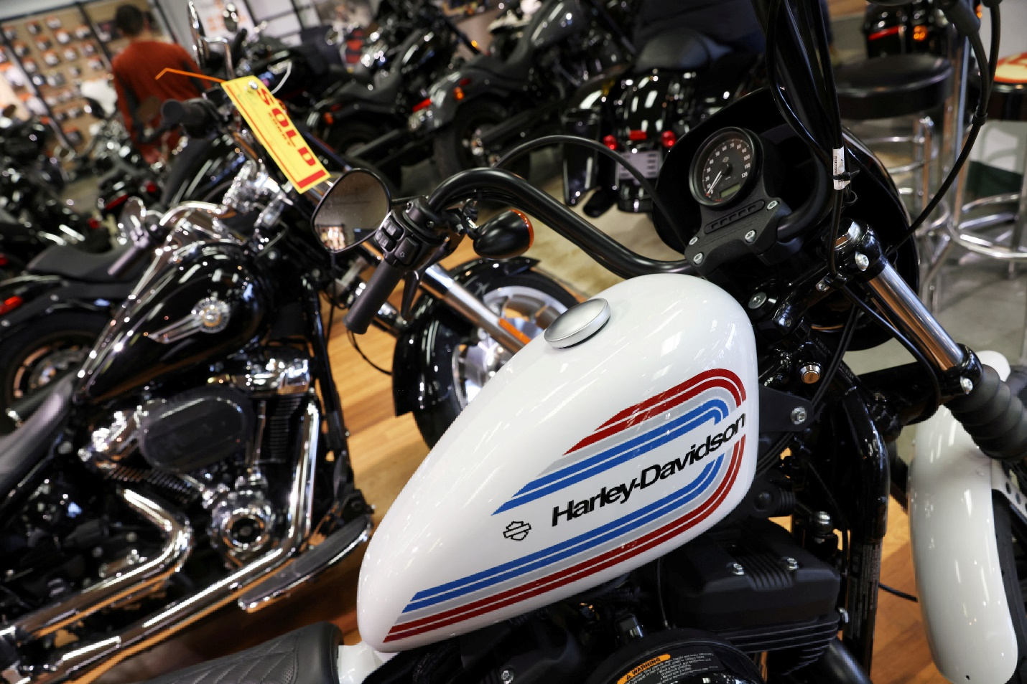
[1/4]Harley-Davidson motorcycles are seen at a dealership in Queens, New York City, U.S., February 7, 2022.
Oct 26 (Reuters) - Harley-Davidson Inc (HOG.N) on Thursday reported a 24% yearly decline in third-quarter profit as customers cut back on discretionary spending due to higher borrowing costs and inflationary pressures, sending shares down 11%.The Milwaukee-based company's shares hit their lowest level in three years. Customers have become reluctant to splurge on big-ticket leisure items as U.S. interest rates climbed over the past year while higher inflation forces them to focus on essentials. "It is clear that the macroeconomic backdrop has been a challenge for our customers globally," Chief Executive Jochen Zeitz said on a conference call.
Harley has maintained margin growth through its wealthier customer base, but hasn't been as successful in luring younger riders with the its fleet of lower-priced models and the revamping of its apparel business, featuring a series of new collections and collaborations with A-list celebrities. Company executives reassured investors they are focused on "what we can control" by managing inventory levels that are expected to be higher compared to the past two years but in line to meet demand. Yearly operating income guidance was unchanged.
Harley's price increases and surcharges for popular models have lifted the manufacturer's earnings per share in previous quarters, but analysts say slowing demand is reflective of a murkier outlook for the leisure retail sector heading into next year.
Harley's retails sales were down across all of its regions. North America, its largest market, declined for a third consecutive quarter. The company attributed the revenue shortfall to higher borrowing costs and the discontinuation of its legacy Sportster model at the end of last year.Sales from motorcycles and related products fell about 9% to $1.30 billion in the quarter ended Sept. 30.Global motorcycle shipments decreased 20% during the period due to the production suspension announced late in the second quarter, the company said.
Harley's net profit fell to $198.6 million compared to $261.2 million year ago.

https://www.dmcsidecars.com/sidecars

- How can Urals’ sales in Russia be increased? Think of a new marketing idea, consider costs, new models, how to attract younger riders…etc.
- Urals are popular in the US, but expensive. Compare this American company with Urals
https://www.dmcsidecars.com/sidecars
Should Urals drastically expand their product line ( It seems like they have only 3 models). They produce very few models a year. This makes the bikes exclusive but reduces profits. Should production remain low with prices high or the opposite?
- One thing non-russians like about the bikes is the fact that they are customizable. What other customizations would you include? ( the article mentions AR, phones…)
- Should Urals produce an electric or hybrid motocyle?

- Should Urals produce a double sidecar product?

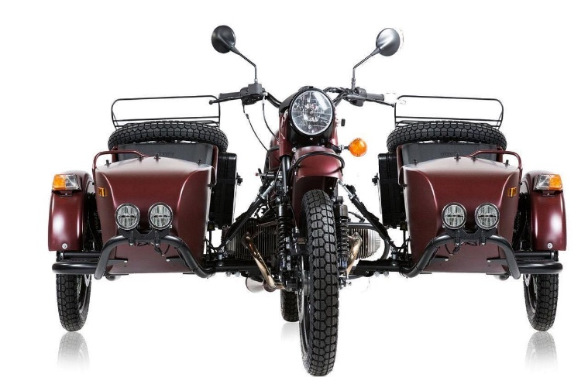
- The bad weather in Russian is one factor why motorcycle sales are so low. Look at the following bikes. Would this solve the problem? Which one should Urals copy?
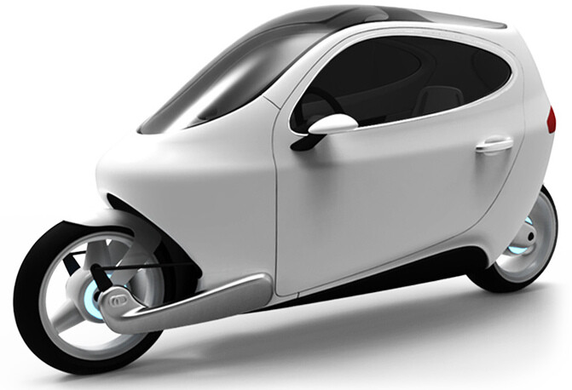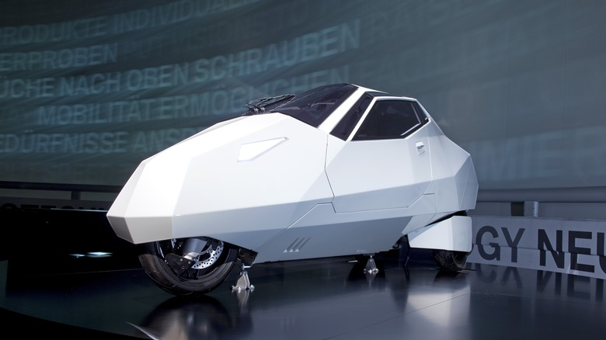

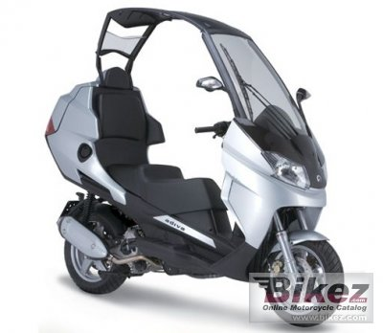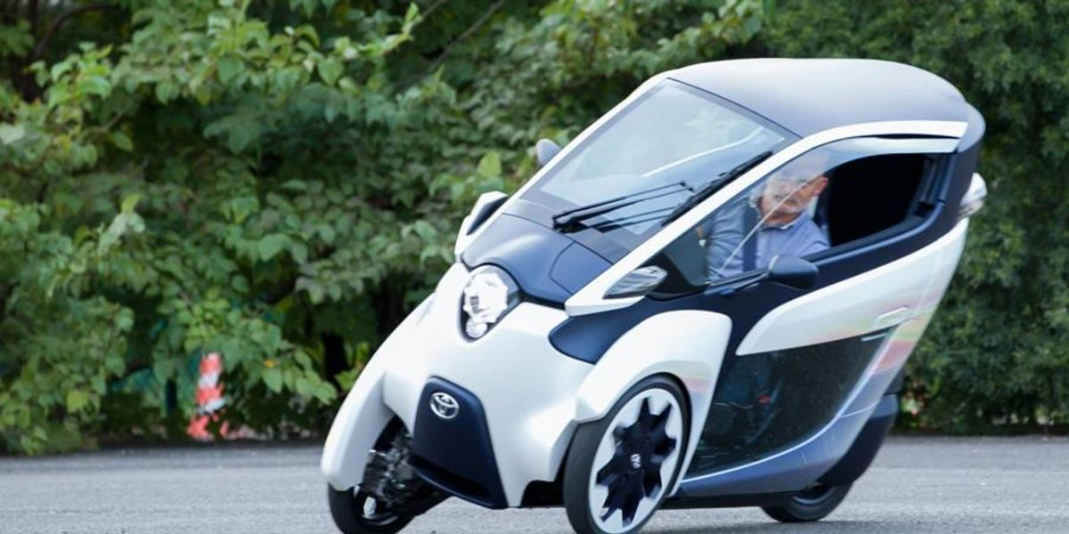
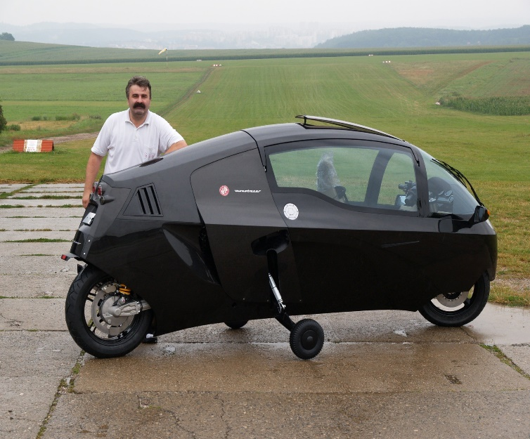
- Harley Davidson is not doing well. Their bikes are really expensive and mostly guys in their 50’s buy them. How would make them more attractive to WOMEN and Younger people?
- Harley makes only traditional, old fashioned, conservative, old people bikes. Look at the pictures below. If you were the head of HD, which direction would you go? Which do you like the best?

