Trouble For vodka, America’s most-popular spirit
-Vodka has been the top-selling spirit in the U.S. since the 1970s, generating more than $7.3 billion in revenue in 2021.
-However, vodka’s growth has slowed significantly in recent years as other spirits like tequila and whiskey have taken larger chunks of market share.
-Vodka’s historical tie to Russia is now also causing issues.

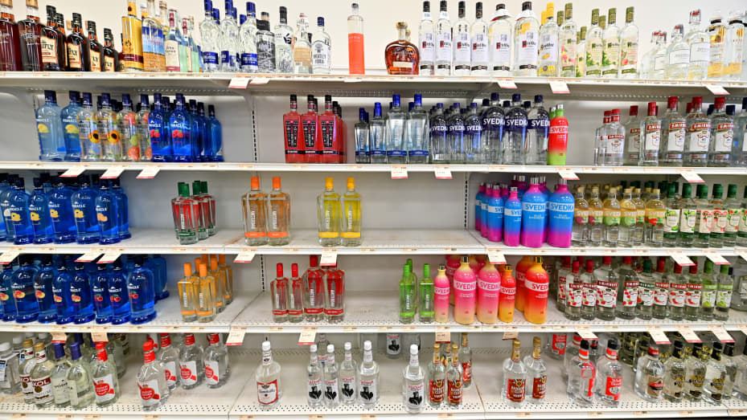
Empty spaces in the shelves of a vodka section of a Pennsylvania liquor store after Russian labels were removed.
The spirit of choice for James Bond to characters on “Mad Men” and “Sex and the City,” vodka has long held the dominant position in the U.S. liquor market. The top-selling spirit in the U.S. since the 1970s, vodka generated more than $7.3 billion in revenue in 2021, $2 billion more than the second-highest selling spirit, tequila and mezcal, according to the Distilled Spirits But over the last several years, vodka’s popularity began to wane due to a variety of factors, whether that was the further introduction of spirits like tequila and mezcal to the market, the growth of the handcrafted cocktail movement that put more focus on spirits like whiskey and bourbon, or a desire from consumers to move towards other spirits that simply provided more flavor. “There was a point where vodka was on a trajectory to outsell everything else combined, and that’s definitely reversed and a lot of the other stuff is growing at the expense of vodka,” Wondrich said. “It’s this dynamic where they figured out how to market the least offensive product that the most people would tolerate, and then people got bored.”
The growth of whiskey and tequila
In the last five years, whisky has significantly outgrown vodka, 5.1% to 1.7%, respectively. “We expect the whisky category to overtake vodka by volume by the end of 2022,” Rand said, adding that when considering the revenue generated by the overall category, “whisky is significantly higher than vodka currently (and has been for years) as most whiskies tend to be premium-priced while standard-priced vodka makes up the bulk of the vodka category value.”
The explosion in the popularity of tequila and mezcal has also come somewhat at the expense of vodka. The U.S. spirits industry grew 12% in 2021 to $35.8 billion, with tequila and mezcal responsible for more than 31% of the total increase in spirits revenue. “Tequila has a very good possibility of eventually outpacing vodka because it’s not something that’s just for margaritas anymore,” said John Coyle, director of sales and engagement at T Edward Wines & Spirits, a New York-based wine and spirit importer and distributor. “For someone interested in drinking a cocktail or who is running a cocktail program, tequila gives you a lot of stuff to play with, there’s a palate of flavors that you can use with all different beverages – vodka, it’s just one.”
Connection to Russia
Vodka is now also facing another challenge — its historical ties to Russia. U.S President Joe Biden issued an executive order that blocked U.S. imports of several Russian products, including vodka and other alcoholic beverages. However, while several vodka brands play up a tie to Russian heritage through marketing or branding, most vodka consumed in the U.S. is not Russian in origin. Imported Russian vodka makes up less than 1% of the total vodka volume in the U.S. according to Rand, which she says is “not material to the category growth.” Roughly half of the vodka consumed in the U.S. is made in the U.S., according to IWSR Drinks Market Analysis. While Russia is the world’s largest vodka producer, accounting for more than 30% of global production, more than 90% of it is consumed domestically. “The Russian tie has always been a little bit of a vulnerability for vodka even though hardly any of it in America is Russian,”
Wondrich said that while vodka will likely remain the top-selling spirit category in the U.S. for the next several years, it will likely not reclaim the position as the bulk of the market as it once had. Coyle agreed, noting that vodka has been “pushed out of the center stage.”
“If you go to a cocktail bar, there will always be a vodka cocktail,” Coyle said. “But the days of James Bond, calling for a specific vodka brand, that’s waning, that’s not going to be the next wave of growth in the spirits industry.”

Russia Gets a Taste For Irish Whiskey

Russia is now the second largest market for Irish whiskey in the world.
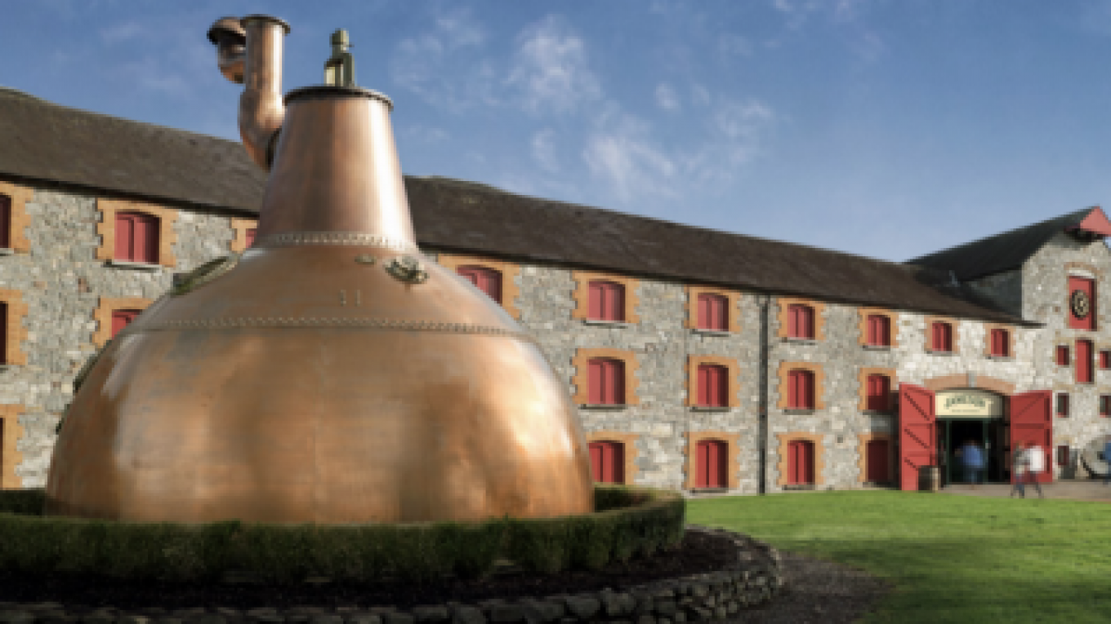Jameson Distillery in Middleton.BNE IntelliNews
Irish whiskey is flying off the shelves in Russian bars, supermarkets and off-licenses, with the country now the second biggest market globally for the spirit after the U.S.
Distilleries say that the thirst for Irish whiskey is growing right across central and eastern Europe, as consumers increasingly turn away from traditional drinks such as vodka and schnapps. The latest data from the Irish Whiskey Association shows Russia is the second largest geographic market with sales of 605,800 cases, or 7.3 million bottles, for the last recorded year in 2019 — a jump of 231% since 2010, “Russia has continued to grow in 2020 and this year, as most western markets have stuttered,” says John Teeling. “We have had many repeat orders and new clients. The taste of Irish whiskey obviously suits the Russian palate and the fact it’s an imported spirit goes well with the middle class, who want to show off by buying imported spirits.”
Such is the increased clamour for Irish whiskey that Russians are now making it for themselves. Praskoveya Winery, which was established in 1898 in the Stavropol region, started to develop its own Irish Prashkovsky Whiskey in 2009 using strict Irish production methods.
As well as the legitimately-made whiskey, there is a huge problem in Russia and across Eastern Europe with fake Irish whiskey brands, says Teeling. “As Irish whiskey grows faster, you are always going to have rip-off merchants.” The Irish Whiskey Association (IWA) last year came across six fake Irish whiskey brands in Russia, three of which were produced in Belarus. It has sought to have the products taken off shelves in Russia and has lobbied the European Union to negotiate intellectual property and geographical indication protection with the Kremlin. Cease-and-desist letters have been issued to various companies and retailers selling the fake Irish whiskey, leading to them no longer being sold. But William Lavelle, head of the IWA, argues these infringing brands are actually “a massive endorsement” of the real product. “We have seen people who buy cheap or knock-off Irish whiskey move up the chain as they develop a taste for it,” Lavelle told bne IntelliNews in an interview.
The single largest constraint for Russians who prefer whiskey to vodka has been the crash in the value of the ruble, but Russian import bans against Jack Daniel’s, certain bourbons, and other types of whiskey have been a problem as well. According to Eastern European Distribution Company, the new brand will be named “Stoli,” and will be priced at 600 and 650 rubles (roughly $7) per 750 ml bottle. It will join the only other domestically produced Russian whiskey brand, Praskoveiskoye, which costs 950 rubles (about $10) a bottle.

RUSSIA’S DEADLY FAKE WHISKY
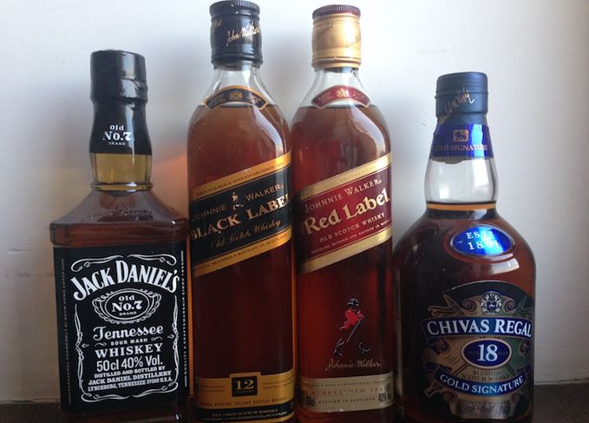
Fake Scotch: Can you tell the difference between a real and a fake? Knowing what the genuine article looks like could save lives.
Last spring, an old friend of mine, Eugene Pivin – a well-known eye surgeon – was checking my eyes. In his cabinet stood a bottle of Hennessy XO Cognac – ‘a funny fake’, as he called it, and a gift from a grateful patient. The bottle didn’t look bad – average-quality glass, average-quality print – and, if you never saw the original, you might even think it was ok. The general shape is identical, but the sides – which should have thick ridges from the neck to the bottom, getting wider as they go – are missing, and the cap is not metal, but is cheap plastic. Read the label and you will notice that the Cognac is produced by JAS Hbnnessy & Co, not Hennessy (although the back label has the address of a real Russian distributor for the brand). A specialist in excise stamps would also notice they are fake.
Funny fake? Maybe not. The first reported poisonings in Krasnoyarsk happened on 19 November, killing three people, with a further nine ending up in intensive care. In both cases, police found empty Jack Daniel’s bottles. By 27 November, the death toll had reached 12, with 51 in intensive care. By mid-December, the figure was closer to 30 dead – but, by that point, the police and the medical authorities had stopped updating the total. Still the reports came in. A few days after the Krasnoyarsk outbreak, there were two deaths in the town of Gai, near Orenburg, from two half-litre bottles of fake Jack Daniel’s bought for RUB200. The exact death toll will never be known – some bottles may have travelled long distances.Cases of fake Jack Daniel’s were discovered dumped in forests around Krasnoyarsk and in the city garbage. One woman died after taking five bottles of fake Jack Daniel’s from a rubbish bin. She had drunk less than half a bottle.

CHALLENGER FROM THE EAST: THE RISE OF JAPANESE WHISKY

The Japanese are renowned for many things, from art and haikus to Hello Kitty and anime. But one thing many people forget about Japan is its booming whisky industry.

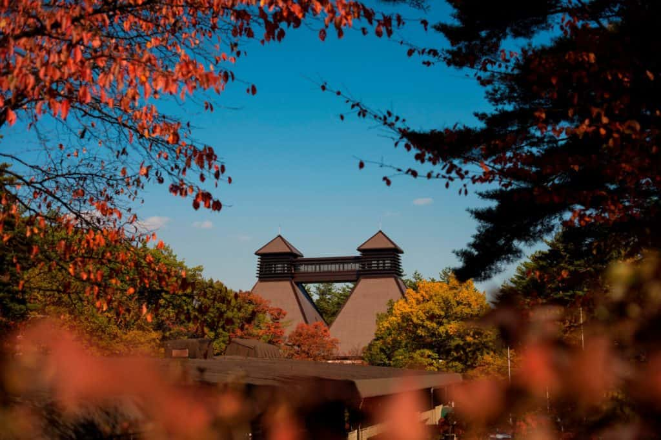
With nine working distilleries and countless awards, Japanese whisky is quickly taking over Scotch as the world’s favourite dram. The Japanese have been distilling whisky since the opening of the Yamazaki Distillery in 1923, but it was very low quality and almost exclusively sold on the domestic market. That was until the release of Nikka’s Yoichi 10 Year Old in 2001. That year it won Whisky Magazine’s “Best of Best”, and so began the Japanese take over.
It was not long before Japanese whisky was hitting the shelves all over the world. And it was not long before that whisky began out-performing Scotch at every turn.
Nikka and Suntory, the two biggest whisky producers in Japan, hoover up awards almost every year. They have been stampeding across the good name of Scotch without bothering to slow down and give their old foe a break. Japanese distilleries are a force to be reckoned with. Like a golden Hello Kitty in combat gear. Only better, and not as cute. Most recently, Suntory’s Yamazaki Single Malt Sherry Cask, released in 2013, stole the title of best in the world, given out each year by whisky legend Jim Murray. So what makes it so good? What could be the secret to this success? Many critics say Japanese is very similar to Scotch in the way it’s distilled. So (whisper it) maybe they’re just better at it? Although better may be a strong word. Different may fit more appropriately.

Ultimately however, there really isn’t any specific reason why Japanese out does Scotch time and time again. It mostly comes down to attention to detail, a high-quality, hard-working work force and an extreme dedication to making something great. Not only do Japanese whiskies take home the gold, but they do so repeatedly. From distillery of the year (won four times by Suntory) to gold medal single malts, Japanese whiskies never seem to drop the ball. There are no paltry silvers here, golds there, every few years. These are gold medal winning whiskies every single year, almost without fail. So there you go, the Japanese are better at more than just drawing cute characters and karaoke. They distil a pretty fine dram too.

RUSSIAN’S IRISH WHISKEY
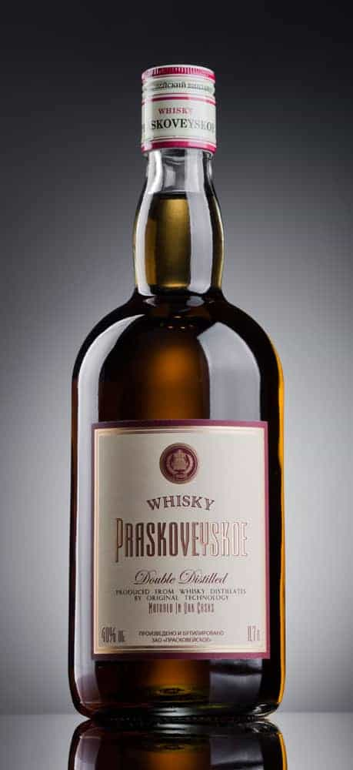
For centuries, the world’s largest country, Russia was well known for its love for Vodka, which has helped the population warm up during the long cold winters. It is even said, that Vodka has helped shape the country’s course of history influencing its religion, politics and economic fate for hundreds of years. Described as the “water for life”, it has a staple upon the recognition of its consumption within Russia and previous Russian empire.
Nowadays, however, there has been a slight shift and interest in other spirits such as whiskey. There has been an increase not only in consumption but also in awareness when it comes to this drink in both economic and social level. Russian distilleries started looking into the whiskey consumption and exportation in more depth in 2008 when Scottish whiskey had a rise of 48% in exportations worldwide.
One distillery in particular, Praskoveya Winery known for its high quality alcoholic beverages such as Wine, Vodka and Cognac, has had a special interest in this market. The Praskoveya Winery was stablished in 1898 receiving numerous awards for its high-quality products, since. Nowadays it is one of the largest wine makers in the Stavropol region and one of the largest Russian companies to reach international markets with wineries and vineyards in France. What has allowed the company to have a continuous growth has been the continuous and stable quality standards, and traditional methods used in the production of its products, innovating where and when necessary in order to reach market needs.
With the experience and expertise of more than 120 years, the Praskoveya Winery decided to invest on a new type of spirit, one that required a knowledge and a familiarity not yet known within Russia. Praskoveya’s director, Boris Pakhunov believes that “Whiskey, like cognac, is a natural, professionally made, high-quality drink.” The strategy of entering the market of high quality whiskies in conjunction with the use of Irish production methods allowed the Praskoveya Winery to develop the Praskoveyskiy Whiskey since 2009, which was compared by many whiskey professionals to the well-known Jameson Whiskey. This selection is not however, a direct competitor of the Irish or Scottish market due to the size of its production. It is known that on average a distillery in Scotland produces around 30 million litres of whiskey per year, while Praskoveyskiy whiskey is developed in smaller quantities for a more niche market supporting mainly the Russian market needs.

- What would you do to reverse the downward Vodka trend in the US? How would you increase Russian vodka imports ( now at only 1%) to the US considering that most American companies have Russian sounding names and Russian vodka is considered the world standard?
- Part of the problem in the US is that Vodka is used for mixed drinks. Nobody drinks it straight. Handcrafted whiskies, bourbons, and tequilas can all be drunk with nothing but ice or a little water. Should Vodka shift its emphasis from a cocktail drink to a solo drink?
- Whiskey is getting more and more popular in Russia. Will it take over the number one position from Vodka? Will the trend continue?
- The only 2 Russian whiskies are 7 and 10 USD. In other words, cheap whisky. Top whiskies from Scotland and Japan go for about 100 USD$. Should Russian companies target the cheap market or higher end whiskey market?
- The Japanese started producing cheap whiskey but now make some of the best whiskies in the world. Can Russia do the same? Why or why not?
- Fake sneakers, downloaded movies and ebooks, and fake whiskey ( and vodka). Considering that it could kill you, is there any way to stop the fake whiskey market?
- To make Vodka great again (MVGA!!!) it may need to adapt to a market with pickier consumers, which means flavored vodka. Which flavors from the list below would be best for the Russian market? Choose 3. Which bottle design is the best?

The 14 Best Flavored Vodkas to Drink in 2023
Vodka has gotten a bad rap partly due to the outlandish, oftentimes poorly made flavored versions that flooded the market decades ago. But times have changed, and flavored vodkas today are as well-crafted as any other spirit. “It is nice to see smaller artisanal distillers bringing in vodkas that have character," says Abou-Ganim.
Humboldt's Finest Hemp Infused Vodka comes out on top.
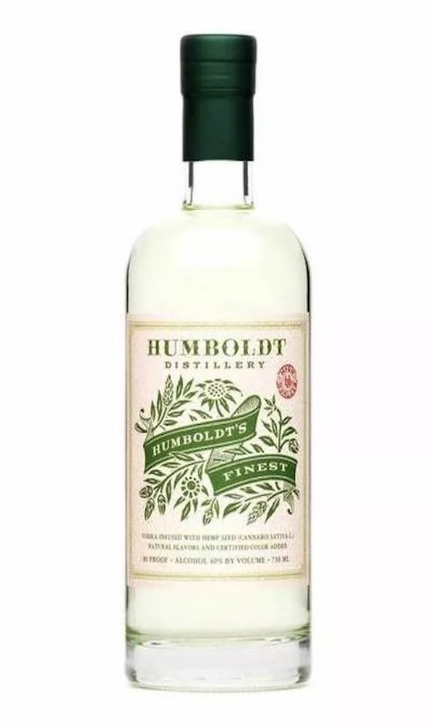
Best Craft44º North Huckleberry Vodka
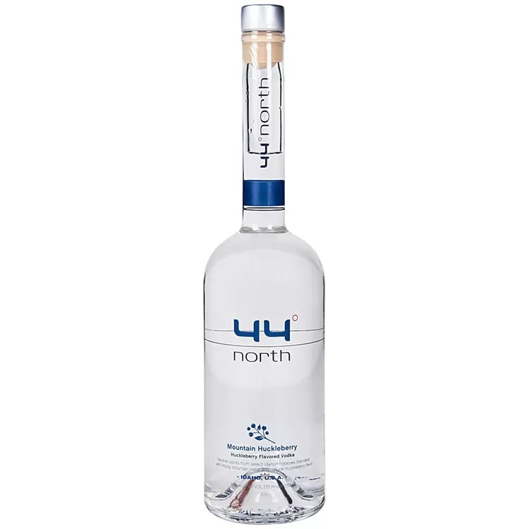
Smoke Lab Aniseed
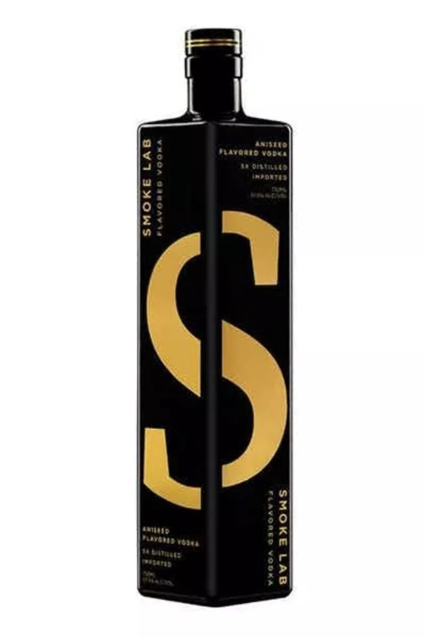

Absolut Citron
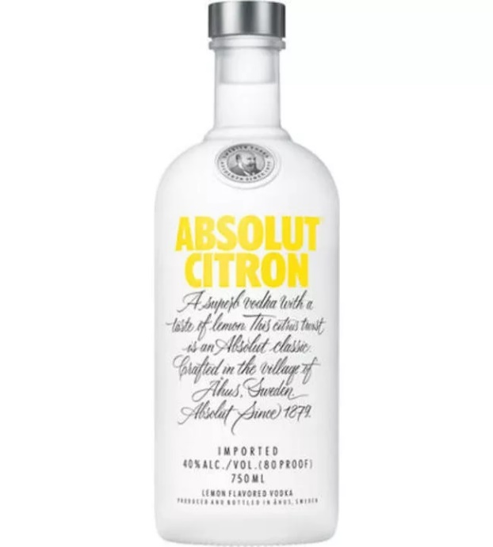
Ketel One Cucumber and Mint
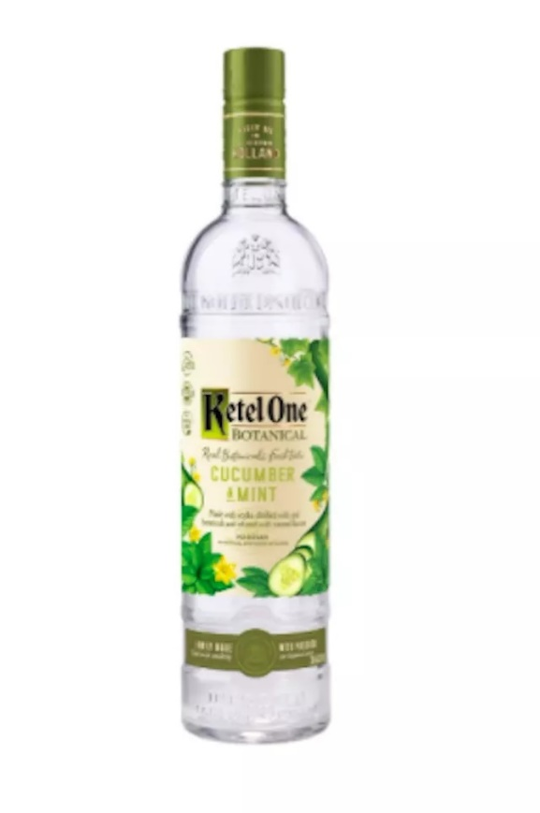
Hanson of Sonoma Habanero
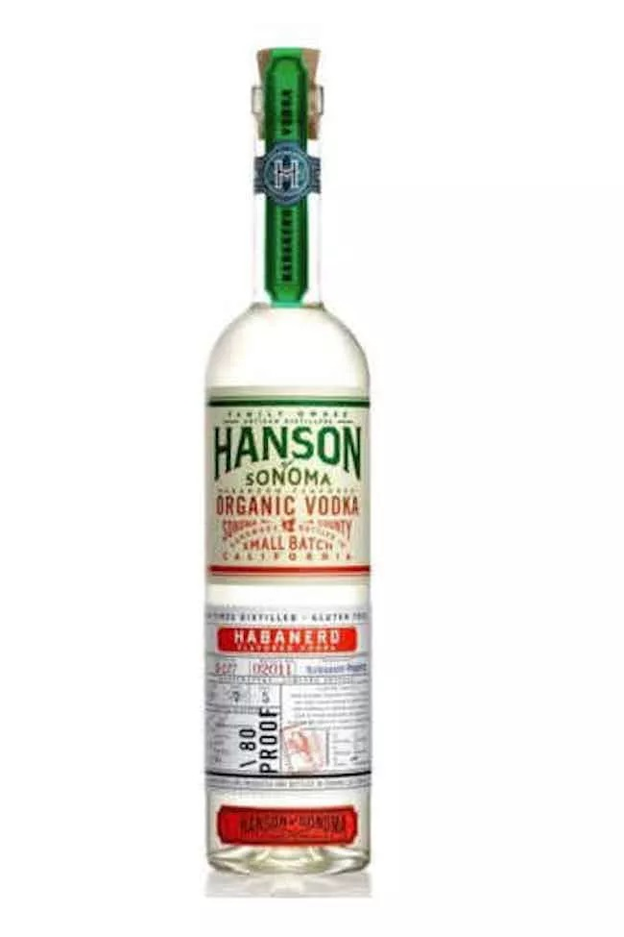
Finlandia Grapefruit Vodka
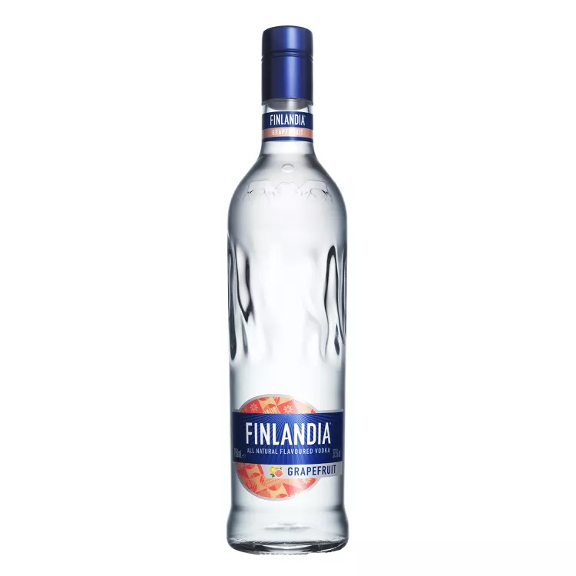
Best OrangeEffen Blood Orange
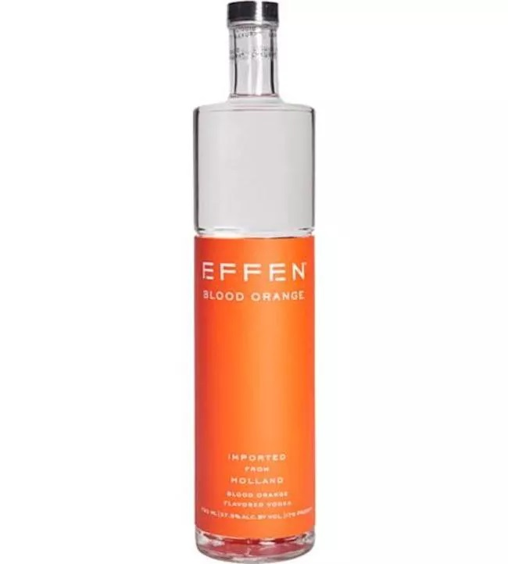

CIROC Peach
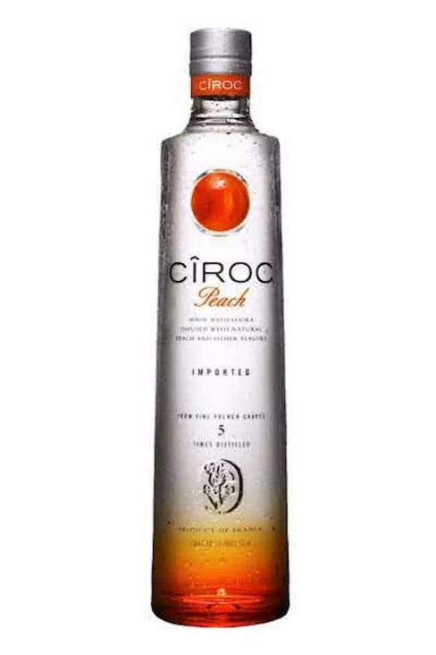
St. George Green Chile
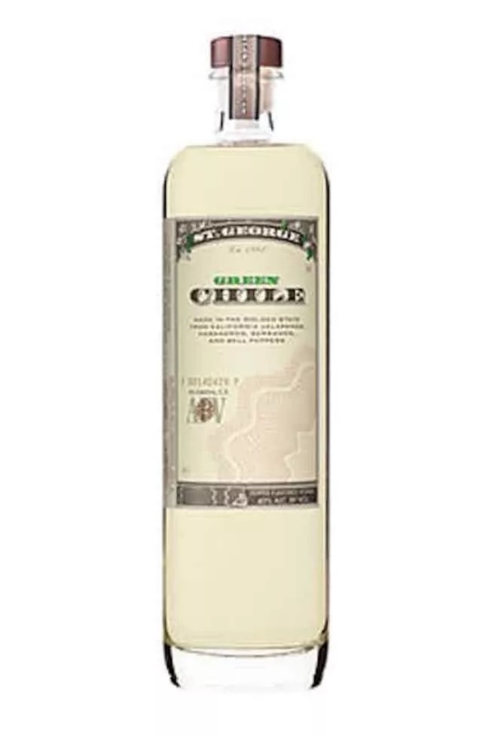
Hanson of Sonoma Organic Cucumber
