The Cult of Biohacking
Are biotech entrepreneurs on the leading edge of science or just looking to make a quick buck? A little of both, probably.

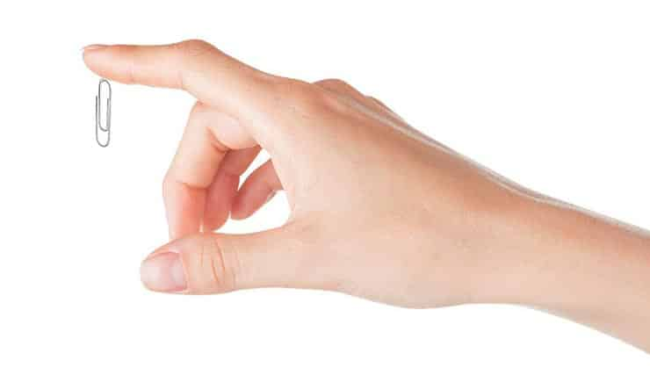

Promising human performance boosts through everything from superfoods (fish oil) and data tracking (neurofeedback) to personalized health testing (blood panels) and fringe technology (electric brain stimulation), is biohacking the cutting edge of human evolution or just another self-improvement industry for the tech-savy? Biohacking is having a moment, one that feeds on the same desire to locate performance shortcuts that fuels the supplement industry. But it’s hard to separate the bona fide claims from the bogus ones, especially given how broadly biohacking is defined. Judging by the vendors the conferences, radical groups like transhumanists—who put magnets and computer chips in their bodies—as well as anyone with a sleep-monitoring app on their smartphone all fall under the biohacking umbrella. And much of what the companies are selling doesn’t exactly sound new. “There’s a lot of salesmanship and a lot of hype,” says Marc Hellerstein, a professor of metabolic nutrition at the University of California at Berkeley. “Since the ancient Greeks, people have been trying to improve health. Calling it hacking is just putting a techy, 21st-century name on it.”
Still, there are a handful of things that make bio-hacking novel. The first is self-experimentation. Another tenet of biohacking is the use of health-data crowdsourcing through sites such as CureTogether and PatientsLikeMe, which allow large groups to compare research results without relying on government- or university-funded studies. In 2008, after hearing that lithium carbonate may help treat ALS, some individuals who suffered from the disease began taking the substance to see whether it had any effect. They uploaded their findings to a website, and a neuropsychologist crunched the data. Of course, such studies would probably be conducted with little to no oversight, which is the third factor common in the biohacking movement. The FDA doesn’t regulate many of the products associated with it, and without peer review, crowdsourced studies do little to guarantee the safety of any particular hack. For many, this is its chief attraction. Drugs or new implants can take years or decades before government agencies give the go-ahead for human trials. Biohackers want results now and are willing to risk themselves to get them, and get rich in the process. Sometimes people go overboard. Says Rhonda Patrick, a fellow at the Children’s Hospital Oakland Research Institute, “That might mean being too enthusiastic with dosage and taking drugs that have negative long-term side effects that haven’t been figured out yet by the academic community.”

Meet The Biohacking Pioneers Who Are Redesigning Their Own Bodies: The Transhuman Movement
In the transhumanism movement, implanted chips are as common as piercings.
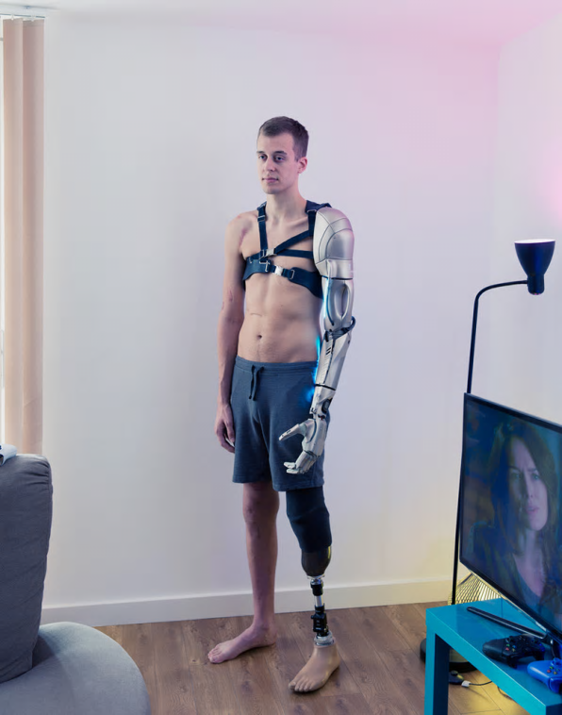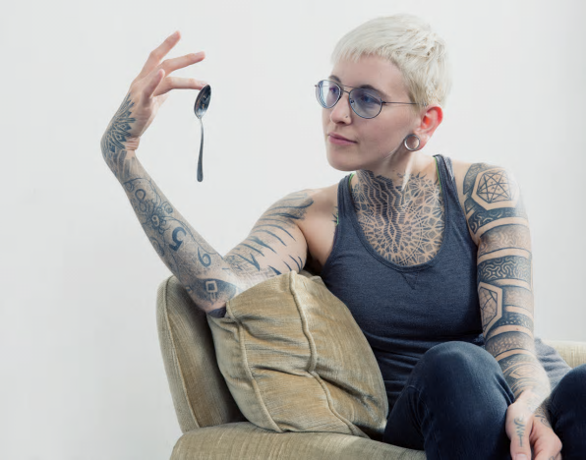

In 2012, 25-year-old James Young was in a rail accident in which he lost both his left arm and left leg. An avid video gamer, Young taught himself how to use a controller using only one hand and, occasionally, his teeth. At the 2016 BodyHacking Con in Austin, Young debuted a $76,000 carbon-fiber arm inspired by the video game Metal Gear Solid. The high-tech limb he designed not only gives Young the dexterity to do most of the things he could before his accident, it also charges his phone, displays his social media feeds, and features a mount for a miniature drone–controlled from a panel on his forearm.
Young who designed the limb along with prosthetic sculptor Sophie de Oliveira Barata, is 1 of 30-odd subjects shot for an ongoing photo series by photographer David Vintiner and creative director Gem Fletcher. The series, Transhuman, documents a rapidly growing international movement of the same name. Covering the fields of medicine, technology, philosophy, art, and academia, transhumanism looks at the ways technology can enhance the physical and psychological capabilities of humans beyond the natural limits of biology. Like

Like Young, some within the movement are developing bionic limbs for differently disabled bodies. Others experiment with machines to enhance their sense of sight or touch.
Fletcher and Vintiner discovered the transhumanism community through a meet-up that takes place in the basement of a University College London building. In 2015, the pair released part of the ongoing series, called Futurists, which captured many of the main figures in London’s transhumanism scene. “The movement itself is in intense flux,” Fletcher tell Co.Design. “It’s going through a period of rapid growth, so there are new people in the movement all the time. It’s truly a shape-shifting subject matter.”
Fletcher and Vintiner’s subjects frequently introduce them to others in the movement; Fletcher says that the community, though international, is relatively tight-knit and inclusive. Meet-ups like the one at UCL, or the BodyHacking conference Young attended in Texas, have made it easy for members to meet each other. Some, like Aisen Caro, who invented a set of headphones that allows humans to experience echo-location, are scholars. (Caro is a PhD candidate in human informatics at Tsukuba University). Others, like the London-based F_T_R design studio, are inventing ways to blur the lines between the physical and digital worlds. F_T_R’s Skinterface project is a full-body suit equipped with actuators that convey a sense of touch to the wearer while she is experiencing a virtual world–while wearing a VR headset, for example.
https://www.youtube.com/watch?v=8VE7H6pyjhM WATCH VIDEO

Another technology featured in the Transhuman series is a fantastical-looking wearable called the Eyesect, designed by the lab The Constitute. The Eyesect is an otherworldly headset that covers the user’s head completely, and comes equipped with two handheld cameras. The camera feeds what they are seeing onto a screen inside the headset, giving viewers a sense of 360-degree vision. “You can move around the camera ‘eyes,’ so that you have complete freedom to look up, down, forward, and backward all at the same time,” says Fletcher. “It gives humans the experience that lots of different animals have with this improved spatial perception.”



The most popular forms of small bodyhacks they’ve seen are people experimenting with DIY RFID (radio-frequency identification) implants that allow them to unlock doors or turn on lights with the swipe of a hand, for instance. This would also allow them to interact with their phones, computers and any other electronic device without touching them. Also popular in this community are implantable biomagnets, which allow people to interact with the world in new ways—like by picking up magnetic objects with the touch of a finger.
“It’s becoming more accessible,” Fletcher says of the transhumanism movement. “We keep seeing more and more people with chips or small implants. It’s almost like the popularity of piercings in the ’90s.”


Biohackers view the human body as a system that can be augmented and upgraded. Thanks to widespread availability of affordable, powerful computers and the open sharing of information on the Internet, more biohackers and researchers are going freelance and setting up home labs, and both independent biohackers and many traditional researchers have begun a serious quest to integrate technology directly into the human biosystem. As processors become smaller and more powerful, the lines between biology and technology will become more vague. Today, there are already astonishing biohacking methods emerging that reshape the limitations of the organic human.
Biohacking Trick 1: Nightvision Eyedrops
Last week, a team of freelance researchers working out of a garage-turned-lab in California discovered a simple way to grant humans the ability to see clearly in the dark beyond 50 meters. Science for the Masses, an independent biohacking collective, set out to enhance the biology of vision to provide night sight without cumbersome hardware. They experimented with the chemical Chlorin e6, a close relative of chlorophyll, which has been used sporadically in the past as a cancer treatment. This chemical occurs naturally in some species of deep sea fish, enhancing the function of light receptors in the eyes. One of the researchers, Gabriel Licinia, volunteered to be the first human test subject. A tiny dose of Ce6, 50 microliters, was dripped directly into Licinia’s eyes. Within an hour, the chemical began to interact with the photoreceptors in his retina. The researchers ventured into the night, and conducted a series of vision tests at increasing distances. Licinia was easily able to distinguish images and symbols beyond 50 meters in the dark. The effects wore off after some time, and the biohacking experiment was a clear success.
Science for the Masses now hopes to refine their knowledge of Ce6 through more rigorous testing to perfect their nightvision eyedrops. Thanks to the rise of amateur biohacking collectives like this, bold leaps in biotech are being made every day outside of the predictable, commercial confines of institutional research. Today, anyone with a computer and an imagination can start biohacking and carve out a place in scientific history.

Biohacking Trick 2: Oxygen Crystals
In 2014, scientists in Denmark discovered a crystalline substance that absorbs and stores huge amounts of oxygen from the environment. These synthetic crystals, derived from cobalt, siphon oxygen from the air and water. They may provide a way for people to breathe underwater indefinitely. Scuba tanks are highly limited, as they can only store a small amount of oxygen, and are large and heavy. Comparatively, a tiny crystal could continuously pull enough oxygen from the water to sustain the body. When a small amount of heat is applied to the crystal, the release of oxygen can be precisely controlled.

Cute baby swimming under water.
This technology will also greatly impact people who use an oxygen tank due to lung ailments. Like scuba equipment, oxygen tanks are cumbersome and limited in capacity. Instead of having to pull a cart with a heavy oxygen tank, patients would instead only need a few grains of crystal to provide concentrated oxygen from the environment. Oxygen is also used in many industrial processes like welding, and this crystalline substance will allow safer transportation of massive quantities of oxygen, potentially at a much lower cost.

Biohacking Trick 3: Telepathy Chip
The practice of implanting radio frequency transmitters in the body isn’t all that new. In 1998, famed biohacker Kevin Warwick launched the first phase of Project Cyborg. Working as his own test subject, he designed an RF implant that was installed under his skin. It was used to perform basic tests on signal strength such as opening remote controlled doors, controlling lights, and sending simple commands to computers. In 2002, Warwick began the second phase of Project Cyborg, biohacking by installing an array of electrodes directly into his nervous system to monitor activity at the median nerve. The experiment proved successful, and Warwick was able to control a robotic arm with mental action alone.

Since Warwick’s pioneering work, others have advanced the technology of telepathy and telekinesis. A 2004 experiment successfully used electronic implants to enable very basic communication between the nervous systems of two people. More recently, Brown University scientists developed a new generation of rechargeable neural transmitters that can communicate with external devices. As these implants become smaller and more efficient, humans may soon have the ability to telepathically network multiple nervous systems. Instead of an “internet of things,” this technology is the first step to an “internet of beings.” Proponents point to the potential for increased empathy, efficiency of communication, and the ability to wirelessly interface with prosthetics. Elon Musk is moving this idea forward with Neuralink, although not much is known about the project.
Biohacking Trick 4: Subdermal Magnetism
The practice of surgically installing tiny magnets in the fingertips is already common in some biohacking and body modification circles. These magnets are coated with materials so that they are not rejected by the body. They provide a sort of sixth sense—the ability to feel magnetic fields. When the magnet encounters a strong enough magnetic field, it moves slightly and creates a sensation in the fingertip. Vibrations could be detected from electronic devices that produce electromagnetic fields.

These magnetic implants also allow the user to pick up small metallic objects like paperclips. Though this practice does not provide any huge improvements to the human body, it could evolve to include precision electromagnets and other specialized subdermal transmitters. The current practice is also important for understanding the body’s limits when it comes to the safety and long term effects of subdermal implants. A similar device, which uses a tiny magnetic fiber that stimulates the skin when facing north, is also in development, and could allow built in navigation.
Simple subdermal magnets are readily available. They can be purchased online and some tattoo shops are able to install them. At this rate, we may be seeing the first widely available consumer transhuman options soon enough.

- Is biohacking good or bad? Is it too dangerous? Should the government strictly try to regulate this new industry? How could it do so?
- Drugs take an extremely long time to develop and test. If people are willing to test new drugs on themselves, would this lead to a large number of new drugs that help people or just a lot of dead biohackers?
- It is possible that humans will all have DIY RFID implanted in their bodies. What are some possible applications of this technology? Think of 3
- Which of the above Biohacks has the most potential? Think of its good and bad points, and some possible new uses for it.
- Bionic prosthetics could eventually allow the same sensation as a real limb but be much stronger and include some of the options listed above (built in phone, computer, drone…)
If it were cheap, would you get prosthetic arms and legs? If most people did, how would this change society? What would the economic effects be if people could lift cars and run 100 km per hour?

