**Paint Job with Functions and Output Files**

You will be coding **Chapter 5 Programming Exercise 8 Paint Job Estimator**. Refer to the book and review the requirements but Prof. Candido will add some additional requirements so make sure you read the entire assignment.

1. In this assignment you will be asking for input for these float variables:
   * Square Feet of the Wall
   * Paint Price
   * Feet per Gallon of Paint
   * Labor Hours per Gallon
   * Painting Labor charge per hour
2. Code a function called **getFloatInput** that receives a **string** as a parameter to be used as the prompt input text and it returns a **float**. You will be calling this function for 5 times for each of the variables listed above and assign the function’s return value and assign to each of the listed variables. For example:

fPaintPrice = getFloatInput(“Enter Paint Price”)

Perform data validation within these function on the inputted value using Python error handling which can be found in Blackboard. Use Python’s loops to accomplish the sub-tasks below:

* + If the contents are not numeric issue a message and prompt them again until the user enters a valid number for each of the input variables.
  + Make sure the inputed value are non-zero and positive values or issue an error message and ask for input again.
  + Return a valid non-zero float

1. Prompt the user for the state of the job will take place in and store it in a variable.
2. Refer to the book for details on the calculations. But do not use global variables nor global constants. You will use the variables from Step 1. You must place each of assignment’s calculations into their own functions that will return the calculated amount. You will need to determine what parameters you must pass to these functions:
   * **main()** that will contain the logic for the program
   * **getGallonsOfPaint** returns an **int** of how many gallons are needed for the job rounded up to the next highest gallon. The reason for this you can only buy whole gallons.
   * **getLaborHours** returns the Labor Hours to paint the wall as a **float**.
   * **getLaborCost** returns the Labor Cost to paint the wall as a **float**.
   * **getPaintCost** returns the Paint Cost to paint the wall as a **float**.
   * **getSalesTax** that returns the tax rate for the passed in state as follows:
     + If the state is CT the tax rate is .06
     + If the state is MA the tax rate is .0625
     + If the state is ME the tax rate is .085
     + If the state is NH the tax rate is .0
     + If the state is RI the tax rate is .07
     + If the state is VT the tax rate is .06
     + None of the above tax rate is 0.
   * **showCostEstimate** takes in all the calculated values and outputs the values to the screen formatted.

You must also add code to print all the same screen output to a file called **PaintJobOutput.txt**. This function returns nothing.

1. Make sure you use Hungarian Notation when naming the variables.
2. Make sure to include comments in your code.

**Sample Output** 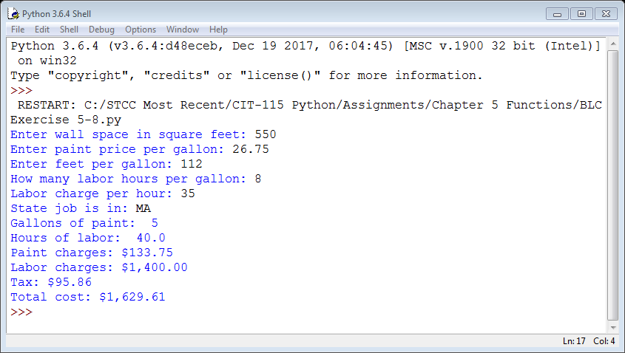

Grading Rubric

|  |  |  |  |
| --- | --- | --- | --- |
| **Criteria** | **Meets**  **(100%)** | **Somewhat**  **(50%)** | **Not Present**  **(0%)** |
| **Input Conversions and**  **Data Validations placed in the getFloatInput function.**  20 points | Input Function fully coded.  Data validation was fully implemented and functional. | Input Function somewhat coded.  Data validation was attempted but not fully functional. | Input Function not present.  Data validation not implemented. |
| **Calculations**  25 points | Calculations were done properly with the correct results. | Calculations were attempted but with some errors or incorrect results. | Calculations were not attempted. |
| **Functions**  50 points | Functions fully coded and efficient in terms of execution with the correct results.  File output is present and fully operational. | Functions were attempted but with some errors or incorrect results or not coded in the most efficient manner in terms of execution.  File output is attempted and partially operational. | Functions were not attempted.  File output is not present. |
| **Comments,**  **Formatting**  **and**  **Variable Prefixing** 5 points | Comments present and variable prefixing.  Output was correctly formatted per the sample. | Either Comments present or variable prefixing.  Output was attempted but did not match the sample. | No Comments present and No variable prefixing.  No formatting was attempted. |