**Lists and Graph Rainfall Statistics**

You will be coding **Chapter 7 Programming Exercise 3 Rainfall Statistics**. Refer to the book and review the requirements but Prof. Candido will add some additional requirements so make sure you read the entire assignment.

1. Declare a **tuple** that contains the month names for all 12 months.
2. Declare a **list** to contain the average rainfall for each month.
3. Enter a loop to prompt the user for the rainfall average for each of the 12 months. Code a function called **getRainfallInput** that receives a string as a parameter that is the month’s name from the tuple to be used as the prompt input text and it returns a float. Add the function’s return value to the list. See sample screen shot below for guidance.

Use Python’s loops to accomplish the sub-tasks below:

* + If the contents are not numeric issue a message and prompt them again until the user enters a valid number for each of the input variables.
  + Make sure the inputted value is 0 or a positive value or issue an error message and ask for input again.
  + Return a valid non-negative float

1. You will need use Python’s built-in list functions to determine the Sum, Min and Max values. You will need to calculate the average as well. When outputting the Min and Max output the Month’s name. See the sample output.
2. Create a Python Line Graph to visually depict the rainfall averages. See the sample output.
3. Make sure you use Hungarian Notation when naming the variables.
4. Make sure to include comments in your code.

**Sample Output** 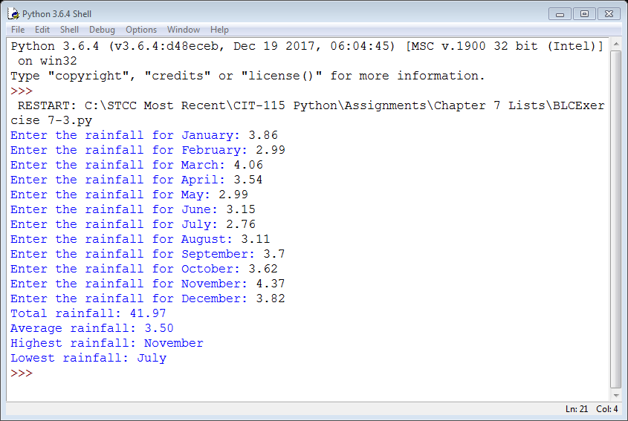

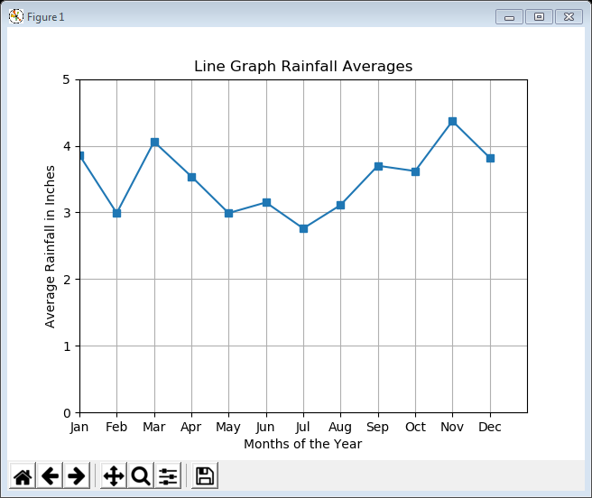

Grading Rubric

|  |  |  |  |
| --- | --- | --- | --- |
| **Criteria** | **Meets**  **(100%)** | **Somewhat**  **(50%)** | **Not Present**  **(0%)** |
| **Input Conversions and**  **Data Validations placed in the getRainfallInput function.**  5 points | Input Function fully coded.  Data validation was fully implemented and functional. | Input Function somewhat coded.  Data validation was attempted but not fully functional. | Input Function not present.  Data validation not implemented. |
| **List Functions and Calculations**  45 points | Calculations were done properly with the correct results using Python list functions. | Calculations were attempted but with some errors or incorrect results. Or Python list functions not properly used. | Calculations were not attempted. |
| **Line Graph Created**  45 points | Line Graph done properly with the correct results and coded efficiently. | Line Graph attempted but with some errors or incorrect results or not coded in the most efficient manner in terms of execution. | Line Graph not attempted. |
| **Comments,**  **Formatting**  **and**  **Variable Prefixing** 5 points | Comments present and variable prefixing.  Output was correctly formatted per the sample. | Either Comments present or variable prefixing.  Output was attempted but did not match the sample. | No Comments present and No variable prefixing.  No formatting was attempted. |