## **1. Introduction**

I applied K-means clustering to identify patterns in customer behavior, ultimately aiding in targeted marketing strategies and business decision-making.

## **2. Data Preprocessing**

Before clustering, I took the following steps:

* **Concatenate Both Datasets**: The excel file had datasets for both 2009-1020 and 2010-2011. So, I used `pd.concat` to join both into one dataframe.
* **Handling Missing Values**: Approximately 107,927 Customer ID values were missing, and these rows were removed.

| data1 = pd.read_csv("2009_2010_retail.csv") data1 = data1.dropna() data2 = pd.read_csv("2010_2011_retail.csv") dataframes = [data1, data2] data3 = pd.concat(dataframes) print(data3.shape) |
| --- |

* **Feature Engineering**: I derived key features such as:
  + **Total Spending** = Sum of all purchases per customer.
  + **Total Orders** = Count of unique invoices per customer.(number of orders they’ve made)
  + **Total Quantity** = Sum of all items purchased per customer.
  + **Average Order Value** = Total Spending / Total Orders.(Amount spent per order made)
  + **Average Items Per Order** = Total Quantity / Total Orders. (Average items per order)
  + **Distinct Items Purchased** = Number of unique products bought by a customer.
  + **Recency** = Days since the last purchase.

| data3['Customer ID'] = data3['Customer ID'].astype(str) data3['InvoiceData'] = pd.to_datetime(data3['InvoiceDate']) data3 = data3[data3['Quantity'] >0 ] data = data3.groupby('Customer ID', 'Country').agg(  Total_Spending=('Price', lambda x: (x * data3.loc[x.index, 'Quantity']).sum()),  Total_Orders=('Invoice', 'nunique'),  Total_Quantity=('Quantity', 'sum'),  Distinct_Items=('StockCode', 'nunique'),  First_Purchase=('InvoiceDate', 'min'),  Last_Purchase=('InvoiceDate', 'max') ).reset_index()  data['Country'] = data['Country'].astype('category').cat.codes  country_mapping = dict(enumerate(data3['Country'].astype('category').cat.categories)) print(country_mapping)   latest_purchase = data3['InvoiceDate'].max()    data['Last_Purchase'] = pd.to_datetime(data['Last_Purchase'], errors='coerce') data['First_Purchase'] = pd.to_datetime(data['First_Purchase'], errors='coerce') latest_purchase = pd.to_datetime(latest_purchase, errors='coerce')  data['Recency'] = (latest_purchase - data['Last_Purchase']).dt.days data.drop(columns=['First_Purchase', 'Last_Purchase'], inplace=True) data['Avg_Order_Value'] = data['Total_Spending'] / data['Total_Orders'] data['Avg_Items_Per_Order'] = data['Total_Quantity'] / data['Total_Orders'] |
| --- |

* **Standardization**: Since the dataset contained numerical variables on different scales, I applied **StandardScaler, Log Values and Winsorization**  to normalize the data. Winsorization was used to remove outliers in the 80th percentile.



| data_log['Total_Quantity'] = np.log1p(data_log['Total_Quantity']) data_log['Distinct_Items'] = np.log1p(data_log['Distinct_Items']) data_log['Avg_Order_Value'] = np.log1p(data_log['Avg_Order_Value']) data_log['Avg_Items_Per_Order'] = np.log1p(data_log['Avg_Items_Per_Order']) data_log['Total_Orders'] = np.log1p(data_log['Total_Orders']) data_log['Recency'] = np.log1p(data_log['Recency']) cols_to_winsorize = ['Total_Spending', 'Total_Orders', 'Total_Quantity',   'Distinct_Items', 'Avg_Items_Per_Order', 'Avg_Order_Value']  data_log['Recency'] = data_log['Recency'].replace(-np.inf, np.nan)  # Ensure all columns are numeric for col in cols_to_winsorize:  data_log[col] = pd.to_numeric(data_log[col], errors='coerce')  # Winsorize: Cap values at the 80th percentile for col in cols_to_winsorize:   q8 = data_log[col].quantile(0.80)  data_log[col] = np.where(data_log[col] > q8, q8, data_log[col])  x = data_log[['Total_Spending', 'Total_Orders', 'Total_Quantity',   'Avg_Order_Value', 'Avg_Items_Per_Order', 'Distinct_Items', 'Recency']]  from sklearn.preprocessing import MinMaxScaler from sklearn.decomposition import PCA    scaler = MinMaxScaler() X_scaled = scaler.fit_transform(x[features])  pca = PCA(n_components=2) x_pca = pca.fit_transform(X_scaled)  X_scaled_ = pd.DataFrame(x_pca, columns=['PCA1', 'PCA2']) |
| --- |

## **3. Clustering Methodology**

I used **K-Means Clustering** to segment the customers. The process included:

* **Choosing the Optimal K**:
  + The **Elbow Method** was used to determine the best number of clusters.
  + Based on the analysis, I selected **K = 6** as the optimal number of clusters.
* **Applying K-Means**: The algorithm was implemented on the PCA-transformed data, ensuring efficiency and interpretability.

| wcss = []  for i in range(1,10):  kmeans = KMeans(n_clusters=i, random_state=42, n_init=10)  kmeans.fit(X_scaled_)  wcss.append(kmeans.inertia_)   wcss  plt.plot(range(1,10), wcss) plt.xlabel("number of clusters") plt.ylabel('wcss')  kmeans = KMeans(n_clusters=6, random_state=42, n_init=10) identified_clusters = kmeans.fit_predict(X_scaled_) x['Cluster'] = identified_clusters X_scaled_['Cluster'] = identified_clusters |
| --- |

## **4. Results & Analysis**

| import matplotlib.pyplot as plt import seaborn as sns import matplotlib.pyplot as plt import seaborn as sns  plt.figure(figsize=(10, 6)) sns.scatterplot(  x='PCA1', y='PCA2', hue='Cluster', palette='viridis',   data=X_scaled_, alpha=0.6 ) plt.title('Customer Segments (K-Means Clustering)') plt.xlabel('Principal Component 1') plt.ylabel('Principal Component 2') plt.legend(title="Cluster") plt.show() |
| --- |

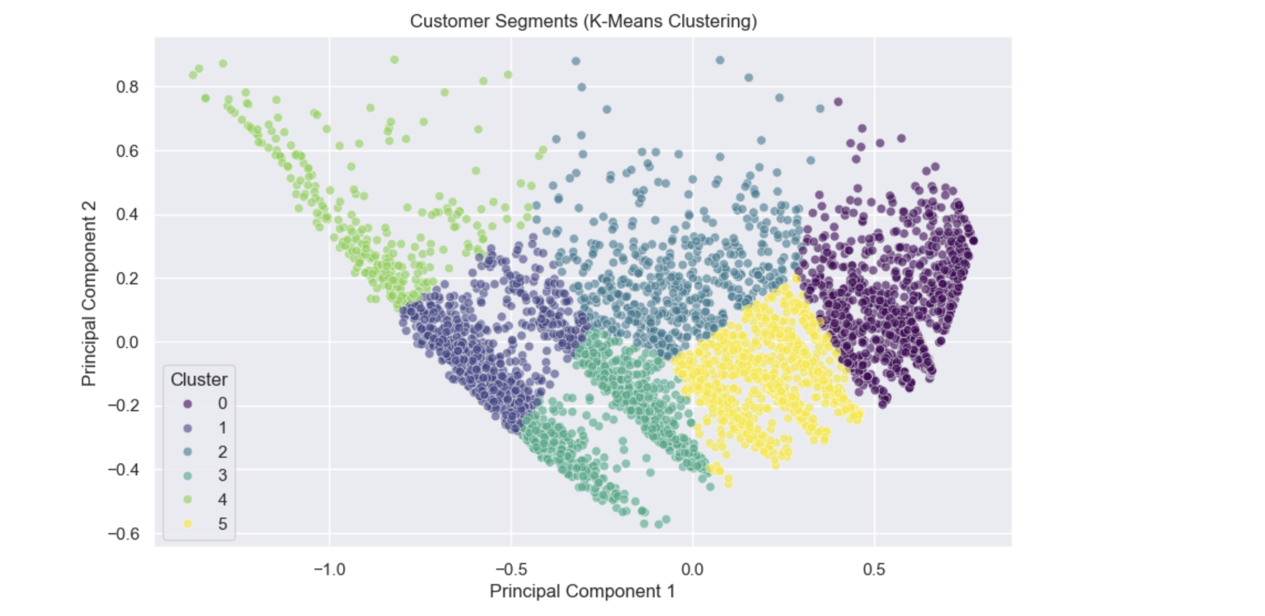

| pca_components = pd.DataFrame(pca.components_, columns=features, index=['PCA1', 'PCA2']) print(pca_components) |
| --- |

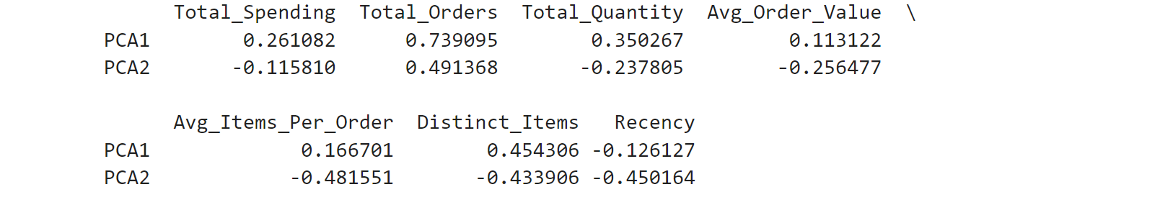

| cluster_summary = x.groupby("Cluster")[features].mean() print(cluster_summary) |
| --- |

### 

### 

### **Key Insights:**

##### **Cluster 0: "Frequent Big Spenders"**

##### High Spending, High Orders, High Variety

##### Low Recency (very recent customers)

##### **Cluster 1: "Occasional Buyers"**

##### Average Spendings, Low Orders, Low Variety(Low Distinct Items)

##### High Recency (older customers)

##### **Cluster 2: "Balanced or Regular Buyers"**

##### Average Spendings, Average Orders, Average Variety(Average Distinct Items)

##### Low Recency (Recentcustomers)

##### **Cluster 3: "Loyal but Rare Buyers"**

##### Average Spendings, Low Orders, Average Variety(Average Distinct Items)

##### High Recency (Old customers)

##### spend well when they buy

##### **Cluster 4: "Inactive Customers"**

##### Low Spending, Low Orders, Very Low Variety

##### Highest Recency (Oldest customers)

##### **Cluster 5: "High-Value Customers"**

##### High Spending, Average Orders, High Variety

##### High Recency (not very recent customers)

##### Spend a lot, buy different items, but not as often as Cluster 0.

## **4. Conclusion & Business Recommendations**

* **Target High-Value Customers (Cluster 0 and 5)**: Implement exclusive promotions and personalized discounts.
* **Re-engage Low-Activity Customers (Cluster 1 & 3)**: Utilize email marketing, limited-time offers, and reminders to encourage purchases.
* **Reactivate Inactive Customers(Cluster 4)**: free shipping offers, or surveys to understand why they left.
* **Nurture Average Customers (Cluster 2)**: Offer a subscription model or loyalty rewards to increase their frequency.