## **1. Introduction**

I applied K-means clustering to identify patterns in customer behavior, ultimately aiding in targeted marketing strategies and business decision-making.

## **2. Data Preprocessing**

Before clustering, I took the following steps:

* **Concatenate Both Datasets**: The excel file had datasets for both 2009-1020 and 2010-2011. So, I used `pd.concat` to join both into one dataframe.
* **Handling Missing Values**: Approximately 107,927 Customer ID values were missing, and these rows were removed.

| data1 = pd.read_csv("2009_2010_retail.csv") data1 = data1.dropna() data2 = pd.read_csv("2010_2011_retail.csv") dataframes = [data1, data2] data3 = pd.concat(dataframes) print(data3.shape) |
| --- |

* **Feature Engineering**: I derived key features such as:
  + **Total Spending** = Sum of all purchases per customer.
  + **Total Orders** = Count of unique invoices per customer.(number of orders they’ve made)
  + **Total Quantity** = Sum of all items purchased per customer.
  + **Average Order Value** = Total Spending / Total Orders.(Amount spent per order made)
  + **Average Items Per Order** = Total Quantity / Total Orders. (Average items per order)
  + **Distinct Items Purchased** = Number of unique products bought by a customer.
  + **Recency** = Days since the last purchase.

| data3['Customer ID'] = data3['Customer ID'].astype(str) data3['InvoiceData'] = pd.to_datetime(data3['InvoiceDate']) data3 = data3[data3['Quantity'] >0 ] data = data3.groupby('Customer ID').agg(  Total_Spending=('Price', lambda x: (x * data3.loc[x.index, 'Quantity']).sum()),  Total_Orders=('Invoice', 'nunique'),  Total_Quantity=('Quantity', 'sum'),  Distinct_Items=('StockCode', 'nunique'),  First_Purchase=('InvoiceDate', 'min'),  Last_Purchase=('InvoiceDate', 'max') ).reset_index()  latest_purchase = data3['InvoiceDate'].max()    data['Last_Purchase'] = pd.to_datetime(data['Last_Purchase'], errors='coerce') data['First_Purchase'] = pd.to_datetime(data['First_Purchase'], errors='coerce') latest_purchase = pd.to_datetime(latest_purchase, errors='coerce')  data['Recency'] = (latest_purchase - data['Last_Purchase']).dt.days data.drop(columns=['First_Purchase', 'Last_Purchase'], inplace=True) data['Avg_Order_Value'] = data['Total_Spending'] / data['Total_Orders'] data['Avg_Items_Per_Order'] = data['Total_Quantity'] / data['Total_Orders'] |
| --- |

* **Standardization**: Since the dataset contained numerical variables on different scales, I applied **StandardScaler, Log Values and Winsorization**  to normalize the data. Winsorization was used to remove outliers in the 80th percentile.



| data_log = data.copy() data_log['Total_Spending'] = np.log1p(data_log['Total_Spending']) data_log['Total_Quantity'] = np.log1p(data_log['Total_Quantity']) data_log['Distinct_Items'] = np.log1p(data_log['Distinct_Items']) data_log['Avg_Order_Value'] = np.log1p(data_log['Avg_Order_Value']) data_log['Avg_Items_Per_Order'] = np.log1p(data_log['Avg_Items_Per_Order']) data_log['Total_Orders'] = np.log1p(data_log['Total_Orders']) data_log['Recency'] = np.log1p(data_log['Recency']) cols_to_winsorize = ['Total_Spending', 'Total_Orders', 'Total_Quantity',   'Distinct_Items', 'Avg_Items_Per_Order', 'Avg_Order_Value']  data_log['Recency'] = data_log['Recency'].replace(-np.inf, np.nan)  # Ensure all columns are numeric for col in cols_to_winsorize:  data_log[col] = pd.to_numeric(data_log[col], errors='coerce')  # Winsorize: Cap values at the 80th percentile for col in cols_to_winsorize:   q8 = data_log[col].quantile(0.80)  data_log[col] = np.where(data_log[col] > q8, q8, data_log[col])  x = data_log[['Total_Spending', 'Total_Orders', 'Total_Quantity',   'Avg_Order_Value', 'Avg_Items_Per_Order', 'Distinct_Items', 'Recency']]  from sklearn.preprocessing import StandardScaler  scaler = StandardScaler() X_scaled = scaler.fit_transform(x) |
| --- |

## **3. Clustering Methodology**

I used **K-Means Clustering** to segment the customers. The process included:

* **Choosing the Optimal K**:
  + The **Elbow Method** was used to determine the best number of clusters.
  + Based on the analysis, I selected **K = 2** as the optimal number of clusters.
* **Applying K-Means**: The algorithm was implemented on the PCA-transformed data, ensuring efficiency and interpretability.

| wcss = []  for i in range(1,10):  kmeans = KMeans(i)  kmeans.fit(X_scaled)  wcss.append(kmeans.inertia_)   wcss  plt.plot(range(1,10), wcss) plt.xlabel("number of clusters") plt.ylabel('wcss')   kmeans = KMeans(n_clusters=2, random_state=42) data_log['Cluster'] = kmeans.fit_predict(X_scaled)  identified_clusters = kmeans.fit_predict(X_scaled) identified_clusters  data_with_clusters = data_log.copy() data_with_clusters['Cluster'] = identified_clusters data_with_clusters |
| --- |

## **4. Results & Analysis**

| import matplotlib.pyplot as plt import seaborn as sns from sklearn.decomposition import PCA  # Reduce to 2D for visualization pca = PCA(n_components=2) X_pca = pca.fit_transform(X_scaled)  # Add PCA components to the DataFrame data_with_clusters['PCA1'] = X_pca[:, 0] data_with_clusters['PCA2'] = X_pca[:, 1]  # Scatter plot of clusters plt.figure(figsize=(10, 6)) sns.scatterplot(x='PCA1', y='PCA2', hue='Cluster', palette='viridis', data=data_with_clusters, alpha=0.6) plt.title('Customer Segments (K-Means Clustering)') plt.xlabel('Principal Component 1') plt.ylabel('Principal Component 2') plt.legend(title="Cluster") plt.show() |
| --- |

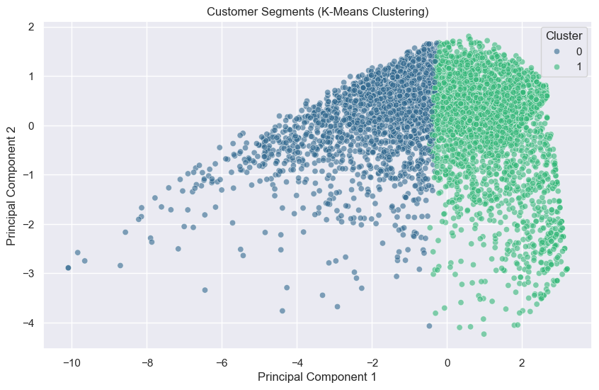

| data_with_clusters['Cluster'] = identified_clusters  cluster_summary = data_with_clusters.groupby("Cluster").mean(numeric_only=True) print(cluster_summary) |
| --- |

### **Cluster Characteristics**

| **Metric** | **Cluster 0** | **Cluster 1** |
| --- | --- | --- |
| Total Spending | 6.25 | 8.37 |
| Total Orders | 0.93 | 1.74 |
| Total Quantity | 4.78 | 6.77 |
| Distinct Items | 2.63 | 4.26 |
| Recency | 5.57 days | 4.99 days |
| Avg Order Value | 5.84 | 6.75 |
| Avg Items Per Order | 4.39 | 5.19 |

### **Key Insights**

* **Cluster 1** customers tend to purchase more items and spend more per order.
* **Cluster 0** customers exhibit lower spending
* Customers in Cluster 1 made purchases more recently (lower Recency value), indicating more engagement with the store.
* The business can target Cluster 1 customers with loyalty programs, rewards and others to encourage them to keep coming, while Cluster 0 customers may require re-engagement strategies, discounts, sales and targeted ads to make them spend more.

## **4. Conclusion & Business Recommendations**

* **Target High-Value Customers (Cluster 1)**: Implement exclusive promotions and personalized discounts.
* **Re-engage Low-Activity Customers (Cluster 0)**: Utilize email marketing, limited-time offers, and reminders to encourage purchases.
* **Monitor Customer Behavior**: Regularly update clustering models to reflect changing consumer habits.