**Uncommon Solutions**

**Group 3**

**Development Progress Report**

**Phase 3**

**UNCOMMON SOLUTIONS PHASE 3**

**Prepared By**

|  |  |
| --- | --- |
| Document Owner(s) | Project Role |
| Michael Kiefer | Project Manager |

**Requirements Version Control**

|  |  |  |  |
| --- | --- | --- | --- |
| Version | Date | Author | Change Description |
| 1.0 | 11/23/2019 | Michael Kiefer | Document creation |
| 1.1 | 11/30/2019 | Michael Kiefer | Phase 2 Additions |
| 1.2 | 12/07/2019 | Michael Kiefer | Phase 3 Additions |

**Summary Details**

|  |  |
| --- | --- |
| Participants | Name(s) |
| Project Manager: | Michael Kiefer |
| Project Team: | Hither Guzha – Technical Writer  Andrew Benson - Software Engineer  Donn Eddy - UX/HCI  Sean Mooneyham - Integration Engineer  Chase Thorpe - Test Engineer |
| End Users: | HR Departments |
| Description w/ Goal: | The purpose of this project is the implementation of an HR database and front end for personnel tracking. This document is to detail the design and architecture of the Uncommon Solutions Application. |

INTRODUCTION 4

1.1 Purpose 4

1.2 Background 4

1.3 Scope 4

1.4 Phases 4

1.5 Schedule 4

1.6 Design Considerations 4

2 PHASE 1 5

2.1 Development Progress 5

2.2 Database Development 5

2.3 Program Development 5

2.4 Milestone Evaluation 5

3 PHASE 2 6

3.1 Development Progress 6

3.2 Database Development 6

3.3 Program Development 6

3.4 Milestone Evaluation 6

4 PHASE 3 7

4.1 Development Progress 7

4.2 Database Development 7

4.3 Program Development 7

4.4 Milestone Evaluation 7

5 APPROVALS 8

# 

# INTRODUCTION

## Purpose

The purpose of this document is to detail the implementation process of the Uncommon Solutions HR Management System. The Uncommon Solutions HR Management System is being developed using an Agile SDLC framework. Any deviations from the planned Uncommon Solutions HR Management System will be reflected by updated changes to the associated design and system management documents. This document contains the necessary information required to effectively capture the development efforts of the team.

## Background

The Uncommon Solutions HR Management System will be designed in a way that makes it easy to support multiple platforms such as Windows, macOS, iOS and Android. This web-based tool provides a direct method for storing and providing access to individual personnel records, and for all processes required for HR tracking and data aggregation requirements. The HR system will be implemented using AWS Elastic Compute Cloud (EC2) and Amazon’s Relational Database Service (RDS) in order to allow for universal deployability and access.

## Scope

This document describes the development progress of the Uncommon Solutions HR Management System during each of the phases. This is a living document and will be updated as changes are made to the HR Management Systems design.

## Phases

The planned implementation of this project is broken down into three phases as follows:

1. Phase 1 consists of the creation of the database structure for information storage and the generation of the UI panels.
2. Phase 2 will consist of the functionality behind the login screen to include session management for the program. Additionally, user administration function to allow for management of user accounts will be implemented in this phase.
3. Phase 3 will consist of the data management functionality associated with this HR management system for the entry, modification, and management of the personnel information for the company.

## Schedule

The phased development schedule is a three-week process running from 18 November 2019 to 8 December 2019. There is an additional one-week flex time to allow for any schedule overruns and to allow for additional functionality to be added if time allows. This flex week runs from 9-15 December 2019.

## Design Considerations

The design for this program is as described in the Uncommon Solutions HR Management System Design Document. Any design variations will be validated by all members of the development team and incorporated into all design documentation to ensure that the entire development process is captured in documentation.

# PHASE 1

## Development Progress

In accordance with the planned steps for Phase 1 development, the initial process of creating the database structure independently from the creation of the initial user UI was executed. The individual talents of team members were employed at this phase in order to best make use of developmental strengths and deliver a solid foundation for later development process. The goals for Phase 1 were to create and implement the initial database structure and design and to build the initial program containing the User Interface for the system.

## Database Development

The database has been instantiated based on the design outlined in the original Design Document. There were some minor changes to the table and field names based on requirements unearthed during Phase 1 development. The updated Data Design Diagram is below, and has been updated in the Design Document.

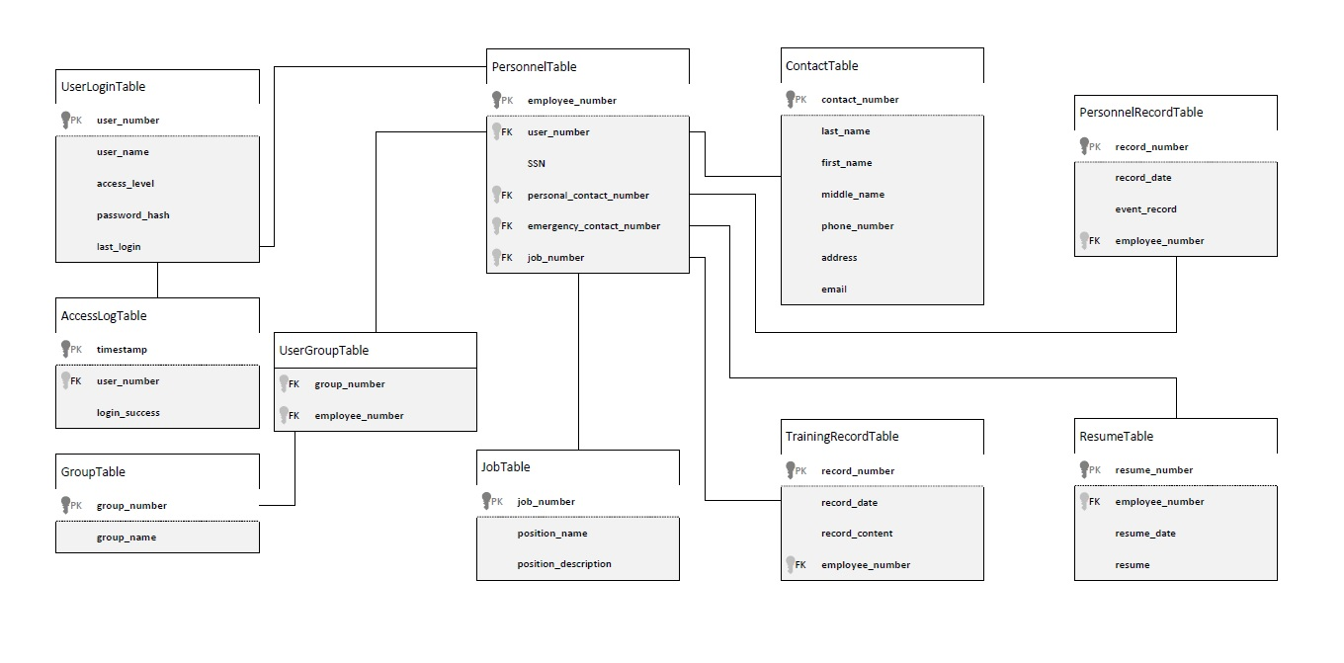

Figure 1: Data Design Diagram

The described tables had SQL statements built to create them and the foreign key dependencies defined by the Data Design Diagram. This SQL was executed in the instantiated Amazon RDS instance creating the baseline database structure for the Uncommon Solutions HR Management System to utilize. The below image shows the connected database after the SQL has been run and the tables are instantiated.

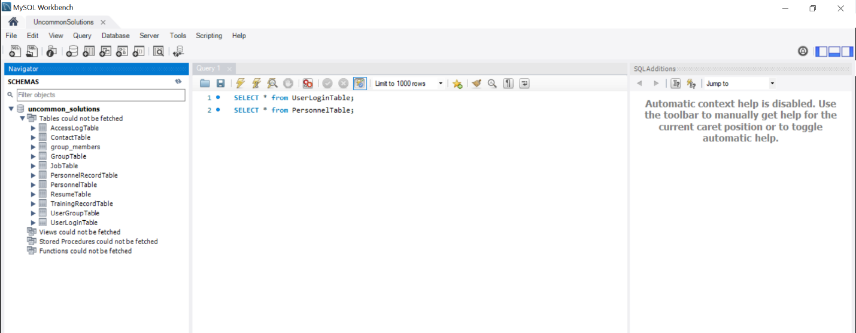

Figure 2: Database Instantiation

## Program Development

Initial development of the user interface systems was executed within PHP as a best option for the execution of a web-based interface system. With that in mind the initial interface design was created to show the login screen, user management console, and user data screen. In Phase 2, the first two of these will have their database connection instantiated and functionality created.

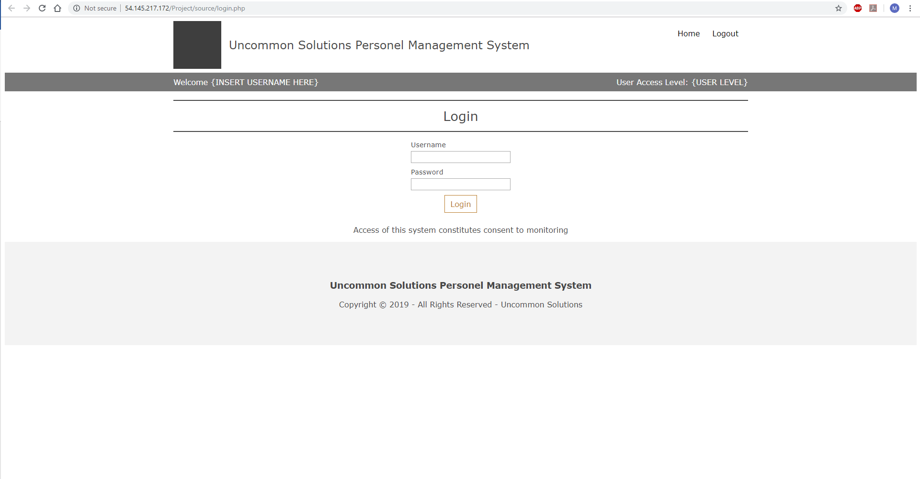

Figure 3: Login Screen

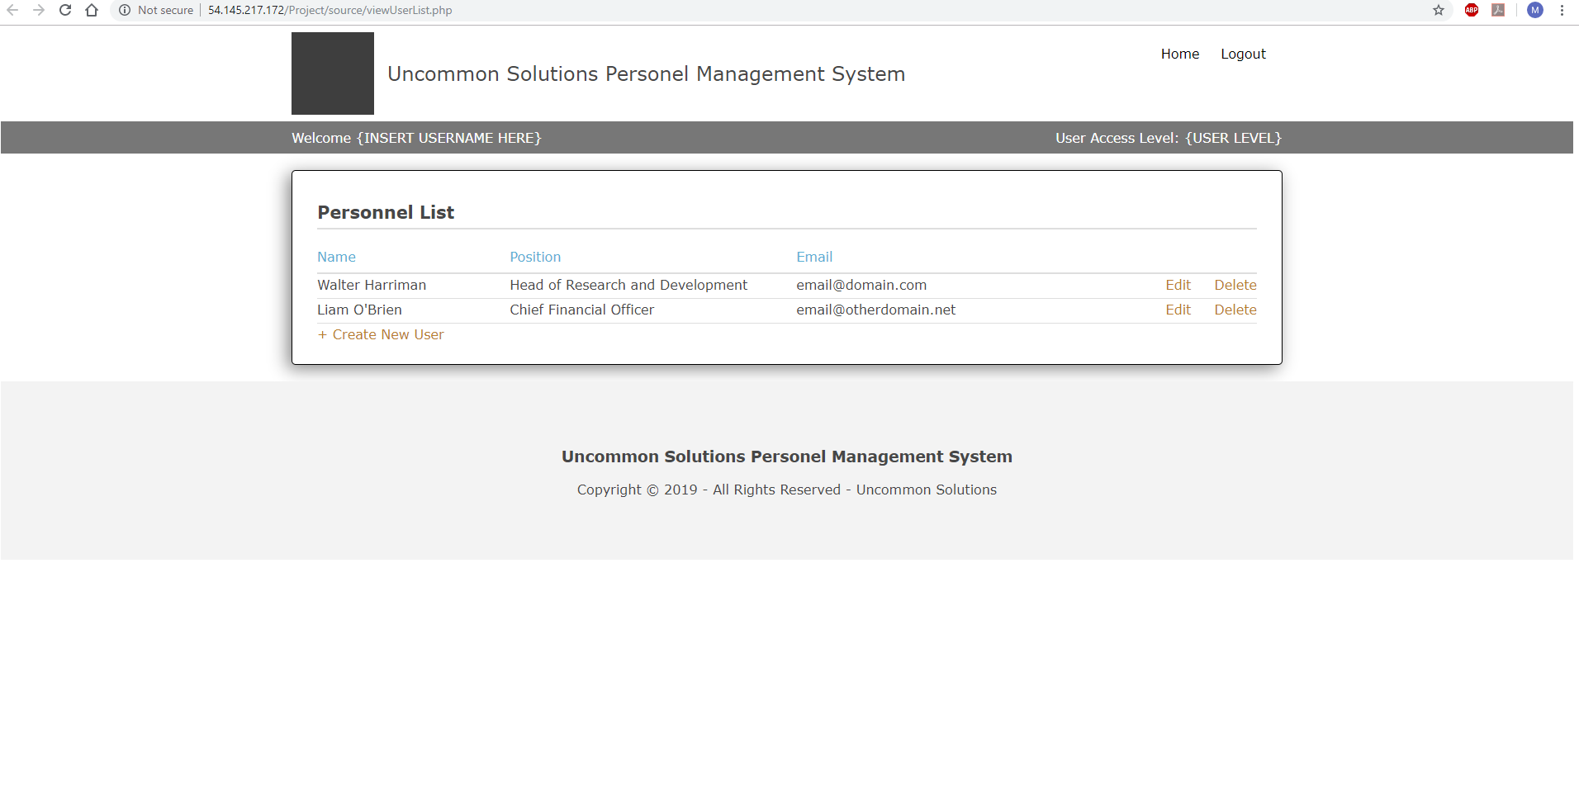

Figure 4: User Management Console

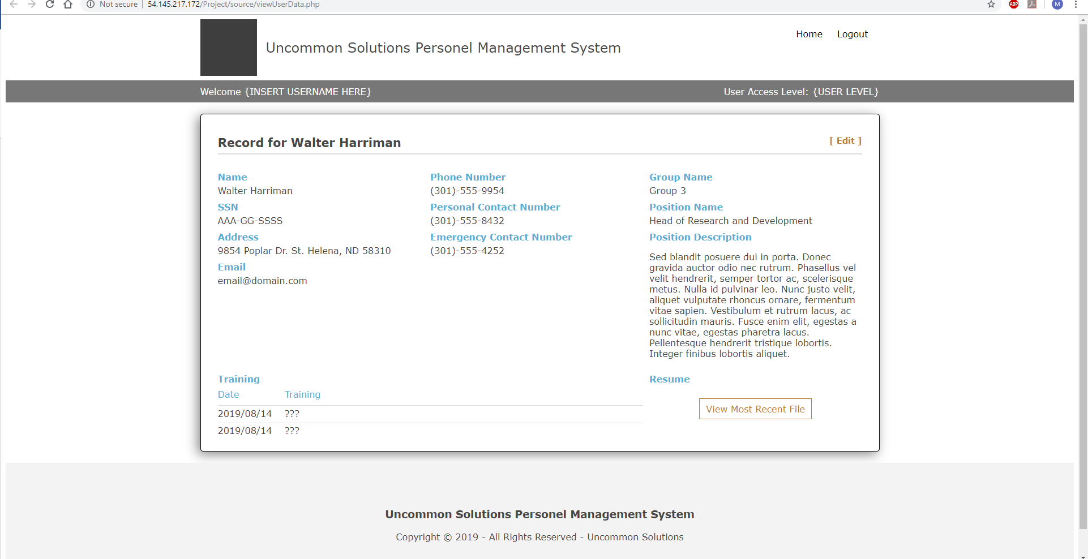

Figure 5: User Data Screen

## Milestone Evaluation

All milestone objectives for Phase 1 development were met by 23 November 2019. This was slightly ahead of projected scheduled development. As there is a major holiday occurring toward the end of Phase 2 development, Phase 2 was entered early to ensure that development would remain on track for the program.

# PHASE 2

## Development Progress

In accordance with the planned steps for Phase 2 development, the interface for user login functionality was completed to include session management for the user interface, this includes database level logging of all login attempts. In addition, the functionality for user account administration was implemented and validated to function. The individual talents of team members were employed at this phase in order to best make use of developmental strengths and deliver a solid foundation for later development process. The goals for Phase 2 were to build and demonstrate the functionality behind the login screen to include session management for the program. Additionally, user administration functions to allow for management of user accounts were to be implemented in this phase.

## Database Development

Some adjustments to the database and the associated table creation scripts were executed during this phase. The creation script includes checking for table existence prior to attempting cleanup, in addition there were some minor corrections in database column naming to ensure proper reflection of the planned schema. Auto-increment was added to the primary keys for all tables in order to ensure clean records addition and automatic iteration of the numeric primary keys on row addition. Finally, the database was simplified slightly by the removal of the UserGroupTable from the schema, this restricts Personnel records to belong to a single group, but greatly simplifies the initial implementation of the API for Personnel record interface. This modified table creation script was executed on the database to ensure clean interaction with the implemented API.

## Program Development

Development in this phase was targeted more at the functionality behind the user interface developed on Phase 1. The initial focus was on a correct implementation of a secure login method to include session management and database level logging of all attempted accesses. Feedback in the form of system messages to the end user were implemented in order to show system functionality for invalid login attempts.

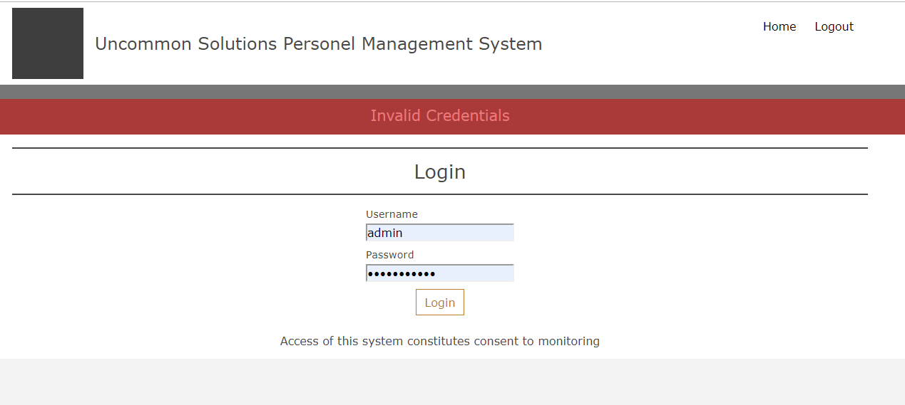

Figure 6: Invalid Login Credentials

As a part of the session management implementation, user-level session visibility on available functionality was added based on the defined access level of the logged in user account. This is reflected in what parts of the UI are displayed depending on access level, such that users will not even be aware of functionality that they do not have access to based on their assigned access level.

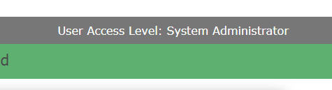

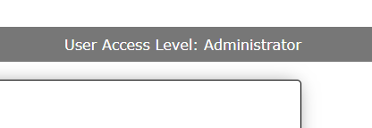

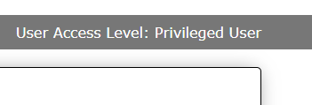

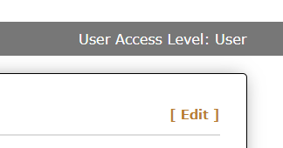

Figure 7: Access-Level Based Display

For the account administration panel, functionality for the creation, modification and deletion of user accounts was added for accounts with the system administration access level. This UI is not available or functional without an active session with system administration capabilities. This includes UI and functionality for the described functions and feedback messages on the success or failure of the attempted actions.

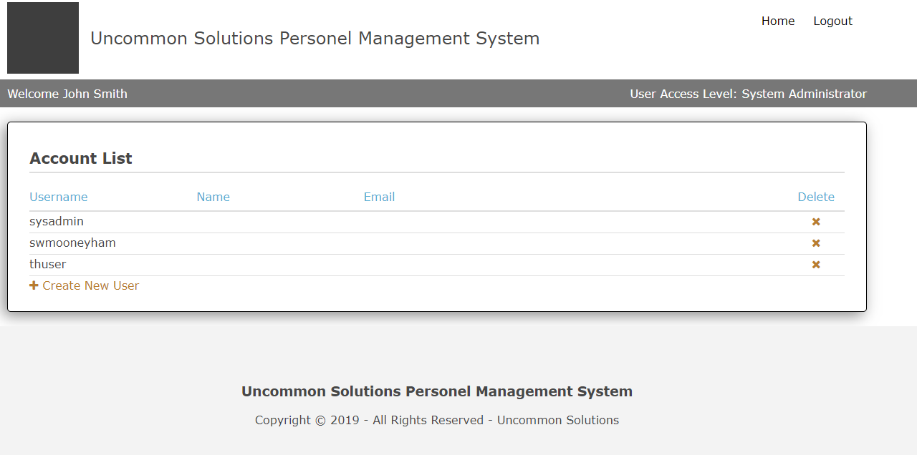

Figure 8: User Administration Panel

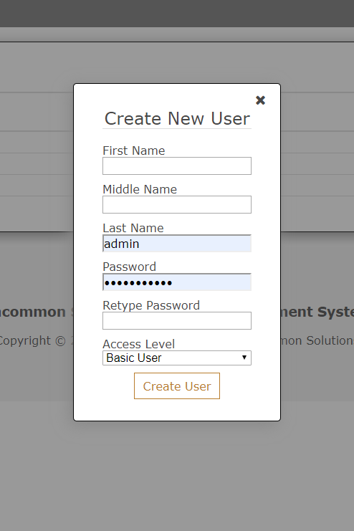

Figure 9: Account Creation

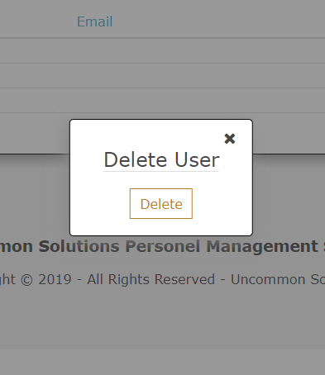

Figure 10: Account Deletion

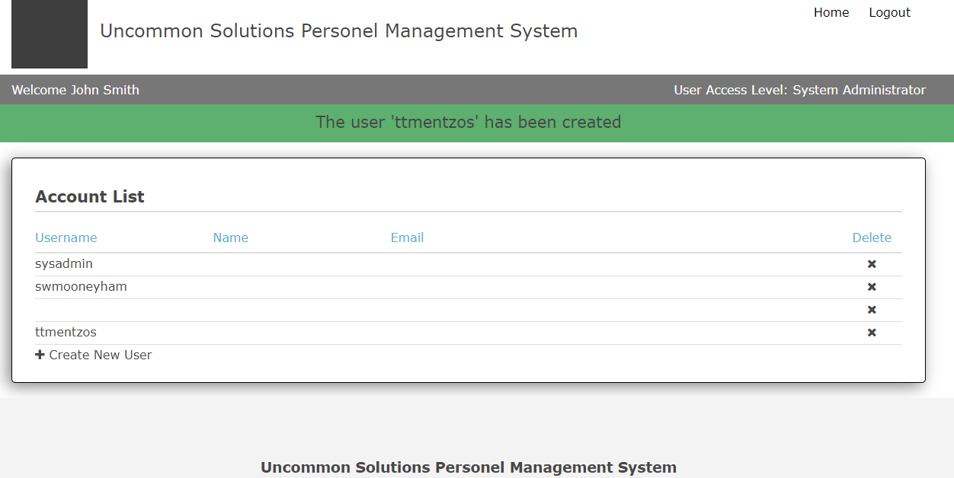

Figure 11: User Feedback Messaging

## Milestone Evaluation

All milestones for Phase 2 implementation have been validated as completed and met by 29 November 2019. At that time there was a break in implementation efforts to regroup, and development on Phase 3 will commence on 1 December 2019. The project remains on schedule for the planned implementation and should be able to enter into execution of the test plan on 8 December 2019 or sooner.

# PHASE 3

## Development Progress

Development for Phase 3 was focused on the UI and APIs for interaction with the employee HR records. With the previous phases having delivered database functionality and the system controls required for our account management and login processes, this was a logical expansion toward the data management for the rest of the system. Our targeted development objectives for Phase 3 are the creation and implementation of database access APIs for HR records data followed by the utilization of those APIs for addition, modification, and deletion of employee HR records by accounts with the appropriate access levels. The test plan was expanded to include a validation matrix, which was applied after the completion of development.

## Database Development

No database modifications were required at this stage of development, the changes made in Phase 2 were the only changes needed for smooth implementation. There were additional user accounts and data provided to the HR database segments to allow for validation and demonstration of functionality as those APIs/UI were built and tested.

## Program Development

This phase was begun with the development of the APIs for access to the HR records data associated with the specific users of the system. There is little to illustrate with these APIs, but their success and utilization will be apparent later in this narrative in the look at integration with the designed UI.

At this stage of development, we were already complete with user management and the system administrator access for account management:

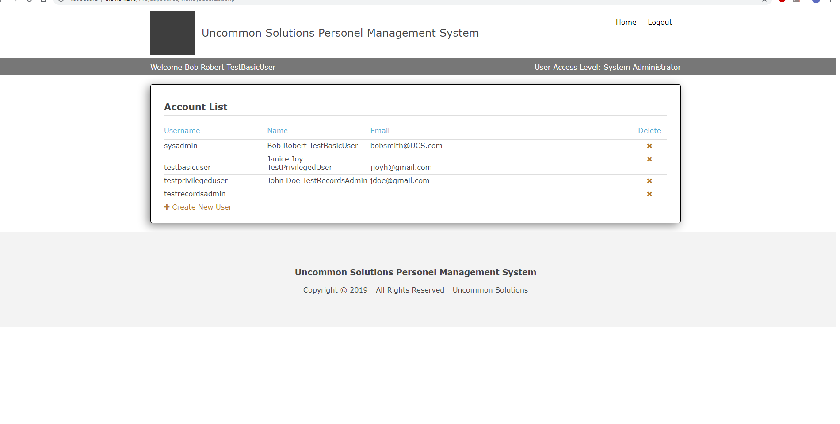

Figure 12: System Administrator Home Screen

Next for development was the integration of functionality for individual users, privileged users, and records administrators as described in the system design. The functional APIs were integrated to previously created framework, and additional framework and logic was created to display individual records as requested, depending on the access level of the individual utilizing the system. The displayed home screen was different depending on the access level of the individual user on the system, as illustrated below:

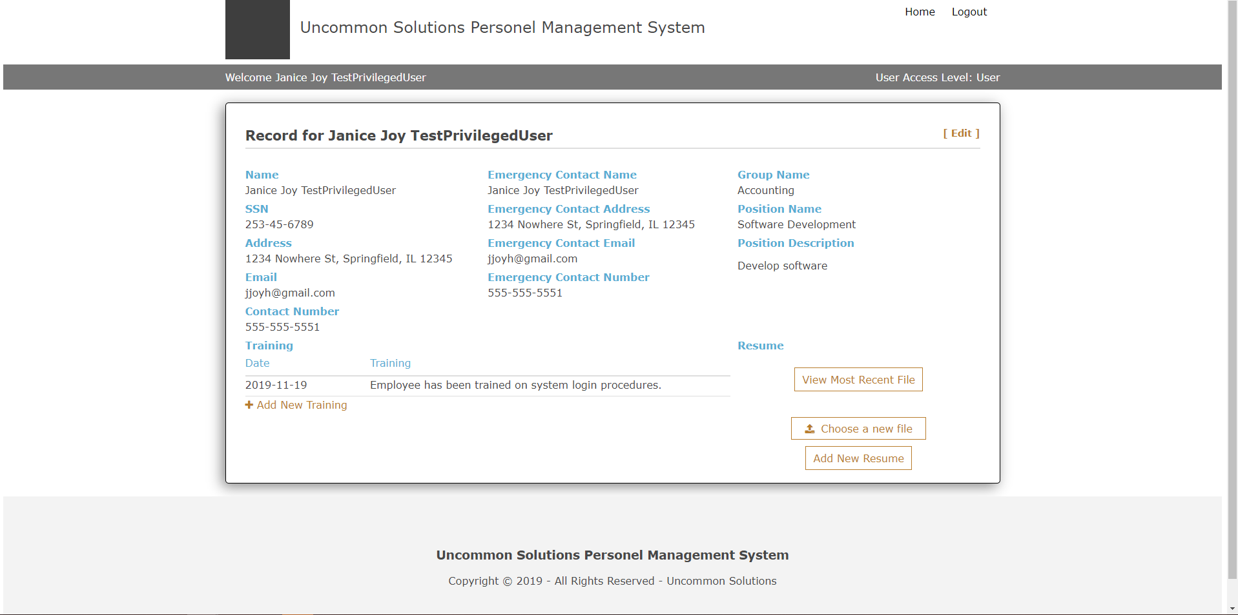

Figure 13: Standard User Home Screen

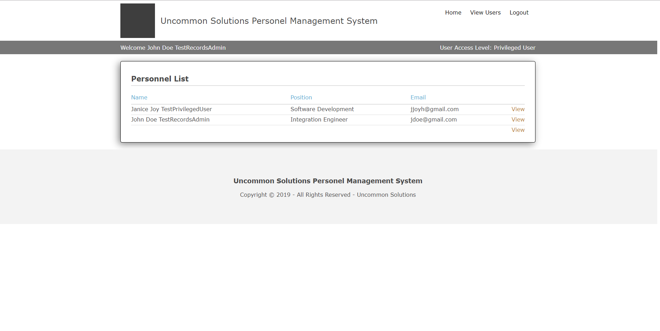

Figure 14: Privileged User Home Screen

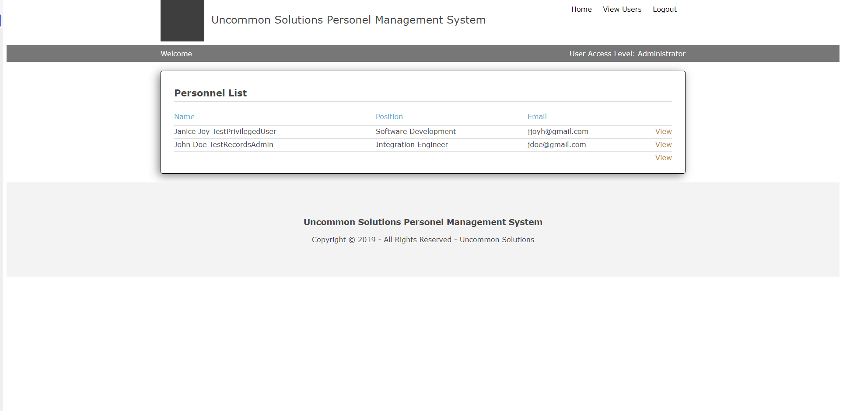

Figure 15: Records Administrator Home Screen

As can be seen, the functionality presented for our higher-level users allows access to more than just their own information, and by making use of the ability to view and modify records other than your own, the Records Administrator level has full access to do so:

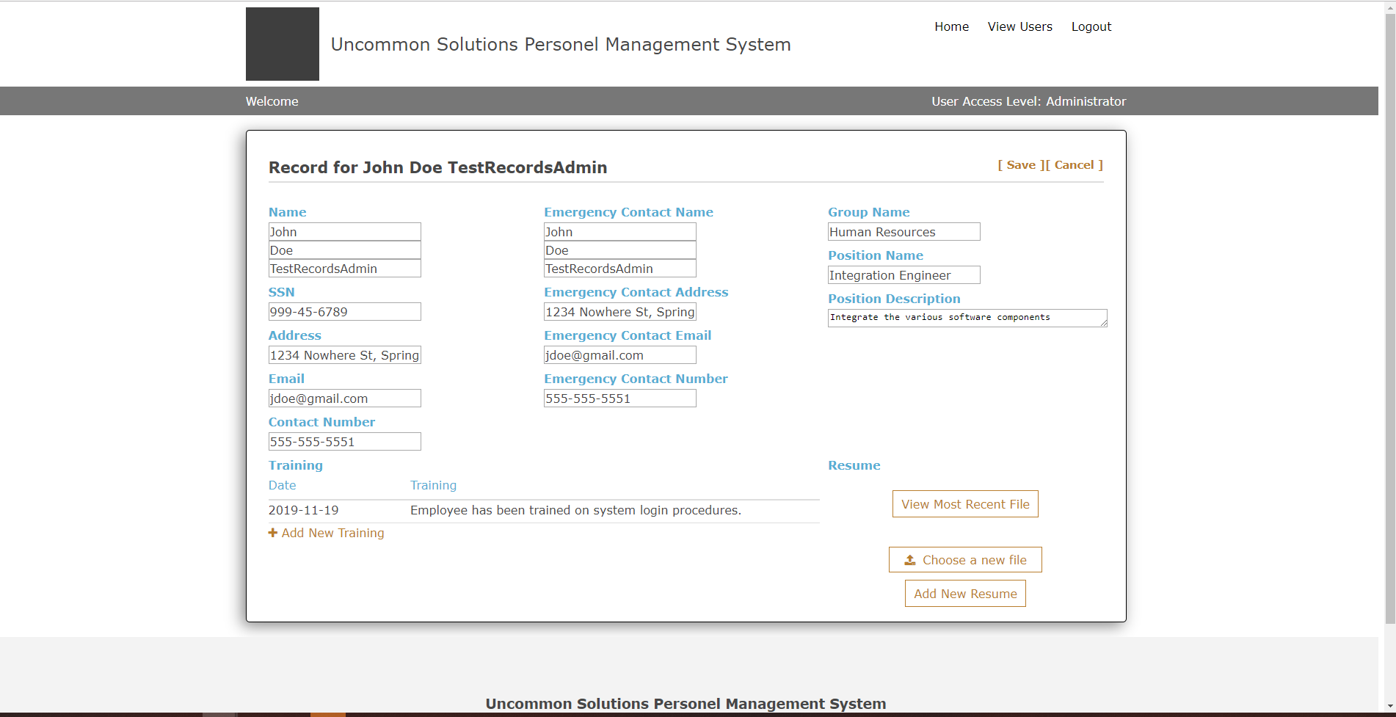

Figure 16: Records Administrator Other User Record

These looks at the logged-in home screens of each user level also serve to illustrate the previously implemented visual cue of current access level implemented in Phase 2 and show that the functionality has been carried across to all screens of the system.

After the completion of the development milestones required for Phase 3, systems level testing was executed by our test manager and documented appropriately. The updated Test Plan is included with the submission for Phase 3 to illustrate.

## Milestone Evaluation

Overall Phase 3 was executed successfully, however development timelines shifted slightly from the original plan and work was not completed until day six of the week cycle. This fell within the flex time built into each week of development, but slightly compressed the available time for documentation of development progress. Communication was a bit slower, but that was to be expected in the week following a holiday, however all members completed their assigned work for the Phase and it was completed. There are some minor technical issues in the current implementation which have been identified during group function validation and execution of the test plan, these will be resolved early next week inside of our “flex time” in the schedule prior to final delivery. Execution of the test plan revealed a need for individualized testing of specific segments of the site, which will be added to the final test plan to be re-evaluated after the completion of development fixes.

We expect the final version and associated documents to be ready for submission by Friday, 13 December in accordance with the current development schedule. As usual, this allows for additional flex of the remaining two days of the term, but as a number of us will be attending commencement on 14 December, the goal is to have all work complete prior to that date.

# APPROVALS

I have read the above Software Development progress report and agree that it is an accurate summary of software development efforts to date. I will continue to execute my proscribed tasks for each phase of developmentand pledge my full commitment and support for the Development Effort.

Sign-off Sheet

**Prepared by** ___Michael Kiefer_________________________

Project Manager– Michael Kiefer

**Approved by**___Hither Guzha________________________

Technical Writer– Hither Guzha

**Approved by**___Andrew Benson_______________________

Project Team Member– Andrew Benson

**Approved by**___Donn Eddy___________________________

Project Team Member– Donn Eddy

**Approved by**___Sean Mooneyham_____________________

Project Team Member– Sean Mooneyham

**Approved by**___Chase Thorpe_________________________

Project Team Member– Chase Thorpe