**Uncommon Solutions**

**Group 3**

**Development Progress Report**

**Phase 1**

**UNCOMMON SOLUTIONS PHASE 1**

**Prepared By**

|  |  |
| --- | --- |
| Document Owner(s) | Project Role |
| Michael Kiefer | Project Manager |

**Requirements Version Control**

|  |  |  |  |
| --- | --- | --- | --- |
| Version | Date | Author | Change Description |
| 1.0 | 11/23/2019 | Michael Kiefer | Document creation |

**Summary Details**

|  |  |
| --- | --- |
| Participants | Name(s) |
| Project Manager: | Michael Kiefer |
| Project Team: | Hither Guzha – Technical Writer  Andrew Benson - Software Engineer  Donn Eddy - UX/HCI  Sean Mooneyham - Integration Engineer  Chase Thorpe - Test Engineer |
| End Users: | HR Departments |
| Description w/ Goal: | The purpose of this project is the implementation of an HR database and front end for personnel tracking. This document is to detail the design and architecture of the Uncommon Solutions Application. |

INTRODUCTION 4

1.1 Purpose 4

1.2 Background 4

1.3 Scope 4

1.4 Phases 4

1.5 Schedule 4

1.6 Design Considerations 4

2 PHASE 1 5

2.1 Development Progress 5

2.2 Database Development 5

2.3 Program Development 5

2.4 Milestone Evaluation 5

3 PHASE 2 6

3.1 Development Progress 6

3.2 Database Development 6

3.3 Program Development 6

3.4 Milestone Evaluation 6

4 PHASE 3 7

4.1 Development Progress 7

4.2 Database Development 7

4.3 Program Development 7

4.4 Milestone Evaluation 7

5 APPROVALS 8

# 

# INTRODUCTION

## Purpose

The purpose of this document is to detail the implementation process of the Uncommon Solutions HR Management System. The Uncommon Solutions HR Management System is being developed using an Agile SDLC framework. Any deviations from the planned Uncommon Solutions HR Management System will be reflected by updated changes to the associated design and system management documents. This document contains the necessary information required to effectively capture the development efforts of the team.

## Background

The Uncommon Solutions HR Management System will be designed in a way that makes it easy to support multiple platforms such as Windows, macOS, iOS and Android. This web-based tool provides a direct method for storing and providing access to individual personnel records, and for all processes required for HR tracking and data aggregation requirements. The HR system will be implemented using AWS Elastic Compute Cloud (EC2) and Amazon’s Relational Database Service (RDS) in order to allow for universal deployability and access.

## Scope

This document describes the development progress of the Uncommon Solutions HR Management System during each of the phases. This is a living document and will be updated as changes are made to the HR Management Systems design.

## Phases

The planned implementation of this project is broken down into three phases as follows:

1. Phase 1 consists of the creation of the database structure for information storage and the generation of the UI panels.
2. Phase 2 will consist of the functionality behind the login screen to include session management for the program. Additionally, user administration function to allow for management of user accounts will be implemented in this phase.
3. Phase 3 will consist of the data management functionality associated with this HR management system for the entry, modification, and management of the personnel information for the company.

## Schedule

The phased development schedule is a three-week process running from 18 November 2019 to 8 December 2019. There is an additional one-week flex time to allow for any schedule overruns and to allow for additional functionality to be added if time allows. This flex week runs from 9-15 December 2019.

## Design Considerations

The design for this program is as described in the Uncommon Solutions HR Management System Design Document. Any design variations will be validated by all members of the development team and incorporated into all design documentation to ensure that the entire development process is captured in documentation.

# PHASE 1

## Development Progress

In accordance with the planned steps for Phase 1 development, the initial process of creating the database structure independently from the creation of the initial user UI was executed. The individual talents of team members were employed at this phase in order to best make use of developmental strengths and deliver a solid foundation for later development process. The goals for Phase 1 were to create and implement the initial database structure and design and to build the initial program containing the User Interface for the system.

## Database Development

The database has been instantiated based on the design outlined in the original Design Document. There were some minor changes to the table and field names based on requirements unearthed during Phase 1 development. The updated Data Design Diagram is below, and has been updated in the Design Document.

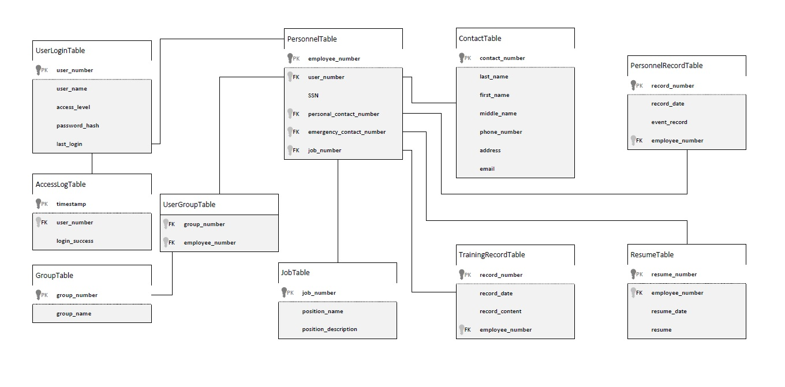

Figure 1: Data Design Diagram

The described tables had SQL statements built to create them and the foreign key dependencies defined by the Data Design Diagram. This SQL was executed in the instantiated Amazon RDS instance creating the baseline database structure for the Uncommon Solutions HR Management System to utilize. The below image shows the connected database after the SQL has been run and the tables are instantiated.

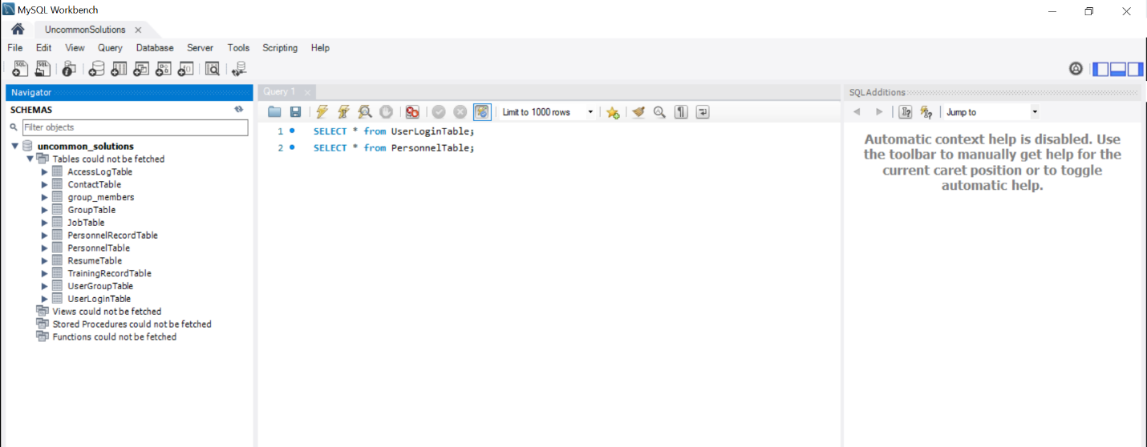

Figure 2: Database Instantiation

## Program Development

Initial development of the user interface systems was executed within PHP as a best option for the execution of a web-based interface system. With that in mind the initial interface design was created to show the login screen, user management console, and user data screen. In Phase 2, the first two of these will have their database connection instantiated and functionality created.

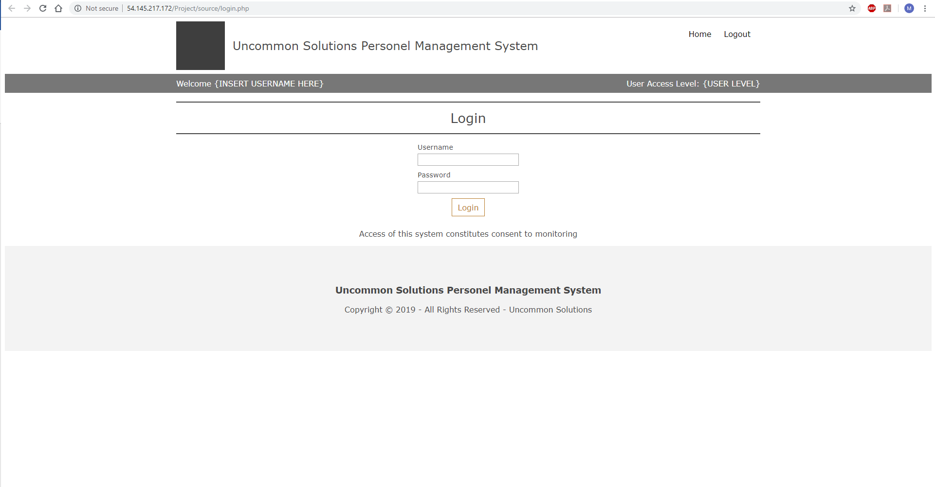

Figure 3: Login Screen

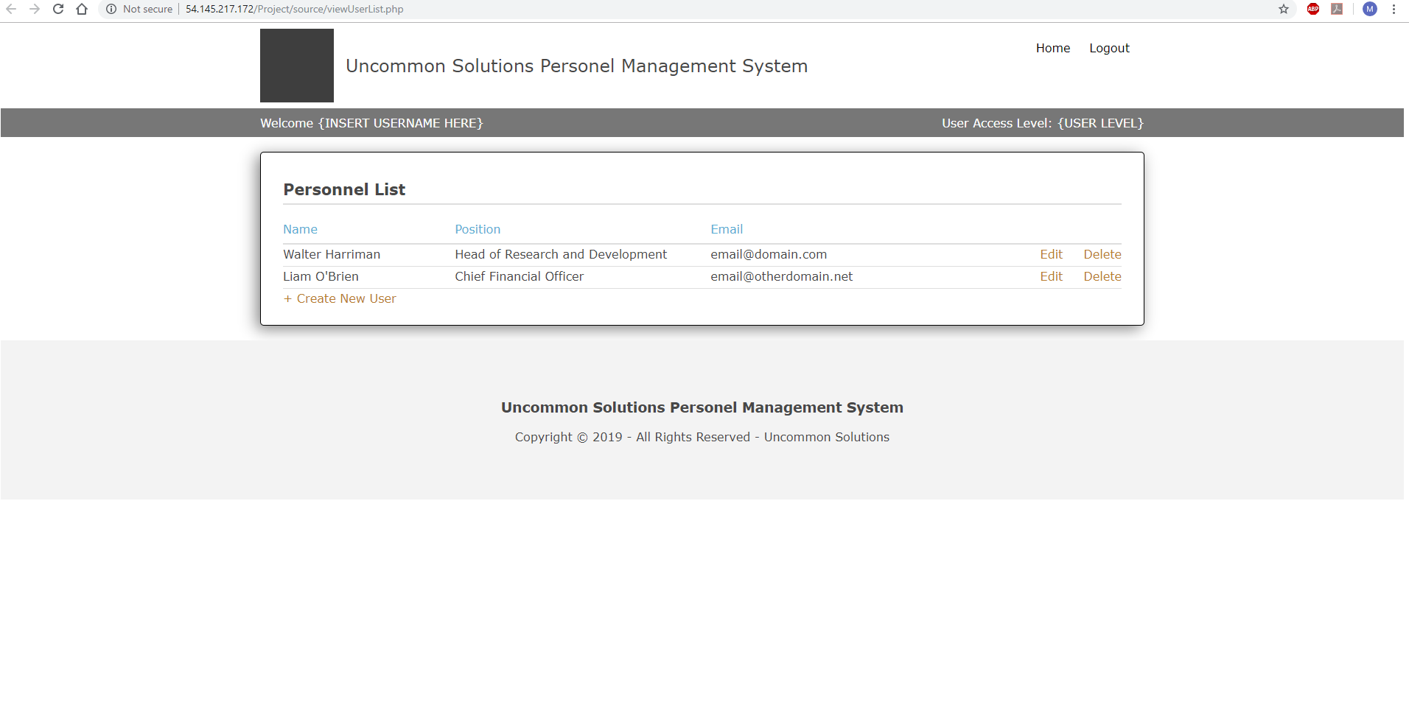

Figure 4: User Management Console

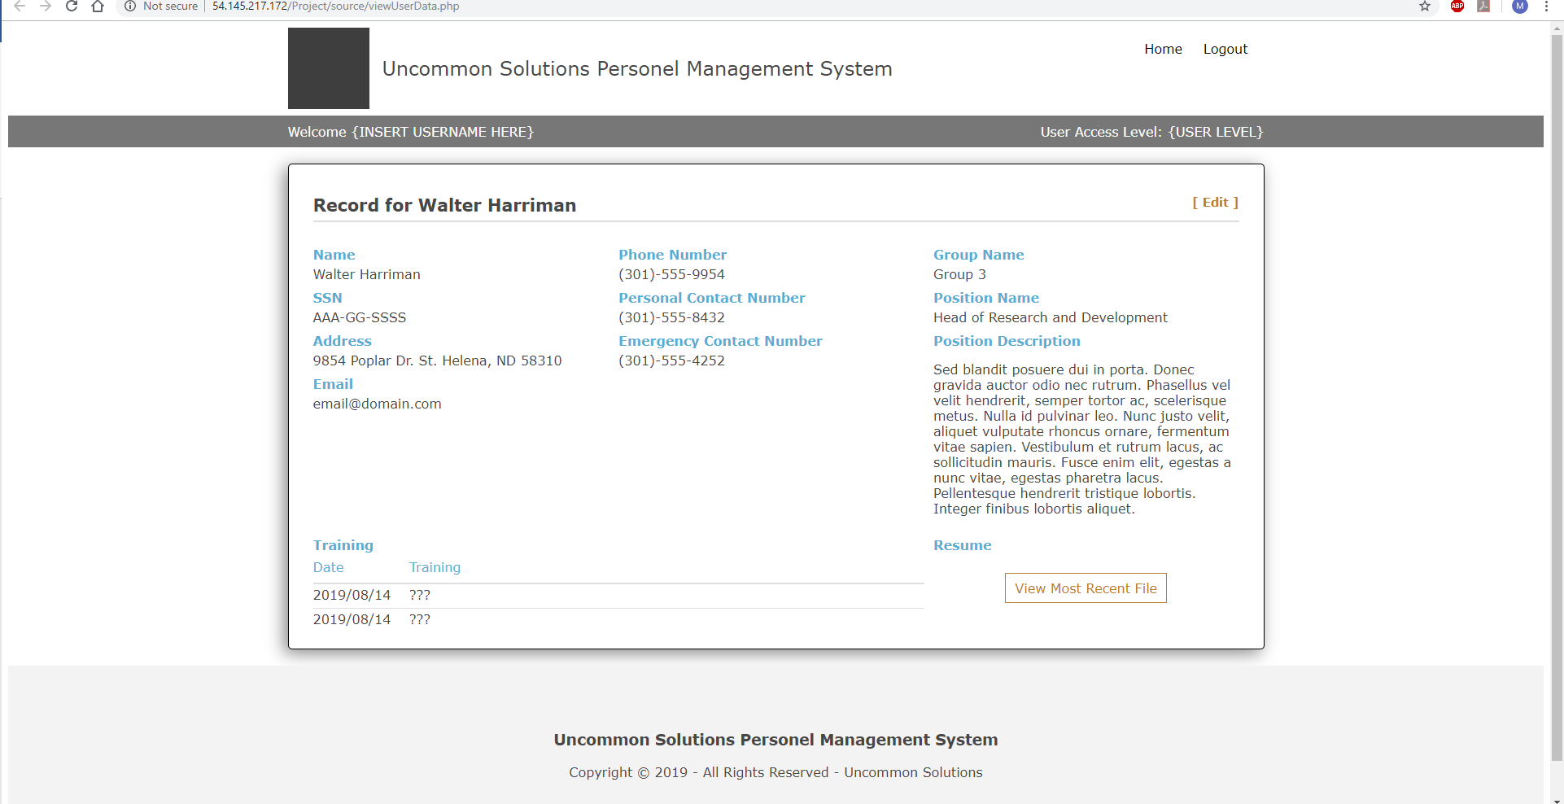

Figure 5: User Data Screen

## Milestone Evaluation

All milestone objectives for Phase 1 development were met by 23 November 2019. This was slightly ahead of projected scheduled development. As there is a major holiday occurring toward the end of Phase 2 development, Phase 2 was entered early to ensure that development would remain on track for the program.

# PHASE 2

## Development Progress

Summary of development efforts for Phase 2.

## Database Development

Summary of database development efforts for Phase 2.

## Program Development

Summary of program development efforts for Phase 2.

## Milestone Evaluation

Evaluation of milestone completion effectiveness for Phase 2.

# PHASE 3

## Development Progress

Summary of development efforts for Phase 3.

## Database Development

Summary of database development efforts for Phase 3.

## Program Development

Summary of program development efforts for Phase 3.

## Milestone Evaluation

Evaluation of milestone completion effectiveness for Phase 3.

# APPROVALS

I have read the above Software Development progress report and agree that it is an accurate summary of software development efforts to date. I will continue to execute my proscribed tasks for each phase of developmentand pledge my full commitment and support for the Development Effort.

Sign-off Sheet

**Prepared by** ___Michael Kiefer_________________________

Project Manager– Michael Kiefer

**Approved by**___Hither Guzha________________________

Technical Writer– Hither Guzha

**Approved by**___Andrew Benson_______________________

Project Team Member– Andrew Benson

**Approved by**___Donn Eddy___________________________

Project Team Member– Donn Eddy

**Approved by**___Sean Mooneyham_____________________

Project Team Member– Sean Mooneyham

**Approved by**___Chase Thorpe_________________________

Project Team Member– Chase Thorpe