**Uncommon Solutions**

**Group 3**

**Requirements Specification**

**UNCOMMON SOLUTIONS REQUIREMENTS SPECIFICATION**

**Prepared By**

|  |  |
| --- | --- |
| Document Owner(s) | Project Role |
| Michael Kiefer | Project Manager |

**Requirements Version Control**

|  |  |  |  |
| --- | --- | --- | --- |
| Version | Date | Author | Change Description |
| 1.0 | 12/13/2019 | Michael Kiefer | Document creation |

**Summary Details**

|  |  |
| --- | --- |
| Participants | Name(s) |
| Project Manager: | Michael Kiefer |
| Project Team: | Hither Guzha – Technical Writer  Andrew Benson - Software Engineer  Donn Eddy - UX/HCI  Sean Mooneyham - Integration Engineer  Chase Thorpe - Test Engineer |
| End Users: | HR Departments |
| Description w/ Goal: | The purpose of this project is the implementation of an HR database and front end for personnel tracking. This document outlines the requirements for this project that must be met in order for the project to be considered a success. |

INTRODUCTION 4

1.1 Purpose 4

1.2 Background 4

1.3 Scope 4

1.4 Assumptions 4

1.5 Constraints 4

2 Software Requirements 5

2.1 Requirements Overview 5

2.2 Product Features 5

2.3 User Classes and Characteristics 5

2.4 Design and Implementation Constraints 6

2.5 Assumptions and Dependencies 6

2.6 User Interfaces 6

2.7 Software Quality Attributes 7

3 APPROVALS 8

# 

# INTRODUCTION

## Purpose

The purpose of this document is to detail the software requirements specification of the Uncommon Solutions HR Management System. The Uncommon Solutions HR Management System is being developed using an Agile SDLC framework. Any deviations from the planned Uncommon Solutions HR Management System will be reflected by updated changes to the associated design and system management documents. This document contains the necessary details to implement the software requirements for the planned development process.

## Background

The Uncommon Solutions HR Management System will be designed in a way that makes it easy to support multiple platforms such as Windows, macOS, iOS and Android. This web-based tool provides a direct method for storing and providing access to individual personnel records, and for all processes required for HR tracking and data aggregation requirements. The HR system will be implemented using AWS Elastic Compute Cloud (EC2) and Amazon’s Relational Database Service (RDS) in order to allow for universal deployability and access.

## Scope

This document provides a clear overview of the designed software requirements for the completion of the Uncommon Solutions HR Management System. Specific system requirements for development and deployment are covered within the System Specification accompanying this document.

## Assumptions

The following assumptions are relevant to the design of the proposed system:

* The proposed new system will leverage the Uncommon Solutions HR architecture.
* The existing architecture and system design will be used including all existing components and sub-systems.
* It is assumed that additional functionality will be added to the proposed solution as required during development and testing.

## Constraints

* There are no hardware or software technical constraints identified with this project.
* System interoperability may be a constraint since the design will leverage free tier AWS EC2 instance and RDS with the potential to expand to paid utilization at a larger-scale fielding.

# Software Requirements

## Requirements Overview

The system being designed will provide a username/password authenticated access to a system for the management of HR records. This will present in a simple interface for users to be able to view and modify some parts of their individual records. Privileged users will have additional accesses to manage more data for other users as a part of their role within the system. Management of the accounts associated with the system and their access levels will be controlled through a separated account administration interface which requires an account with that privilege level but no database level access, ensuring separation of access controls.

## Product Features

The delivered software product will provide API interfaces invisible to the end user for access of data stored in the system associated database. This will present to the end user via a simple to operate interface that presents all relevant data in an easy to read and well-structured format. For accounts with higher privilege levels, the current privilege level will be easy to identify within the interface and present in a cleanly structured format for ease of account and personnel records management. All deletions and modifications will present with a confirmation dialogue that clearly states the action about to be executed.

## User Classes and Characteristics

The design of the API uses a simple MVC pattern where the models use an Object-Oriented design and have standard attributes such as private properties that are accessible with getter and setter methods. Since the scope of the application is small only one controller will be used to handle all the database operations. Classes will be implemented to handle database connectivity, user login, and audit logging.

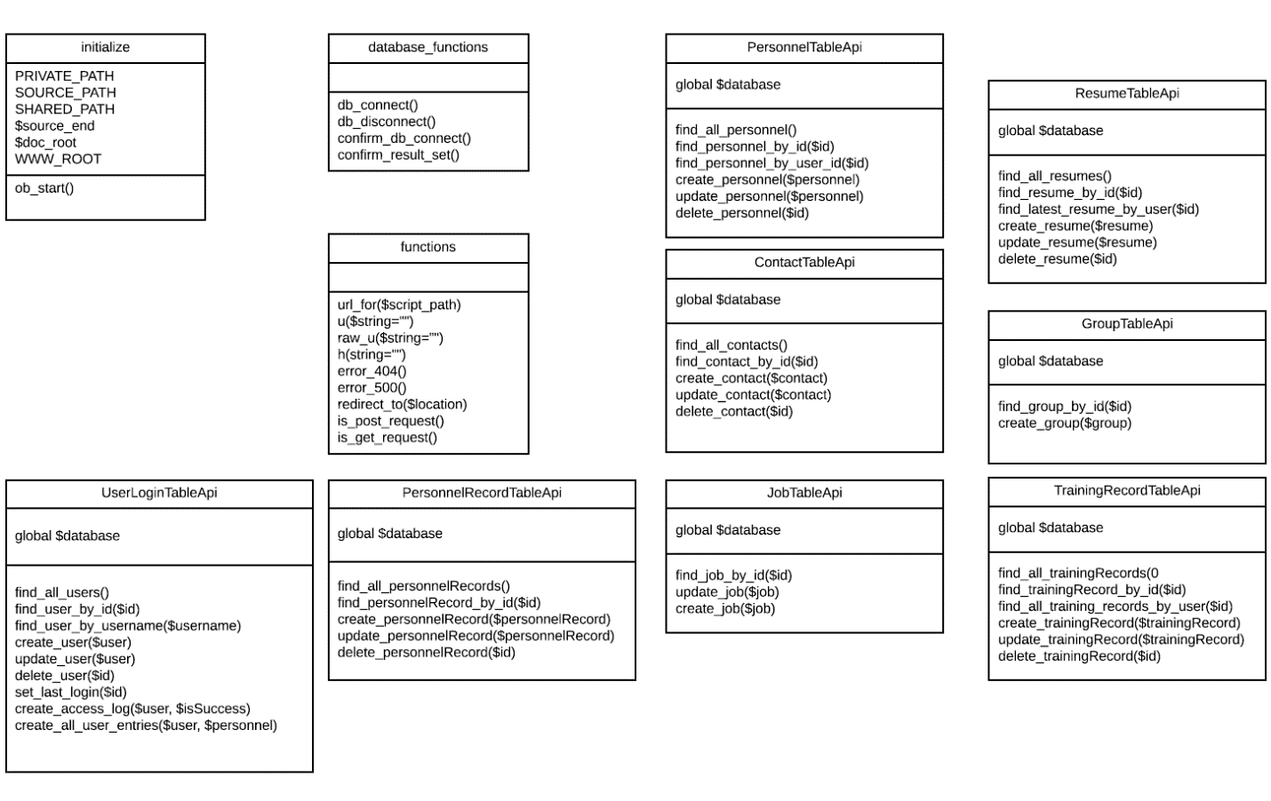

**Figure 1: The Class UML Diagram**

## Design and Implementation Constraints

Software will be designed and implemented to be platform agnostic and function to connect to the database through a standard SQL interface based on an external configuration file. This will allow for customer fielding of a database on whatever platform they choose, requiring only industry standard access methods.

## Assumptions and Dependencies

It is assumed that the underlying system will provide the required supports as defined in the System Requirements document. All software will be designed and implemented to ensure maximum clarity.

## User Interfaces

The User Interface for the will adopt a flat design. Not only would this provide the design with a modern aesthetic, but would also minimize the system resources consumed to render the web pages expanding the compatibile range of platforms. The design will be seamless between pages to ensure that there are no sudden shifts in design. Refer to the Appendix for page wireframes.

The User Interface presented after completion of the login process will depend on the level of access associated with the individual user account. The interface presented to a standard user will vary significantly from that presented to a system administrator as outlined in the wireframes presented in the appendix.

## Software Quality Attributes

All software design will adhere to industry standards for modularity, programming structure, algorithm efficiency, object-oriented design and clear and understandable in-source documentation (commenting). Known security vulnerabilities will be protected against and the software will be built in such a way as to ensure that future optimizations, security fixes, and expansions will be able to be implemented without additional effort to understand existing source code.

# APPROVALS

I have read the above Software Development progress report and agree that it is an accurate summary of software development efforts to date. I will continue to execute my proscribed tasks for each phase of development and pledge my full commitment and support for the Development Effort.

Sign-off Sheet

**Prepared by** ___Michael Kiefer_________________________

Project Manager– Michael Kiefer

**Approved by**___Hither Guzha________________________

Technical Writer– Hither Guzha

**Approved by**___Andrew Benson_______________________

Project Team Member– Andrew Benson

**Approved by**___Donn Eddy___________________________

Project Team Member– Donn Eddy

**Approved by**___Sean Mooneyham_____________________

Project Team Member– Sean Mooneyham

**Approved by**___Chase Thorpe_________________________

Project Team Member– Chase Thorpe